Easy Apps 32-bit & Easy Apps Pro - Instructions for Network Installations

For Windows 95/98/NT/2000/XP systems
You will need to call Agency Software at (800) 342-7327 while you are performing the installation to obtain the passwords to set up your agency information and complete the installation.

Network Setup Overview
Your network will be either a peer-to-peer network or a client-server network.
In a peer-to-peer network, the EasyApps database files are located on one user’s machine (called a non-dedicated server) and are used at other machines as well (called workstations).
In a client-server network, the EasyApps database files are located on one machine that no one works at (called a dedicated server) and are used only at other machines (called workstations).
In both types of networks, the database file will be located on the server machine, on a drive or in a folder that’s shared with full permissions for the workstations. Each of the workstations uses the program and files that are located on the server.

Where to install the program on the server:
You can install EasyApps to the root drive of the server (usually the C: drive) or into a folder on the root drive. Wherever you decide to install EasyApps, that drive or folder must be shared with full permissions over the network.
Installing into a shared folder: If you don’t want to share the root drive of your server, you can create a folder on the root drive and install into that folder. The folder must be shared with full permissions across the network. If you map to a shared folder, the non-dedicated server on a peer-to-peer network must be mapped to the same drive letter and path as the workstations.

Note: If you want to install EasyApps into a shared folder, the name of the shared folder must have no more than 8 characters and no spaces (e.g. you cannot install EasyApps into the Program Files folder). Good-shared folder names are “Data” and “Apps”.

Mapping Drive Letters at the Workstations
Before you begin to install the program on the server, get your workstations set up. To set up the workstations, you need to map a drive letter at each workstation (and at the server, if you’re installing EasyApps into a shared folder).
Mapping a drive means you create a new drive icon in the workstation that connects to the shared folder or drive on the server. For example, a mapped drive letter might be Q or F or Z. Do not use the letter C (which is usually the local hard drive in the workstation) or any other letter already assigned to the CD-ROM or Floppy Disk or a second hard drive in any workstation.
TIP: For simplicity and convenience, choose a mapped drive letter that’s near the end of the alphabet, and map the same drive letter at every workstation.
These procedures illustrate mapping the drive letter Q, and the rest of the installation procedures will use the Q drive as the example. If your mapped drive letter is different, use your mapped drive letter instead.
Mapping a drive letter on Windows 2000/XP:
- First, you need to know the full computer name of the server.
  - Right-click the My Computer icon and click Properties.
In Windows XP, the Full Computer Name is found on the Computer Name tab.
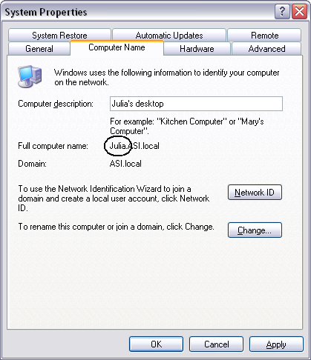

In Windows 2000, the Full Computer Name is found on the Network Identification tab.
  - Write it down – spelling counts – then click Cancel to close the System Properties dialog box.
- Right-click the My Computer icon again, and click Map Network Drive.
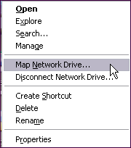

- In the Map Network Drive dialog box, click the arrow on the right side of the Drive box, and select your chosen mapped drive letter.
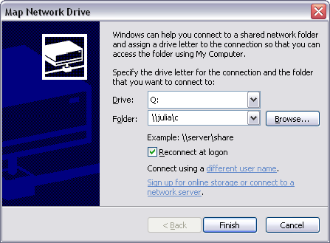

- In the Folder box, type the path to the shared drive or folder in this format:
\\servername\C (to map to the shared drive C on the server)
\\servername\apps (to map to a shared folder named “apps” on the server)
***Do NOT map to the EAPPW folder***

- Click the Finish button. If you get no errors, then your drive mapping is complete.
- Double-click the My Computer icon. You should see the mapped drive letter in the My Computer window. You’ll see the shared drive or folder name, the computer name, and the mapped drive letter in parentheses. When you double-click on the mapped drive icon, the shared drive or folder to which you mapped will open. When you finish, a folder window opened to your new mapped drive letter opens. The mapped drive letter appears in the window’s title bar.
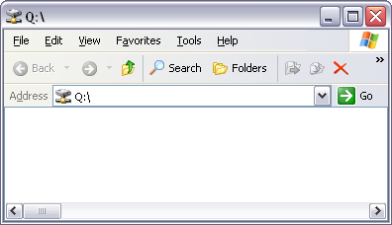

Mapping a drive letter on Windows 95/98/NT:
- Double-click the Network Neighborhood icon on the desktop.
- Locate the icon for the network server, and double-click it to open it.
- Locate the shared drive or folder where you will install EasyApps, right-click that icon, and click Map Network Drive on the shortcut menu.
- In the Map Network Drive dialog box, click the arrow on the right side of the Drive box, and select the mapped drive letter you want to use. The path will be filled in for you.
- Click OK.
- Double-click your My Computer icon and check that the new mapped drive icon is there. When you double-click the new mapped drive icon, the shared drive or folder that you mapped will open. When you’ve confirmed that the new mapped drive letter is correct, close the My Computer window.

Installing to the Server
You will need to call your sales rep at (800) 342-7327 to obtain the passwords to set up your agency information and complete the installation.
- Disable your anti-virus program (this will make the procedures run more smoothly and quickly).
- At either the server or a workstation, place the EasyApps CD in the CD-ROM drive.
- Click the top choice – either EasyApps (32 Bit) or EasyApps Professional.
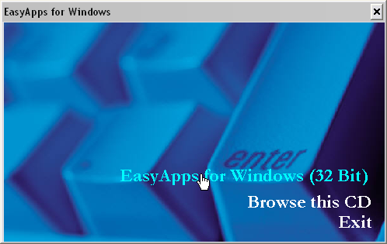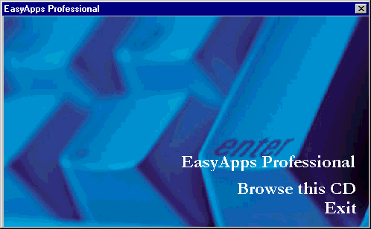

- In the CHOOSE DESTINATION LOCATION screen, make sure that the Destination Folder is pointing to the shared network drive to which all the workstations are mapped. (If you’re installing to a shared folder on a peer-to-peer server, install to the mapped drive letter instead of to the folder.)

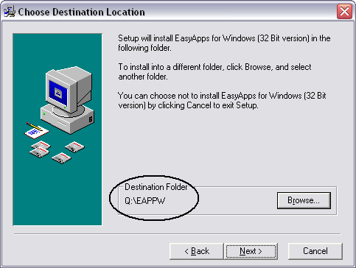
Always check the Destination Folder

If the destination folder is not pointing to the correct drive letter, click on the Browse button. In the top box on the next screen, type in the correct drive letter followed by :\EAPPW. (e.g., Q:\Eappw), Then click OK to return to the Choose Destination Location screen, and click Next.
- In the Start Installation screen, click Next. The program will begin installing.
- After the installation has been completed, a window of shortcut icons for EasyApps (like the one shown below) will open. This window can be closed at any time. An EasyApps icon will also be installed to the desktop.

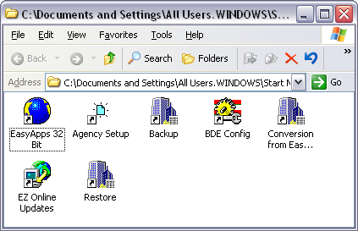
These shortcut icons will appear on your Programs menu

- When the server installation is complete, click Exit in the initial installation window and take the EasyApps CD out of the drive and put it away. Then follow the Setting Up Each Workstation procedure below.

Setting Up Each Workstation
At this point, you’ve installed EasyApps at your server and you’ve already set up each workstation with your chosen mapped drive letter. Follow this procedure to set up each workstation (you will not need your EasyApps CD for this or any other procedures).
At each workstation:
- Double-click the My Computer icon to open the My Computer window. (In Windows XP, you may need to click the Start button and then click the My Computer icon on the Start menu.)
- In the My Computer Window, double-click the mapped drive where you installed EasyApps (in this example, I’m installing it to the mapped Q drive).
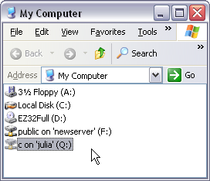
- Double-click the EAPPW folder to open it.
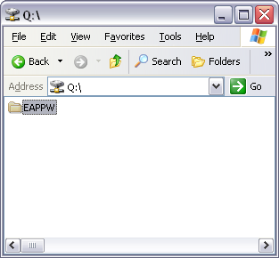

- Double-click the file named setupws (or setupws.exe)
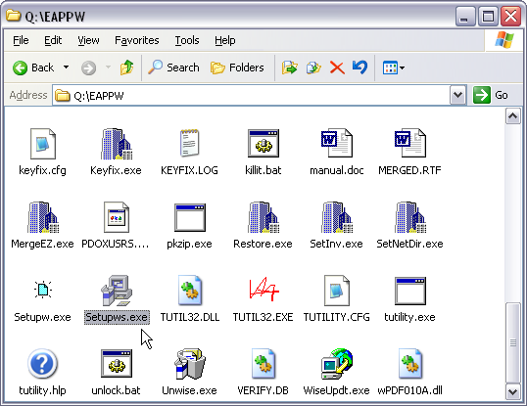

This file creates the settings and shortcuts that the workstation uses to work in the database you installed on the server.
When the workstation setup is complete, you’ll see a window of icons. Close the window by clicking the window’s “X” close button. A new shortcut icon for EasyApps has been placed on your desktop. (After you update the first time, the icon will be labeled “EasyApps 32”.)
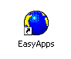
You have a new EasyApps icon that resembles a globe
You are now ready to run the program from the workstation by double-clicking the EasyApps icon on the desktop.

