Easy Apps Pro - Installation Instructions for Standalone Installs

For Windows 95/98/NT/2000/XP systems
You will need to call Agency Software at (800) 342-7327 while you are performing the installation to obtain the passwords to set up your agency information and complete the installation.

- Place the EasyApps CD in the CD-ROM. After a few seconds, you will be presented with the option to install EasyApps.
- Click the words EasyApps Professional.

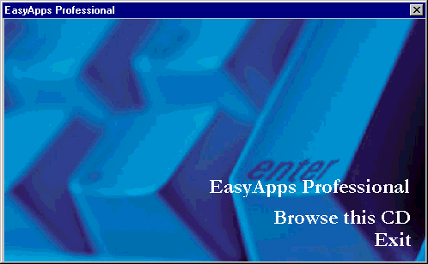

- In the WELCOME screen click NEXT. EasyApps will search your hard drive to see if it can find a previously installed version of itself.
- In the CHOOSE DESTINATION LOCATION screen, examine where the program will be installed. (Normally this should be C:\Eappw).
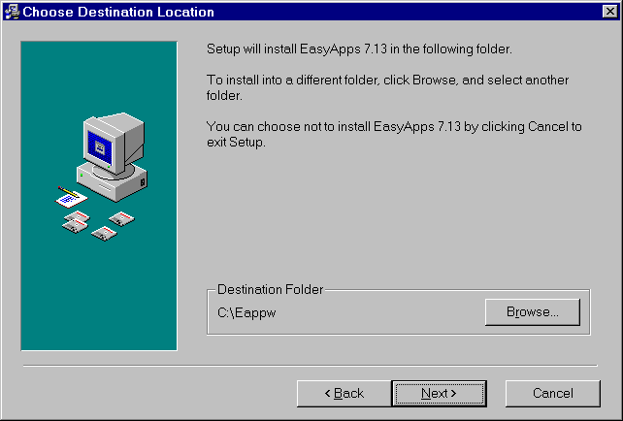
Always check the Destination Folder

- If the destination folder is not correct, click the BROWSE button. In the top box on the next screen type in the correct path (don’t try to browse for it). Then Click OK to return to the CHOOSE DESTINATION LOCATION screen, and click NEXT.
- In the START INSTALLATION screen, click NEXT.
- The installation will begin. You will see a screen similar to the one below.
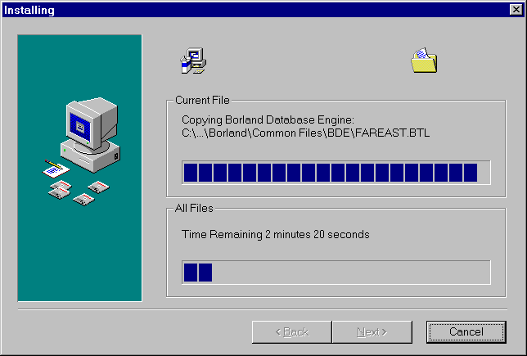

- After the installation has been completed, a window of shortcut icons for EasyApps (like the one shown below) will open. This window can be closed at any time. An EasyApps icon will also be created on the desktop.

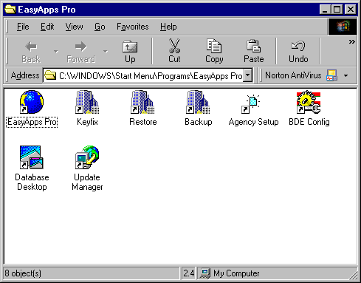

Once the shortcut icons appear on your desktop the install is finished!

