EZAgent for Windows
Product Manual



215 W. Commerce Dr.
Hayden, Idaho 83835
Sales & Technical Support 800.342.7327

License and Sales Agreement
This document is an agreement between you, the end user, and Agency Software, Inc. by initial installation and/or use of any of the programs which are part of Agency Software, Inc. (EasyApps, EZAgent, and AgencyPro, herein after called the program). You are agreeing to become bound by the terms of all parts of this agreement. This agreement constitutes the complete agreement between you and Agency Software, Inc., and it may not be changed or terminated orally but only by an instrument in writing signed by the party against whom enforcement of any waiver, change, modification, extension, discharge or termination is sought.

GRANT OF LICENSE
In consideration of payment of the License Fee, which is a part of the price you paid for this product, Agency Software, Inc., as Licenser, grants to you, the Licensee, nonexclusive right to use and display this copy of the program at a single location.

OWNERSHIP OF THE PROGRAM
As licensee, you own the magnetic or other physical media on which the program is originally or subsequently recorded or fixed, but Agency Software, Inc. retains title and ownership of the program recorded on the original disk copy(ies) and all subsequent copies of the program, regardless of the form or media in which the original and other copies may exist. This license is not a sale of the original program or any copy.

USE RESTRICTIONS
As the Licensee, you may physically transfer the program from one computer to another provided that the program is used only by up to FIVE LICENSED USERS. A licensed user is defined as a single person to whom the software is licensed. This means that you may use the software on any computers associated with the single licensed user including office, home, notebook, and network computers. Branch offices, satellite offices, or multiple businesses sharing the same location are not covered under this agreement. Additional licenses for additional users may be purchased at an additional fee.

TRANSFER RESTRICTIONS
The program is licensed only to you, and may not be transferred to anyone without the prior written consent of Agency Software, Inc. Any authorized transferee of the program shall be bound by the terms and conditions of this agreement. In no event may you transfer, assign, rent, lease, sell or otherwise dispose of the program on either a temporary or permanent basis.
Agency Software, Inc.’s entire liability and your exclusive remedy as to the media shall be at Agency Software Inc.’s option, either (a) return of the purchase price, or (b) replacement of the media that do not meet the above-stated limited warranty and which is returned to Agency Software, Inc. with a copy of the receipt. If a failure of the disk had resulted from accident, abuse, or misapplication, Agency Software, Inc. shall have no responsibility to replace the media or refund the purchase price. Any replacement media will be warranted for the remainder of the original warranty period or thirty (30) days, whichever is longer.
IN NO EVENT WILL AGENCY SOFTWARE, INC. BE LIABLE FOR ANY DAMAGES INCLUDING LOST PROFITS, LOST SAVINGS, OR OTHER INCIDENTAL OR CONSEQUENTIAL DAMAGES RESULTING FROM THE USE OR INABILITY TO USE THE PROGRAM, EVEN IF AGENCY SOFTWARE INC. HAS BEEN ADVISED OF THE POSSIBILITY OF SUCH DAMAGES, OR FOR ANY CLAIM BY ANY OTHER PARTY.

Credits and Copyright
EZAgent® for Windows
Program written by K. Mitchell McInelly
Copyright 2005-2018 by Agency Software, Inc.
All Rights Reserved
No part of this manual may be reproduced, transmitted, transcribed, stored in a retrieval-based system, or translated into any language, natural or automated, in any form or by any means, without the prior written consent and permission of an officer of Agency Software, Inc.
The software described in this manual is protected by the outlined copyright laws.
This manual could include technical inaccuracies or typographical errors. Changes are periodically made to the information herein. These changes may be incorporated in new additions of the manual which can be found at www.agencysoftware.com.
EZ Agent for Windows is a registered trademark of Agency Software, Inc.
ACORD is a registered Trademark of ACORD Corp.
Windows is a registered trademark of Microsoft Corp.

History of Agency Software, Inc.
Agency Software, Inc. (ASI), established in 1988, has been the forerunner of property & casualty insurance software since its inception date. Founded by James M. Carpenter and current President and CEO K. Mitch McInelly, ASI has an existing insurance user group that exceeds 20,000 agencies. With 70,000 insurance agents in the United States, ASI is proud to claim an installation base rate of nearly 26% of all agencies, and over 30% of all automated (PC based) agencies in the U.S.A. ASI has helped these agencies' users actuate their PC's for the purpose of increasing overall penetration of personal and commercial lines markets.
ASI has proven to be an invaluable asset to their agency users through the creation and support of an impressive library of insurance software products. These products include such industry standards as, EasyApps, EasyApps Professional, EZAgent, EZ Download Manager, EZ Download Plus, and AgencyPro.
AgencyPro is our full-featured insurance agency management system. With careful attention to ergonomics and ease of use, AgencyPro provides maximum functionality.
With company focus, development, and marketing strategies aimed and addressed toward Property and Casualty insurance companies and their ever-changing needs, Agency Software, Inc. is committed to developing customized software systems for those carriers who share the common goal of increasing overall written premiums while decreasing errors and omissions exposure.

About Our Products
Our products create a central database for all your client information, and in some cases, direct access to insurance company web sites.
For years, agents have been populating their companies' databases with their own client information; now it's time to get that information back! Keep your client information in your own database as well as in the company database, and pull existing client information from the company database down into your database.
It is easy to transfer your customer information from Outlook into the Clients window; just drag the customer name from the Outlook window and drop it onto the program icon on your desktop.
Track your clients' policies, claims, personal data (family names, birthdays, etc.), and any notes you wish to permanently record about client interactions.
Run preloaded reports, such as Commission by Rep and Customer by Expiration Date, or create your own custom reports for any specific data you want. Print mailing labels for any or all of the clients in your database.
You can also write letters to specific clients or create form letters for several clients, and attach those letters to specific clients so you can find them easily in the future. There are many pre-built marketing letters that you can either use as is or edit, and they are ready to merge with client data such as names, addresses, and personal and policy information.
The Tickler system allows you to set reminders, and an automatic transactional file that records every transaction anyone made.
In short, our products makes your work as an agent much more efficient and puts you in control of your clients' insurance needs!

Support Maintenance and Updates
To maintain support and product updates you must:
Have internet access – All updates are available by internet only.
Renew support fees – To continue support and updates you must pay an annual maintenance fee, for which you will be billed in advance. In addition, if you experience hardware technical problems, you must have an experienced technical person available to deal with our technical support team.

Contacting Support
If you suspect the problem is with your computer hardware, printer, or software unrelated to Agency Software programs, seek help from a local tech person.
If you feel the problem is related to your Agency Software program you can access technical resources or contact our technical support team through:
Website: www.agencysoftware.com
Email: support@agencysoftware.com
Telephone: 800.342.7327 ext. 30
Our support team will respond as quickly as possible considering the current call load, usually the same day, usually within the hour (during business hours of 7am to 4pm Pacific Time (pst), Monday through Thursday, and 7am to 3pm Friday). If you are hiring outside tech support, make sure to make an appointment with one of our tech team members in advance to minimize your costs for outside support. If your tech is on site, be sure to say so if you reach our voice mail during business hours.

Using this Manual
This manual has been designed to take you from initial installation to proficiency. When changes are made to this manual, the newest version will be available on our website at agencysoftware.com.

Table of contents
License and Sales Agreement ii
GRANT OF LICENSE ii
OWNERSHIP OF THE PROGRAM ii
USE RESTRICTIONS iii
TRANSFER RESTRICTIONS iii
Credits and Copyright iv
History of Agency Software, Inc. v
About Our Products vi
Support Maintenance and Updates vii
Contacting Support vii
Using this Manual viii
Table of contents 9
SECTION 1 14
Technical Requirements 14
Server 14
Workstation 15
PROGRAM INSTALLATION 15
Standalone Installation 15
Network Installation 18
Setting up the Network 18
Mapping Letter Drives 18
Initial Installation 20
Workstation Setup 22
Your First Login 24
More Technical Information 24
User Rights 24
Network Attached Storage (NAS) Devices 25
Wide Area Networks 25
Backing Up 25
Qualified Technical Support 25
Data Storage Information 26
Updating the Program 26
Obtaining the update password 26
Accessing the update 26
Moving the Program 27
SECTION 2 28
Navigation 28
Help Files 28
List Boxes 28
Choosing a Style 28
Toolbars 30
Scroll Bars 30
Moving Around in EZAgent 30
SECTION 3 34
PROGRAM FEATURES 34
Clients 34
Adding a Client 35
Editing Client Information 36
Deleting a Client 36
The Clients Toolbar 36
Emailing a Client 38
Policies 41
Policy Options 41
Display Options 42
For options 43
Using the Policies Window 43
Policy Notes 43
Coverages Report 44
Attached Images 44
Add a New Policy 44
Coverages 49
The Limits Window 49
Setting Default Limits 50
Web view 51
How to Use the Webview Window 52
The Webview Toolbar 54
ACORDs 55
ACORD Options 55
Duplicate Client’s Form 58
Mark Forms for Mass Print 59
Print Mass Marked Forms 59
Move Forms to Disk 60
The ACORD Formview Window 62
The Formview Toolbar 62
The ACORD Formview Dropdown Menus 64
Entering Client Information in ACORD Forms 67
Certificate Holders 67
Certificate Holders Menu 68
Adding Certificate Holders 68
Description of Operations 71
Editing Certificate Holders 72
Adding Certificate Holders from the Master List 72
Deleting Certificate Holders 74
Certificate Output for Selected Cert Holders 74
Generate Cert Holder List 76
Close the Certificate Holders Menu 76
Vehicle Database 76
Enter Vehicles in the Vehicle Database 76
Fill a Form with Vehicle Information 78
Attach Vehicles to Specific Policies 78
Print a Vehicle List Report for a Client 79
Equipment Database 79
Add Equipment to the Equipment Database 79
Drivers Database 80
Add Drivers to the Drivers Database 80
Property Database 80
Enter Property in the Property Database 81
Fill a Form with Property Information 82
Print a Property List Report for a Client 83
Additional Interest Database 83
Emailing Forms 83
Setting Up Email 84
Sending an Email 85
Notes 86
Personal 88
Claims 90
Reports 91
Create a Custom Report 93
Create Mailing Labels 96
Edit a Report 96
Permanently Delete a Report 97
Letters 97
What’s In the Letters Window 97
Merge Client Data into a Letter 98
Creating Custom Merge Documents 99
Attaching Letters to Clients 100
Images 102
The EZAgent Document Manager 102
Adding Files to Images 104
Adding Files from the Images Window 104
Adding Files with the Desktop Document Manager Icon 106
Adding Files from ScanSoft™ PaperPort 9 109
Adding Files using the Agency Software Printer 111
Using Your Attached or Linked Files in EZAgent 112
Surveys 115
TFile 116
Date Range Display Options 117
Manually Add a TFile Item 117
Calendar 118
Setup 121
Agency Information 121
Coverage Classes 121
Encrypt Client SSN’s 122
Automatic Data Backups Configuration 122
Companies Information Database 123
Company Commission Grid 123
Employees Information Database 124
Employee Passwords 126
Demographics Categories 127
Skins Settings 127
Reset Grids 127
SECTION 4 128
TROUBLESHOOTING 128
EZAgent Slow to Open 128
EZAgent will not open, no error 128
User Can’t Delete Clients 128
User gets Key Violation when Logging In 128
Client tab is blank for one user 128
Cannot Perform Operation on Open Dataset 129
Index Out of Date 129
Forms will not open, giving error 129
Unrecognized Tag in Mail Merge 130
Printer Doesn’t Print from EZAgent 130
Text Won’t Fit into Lines on Forms 130
Backups taking a long time 131
External Exception/Unknown Internal Operating System Errors 131
Report print is too small 131
Index 133

The EZ Download Manager Instruction Manual may be added as a supplemental manual to the back of this document.

SECTION 1
INSTALLATION
This section will cover the product requirements and direct you through installing EZAgent to either your local machine (as a standalone) or to a shared location to be accessed by the entire office.

Technical Requirements
The following technical requirements are what you must have to install and run EZAgent. These system requirements and recommendations are subject to change as technology evolves.

Server
- 2+ Ghz Quad Core processor (or better)
- 8+ GB RAM
- 1 GB HD space free* (NAS drives not supported)
- 100 MBPS wired network** (Gigabit highly recommended)
- Windows Professional versions: Windows 7, Windows 8, Windows 10, Server 2008*** and Server 2012*** (not Essentials versions)
- Internet connection (high-speed recommended)
*Initial HD space for program and database storage, this does not include document storage (which is likely to use up significantly more space as the agency goes paperless).
**Databases are prone to corruption over wireless networks.
***Not recommended for Terminal Services.

Workstation
- Dual core processor (or better)
- 4+ GB RAM (6+ recommended)
200 MB HD space free
- 100 MBPS wired network (Gigabit highly recommended)*
- Windows Professional versions (Windows 7, Windows 8, Windows 10)Internet connection for technical support
- TCP Port 1163 opened (to check subscription status for update password)
- Installed default printer driver
*If workstation accesses the program through the network.

PROGRAM INSTALLATION
Installation procedures must be followed precisely. A faulty installation will produce negative results and possible loss of data. Qualified technical personnel should install the software.
NOTE: Due to an unlimited number of possible computer configurations, Agency Software, Inc. cannot be held responsible for loss of data under any circumstances. Data can be lost or become corrupted by means beyond our control.
The installation will attempt to connect to our server to verify your current support status, therefore, you may have to disable your firewall to allow this connection.

Standalone Installation
Use these directions to install a new copy of EZAgent to a single computer. Use the Moving Program instructions when moving an existing installation from one standalone to another.
NOTE: Multiple datasets can only be combined by Agency Software for a fee. If you intend to share the program over a network in the future, you may consider this when loading the program to multiple standalones.
- Plug in the installation USB drive from the front cover of this manual and choose the option to Open Folder to View Files (or browse to the drive using Windows File Explorer)
- Double-click AutoPlay from the root of the drive
- Click on EZAgent from the Agency Software, Inc. window (this may take a minute to launch); click Next in the Welcome screen
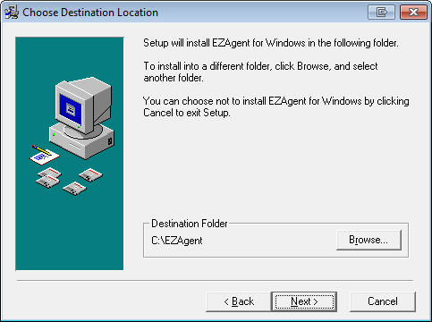
Figure 1 - Choose Destination Location
- In the Choose Destination Location screen, examine where the program will be installed (this defaults to the C: drive). Change the drive if necessary, but do not change the folder name
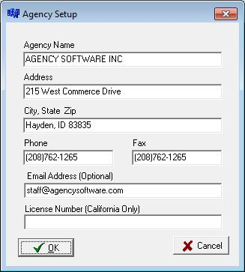
- In the Start Installation screen click Next
Figure 2 - Agency Information
- Enter the password provided by your Agency Software account representative
- The installation will begin and, when complete, the Start Menu program group will be displayed and the program shortcut(s) will appear on your desktop. You can now Exit the initial installation window and remove the USB drive
- Run an update following the Updating the Program instructions in the More Technical Information section
- Run Agency Setup (an option available from the EZAgent folder in your Start Menu program group; if you do not find it there you can run setupw.exe from the EZAgent folder created in this installation). Enter your ten digit agency phone number (the one on record for your account) and click OK
- Run Techtools (TechtoolsV8 for Windows 8/10 computers) for supplemental install adjustments. The common adjustments depend on which program you are installing and which version of Windows you are running

If you are running Windows:
Windows 7 - click the tab to:
- Run as Admin – click the blue button to fix Vista and Windows 7
- ASI Printer – click Install ASI Printer
Windows 8/10 – Click the blue button on the first tab which will give further instruction if additional action is necessary, then install the ASI Printer from the third tab.

Network Installation
Use these directions for the initial installation of EZAgent to a network (or peer to peer) server. (Use the Moving Program instructions when moving an existing installation from one server to another.) The preferred setup is to a dedicated server (server is not used as a workstation), however, the program can be installed to a peer to peer server (a system someone also uses as a workstation).
NOTE: For best results in Windows 7, first disable User Account Controls and reboot prior to the installation.

Setting up the Network
Your network should be set up by a qualified network technician. Our program is loaded to a shared folder on a physical drive (see information on NAS devices in the Technical Requirements section) of the server computer (we would typically call the share ASI). Full control must be granted over the shared folder and all subdirectories to all users (Everyone).

Mapping Letter Drives
Drive letters should be mapped identically on the server and all workstations (very important for imaging purposes). These common network drives are mapped to the shared folder, not the Agency Software program folder.
First, get the Full Computer Name of the server machine.
To find the Full Computer Name right-click the Computer (or This PC) icon on the server machine and click Properties. Find the Computer Name (not the Computer Description) without the period that follows it. On Windows 7 it will be listed under Computer Name.
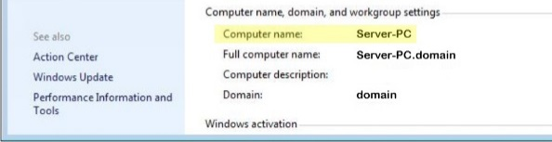
Figure 3 - Find Computer Name
Next you will map a network drive:
- Click with the right mouse button on the Computer (or This PC) icon.
- Select Map Network Drive.
- Open the list in the Drive box and select the network drive letter you want to use (for example, Q:).
- In the Folder box, type the path to the drive where you will install the program (e.g., if you are going to install the database to the C:\ drive on the computer named Server-PC, you would enter \\Server-PC\C).
Note: It is recommended to install to a shared folder (e.g., a folder named ASI) instead of the C: drive, in that case you would type \\Server-PC\ASI in the Folder box.
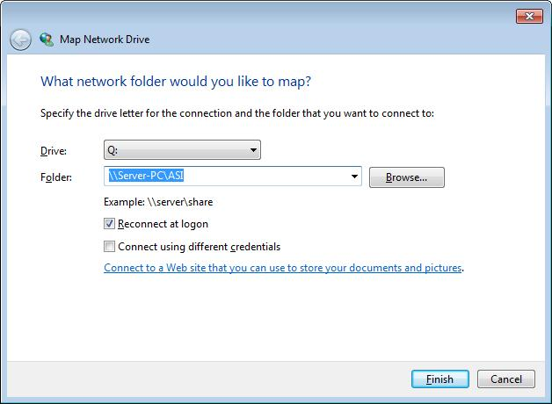
Figure 4 - Mapping network drive
**Do not map to the product’s program folder**
- Click Finish. A window to the new mapped drive opens, and it reads Q:\ in the window’s title bar.
You are now ready to install the software to the drive that you just mapped.

Initial Installation
- Plug in the installation USB drive from the front cover of this manual and choose the option to Open Folder to View Files (or browse to the drive using Windows File Explorer)
- Double-click AutoPlay from the root of the drive
- Click on EZAgent from the Agency Software, Inc. window (this may take a minute to launch); click Next in the Welcome screen
- In the Choose Destination Location screen, examine where the program will be installed (this defaults to C: drive). Change the drive if necessary, but do not change the folder name
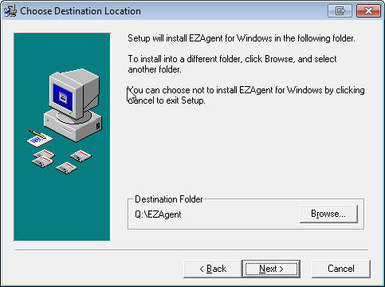Figure 5 - Choose destination location
- In the Start Installation screen click Next
- Enter the password provided by your Agency Software account representative
Figure 6 - Agency Information
- The installation will begin and when complete the Start Menu program group will be displayed and the program shortcut(s) will appear on your desktop. You can now Exit the initial installation window and remove the USB drive
- Run an update following the Updating the Program instructions in the More Technical Information section
- Run Agency Setup (an option available from the EZAgent folder in your Start Menu program group; if you do not find it there you can run setupw.exe from the EZAgent folder created in this installation). Enter your ten digit agency phone number (the one on record for your account) and click OK
If this is a peer to peer server you will also run as a workstation, follow the Workstation Setup instructions below.

Workstation Setup
The network drives should already be (identically) mapped as part of the Setting up the Network process in the Network Installation section of this manual.
Follow this procedure at each one of the workstations:
- Double-click the Computer icon to open the Computer window.
- In the Computer Window, double-click the mapped drive where you installed the program (in this example the Q: drive)
- Double-click to open the EZAGENT folder
- Double-click the file named setupws.exe (that is setupws.exe not setupw.exe) Windows 8/10 workstations skip this step and continue to step 7
- Click Next in all the dialog boxes
- When the workstation setup is complete, a window of program icons appears on your desktop (your Start Menu program group). You can close this window at any time
- Run Techtools (TechtoolsV8 for Windows 8/10 computers) for supplemental installation adjustments. The common adjustments depend on which version of Windows you are running. If you are running Windows:
Windows 7 - click the tab to:
- Run as Admin – click the blue button to fix Vista and Windows 7
- Disable IE Security Warning - click the blue button
- ASI Printer – click Install ASI Printer
Windows 8/10 – Click the blue button on the first tab which will give further instruction if additional action is necessary, then install the ASI Printer from the third tab.
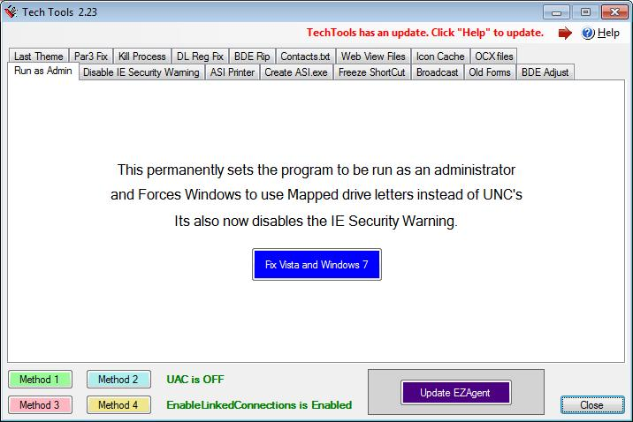 Figure 7 - Techtools
You are now ready to run the program from the workstation by double-clicking on the icon on your desktop.
When you open EZAgent on a workstation you are opening the database that you installed on the server. If the workstations were set up correctly, multiple users can open the database at multiple workstations at the same time, and all will see the same data.

Your First Login
When the login Screen comes up for the first time, enter the Username SUP and the Password SUPER.
When EZAgent opens, click the Setup tab and click the Employees button. In addition to SUP, you’ll have five employee names entered– User 2 through User 5. Do not delete any of these employees – instead, edit each employee to change the name and password to a user.
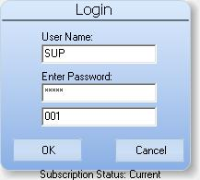
Tip: Don’t change the SUP name until you’ve changed all the others – that way you’ll always be able to login with SUP and SUPER even if you can’t remember a user’s name and password.
For more information on setting up users see “Employee Information Database” in Section 3.

More Technical Information
For best results please review the following information carefully prior to installation.

User Rights
For best results, the user should be granted Administrative rights over the local machine and the network share (if applicable). If the workstation is running Windows 7, the User Accounts Controls can be disabled (followed by restarting the workstation) prior to installation for easiest configuration. Please contact technical support for more information or other options.

Network Attached Storage (NAS) Devices
Network attached storage devices are not recommended. With no controller card, these devices are not a solution for multiple user configurations and may cause significant slowdowns of data retrieval as well as issues propagating permissions.

Wide Area Networks
EZAgent is adaptable to wide area solutions, such as Terminal Services or cloud services (please read the copyright notice for more information). These wide area solutions must be properly configured by your technician to support program functionality. For more information, please contact customer support.

Backing Up
Our programs have an option for Automatic Data Backups. These backups are written to the same location as your program data (in the Backup folder) and are not a valid backup solution for your program data. You MUST have an offsite backup method available as your primary backup source. We suggest backing up the entire program folder to an external location regularly, but making sure this is done while no one is in the program.

Qualified Technical Support
Your equipment needs to be properly configured and maintained by a qualified local technician.

Data Storage Information
The initial installation creates an EZAGENT folder where all shared program data will be stored. This program folder will be typically located at the c:\ of a standalone or the root of a mapped network drive. All of our databases and executables are located inside of the EZAGENT folder.

Updating the Program
We suggest doing monthly updates so you have available the most current Acord forms and product features. Our updates are available online only and must be done with no one in the program or forms.

Obtaining the update password
The update will ask for a password. The Password will check your support status at our servers (your support must be current to access the updates) and give you the current update password.
- From the Windows Start menu (or the ‘Utilities for EZAgent folder on your desktop if you are running Windows 8 or 10) select Programs, then the EZAgent for WIndows program folder
- Select Password.

Accessing the update
Make sure the program and all forms are closed on all workstations before starting the update.
- From the same folder from which you got the password, select the ‘Updates for EZAgent’ option (or go to www.agencysoftware.com, click the Updates heading, and choose EZAgent Updates from the Select Update drop down list)
- Click the link reading:
“CLICK HERE TO START THE UPDATE INSTALLATION”
- Run the downloaded file and click Next on the Welcome screen
- In the Choose Destination Location check the location for accuracy and click Next
- Click Next on the Start Installation screen
- After the backup enter the password obtained
During the update process the program will:
- Download the most current features
- Run utilities
- End by opening up your start menu folder.

Moving the Program
The EZAgent files are contained in the EZAGENT folder. To transition to a new server (or standalone workstation) you must first copy the entire EZAGENT folder from the old location to the new location.
If this is a network installation be sure to follow instructions in the Setting up the Network section to set up the new shared folder and map the network drives. The program folder then can be copied to the new shared folder on the new server.
Existing Workstation:
- Remap the common drive (let’s call it Q:) at the workstation to the new server’s shared folder (should be the same drive letter as the previous setup for imaging purposes)
- Run Techtools.exe (or Techtoolsv8.exe if you run Windows 8/10) from the program folder and disable the IE warning if you get the “Publisher could not be verified” message opening the program.
If this is a new workstation follow the previous Workstation Setup instructions.

SECTION 2
HINTS & TIPS
Check out these techniques to quickly master navigation of EZAgent for Windows, and for the most efficient ways to do things. We also recommend reviewing the online tutorials available at www.agencysoftware.com/support/tutorials.

Navigation
EZAgent uses common Windows navigation techniques and keystrokes, which allow you to move around within EZAgent with great ease. Understanding and using these features will make your job much easier, speed up your work, and make using this program a pleasure.

Help Files
The Help Files contain Hints & Tips, a comprehensive Index, and Help files for all main topics, although a few are limited in their scope. Improved Help Files will be made available with most updates. In the Help File click on the green underlined text to go straight to that main or sub-topic.

List Boxes
You’ll find many list boxes with dropdown arrows that allow you to open a list and select an entry. Some of these lists are codes in the system while others are comprised of entries that have been keyed into the field.

Choosing a Style
You can access the Program Customization window by clicking the gear icon in the lower right corner. The options in this menu allow you to modify your font, font size, and color themes. You will also find the option to switch your user interface between the Classic and Modern styles. Certain program functionality is packaged with each style.

Classic Style
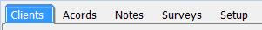
By default the program is set to Classic, which displays tabs at the top to access each particular area of the program. If you cannot see all the tabs or icons, either make the EZAgent window wider, or click the arrow buttons at the right end of the tabs to scroll and display the hidden tabs at each end. You may not have all the tabs/icons available if your User Account has limited access. The Search feature while set to this style is a client level filter described later in this section.

Modern Style
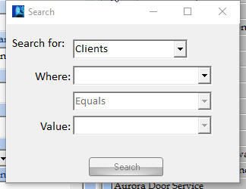
Switching to the Modern style replaces the navigation tabs with an icon toolbar that you can place on any side of the EZAgent window (location). By default this interface is set to animated, which brings forward the icon of interest (this feature can be disabled by unchecking Animated). The icons on the modern toolbar can be reordered by simply dragging these around, then locked by checking Lock Icons.
In the Modern interface you can enable the new search style, which provides advanced search capabilities on clients, policies, or claims.
Other feature settings in this menu include:
- New sticky note style – With a different look, this new sticky note allows you to tack your sticky window outside of the EZAgent window.
- Color for Inactive Clients – You can set up a color in which the left client pane will display if you have the word “Inactive” in the client status field.
- Reset all Settings to Default – If you have lost an icon in your modern menu, or simply want to go back to our original settings click this button, close EZAgent, then log back in.

Toolbars
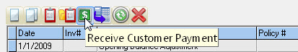
Most windows, and all ACORD forms, have Toolbars for your convenience. Learn what each button does and use them to save time.
When you point your mouse at a specific button, a screen tip with the button’s name appears – this will help you figure out which button does what.

Scroll Bars
Scroll Bars appear at the right side and/or bottom of lists that exceed the current view. Scrolling up, down, right, or left will bring more information into view.

Moving Around in EZAgent
EZAgent will open to the Clients screen by default. The entire client list will be in view and the left side of the screen will display the information for the current client selected. You can select a new client by:

Typing in the first few letters
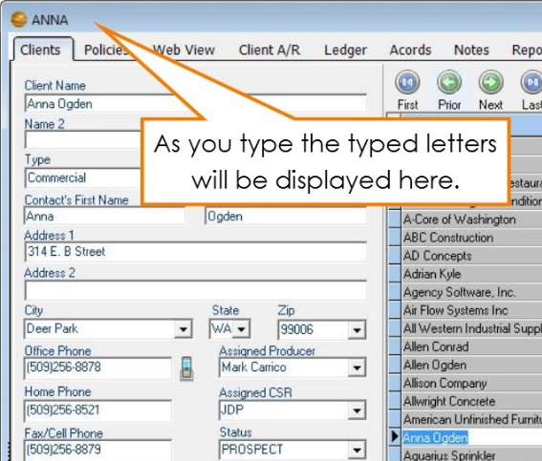
In many lists within EZAgent, you can start typing the item you wish to look up. For instance, if you are on the Clients tab and you want to look up Anna Ogden you can type in A-N… and you will be taken to that area of the list while the typed letters will appear in the top left corner of the EZAgent window. If all you have is an address, first put the list in Address order (see Sort by heading section on the next page) and then type in the first few numbers of the address. This is the easiest way to select a client.
Figure 8 - Typing in your desired selection

Using the navigation icons
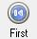
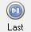
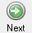
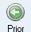
Throughout EZAgent are variations of these icons that move you through the database either record by record, or jump from the current selection to the first or last records in the database.

Program search and filter utilities (Original Style)
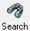
You can locate a certain value by using the search or filter utilities. The client filter (available on the Classic style), for instance, will clear the client detail window (the left side of the Clients tab that normally displays the current client information) and allow you to enter your filter criteria. Once your desired criteria has been entered, simply click the Filter icon again and the filter will apply to the client list, showing only the returned values. Click the Restore icon to release the filter and view all clients. The filter is a great way to display a group of clients. For instance, if you would like to view all clients in a certain city, click the Search icon, choose the city from the City drop-down, and click Search again. The client list will now show only clients in that city and the filter will display on the header bar.
Figure 9 - Header bar displaying current filter
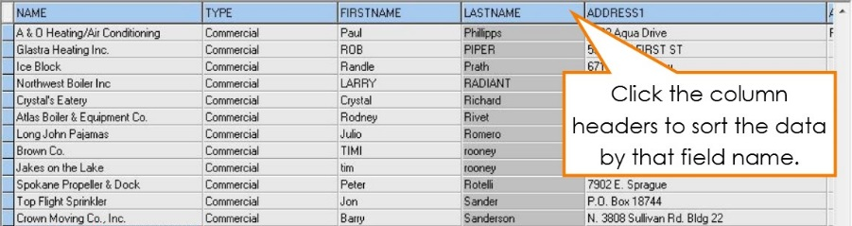
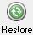
This filter will carry into many client selection screens in the other marketing areas (and reports), allowing you to first place the desired filter, then run letters and reports based first on that filter. Be sure to remove this filter before attempting to run letters or reports on the entire database.
Figure 10 - Clients tab ordered by Last Name field

Sort by heading
In most tables and lists, if you click on a column heading (such as Address in the Clients tab), the list or table will be sorted by the entries in that column.
Also, when you click a column heading to sort, the sorted column will be shaded so that you can tell at a glance which column the table is sorted by.

Using the keyboard
In most tables and lists, you can navigate through the data by using the arrows and navigation keys (Home, End, Page Up, and Page Down) keys on the keyboard.

Searching by Policy
There are two ways to identify the client by policy number:
Classic view method: Go into the Policies tab (under any client), click the All Clients button in the For box (bottom right corner), and then sort all of the policies in Policy # order by clicking that heading. Now type in the first few numbers (or letters) of that client’s policy number and it will take you to that area of the list.
Modern view method: Click on the Search button, Search for ‘Policies’ where POLICY # ‘Contains’ and type in part of the policy number; click Search, which will locate any clients with matching information for you to select.

SECTION 3

PROGRAM FEATURES

Clients
The Clients window is where you enter client information, such as client name, address, and phone numbers. EZAgent always opens with the Clients window displayed. The client names are listed on the right side of the window, in the list, and the data for the selected client is displayed on the left side of the window. To open the Clients window from any other window in EZAgent, click on the Clients tab at the top of the program window.
The status bar at the bottom of the EZAgent program window always indicates the selected client name, their phone number, and the current date and time.
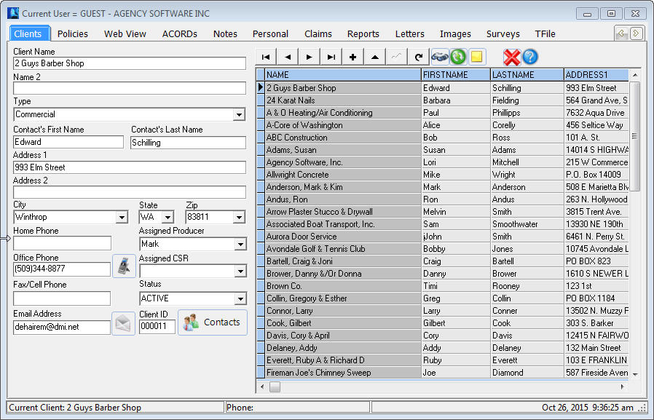
In the name list, columns other than the name column can be displayed by scrolling to the right in the horizontal scroll bar below the list.
Figure 11 - Client tab
You can reorder these columns by clicking on the column header and dragging to the left or right while holding down the mouse button. You may also sort by any of the columns by clicking the column header for that column.

Adding a Client
To add a client, click the Insert button above the client list. The client information fields on the left side of the window are emptied so that a new client’s information can be typed into the appropriate fields. You can use your Tab key to move between fields while entering client information or you can click in the field where you want to enter data.
Click on the Contacts button. Whichever contact you mark as Primary will automatically fill in the First Name, Last Name and phone number fields in the main client information screen.
You may list multiple contacts for this client by clicking the plus sign on the top toolbar to add an additional contact name or the plus on the bottom toolbar to add additional email addresses.
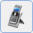
You can also keep additional phone numbers by clicking the Phone Numbers icon, where you can list as many phone numbers as you need.
After all of the client’s information has been entered, click on the save button (check mark icon) to save the information.

Adding an Outlook Contact to EZAgent
If you have customer data in your Outlook Contacts folder, you can easily transfer them into the EZAgent Clients window by saving them as vCards and then dragging and dropping the vCards from the folder (where the vCards were saved) onto the EZAgent desktop icon.
To save an Outlook contact as a vCard, select the contact in Outlook and click File – Save As, in the Save As dialog box, in the Save As Type box, select vCard Files (*.vcf), click Save.
In newer versions you may have to Forward as a Business Card, then save the *.vcf file first to a folder or desktop.
Open the folder where the vCard is saved and drag all vCards you wish to import onto the EZAgent window, or directly onto the EZAgent icon if the program is not yet open. You will see the contact(s) have been added to the Clients list in EZAgent.

Editing Client Information
To edit client data, select the client’s name in the list on the right (click the client name to select it), and then click on the edit button to open that client’s record for editing. The selected client’s information appears on the left side of the window. Edit the data, and save your changes by clicking on the save button.

Deleting a Client
To delete a client, click the client’s name in the list on the right then click the delete button. Click Yes in the Delete This Client? message. That client’s data and forms are permanently removed from the database.

The Clients Toolbar
When you position the mouse over a specific button on the toolbar, the name of that button will appear in a “hint” screen.
The buttons, left to right, are:
First Record Selects the client name at the top of the list.
Prior Record Selects the next client above the selected client.
Next Record Selects the next client below the selected client.
Last Record Selects the client at the bottom of the client list.
Insert Record Creates a new client record, ready for data entry. Click the Post Edit button to finish and save the new client record.
Edit Record Select the client that you want to edit in the list, then click this button to edit the fields on the left. When done, click the Post Edit button to save the changes.
Delete Client Select the client you want to delete from the list on the right, and then click this button to delete the client. All entries in all modules for that client will be deleted from your system. A confirmation box will appear before the client can actually be deleted.
Post Edit Permanently posts the change to the database while adding or editing a client’s record.
Restore Client List Restore the full client list after filtering.
Filter Client Database Click on the magnifying glass button to clear all fields on the left. Type in your search criteria in any fields, and then click the Filter Client Database button again. The client list will be filtered to show only those clients who match your search criteria and most reports will show results only for this filtered list of clients.
Add a Sticky Note to Client Click on the yellow sticky note to add a note that will appear whenever this client record is brought up.
Tip: Instead of scrolling down to find a client in a long list, you can jump to a specific area in the clients list by pressing a key (or two or three) on your keyboard. For example, suppose you want to find a client whose name is listed as Longhorn Barbecue. To jump to the first name that begins with the letters LON, click in the clients list, and then type ‘LON’ on your keyboard.

Emailing a Client
You can use the EZAgent E-mail feature to email clients directly from EZAgent through your email provider.
You need: Either Outlook configured on your local workstation, or you need your SMTP server name, user name, password, protocol and port number (if one is required for outgoing mail). You can get all this information from your Internet Service Provider (ISP) or from reviewing your Account settings in your email program. If you use Outlook simply check Send through Outlook to have the email sent directly through Outlook and show up in Outlook’s Sent Items folder. If you do not use Outlook follow the directions below to configure your outgoing email.

Setting up Email:
- Click the  icon next to the client Email Address field.
- The Email form opens (shown below).

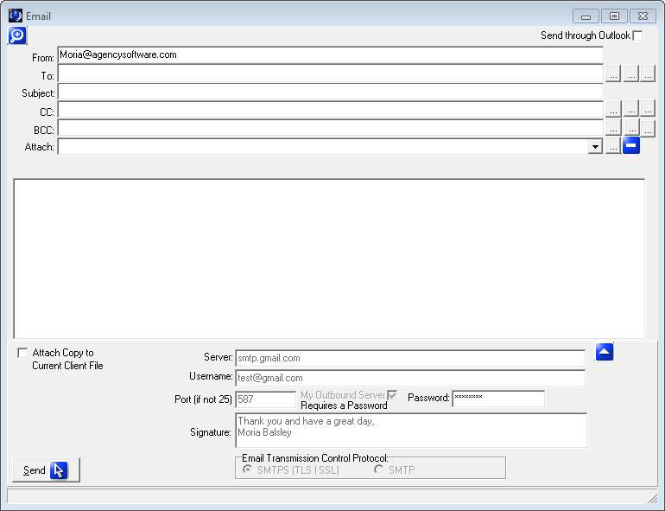
Figure 12 - Configure/Send an email
- Click the ▲ button to access the setup information and enter your server information in the fields provided.
- In the Signature field you can enter up to six lines of text (if you are sending through Outlook you will want to enter this information prior to checking the Send through Outlook box).
- Enter your email address in the From: field at the top of the window.
- Test the email by entering a test account (or your own) in the To: field, entering a Subject, and clicking Send.

Sending Email:

Email Lookups
At the end of the To:, CC:, and BCC: fields are lookup options. The three lookup buttons access different email databases.
- The first accesses email addresses listed on the Clients tab. This lookup is filter sensitive (which means that you can filter your database to return only email addresses of the filtered clients), but by default will show all email addresses for all clients allowing you to Check All if you wish to email everyone.
- The second lookup icon accesses the email addresses entered into the Contacts database.
- The third lookup accesses the email addresses listed on the Company setup.
Note: In the case of mass emails you may want to use the BCC field so the recipients did not see other recipient’s email addresses).

Attach
You can click the lookup icon next to the Attach: field and select any file you wish to attach to the email.
Attach Copy to Current Client File
If you check the box Attach Copy to Current Client File prior to sending an email it will attach in the Attachment database which you can access by clicking the icon in the top left corner of the Email screen. When you click this icon you can view or resend the attached emails from the Email History window.

Policies
The Policies window serves as a database for quotes, binders and policies. On the Clients window, choose the customer (or add the customer for whom you want to enter a policy) then click the Policy tab or icon to see policies specific to that client. You will notice that current policies will be displayed in black, while expired and closed policies will be displayed in red.
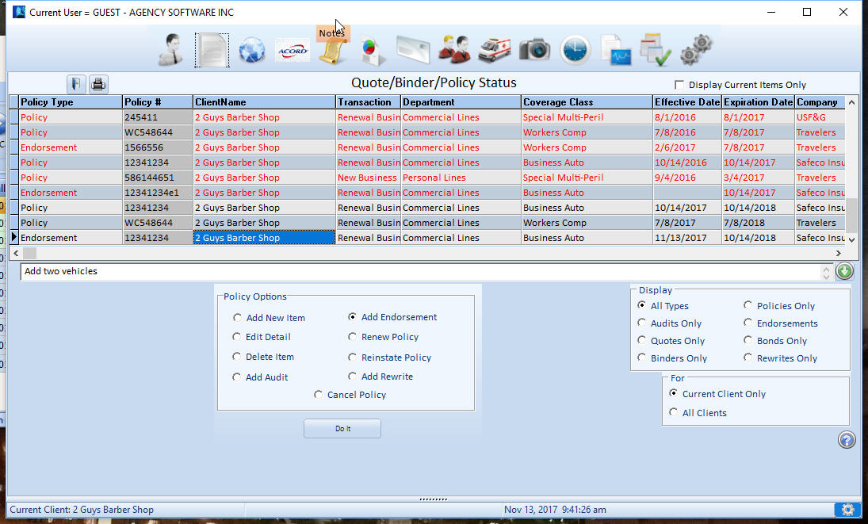
Figure 13 - Policy tab

Policy Options
Be sure to use your policy options as you are entering your policy information. Many of these options will draw the information from the selected policy to save you time entering information. These policy options are:
Add New Item - Add a quote/binder/policy/endorsement
Edit Detail - Edit the details of a selected quote/binder/policy/endorsement
Delete Item - Delete the selected quote/binder/policy/endorsement
Add Audit - Create a new audit
Add Endorsement - Create a new endorsement
Renew Policy - Renew the selected policy
Reinstate Policy - Reinstates the selected policy
Add Rewrite - Rewrite the selected policy
Cancel Policy - Cancel the selected policy
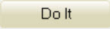
After you select a Policy option, click the Do It button to proceed.

Display Options
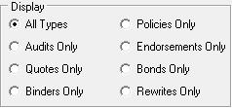
The display options are to limit the view of the policies window to the type of your choice. For instance, if you only want to see policies, not endorsements or audits, you click Policies only. Here are the display options:
The Display Current Items Only checkbox, located in the top right corner of the Policy tab, allows you to limit the view to open, current term policies. When you check this box any policies that are expired or have policy status closed will be hidden. With this box checked the other tabs for this client will only show items attached or created for the current policies displayed on the Policy tab. To see items that are attached or created from expired or closed policies simply un-check the Show Open Items Only check box.

For options
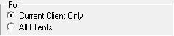
These options filter the list to display only the policies for the current client, or all the policies for all the clients in the database.
Note: You can only create a new policy, quote, binder, or endorsement if Current Client Only option is selected in the For option.

Using the Policies Window
You’ll find procedures for working with policies in the following sections.

Sorting and Finding Policies
Like the Client Grid, you can sort the Policies grid by any field simply by clicking on the column header. You can then search that column by typing in the first few letters of what you are looking for.
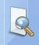
If you are trying to locate a client by policy number you can click the All Clients radio button in the For box (which will display all policies for all clients) then order the grid by Policy #. You then can type in the policy number you are looking for.
If you use the Modern interface and are set to the new search style, you can click the search option from the Icon bar and change the Search for: to ‘Policies’.

Policy Notes
The Expand Policy Notes icon on the right of the policies screen is used to enter policy specific notes. Clicking this icon will toggle between the notes area expanding and contracting in size. To add a new policy note, simply start typing in this area. The note will be attached to the currently selected policy record.

Coverages Report
You can get a quick view of the policy, limits, premium, and attached schedules by clicking the Print icon with the policy in question selected. The information reported on the Coverages Report is specific to the department and line of business of the policy.
To have vehicles, properties and equipment reported you must attach the schedule item to the policy in questions. If you download with your carrier, this will often be done automatically. To include a driver on an auto policy coverage report, the Rated Driver box must be marked on the Personal window.
Policy Forms and Endorsements will also report on the Coverages Report. The information may download from your carrier, but can also be manually added by clicking the Policy Forms and Endorsements icon on the toolbar.

Attached Images
The View Attached Images icon above the policy grid displays only when you have selected a policy with attached images. Clicking this icon will display a list of those attached images.

Add a New Policy
When you choose Add New Item from the Policy Window and click the Do It button, the Policy Detail screen is displayed.
When filling in the policy it is important to fill in the field using the drop down arrows. On the right end of a box, click the arrow to open a list of choices, then click the entry you want in the list.
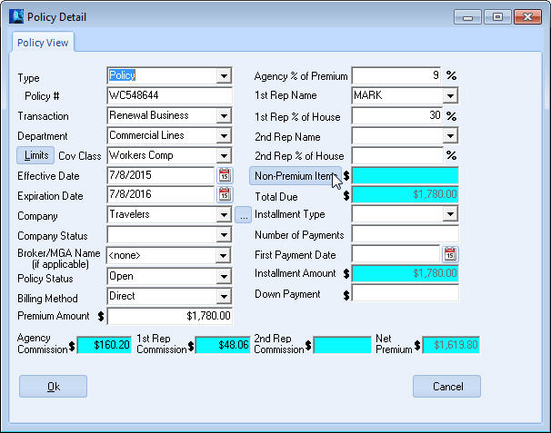
The blue fields are automatically calculated, but typically can be overwritten.
Figure 14 - Entering a policy
Policy Fields:
Type – Typically Policy, but select the appropriate selection from the dropdown list
Policy - Type the Policy or Bond Number (depending on type)
Transaction - Important for New Business reporting
Department - Important for departmental reporting
Limits Button - Opens the Coverage’s window (see Coverages section).
Coverage Class - Choose your entry from the list. You can add to this list by typing in an entry (if Show All Coverage Classes is selected on the Agency Setup tab).
Effective Date - Click the button on the right. A calendar appears with the current date selected. Click OK to accept that date, or click to select a different date and then click OK. You can also type the date instead of using the calendar.
Expiration Date - Click the button on the right. A calendar appears with the date one year from the effective date selected. Click OK to accept that date, or select a different date and then click OK. You can also type the date instead of using the calendar.
Company - Choose your entry from the list. (The button to the right of the dropdown box opens the Company Database for entering or editing the companies in this list but only if you have Supervisory access in the EZAgent Employee database).
Broker/MGA Name: Fill if you write this policy through a brokerage.
Note: The field after Company may display as Broker/MGA Name - choose your entry from the list (same as Company) if a broker is used. The only companies that will appear in this list are those that are marked as a broker in the company record on the Agency Setup tab. You can leave this at the default <none> if the billing company is the same as the company chosen.
Policy Status - Choose your entry from the list, must be Open to post accounting.
Billing Method - The entry defaults from the Company Setup database, but you can change it by selecting a different entry in the list.
Premium Amount - Type the Pure Premium amount.
Agency % of Premium - This is where you enter the commission rate. This is pre-defined in Company Setup, but can be changed or added if needed.
1st Rep Name - Choose your entry from the list. The list comes from the Employees database in the Agency Setup tab, and can only be changed there.
1st Rep % of House - Percent of agency commission due to rep.
2nd Rep Name - This is for ‘split’ commissions. Choose your entry from the list. The list comes from the Employees database in the Agency Setup tab, and can only be changed there.
2nd Rep % of House - Pre-defined in Employee Setup, but can be changed or added if needed.
Non-Premium Items - Click the button to add Non-Premium Items such as Agency Management Fees, Policy Fees, or Taxes. Use the down arrow on your keyboard for additional lines. Supervisory users can click the Setup button to set up their own non-premium items. Once you click ok, the blue field will auto-calculate with the sum of the non-premium items.
Total Due - Auto-Calculated field. On an agency billed policy this field should equal the total of your premium plus fees and taxes (the amount the customer owes you).
Installment Type - Choose your entry from the list, or leave blank for annual.
Number of Payments - Auto-Calculates from Installment Type, but can be changed.
First Payment Date - Click the button on the right. A calendar appears with the current date selected. Click OK, or select another date and then click OK.
Installment Amount - Auto-Calculate field.
Down Payment - Type the Down Payment amount being deposited.
Agency Commission - Auto-Calculated field.
1st Rep Commission - Auto-Calculated field.
2nd Rep Commission - Auto-Calculated field.
Net Premium - Auto-Calculated field.
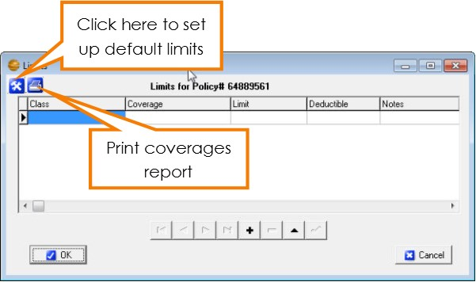
When you’re done, click OK to save your entries. This record will be added to the current client.
Figure 15 - Limits window with option for default setup and print coverages report

Coverages
The Limits window is where the coverages for the client’s policy are entered. To open this window, click the Limits button to the left of the Coverage Class box on the policy detail screen. Information entered in the Limits window will automatically fill into your ACORD forms as long as the ACORD form being added or edited has a specific field for those coverages and you use the drop down list when adding the Class and Coverage in the Limits window.

The Limits Window

Class
This specifies which class of coverage you are going to use. It also specifies the types of forms into which the information can prefill. To select a coverage class, click in the Class box, click on the down arrow that appears in the box, then select the appropriate type. You will have to select a class for each line item entered.

Coverage
The choices that appear in this dropdown list are filtered depending on what Class you have selected in the Class field. To select a coverage type, click in the Coverage box, then click on the down arrow that appears in the box, and then select the appropriate type.

Limit
Enter the amount of the limits for the selected coverage.

Deductible
You can enter a deductible amount, or you can leave this field blank.

Notes
This field allows you to enter any additional notes about the specified coverage.

Coverages Report
Click the printer icon to print the limits in the form of a Coverages Report.

Setting Default Limits
Use the Tool button to open the Set Limit Defaults Window. Here you can set agency-wide default values for Limits and Deductibles.
The Auto field requires an ‘*’ asterisk to be active. This will allow any row with an asterisk to fill in the previous Limit window when that class is selected. To set a limit as Auto, type in the limit and/or deductible information and press the space bar in the auto field to mark it with an asterisk. Remove the asterisk to remove from the selected default coverages.
Rows without the ‘*’ asterisk will only fill in the Default values when the coverage is selected in the Limit Window.
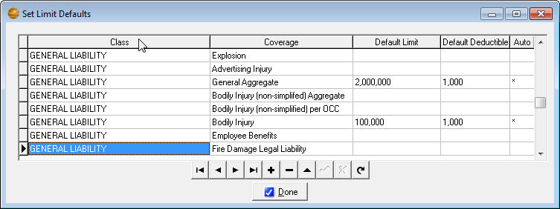
Figure 16 - Setting up default coverage limits
In the above example, the first two (2) GENERAL LIABILITY rows will auto fill when GENERAL LIABILITY is first selected in the Limits window. The third row would only fill in the defaults when the coverage, “Automatic Coverage for Newly Acquired” is selected in the Limit window.
When you’re done, click the ‘Done’ button to save your default values.
When you’re done selecting Limits, click the OK button to save your entries. These limits will be added to the current client policy.

Web view
The Webview window is where EZAgent can make online policy access much easier. The Webview window:
- Opens the web page of the insurance company of the policy you have selected (must set up home pages under Company in Agency Setup tab).
- Will log you in automatically to some company websites. (You must set up usernames and passwords under Employees in Agency Setup tab and it must be a compatible company website, which you can find on our Download Partners list at www.agencysoftware.com).
- May find the currently selected client or policy, if they are already an insured with that company.
- Allows you to get a snapshot of the page you are on, which saves as a PDF file in the Images tab.
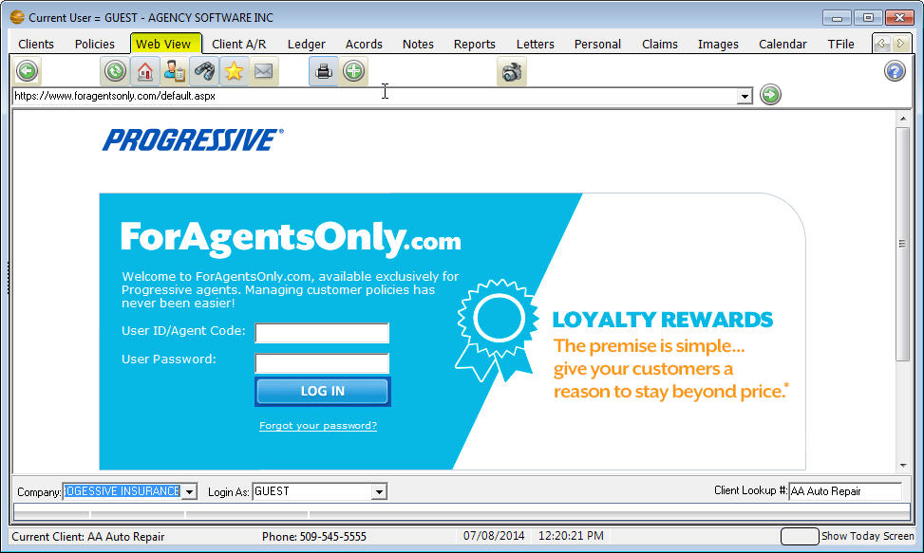
Figure 17 - WebView tab accessing Progressive site

How to Use the Webview Window
The Webview window works most efficiently when you have the insurance company and their web page URL entered in the Companies form in the Agency Setup window, and you have your login name and password for that company web page entered in the Passwords section under each employee in your Employees form in the Agency Setup window. See the Agency Setup Window section to learn more.
1. Select your client in the Clients window by clicking their name.
2. Click the Policy tab and select the policy in question.
3. Click the Webview tab.
The Webview window opens the web page for the company entered on your policy.
If you want to open a different company's web page, select the company name from the Company list box in the lower-left corner of the Webview window. Note: Only companies with URLs entered in the Agency Setup window's Companies form appear in this list.
The company name is displayed in the Company list box. Your user name is displayed in the Login As box. The Client Lookup # box displays the selected client's first policy number, or the client name if they have no policies in EZAgent yet.
4. If your EZAgent Employee form has the appropriate name and password entered in the Password database, the Webview window will try to automatically log you in at the company site.
If your EZAgent Employee Password form does not have a Username or Password entered correctly you can enter your login name and password yourself and log in to the company web page.
5. EZAgent will try to find the selected client automatically in the company web page using the client's policy number selected in the EZAgent Policies
tab.
Note for Farmer’s ECMS users: In Employees make sure that the Default Screen Name and Screen Password reflects the user’s ECMS login information. The company also must be set up as “Farmers Insurance Group” and the proper Home Page information set for the Farmer’s WebView integration to function.

The Webview Toolbar
When you position the mouse over a specific button on the toolbar, the name of that button appears in a tooltip.
The buttons, left to right, are:
 | Back Opens the previous web page
 | Forward Opens the next web page you opened
 | Stops loading the current page
 | Refresh Refreshes the current page with current data
 | Home Opens the company website Home page
 | Search Opens the Google search page
 | Favorites Opens the Favorites folder
 | E-mail Opens an EZAgent e-mail message, addressed to the current client, that uses your e-mail program to send
 | Open Outlook Folders
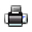 | Print Opens the Print dialog box so you can print the page to the printer you choose (see Workstation Installation for ASI Printer setup instructions)
 | Open a New Instance of Browser Opens a new browser window so you can open a different web page without leaving the page you have open in the Webview window - the new browser window appears minimized in the lower-left corner of your computer screen; you can open up to two more browser windows
 | Help and Tutorial This opens the EZAgent help files
 | Snapshot will capture the entire current web page to a PDF file in the client’s Image tab (must have ASI Printer set up on each workstation).
In the Webview toolbar is a standard browser Address bar with a Go button on the right end. You can type any URL in the Address bar and click Go to open that web page, and then use the Webview toolbar's Back and Forward buttons to move between all the pages you've opened.

ACORDs
The ACORDs window contains all the Acord forms for the selected client. In this section we will cover some key processes that can save you valuable time.

ACORD Options
This section explains the various options in the lower pane of the Acord window.

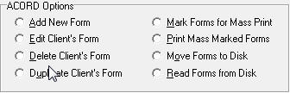

Add New Form
When you select the Add New Form option and click the “Do It” button, the Add New ACORD Forms window appears. This window displays all available ACORD forms in alphabetical order.
This list is first-key sensitive – to jump quickly to a specific point in the alphabetical list, you only need to press a letter key on your keyboard. For instance, if you need to add a Workers Comp form, press “WOR” on your keyboard. The first form starting with ‘WOR’ is selected. You may then scroll down, page down, or arrow down to the Workers Comp form. Select the form you want, and click OK to open the form.
You also can click the Number header on this screen and type in the ACORD form number you are looking for.
You may notice that most forms are listed in red. These forms are the new style (pdf) forms. The old forms (shown in black text) will be phased out in the following years and all new version forms will be created in this new style. The pdf forms do not always fill from the old style forms, making manual form entry necessary during the first term using the new style. Due to this temporary inconvenience we will make both versions available for a time.
Use the options below the list to filter the more than 800+ ACORD forms to a more manageable list.
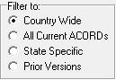
- The Country Wide option filters the list to display all the forms that are NOT state-specific.
- The All Acords option removes the filters and displays the entire list of ACORD forms.
- The State Specific option filters the list to show just the forms that are specific to a particular state (after you select the State Specific option, select the state you want in the list box that appears to the right).
- The Prior Versions will show prior versions of select accord forms, such as the Certificate of Liability and Evidence of Property.
After selecting a form, you may be asked which policy you would like to prefill from, if this client has policies. The Limits sections of the policy, as well as some other policy information, may be prefilled in the form, depending on what type of form you have selected. In addition, selecting a policy from this window will allow you to keep all of the ACORD forms for one policy separate from similar ACORD forms for different policies. You can hold the CTRL key and select multiple policies if needed (which will fill in the order selected).
Note: The default selection on the Attach Policy screen is None. When reopening a filled form, selecting None will ensure that the form information is not overwritten with reselected policy information.

Edit Client’s Form
To edit an existing ACORD form for the current client, select a form from the list of existing forms, select Edit Client’s Form, and then click “Do It” (or simply double-click the form you wish to edit). The selected form will appear and you may edit as needed.

Delete Client’s Form
To delete an existing ACORD form from the current client, select the form from the list of existing forms, select Delete Client’s Form, and then click “Do It”. You will be prompted if this is what you really want to do. The form will be permanently deleted from the client (as well as any attached certificate holders).

Duplicate Client’s Form
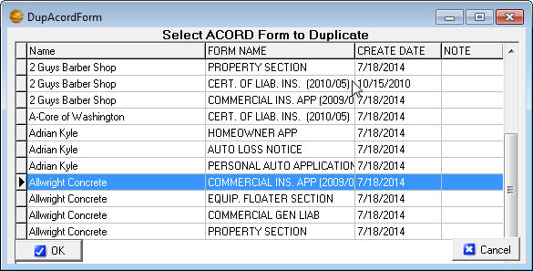
If you wish to create an exact duplicate of a different client’s ACORD form for the client you have selected, click on the Acords tab and then select “Duplicate Client’s Form.” The DupAcordForm dialog box opens with a list of all the clients in the database and all their forms.
Figure 18 - Duplicate an Acord from a different client
- Scroll down to select the client and the form you wish to duplicate for the open client. You can often find the form you want more easily if you sort the list by Name or Form Name or Create Date (by clicking on the appropriate column heading).
- After you select the form you want to duplicate, click OK.
Note: When you duplicate an existing form year after year, you run the risk of using outdated, non-current forms. A better approach is to add a new form of the type you are renewing, and then use the Prefill Form From Another button (at the top of the new form) to fill the new, current form with the data in the old, expiring form and then make the changes for the renewal term.

Mark Forms for Mass Print
You can send several forms from several different clients to the printer, pdf, or email all at once with the Mark Forms for Mass Print option.
- Choose a client, then click the Acords tab and click the Mark Forms for Mass Print option. Click the Do It button, click to mark the forms you want to print, and click OK.
- Then choose another client, click the Acords tab, click the Mark Forms for Mass Print option, click the Do It button, click to mark the forms you want to print, and click OK.
- When you’ve selected all the clients’ forms you want to mass print, you’re ready to use the Print Mass Marked Forms option.

Print Mass Marked Forms
- Select any client and click the Acords tab. Click the Print Mass Marked Forms option, and click Do It.
- A Print Preview of all the marked forms opens. Click the Print button in the toolbar and send the forms to your printer, or if you have email setup, click on File and Email and it will email all those forms at once. You can save this packet to PDF by selecting Save as PDF File from the File menu.
- After the forms are sent to the printer, saved or emailed, you’ll be asked if you want to unmark the forms for mass printing – click Yes.

Move Forms to Disk
If you want to move a specific client’s data and forms to an EZAgent database on another computer (perhaps a computer at home, or a different standalone database in your office) you can use the Move Forms to Disk and Read Forms from Disk options.
The procedure is to save a client and their forms to a file that you can send to the other computer and import (Read) into another copy of EZAgent. To use the Move Forms To Disk option:
- On the Clients window, select a client whose data and forms you want to move.
- From the ACORDs window select the option Move Forms to Disk and click the Do It button. A window listing the client’s forms will appear.
- Select each form you wish to move by clicking the form name (if you want to de-select a form, click that form name again) or you can click the Mark All button to move all their forms. When you’ve selected all the forms you want to move, click the OK button.
- In the Save As dialog box choose a valid location and click Save. A file that contains the client’s data and forms will be saved with the client’s name the default filename.
- Repeat steps 2 through 5 for each client whose forms you want to move. (If you are moving the entire database you can choose Mark ALL Forms for ALL Customers.)
- Email or move the resulting .sav files to a CD or USB drive, or save to a folder.

Read Forms from Disk
After you have transferred the .sav files to the other computer and are ready to move the clients and their forms into the other database, follow these steps to use the Read Forms from Disk option:
- Get a backup!
- Open EZAgent and click on the Acords tab for any client.
- In the Acord Form Options section, click the Read Forms from Disk option. An Open Account dialog box displays the files you moved to the disc.
- In the Open Account dialog box appears, allowing you to browse to the .sav files. Select a client filename, then click Open. The client data and forms are imported, and a message tells you “ACORD forms successfully imported from Disk!”.
- Repeat steps 3 through 4 for each client file.
Note: You don’t need a CD or Flash Drive if you’re moving files to a different database across a network. When the Save As box appears navigate to a folder where you can save or open the files.

ACORD Notes
You can type (or edit) short notes about specific forms by clicking + icon with the desired record selected. Type your note in the Acord Note window and click OK.

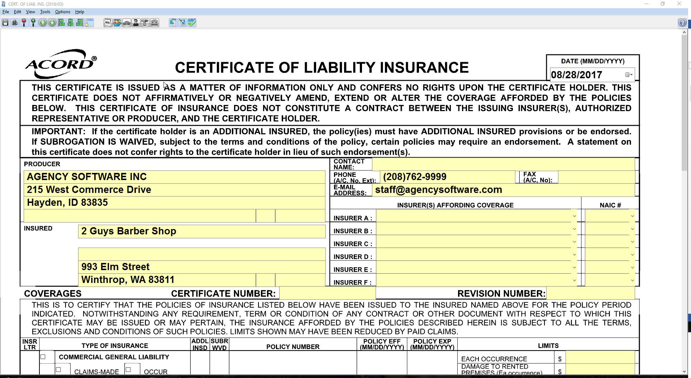
The ACORD Formview Window

The Formview Toolbar
The Formview toolbar appears at the top of the open form. When you place your mouse over a Formview toolbar button, the name of the button appears. The buttons, left to right, are as follows:
 | Save Form saves your current work while you work in the open form. When you finish working in a form and close it, all your work is automatically saved.
 | Print prints the open form.
 | Increase Form View makes the form bigger on the screen
 | Decrease Form View makes the form smaller on the screen.
 | Go To Previous Page goes forward one page in a multi-page form..
 | Go To Next Page goes back one page in a multi-page form.
 | Left Justify left-aligns text in the selected field.
 | Center Justify center-aligns text in the selected field.
 | Right Justify right-aligns text in the selected field.
 | Font Selection lets you select a different font for the selected field.
 | Toggle Expanded Fields allows you to type more in a field than would normally fit. If you have a lot of data, this process can take several minutes
 | Cert Holder’s Menu accesses certificate holders database; lets you add, edit, delete, and print certificate holders.
 | Vehicle Menu accesses vehicles database; lets you add, edit, delete, and prefill vehicle information for vehicle forms.
 | Drivers Menu accesses drivers database; lets you add, edit and delete drivers to prefill to ACORD forms that contain driver information.
 | Equipment Menu accesses equipment database; lets you add, edit and delete equipment to prefill to ACORD forms that contain equipment information.
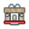 | Property Menu accesses property database; lets you add, edit, delete, and prefill property information for property forms
 | Additional Interests accesses the additional interests table to add lienholders, additional insureds, billing parties, etc.
 | Pre-Fill Form From Another will fill a new form with data from existing forms, including prior forms certificate holders.
 | Electronic Signature lets you put your electronic signature on a form before you print, e-mail, or fax the form.
 | Spell Checker will correct spelling errors.
 | Help has general instructions for filling out forms.

The ACORD Formview Dropdown Menus

File . . .
Save - saves the changes in the open form without closing it.
Save As PDF File - saves the form as a PDF image file.
Print - opens the Print dialog box so you can print the ACORD form.
Print Setup - opens the Print dialog box to change print settings.
Print Preview - shows how the document will look when printed.
E-mail Customer* - allows you to send a form in an e-mail message directly from EZAgent.
E-mail Cert Holders Directly* - allows you to send a certificate or evidence of insurance by e-mail to each individual marked holder directly from EZAgent.
*Note: Email must be setup first (see Emailing Forms section).Fax - allows you to send the form to your fax software.
Exit Without Saving - closes the form without saving your changes.
Exit - closes the form and saves all changes you’ve made.

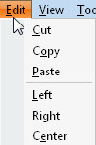
Edit . . .
Cut/Copy/Paste - are standard windows commands to cut, copy, and paste text.
Left/Right/Center - are used to justify text within the selected field.

View. . .
Reduce Form and Enlarge Form - allow you to adjust the magnification of the form on your screen.
Toggle Floating Menu - Will show or hide a small menu allowing you next page and print utilities (made for PDF forms).
Remove/Use Enhanced Controls - Toggle on or off the advanced form controls in the new version forms. These controls include date pickers and forced field masks (forces a numeric entry in numeric fields). Toggling off simulates the old style form functions.

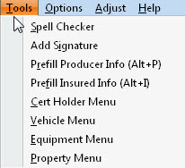
Tools. . .
Spell Checker - opens the Spell Check dialog to check your text for errors.
Add Signature will place an electronic graphic representation of your signature (in your own handwriting), if you have taken steps to create your electronic signature.
Note – Signatures must be created as 300x60 dpi Bitmap (.bmp) images. These can be ordered from Agency Software using the Electronic Signature Order Form available from the support page at agencysoftware.com.
Prefill Producer Info - automatically pre-fills your current agency information onto the form. This is handy if you have changed your agency information and are opening old forms that have your old info on them.
Prefill Insured Info – automatically pre-fills the insured’s current information if you’re opening an old form and their information has changed.
Cert Holder Menu - opens the certificate holder options dialog (see the Certificate Holder section below).
Vehicle/Equipment/Property Menu - opens (if applicable to the form) that client’s vehicle, equipment, or property list (see section below on use of Vehicle, Equipment, and Property databases).

Options . . .
Change All Field Fonts - allows you to change the font of the data you type on the form. The changed font only lasts until you close the form.
Reset to Default Font and Color – Resets to original settings.
Setup Company NAIC Codes – Click to enter NAIC code for company, which saves to the Company Setup.
Display 4 Digit Year – This toggle is only available with Enhanced Controls Enabled, this will allow you to display and print a 4 digit (rather than a 2 digit) year.
Fit PDF to Page – This toggle allows you to fit the form to a page rather than reducing the resolution of the printed form (as most PDF’s do) to have wide margins.

Entering Client Information in ACORD Forms
Data entry in an ACORD form is much like data entry in the Clients window. You can move from field to field using your arrow keys, tab key, or mouse, and edit data using the Insert, Backspace, and Delete keys. You can use your mouse to move the scroll bar at the right to move up and down the form.
The first thing you will notice when you open an ACORD form is that some of your work has already been done for you. Fields for your agency name and address have been filled in with the data you entered during installation and the client name and address information has been filled in with the information from the Clients window.

Certificate Holders
The ACORD certificate forms allow you to have multiple certificate holders for a single certificate (so you can type in a single certificate and print separate certificates for each certificate holder all in one operation).
If the Certificate Holders Menu button is displayed in color, it means that the form can support multiple certificate holders. If the button appears grayed out, it means that the form doesn’t support multiple certificate holders.

Certificate Holders Menu
Here are some things you need to know about working with certificate (cert) holders and entering holder information in certificates.
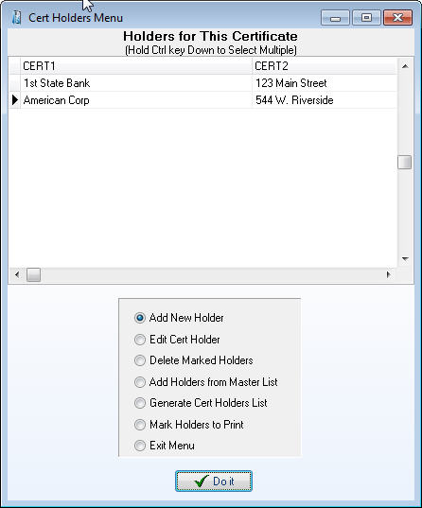
You can type certificate holder and description of operations information in the boxes in the lower-left corner of the certificate, but if you type the information directly in the form on-screen, you will not be able to use the Cert Holders Menu to set up and print the certificate for multiple cert holders, or get a report of the holders attached to that client’s certificate. You’ll only be able to print that certificate for a single cert holder.
If you have more than one holder for a certificate or evidence, use the Cert Holders Menu instead.
Figure 19 - Cert holder menu

Adding Certificate Holders
To add a certificate holder, click the Cert Holders Menu icon
In the Certificate Holder Menu select the Add New Holder option and click the Do It button.
The Certificate Holder Detail dialog box appears. Type the certificate holder’s name and address information in the dialog box.
Note: You cannot have two cert holders in the same certificate with identical names and addresses. If you need to issue multiple certificates to the same cert holder for different jobs, see the sidebar “Same Cert Holder, Multiple Jobs” (below) to learn how.
Enter the “Description of Operations” information in the Override Description of Operations box, and click the Done button. The cert holder name, address, and operations information will not appear on the form on-screen, but it will be printed when that certificate holder is marked for printing.
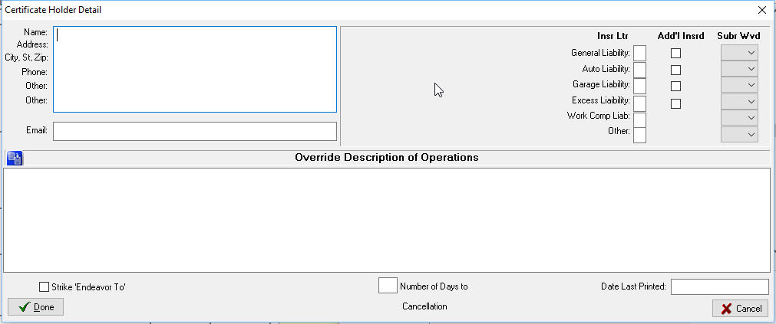
Note: There cannot be any blank certificate holders in the Cert Holders Menu list. If you see a blank certificate holder name at the top of the list, you’ll get a Key Violation error the next time you try to add a new cert holder. You MUST delete the blank cert holder (click in the blank cert holder name, then click the Delete Marked Holders option and click Do It).
Figure 20 – Adding a new certificate holder
Note: If you need to enter a nearly identical name and address block for a different cert holder, you don’t need to retype it. Instead, select the text you need to duplicate, then right-click the selected text and click Copy on the shortcut menu. Then close the Certificate Holder Detail window, add a new cert holder (or edit a cert holder), right-click in the box where the copied text should go, and click Paste on the shortcut menu.

Same Cert Holder, Multiple Jobs
Suppose you have a client, perhaps a construction company, who needs to issue several certificates (for different jobs) to the same cert holder. But you can’t enter cert holders with identical names and addresses in the same cert… so what do you do?
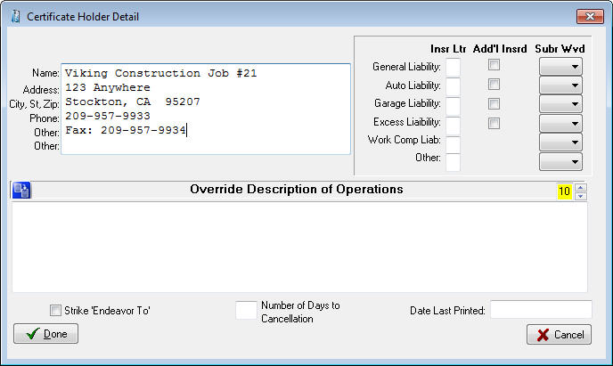
Try this: Add a new cert holder, but enter a job number at the end of the Name line (as shown below).
Figure 21 - Modify certificate holder name to allow for duplicate holders
This keeps the Name and Address field combination (really the Cert1 and Cert2 fields) from being duplicated, and you can print all the certificates you need for the same cert holder’s different jobs. The resulting printed certificate entry looks like this:
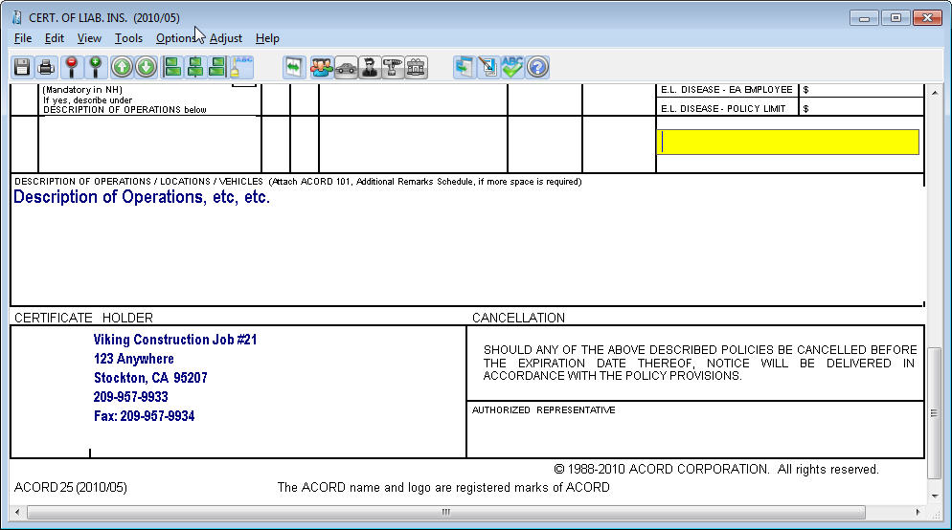
Figure 22 - Certificate holder information will prefill with information entered in the Cert Holders Menu

Description of Operations
The latest version of the Certificate of Liability holds five lines of text in the Description of Operations field. If you have more text than fits in this field you can reduce the font size as low as 7.

Description of Operations Database
The Description of Operations database can hold commonly used descriptions of operations. Access this database from anywhere the displayed icon appears.
This button sends saved information to the cert holder description field.
This button saves the information in the current cert holder description field for use later.
This button will add a blank record if you want to type the description in manually to pre-load the descriptions.
This button will delete the text in the description. All of the description is deleted, not just what is highlighted.
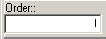
The Order field is used to place the descriptions into the order you want them in so the most used descriptions can be at the top. This is in ascending order and is entered by the User.
When you click Done, a new certificate holder is added to the certificate.

Editing Certificate Holders
To edit or modify existing certificate holders, do the following:
- Click the Cert Holders Menu button (the button that shows a person walking out of an envelope).
- Click the name of the cert holder you want to edit.
- Select the Edit Cert Holder option on the Cert Holders Menu, and click Do It.
- Make your edits, then click the Done button.

Adding Certificate Holders from the Master List
The EZAgent database has a Master List that holds all the certificate holders for all the certificates in the database. If a certificate holder has already been added for one certificate or client, you can add that same cert holder to another certificate (for the same client or for another client) by choosing it from the Master List.
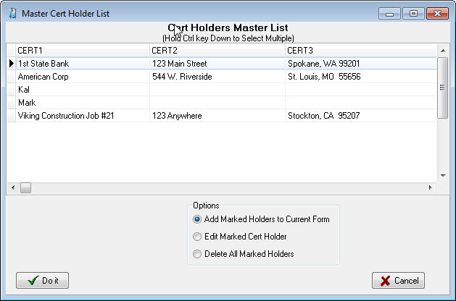
To add an existing cert holder from the Master List to the open certificate, select the Add Holders from Master List option on the Certificate Holder menu, and then click Do It. The Master Cert Holder List appears, showing all of the certificate holders for all of your clients.
Figure 23 - Master Cert Holder database
In this dialog box, click the cert holder name with your mouse to mark them, you can hold your CTRL key down to select multiple holders, click the Add Marked Holders to Current Form option, and then click Do It. The marked cert holders will be added to the cert holder list for the open certificate.
Note: There cannot be any blank certificate holders in the Cert Holders Menu list. If you see a blank certificate holder name at the top of the list, you’ll get a Key Violation error the next time you try to add a new cert holder. You MUST delete the blank cert holder (click in the blank cert holder name, then click the Delete Marked Holders option and click Do It). If you delete cert holders from the Master List, they’ll be deleted from all certificates. To delete a cert holder from just one certificate, open that certificate and delete the cert holder using the Certificate Holders Menu.

Deleting Certificate Holders
- Open the Cert Holders Menu.
- Select the Delete Marked Holders option.
- Select the names of the cert holder(s) you wish to delete. (You can mark multiple holders by holding the Ctrl key down as you click the names.)
- Click the Do It button. EZAgent will ask if you really want to delete the certificate holder – click Yes. The cert holder is deleted from the open certificate.

Certificate Output for Selected Cert Holders
You can print, email, or save to PDF a certificate for a single cert holder or for multiple cert holders. To print certificates for cert holders:
In the open certificate, first add your electronic signature (if you are planning on an electronic output and want the form signed), then click the Cert Holders Menu button. In the Cert Holders Menu, verify the holder(s) are present and select the Mark Holders to Print option; click the Do It button.
The Mark Holders to Print dialog box allows you to select each cert holder you want to print. If you want to mark all the certificate holders with one click, click the Mark/Unmark All check box (click the check box again to unmark all the cert holders). Click OK.
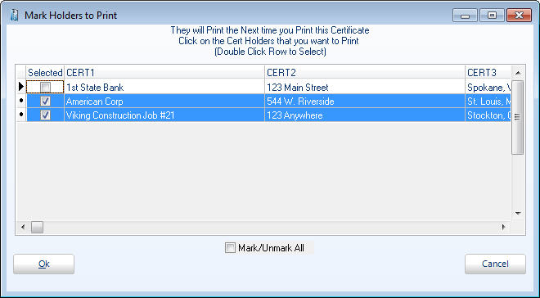
You will be given the options of:
Figure 24 - Mark holders to prefill to certificate for printing
- Print – Will print a page per marked holder to your default printer
- Email Customer – Will open an email with a ‘forms.pdf’ file attached; a single file with a page per marked holder (see Emailing Forms section)
- Email Cert Holders Directly – Will automatically send an email to each holder (with email addresses listed on the holder) with the single holder’s form. This will prompt you to enter an email address for any selected holder without an email address listed.
Select the desired option and click Yes, and the dialog boxes pertaining to your selection will appear.
Click No to print to utilize other options, such as Save to PDF. You will be viewing the form (unfilled with selected holders) and can select Save as PDF File (or any other output option) from the File menu.
After you close the form, you will be asked if you want to unmark all the holders you have marked for printing. Click Yes.

Generate Cert Holder List
To generate a printable list of certificate holders for the open certificate, select the Generate Cert Holder List option on the Certificate Holders Menu, and click Do It.

Close the Certificate Holders Menu
To close the Certificate Holders Menu, select the Exit Menu option, and click Do It.

Vehicle Database
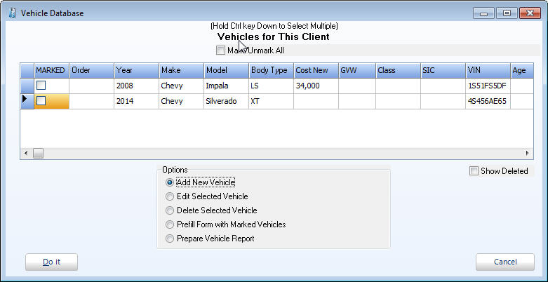
The Vehicle Database stores vehicle information by client and allows entered information to be pre-filled on ACORD forms such as ID cards, Vehicle Schedules, and other auto applications. If the Vehicle Menu button (the car button) is fully colored (not grayed out), it means the open form has access to the vehicle database. You can also access this database from the Personal window.
Figure 25 - Vehicle menu

Enter Vehicles in the Vehicle Database
To open the vehicle database, click on the Vehicle Menu button (the green car button). The Vehicle Database dialog box opens (also available by clicking the Vehicles button on the Personal window).
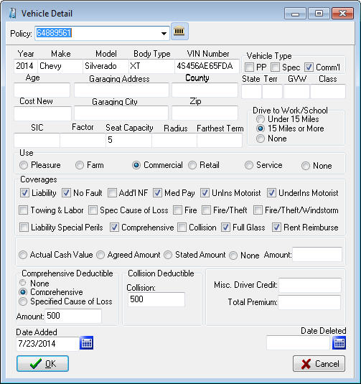
To add a vehicle, click the Add New Vehicle option and then click the Do It button. The Vehicle Detail dialog box appears.
Figure 26 - Adding a vehicle
Fill in all vehicle information*, and then click OK. The Vehicle Database reappears.
Once you have entered all of your vehicles for your client, you can manipulate the order in which they print by updating the ‘Order’ column on the Vehicle Database.
*To display this vehicle on the policy Coverages Report, you must choose the correct policy from the Policy drop-down. For Additional Interests to display, they must be entered here, see Additional Interests later in this chapter.

Fill a Form with Vehicle Information
To prefill the open form with information for specific vehicles, click the Marked box on all vehicles you wish to fill to the form. When all desired vehicles are marked click the Prefill Form with Marked Vehicles option and click Do It. The vehicle data is filled into the open form.
Note: You can only prefill the number of vehicles that the specific open form has spaces for, with the exception of Auto ID cards. In some versions of the Auto ID card, you can prefill several vehicles at a time, and EZAgent will create the number of ID cards required for those vehicles as long as you use the Order number.
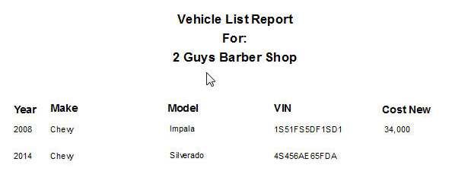
Note: If the Auto ID Card form is more than one page, when you prefill vehicles it will only create one form with one vehicle at a time.
Figure 27 - Vehicle report lists all current vehicles

Attach Vehicles to Specific Policies
You can also attach vehicles to specific polices when adding new vehicles on the Vehicle Detail screen. When you click the car icon on the toolbar of an Auto form, or you click the Vehicle button on the Personal tab, click on Add New Vehicle and Do It to get the Vehicle Detail screen. At the top of this screen is a policy drop down list so you can attach this vehicle to a specific policy.

Print a Vehicle List Report for a Client
A vehicle list report is a printable list of all vehicles associated with the current client. To create it, open the Vehicle Database, then click the Prepare Vehicle Report option and click the Do It button.

Equipment Database
The Equipment Database stores equipment information and allows entered information to be pre-filled on ACORD forms. If the Equipment Menu button is fully colored (not grayed out), it means the open form has access to the equipment database.

Add Equipment to the Equipment Database
Click the ‘Add New Equipment’ option and the following screen appears
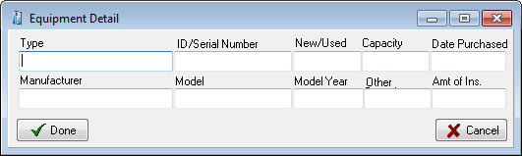
Click ‘Done’ when finished. From the equipment menu you can Add/Edit/Delete/Prefill forms and print an Equipment Report.
Figure 28 - Add equipment

Drivers Database
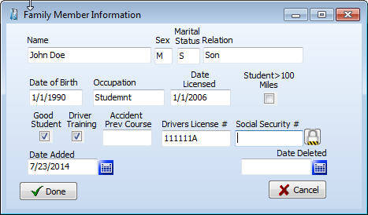
The Drivers Database stores driver information by client and allows entered information to be pre-filled on ACORD forms such as Business Auto Section, and other driver applications. If the Drivers Database button is fully colored (not grayed out), it means the open form has access to the drivers database.
Figure 29 - Add new driver

Add Drivers to the Drivers Database
Click the ‘Add New Driver’ option and the Driver Detail screen appears.
From the drivers menu Add, Edit, Delete, Prefill, and Prepare a Drivers Report are available, similar to the Vehicles Menu.

Property Database
The Property Database stores property information by client and allows entered information to be pre-filled on ACORD forms such as Homeowners Application, Commercial Insurance Application and the Dwelling Fire Application. If the Property Menu button (the house button) is fully colored (not grayed out), it means the open form has access to the property database.
Either the Personal Property or the Commercial Property dialog box opens depending on the Acord application being used.

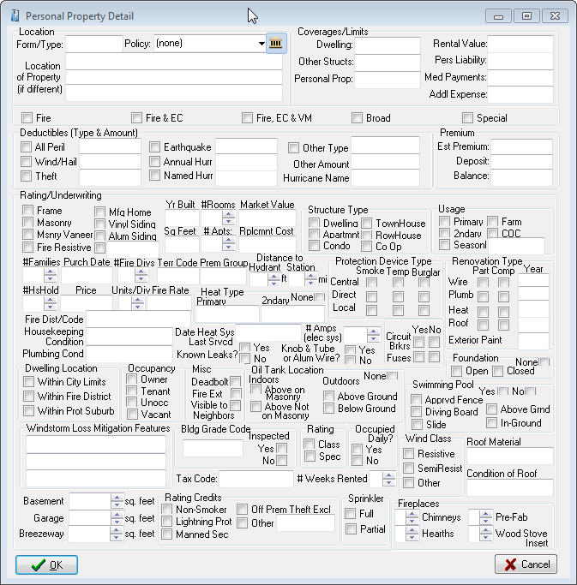
Enter Property in the Property Database
Figure 30 - Add new personal property
To open the Property Database, click on the Property Menu button (the house button). The Property dialog box opens.
The Personal Property and Commercial Property dialog box looks and works the same except for the title.
To add property, click the Add New Property option and then click the Do It button. The Property Detail dialog box appears.
Fill in all property information, and then click OK. The Property Dialog reappears.
Once you have entered all of your properties for your client, you can manipulate the order in which they print by updating in the ‘Order’ column on the Property Dialog window.

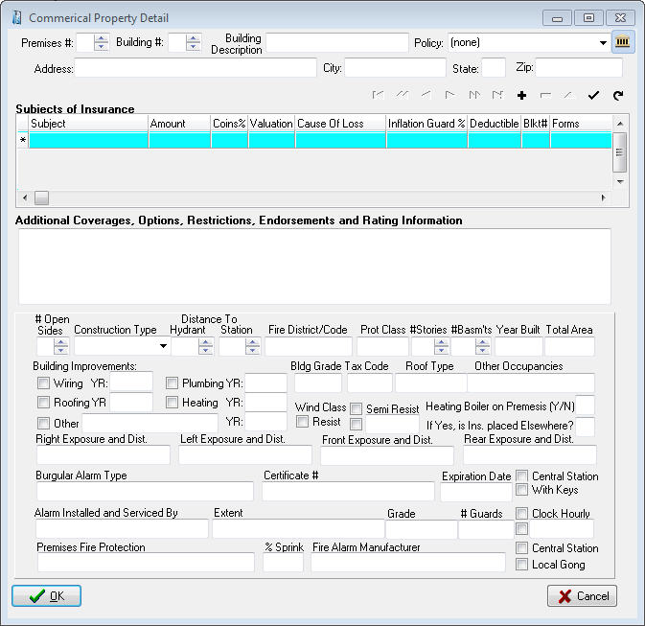
Fill a Form with Property Information
Figure 31 - Add new commercial property
To prefill the open form with information for a specific property, click the property to highlight it. To select more than one property, hold down the Ctrl key while clicking on the properties.
Then click the Prefill Form with Marked Properties option and click ‘Do It’. The property data is filled into the open form.
Note: You can only prefill the number of properties or buildings that the specific open form has spaces for.

Print a Property List Report for a Client
A property report is a printable list of all properties associated with the current client. To create it, open the Property Database, then click the Prepare Property Report option and click the Do It button.

Additional Interest Database
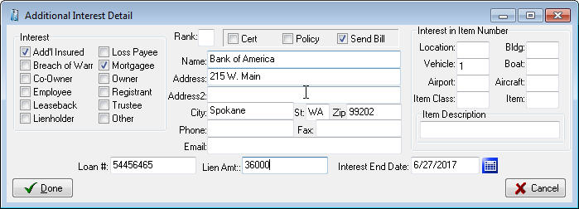
The Additional Interest Database stores information on the additional interest on the assets of the policy holder. This information can be pre-filled to ACORD forms such as the Additional Interest schedule, as well as drawn into the Coverages Report on coverage items attached to a policy.
Click the ‘Add New Interest’ option and the Additional Interest Detail screen appears. Click Done when finished. From the Additional Interests menu you can Add, Edit, Delete, and Prefill similar to the Vehicles or Drivers menus.

Emailing Forms
The Email feature sends forms, saved as PDF or JPG files, directly from EZAgent through your e-mail provider. This must be properly configured using your email provider settings.

Setting Up Email
To set up to email from EZAgent you need to collect your email service information. The required information is:
- Outgoing SMTP server name
- User name
- Port number
- Password (if one is required for outgoing mail).
You can get all this information from your Internet Service Provider (ISP).
Note: Outlook users can simply check the Send through Outlook box and enter their signature information (optional).
To set up email:
- Open any ACORD form, and click File – Email.
- The Email Form dialog box opens with the saved file name in the Attachments box.
- Click the Email Setup button (the button with the gears).
- In the Email Setup dialog box, fill in your ISP information and click OK.
- If your email provider requires a secure connection, you can select SMTPS and enter the specific port given to you by your email provider.
Common gmail settings:
- Server is smtp.gmail.com
- Select SMTPS (select this before setting the port)
- Enter Port 587
These settings may change as your ISP makes configuration changes.
- In the Signature area you can add a Default Signature. There is room for 6 lines of information that will appear at the bottom of each email.
- The Password box is for the password your ISP requires for sending outgoing mail. Not all ISPs require outgoing mail passwords – if yours does not require a password, leave this box blank and uncheck My Outbound Server Requires a Password box.
- Click OK

Sending an Email
From the Acord form select File – Email (after adding signatures and prefilling any pertinent information):
- Enter the recipient address in the To: box.
- In the large box, enter any message text you want to send the recipient.
- Click the Send Email button.
Note: You can attach more files to your message by clicking the ellipsis button (at the right end of the Attachments box), and selecting the files you want to attach.
If EZAgent email doesn’t work for you, you can save your forms as JPG or PDF files by clicking File – Save As PDF (or File – Save As JPG), and then attach the saved files to a message in your outside email program.

Notes
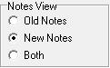
EZAgent offers two modes for the notes window. The first is the original notes that were written to a single page listing the notes by date. These are referred to now as the Old Notes. To print these you either had to print ALL the notes or highlight what you want and copy / paste to a word document to print a section.
In the Agency Setup tab you can select a global preference to have Old Notes, New Notes or Both.
The “Both” option allows you to view Old Notes without the ability to Add and to view New Notes with adding ability. So you can add notes in the New Note format, but be able to view all the notes previously entered in the Old Note format.

Operation of Old Notes
Click the Notes tab to view the Notes window.
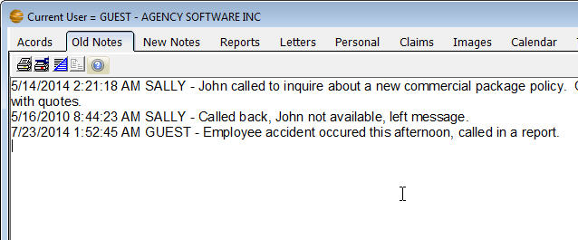
To start a new note, click the New Notes icon. The New Notes window opens.
Figure 32 - Old Notes tab displaying notes entered
Notes are automatically time-and-date stamped, and your login user name is entered. You’ll find buttons for formatting your note text, as well as print, cut, copy, and paste buttons, on the toolbar. Type your note in this window, then click the Commit button.

Operation of the New Notes
The new notes are stored in a database as one (1) note per record. This allows the ability to categorize and print the notes per User and/or date range.
Click on the Notes tab to view the New Notes window. To add a note, click on the Add New Notes icon from the Notes (or New Notes) tab. The New Notes entry window opens.
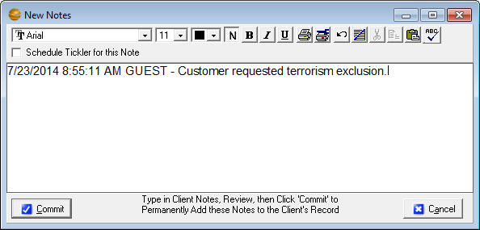
If the note applies to a policy you can select it in the Re: field. Notes are automatically time-and-date stamped, and your login user name is entered.
Figure 33 - New note entry from the New Notes tab
- Click the Spell Checker button to correct spelling
- Check the Tickler checkbox to add a tickler for this note
- Type your note in the body of the note record.
- Click the Commit button to permanently accept the record after reviewing your entries.
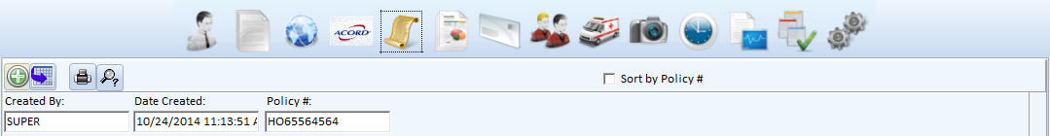
While these notes are unchangeable, there is the option to append to a note. Simply click in the body of the note and click the icon to Append to an Existing Note, which allows you to add text to the end of the existing note.
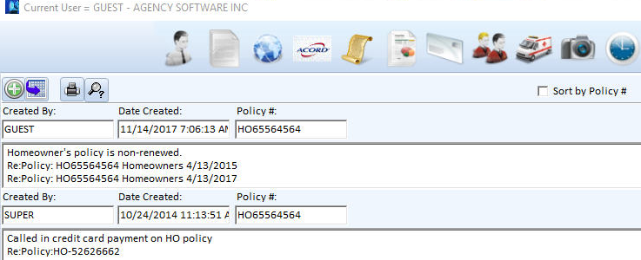
You can run reports on New Notes by clicking the Print Notes icon. The Print Notes window allows you to print by date, user, and client, or combinations of these filters.
Figure 34 - New Notes tab
Note: On either of the mode of notes, clicking the Commit button posts the note and makes it read-only (meaning it cannot be edited or deleted). This is for E&O protection. Do not click the Commit button until the note is complete and correct. If you DO make a mistake entering a client’s notes, you will have to add another entry below it stating your correction.

Personal
The Personal section is where you can record personal data about your clients – such as the names and birthdays of their family members. As always, start by selecting the client’s name in the Clients tab.
Click on the Personal tab to view the personal information pertaining to the selected client. To add a record to the Family Members list, click the Insert Record button (the + button) in the toolbar below the list. Fill in the client’s family members, and personal data about them, on the left. Click the Post Edit button (the check-mark button) to save the record.
The Customer Demographics entries on the right apply to the client, not to the specific family members.
When you first install EZAgent, the field headings are undefined in the Customer Demographics list. Headings for the demographics categories (up to 10) can be assigned from the Demographics button on the Agency Setup tab. Once you have assigned the demographics categories, the headings will appear on this window and can be used for reporting and marketing.
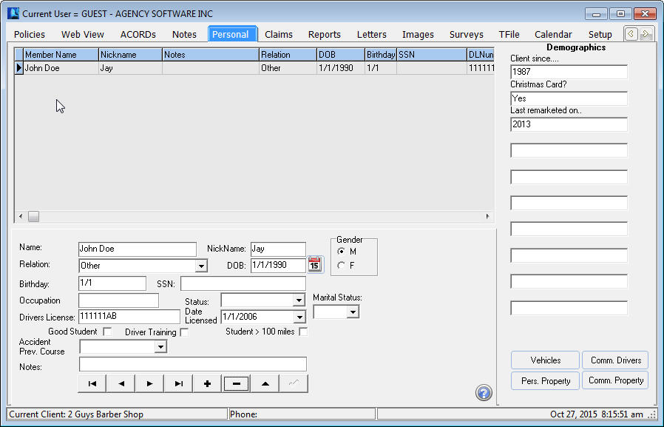
Figure 35 - Personal tab
The toolbar at the bottom of the window allows for adding, editing, and deleting records in the Family Members list. The toolbar has the same functionality as similar toolbars throughout EZAgent.
Also on the Personal tab is a Property button to enter Personal Properties and a Vehicle button to enter Vehicles.

To see a family member listed as a driver on the policy Coverage Report be sure to check the Rated Driver box.

Claims
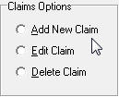
Click the Claims tab to open the Claims window. Use the Claims window to keep records of the selected client’s claims.
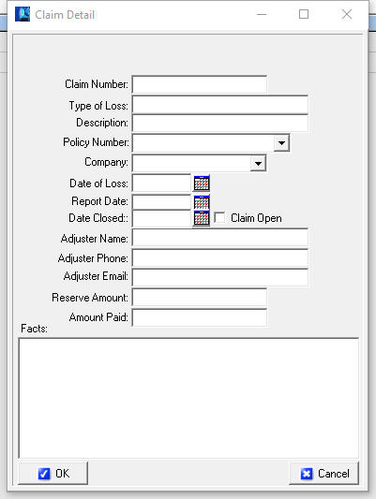
Add a New Claim. The current customer’s name is shown at the bottom of the window. Click the Add New Claim option, then click Do It. On the claim entry screen, enter a Claim number. Click the down arrow in the Policy Number box, and choose a policy number from the list. When you choose the policy number, the Company information for that policy will prefill in the Claim Detail window. Enter the appropriate data in any remaining fields, and click the check mark to post/save, then OK to close the window.
Edit a Claim. Select the claim you want to edit, then click the Edit Claim option and click Do It. In the Claim Detail window, make your changes and click OK.
Delete a Claim. Select the claim you want to delete, then click the Delete Claim option and click Do It. When asked if you are sure, click Yes (unless you change your mind – then click No).

Reports
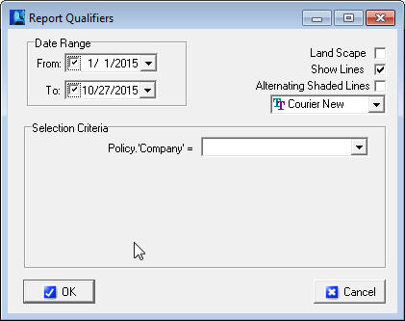
Click the Reports tab to open the list of reports. In the Reports window, you’ll find all the default reports that come with EZAgent (depending on your user security level).
These reports are ready to be used. They can be edited, which requires some understanding of SQL language, and you can also create your own reports with some understanding of how databases relate.
Select the report you wish to run then click the Do It button (or double-click the report name).
The Report Qualifier window opens allowing you to enter the report criteria. Options in the Selection Criteria box typically must be entered to run the report. Display options are listed in the upper corner (Landscape, Show Lines, Alternating Shaded Lines, and font adjustment).
Once you have entered the criteria and click OK, an Options box appears for the output method of the report. This allows you to create a Report, a Mail Merge File as a comma delimited file (*.csv), or Mailing Labels (if the report has the required mailing label fields).
Report - allows you to preview or send directly to the printer
Mail Merge Files - can be used by most spreadsheet, word or database programs
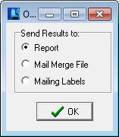
Mailing Labels - will create 3 x 10 mailing labels (3 across, 10 down). The report requires the Client Name, First Name, Last Name, Address1, City, State and Zip to create the labels. This is used when labels are needed for specific criteria such as for expired policies.

If the print is too small
Some reports have several fields (columns) of data, and all the fields will have to fit in one row across a single page. The more fields of data are displayed, the smaller the font will be (to fit it all into one row).
To make small print a little larger:
Rerun the report and select Landscape - When the report is printed in Landscape orientation, there is more page area for the long rows and the print is more readable.
Eliminate unnecessary fields - If the report print is still un-readably small, you can only increase the font size by eliminating some of the fields (columns) in the report.
Select multiple lines per record - You can opt to ‘break’ each row of data into multiple lines (although it is a little harder to read this way). The dialogue box to do this appears only when the report has reached a small font.
Save the report as a Mail Merge file - Open the saved csv file in Excel and then you can manipulate the page and font size to your desired format.

The Report Preview Window Toolbar
In the Report Preview window toolbar (across the top of the window) you have various Zoom buttons to change your view of the report, and buttons to move from page to page in a multi-page report, print the report, and exit the report viewer window.

Create a Custom Report
You can create your own custom reports to show whatever specific data you choose.
To create a custom report (you must have Supervisory access) select the ***Custom Report*** report name at the top of the reports list, and click Do It. In the Query Wizard window that opens, you’ll build your custom report.
The next steps will guide you through creating a custom report listing client names and phone numbers for clients in your zip code area.
- In the Get Records from My box (at the top of the window), select Client.
- Next you’ll enter the criteria that determine which clients will be listed in the report – specifically, the clients with your local zip code.
- In the first line of three boxes, in the (fields) box, select ZIP
- In the (conditions) box, select =
- In the (values) box, type your local zip code. In this example we enter 99021, because I have many clients with that zip code.
- In the Available Fields list, double-click each field you want to display in your report. In this example, I’ll select Client.’Name’, Client.’Address1’, Client.’City’, Client.’State’, Client.’Zip’, Client.’Phone’, and Client.’Phone2’. Keep in mind the more fields you choose the smaller the print on the report will be.
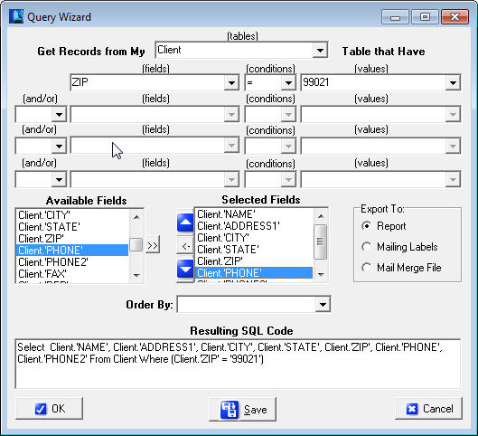As you double-click each field name, it appears in the Selected Fields list. To delete a field from the Selected Fields list, click the field name and the click the Remove Selected Field button (between the red arrows that point up and down).
Figure 36 - Setting up a report for client by zip code
- If you want the records in your report to be listed in a specific order, open the Order By list and choose the field name by which you want to sort the list. The figure below shows this example report set up and ready to run.
You can also 'Subtotal' and 'Group By' rows of your reports together. An example of this would be to create a new report for all policies, Subtotaling premium volume, then Grouping By Company. Note that you need to ‘ORDER BY’ the same field you ‘Grouped By’ for it to work.
- Click the OK button.
- The Report Setup box opens next, with the Preview option selected. Click OK to open a preview of the report before you print it.
- After you close or print the report, you will be returned to the Query Wizard. If you want to save this report, to use again, click the Save button. Give the report a name you’ll recognize later, select Marketing in the Report Category box, and click OK. Then click Cancel in the Query Wizard. The report is added to the list to run at a future date.
Note: In addition to creating this report to ONLY run for clients in ZIP CODE = 99021, you can greatly enhance the functionality of this report by choosing ‘:Value1’, ‘:Value2’, ‘:Value3’ (or ‘:FromDate’ and ‘:ToDate’ if dealing with date fields) in each of the values dropdowns. Choosing these variables instead of hard-coding the value ‘99021’ means that the program will stop and ask you what criteria you want to run the report each time you run the report.
The report you create is nothing more than a set of instructions, called a SQL statement. This tells EZAgent to retrieve the data you specified every time you run the report. This means that every time you run the report, you get the data that is currently in the database when you run it.

Create Mailing Labels
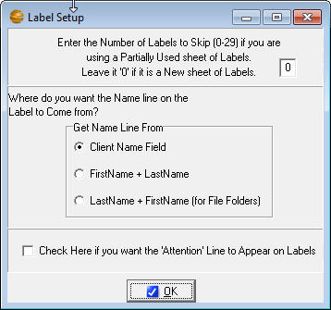
To create mailing labels, your report must have the fields, Client Name, Client First Name, Client Last Name, Address1, City, State, and Zip. When you run the report choose Mailing Labels from the options menu, and you will get the label setup screen.
Figure 37 – Label setup options
Note: If you filter your client list on the Clients window before you create mailing labels, the labels will be created only for the names in the filtered client list.

Edit a Report
Any report, including most default reports that came with EZAgent, can be edited if you understand SQL. If you don’t understand SQL, it’s easier to create a new report and delete the old one.

Permanently Delete a Report
To permanently delete a report, either default or custom, select the report name in the Reports window, and click the Permanently Remove Selected Report button above the blue reports list.
Note: Once you delete a report, it’s gone forever. Agency Software technical support can replace default reports for you, but this will also delete any custom reports you’ve created. So be very sure you want to delete a report permanently before you do it.

Letters
Click on the Letters to open the Letters window. This window has all the features of most modern word processors.

What’s In the Letters Window
There are several insurance-specific letters included in EZAgent. These letters are ready for merging with your client data. You can also edit these letters to customize them, and then save the default letter with your customized changes, or save the changed letter with a new file name so you don’t lose the original default letter.
- To open default letters that come with EZAgent (or custom letters you have created and saved in EZAgent) click File, then click Open. A window opens to the Docs folder in the EZAGENT folder. Click the name of the letter you want to open, then click the Open button.
- To create new custom letters click File, then click New. Follow the procedures in the Creating Custom Mail Merge Letters section below.
- To save changes to an open letter click File, then Save.
- To save a letter with a new file name (as a new letter) click File, then click Save As, and give the letter file a new name.
- To close the open letter click File, then click Close.

Merge Client Data into a Letter
EZAgent allows you to merge your agency and client information into several preinstalled letters, or create your own letter in either EZAgent or a word processor and then merge your data into it.
To merge data into a document that shipped with EZAgent, start by opening that document (the merge fields are already in place in these documents).
Select the client(s) you wish to merge into the letter by clicking the Select Clients to Mail Merge button. This brings up a box with a list of your clients in it. Click to select the clients you want to include. (Select multiple clients by holding down the Ctrl key while clicking on the clients).
Click the OK button. Multiple identical documents are created, each filled with the merged client data.
Print the merged documents by clicking the Print button (or click File, then Print).
After you print the documents, click File, then click Close to close the merged document without saving it.
Note: Do not save the letter after you merge client data into it. Doing so will overwrite the original letter containing merge fields, and you won’t be able to use that letter as a merge-able file again.

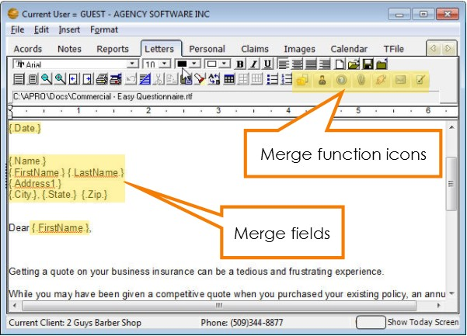
Creating Custom Merge Documents
Figure 38 - Letters tab
EZAgent allows you to merge your agency and client information into custom documents that you create.
Click File, then click New. The window is the same, but the program knows you have started to create a new file.
Type your new letter/document. Wherever you want to enter merge data (such as client name, agency name, date, phone, policy#, etc.), click to place the cursor at that point and then click the Insert Merge Field button. (You can also click Insert, then click Merge Field.)
Scroll down and select the merge field you want to insert, and click OK. When you run the merge in the finished letter, the program will replace each merge field with the corresponding client information in the database.
A merge field consists of a field name from the database, surrounded by periods and curly brackets. You cannot create your own merge fields – the names must be identical to field names in the EZAgent database.
When you finish your document and all merge fields have been entered, save the new document by clicking on the Save button (or click File, then Save).
In the Save As dialog box, enter a name in the File Name box. The document is saved in the Docs folder in the EZAGENT folder.
To merge data into this document for printing, follow steps 2 through 5 in the Merge Client Data into a Letter section above.
Note: Do not save the letter after you merge client data into it. Doing so will overwrite the letter containing merged fields.

Attaching Letters to Clients
When you attach a letter to a client, the document is linked to that client so you can find it again very quickly when that client is selected in the Clients window.
To link a letter to a client first make sure the client is selected (listed as the Current Client in the bottom left corner). In the Letters window, open or create a letter and merge the data into it (using the procedures in the previous sections).
Click File, then click Save As to save the merged letter as a new file with all the merged data in it. In the Save As dialog box, give the file a new name. It’s saved in the Docs folder in the EZAGENT folder.
Click the Add/View Attachments for This Client button (it looks like a paper clip). The Attached Documents window appears.
To attach the current letter to this client, select the Attach Copy of Item to Client option, and click the OK button.
A window opens asking you to enter a description for this document (the description appears in the Description column in the Attached Documents window). In the box, type a description that identifies the document and click OK.
The date, description, and filename for this document will appear in the Attached Documents window after you click OK and then click the Add/View Attachments For This Client button again.
To open and then edit or print letters you have already attached to this client, click the Add/View Attachments button. Click the letter you want to open, then click the Edit Selected Item option and click OK.
To delete the attached letter from the client, click the Delete Link To Attachment option. The document will no longer appear in the Attached Documents window, but the document file will still be saved in the Docs folder in the EZAGENT folder.
To close the Attached Documents window without attaching, opening, or deleting any documents, click the X button in the upper-right corner of the window.
Note: An alternative to attaching to the letters window is to attach to the image tab by printing the merged letter to the Agency Software Printer. This will create a PDF file and attach it to the Images tab.

Images
The Images area is where you can attach files pertaining to the selected client. This section covers the methods you use to attach and access these files.

The EZAgent Document Manager
With the Document Manager, you can attach any kind of electronic document to any specific client in your EZAgent database. Do you have a letter, a picture, or a spreadsheet that you want to attach to a specific client so that you can quickly locate and open that particular file? Now you can do exactly that with the EZAgent Document Manager.

What the Document Manager Can Do for You
The Document Manager is designed to attach or link specific files in your computer to specific clients in your EZAgent database.
You can attach all kinds of files to specific clients: any scanned image, forms saved as PDF or JPG files, text documents (such as a Word file), spreadsheets (such as an Excel workbook), and pictures of any kind.
When you select a specific client on the Clients tab, all the attached or linked files for that client are listed on the Images tab.

What’s the Difference between Linking and Attaching?
Attaching creates a separate copy of the file for the database. Any changes you make to the attached copy in the database are made only in the attached copy – they don’t change the original file.
Linking creates a link to the original file. If you open a linked file and make changes, your changes appear in the original file.
Whether the file is linked or attached, if it’s a graphics file (specifically a BMP or JPG file) you can see the file image in the Image Preview pane on the right side of the Images window.
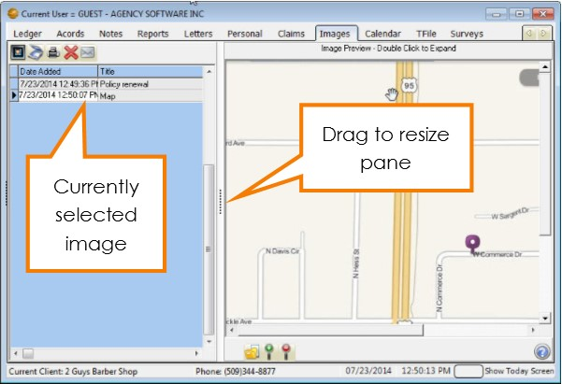
The files are easy to open. You can either double-click the name of the file in the Title pane (on the left side of the window), or double-click the image in the Image Preview pane (on the right side of the window). Double-clicking in either pane opens the file in its native program.
Figure 39 - Images tab

What’s a Native Program, and Can I Change It?
A file’s native program is the program in which the file normally opens in your computer. For example, if your computer normally opens a BMP (bitmap) picture in the Microsoft Photo Editor, then that is the BMP file’s native program – and when you double-click to open that particular file in the EZAgent Images window, that file opens in the Microsoft Photo Editor. Likewise, any PDF file opens in its native program, which is usually the Adobe Acrobat Reader. (The native program is often referred to as the file type or the file association.)
To change the file association – the native program in which a file opens – open any folder window, such as the My Documents folder, where a file of the type resides.
- Right-click a file of the type you wish to associate and select from the menu Open With, then Choose Default Program
- Find the program with which you wish to associate the file either in the Recommended Programs, or by browsing
- Click OK, which should open the file with the chosen default program.

Adding Files to Images
There are several ways to add files to the Images window in EZAgent. You can:
- Add files with the buttons on the Images window in EZAgent
- Use the Document Manager icon on your desktop (even when EZAgent is closed)
- Add scanned files directly from your ScanSoft PaperPort 9.0 scanning software
- Add files by clicking the Snapshot button in the Webview tab
- Print any printable item using the Agency Software Printer
- Use the Save button in the Client A/R invoice.

Adding Files from the Images Window
To add a new file when you have EZAgent open:
- On the Clients window, select the client to whom you want to attach the file.
- Click the Images window to open the Images page.
- Click the Load New Image button.
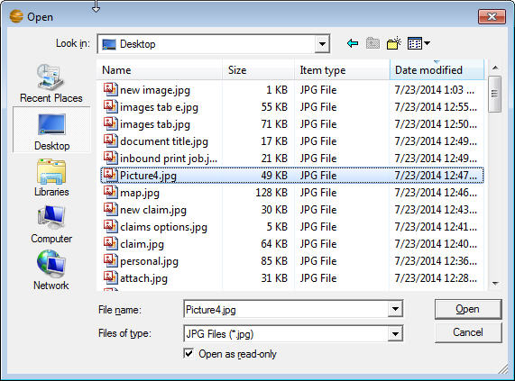
- In the Open dialog box that appears, navigate to the folder where the file is saved.
Figure 40 - Browse for image to attach
- Click the file name, and click the Open button.
- The Enter Document Title box appears. Enter a document title – this is the title that will appear in the Title pane in the Images window (so make it something you’ll recognize).
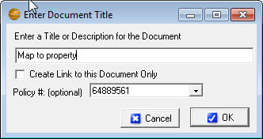
- If you want to link to the file rather than create a copy, click the Create Link to this Document Only check box to mark it.
Note: If you link a document, make sure others in your office have access to that location or they will not be able to open the document in EZAgent.
- If you want to attach a copy of the file, leave the check box clear and EZAgent will make a copy of that file so everyone that has access to EZAgent will have access to that document.
- If you wish to link the image to an existing policy, drop down the list and select the policy number. This will allow the image to be viewed from the Policy tab.
- Click OK.
The file is linked or attached, the title you typed appears in the Title pane, and the image (if it’s a BMP, JPG, or PDF file) appears in the Image Preview pane.

Adding Files with the Desktop Document Manager Icon
To put the Document manager icon on your desktop, open the network drive where EZAgent is installed, then open the EZAGENT folder, right-click the file named DocMgr.exe and select Send To the Desktop.
The Document Manager icon will then be on your desktop. You can attach or link a file to a client by dragging the file’s icon onto the Document Manager icon.
Note: You cannot run the Document Manager by double-clicking the icon – you can only drag-and-drop file icons onto it.
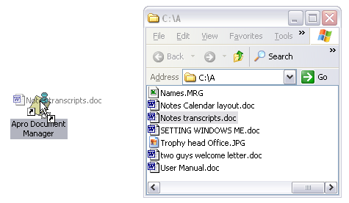
Drag the file icon and drop it on the Document Manager icon
You can drag the file’s icon from the desktop, or from a folder window. When you drop the dragged icon, the Document Importer window opens.
Note: If you want to use the Document Manager icon to attach or link an e-mail message, you must first drag-and-drop the e-mail message from your e-mail program onto the desktop first, then drag-and-drop the e-mail icon from the desktop onto the Document Manager icon. You cannot drag the email directly from the email program to the document manager.
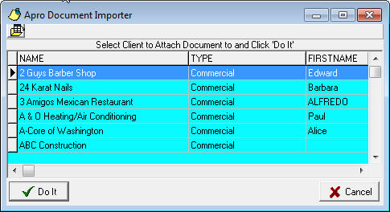
Figure 41 - Choosing a client after dropping a file on the Document Manager Desktop icon
- In this window, navigate to the client to whom you want to attach the file. All the techniques you can use for finding the right client in EZAgent’s Clients window will work here, too – for example, type the first few letters of the client name, or scroll to a different column and click the column header to sort by that column.
- Select the client name, and click the Do It button. You can use any techniques you normally use in the Clients page to navigate to your client (e.g., type the first few letters of the client name to jump to that part of the list).
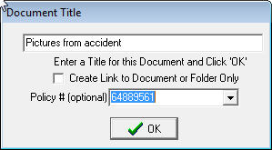
- In the Enter Document Title box that appears, enter a document title – this is the title that will appear in the Title pane in the Images window.
If you want to link to the original file rather than create a copy, click the Create Link to this Document Only check box to mark it. If you want to attach a copy of the file, leave the check box clear.
Note: If you drag a desktop shortcut to your Document Manager icon, it doesn’t matter whether you attach or link – you are attaching or linking a shortcut rather than the actual file, and opening the file from within EZAgent will always run that shortcut and open the original file.
If you wish to link the image to an existing policy, drop down the list and select the policy number. This will allow the image to be viewed from the Policy tab.
- Click OK. The file is linked or attached, the title you typed appears in the Title pane, and the image (if it’s a BMP or JPG file) appears in the Image Preview pane as displayed above.
Note: If EZAgent is open when you attach a file using the desktop Document Manager icon, the newly-added file will not be immediately visible in the Images window. Click the Clients tab, then click the Images tab again, and you’ll see the newly attached file in the list.

Adding Files from ScanSoft™ PaperPort 9
If you have a ScanSoft™ PaperPort 9 scanner, you can attach or link scanned files to your EZAgent clients directly from the PaperPort window.
After you install the EZAgent Document Manager, you’ll see a Document Manager icon in the Send To bar (the programs toolbar at the bottom of the PaperPort window) the next time you open it. If you don’t see the Document Manager icon, click the Arrow buttons on either side of the Send To bar to scroll more program icons into view.
If you still don’t see the Document Manager icon in the Send To bar, click Tools – Refresh Send To Bar. If that doesn’t add the Document Manager icon to the Send To bar, click Tools – Send To Options, and in the Send To Options dialog box, scroll to select the Document Manager icon and then mark the Include Icon On Send To Bar check box.
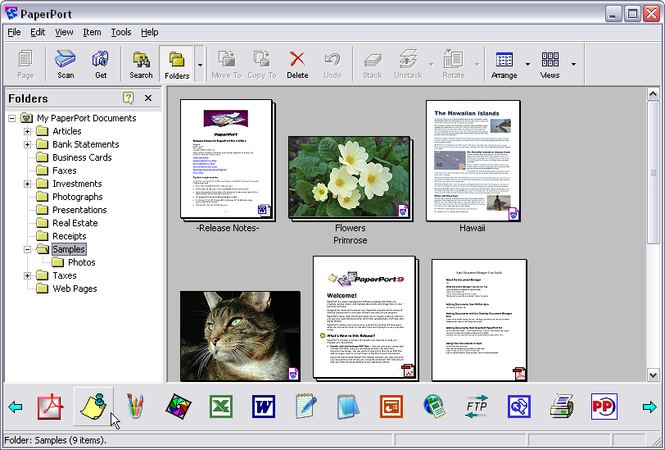
Document Manager Icon
Arrow Button
After you scan a document into PaperPort, you can use the Document Manager icon on the Send To bar to send the new file to EZAgent.
Tip: When you install ScanSoft ™ PaperPort, a new button (the Print To PaperPort button) appears in Microsoft Word, in the Standard toolbar. After you create and save a document in Word, you can click the Print To PaperPort button in the Standard toolbar to add the open document to PaperPort, and from the PaperPort window you can add the file to the EZAgent Document Manager.
- Select the icon for the document in the PaperPort window, then click the Document Manager icon in the Send To bar.
- Select the client name, and click the Do It button. You can use any techniques you normally use in the Clients page to navigate to your client (e.g., type the first few letters of the client name to jump to that part of the list).
- In the Enter Document Title box, enter a document title. If you want to link to the original file rather than create a copy, click the Create Link to This Document Only check box to mark it.
If you want to attach a copy of the file, leave the check box clear.
- Click OK.
The file is linked or attached, the title you typed appears in the Title pane, and the image (if it’s a BMP, JPG, or PDF file) appears in the Image Preview pane.

Adding Files using the Agency Software Printer
ASI Printer Setup must be done at each workstation by running the appropriate ASIPRINTER file at each workstation for that user to have access to the Agency Software Printer and use the Snapshot button in Webview. The ASI Printer is installed using the Techtools utility available from the EZAGENT folder.
After you install the ASI Printer you will have it available in your printer selection. If you choose the Agency Software Printer while on an outside document, email, website, etc. (you must be logged into EZAgent while using this feature) it will ask which client you would like to attach the image to.
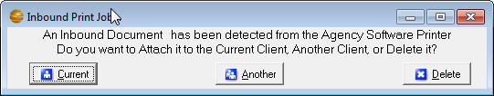
This will create a PDF file in the Images tab of the selected client. Next you will get the same Document Title windows you get when attaching images directly from the Images tab, where you will give the document a Title and you can attach this image to a specific policy.
Figure 42 - Select client for image attachment
Another way of using the Agency Software Printer is by clicking the Snapshot icon from the Webview tab, which will capture the entire current page displayed in Webview to a PDF file in the Images tab.

Using Your Attached or Linked Files in EZAgent
Now that you have files in the Images window in EZAgent, here are some things you can do with them.
Want to take a quick look at a form you’ve saved in the client’s Images window while you’re talking to your client? Select the client name, click the Images window, select the file title in the left pane and open it.
Whether a file is linked or attached, you can open it by:
- Double-clicking the file title in the Title pane on the left side of the Images page
- Clicking the title to select it, then double-clicking in the Image Preview pane on the right side of the Images page
Note: Only BMP, PDF and JPG images can be viewed in the Image Preview pane – other graphics files (such as Email and TIF files) cannot be viewed in the Image Preview pane, but can be opened in their native programs by double-clicking in the Image Preview pane.
Graphic images will be stretched to fit in the Image Preview window. If the picture has unusual proportions, it will be stretched out of shape in the Image Preview pane.
If the picture in the Image Preview is too big to see all at once, use the scroll bars to scroll to hidden parts of the picture, and/or use the Zoom buttons below the image pane to magnify or reduce the image view.
If your file opens in the wrong program, or tries to open in a program you don’t have, see the Images Window section to change the file association.
The Images toolbar appears at the top of the open form. When you place your mouse over a toolbar button, the name of the button appears. The buttons, left to right, are as follows:
The Load Image button loads files from your computer into the Images page
The Image Processing button activates your scanner
The Print Image button sends the selected file to the printer
The Delete Image button deletes the file from the client’s Images page.
Email Customer button opens up an email with the image already attached
Want to open a non-graphic file, such as an attached letter, and work on it? Either double-click the file title on the left, or double-click in the Image Preview pane on the right.
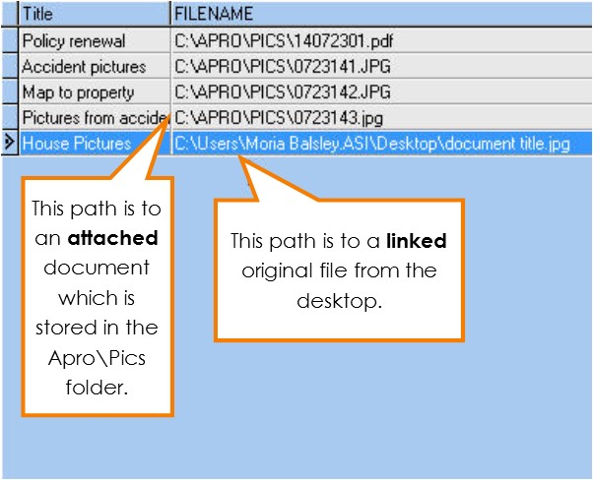
To change the spelling of a file title, click the title name in the list and type your changes, then click on a different title to save your changes. The list will be instantly re-alphabetized.
Figure 43 - Image path comparison; linked vs. attached
To see the location of the file, drag the horizontal scroll button at the bottom of the Title pane to the right. You’ll see the FILENAME column, showing the path to each file.

Surveys
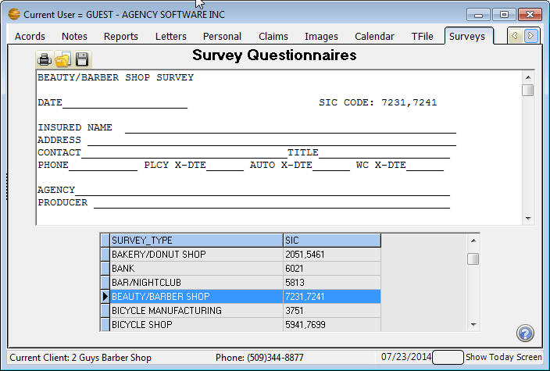
Click the Surveys tab to open the Surveys window. There are more than 200 Business Specific Survey Questionnaires in EZAgent. Most Survey Questionnaires are 7 – 10 pages long and contain a checklist of items that will certainly help reduce your E&O risk – and possibly uncover underwriting credits. Use the scroll bar on the right side of the list of survey titles to locate the survey you want. Double-click on the survey title to display it in the window. When you have the survey you want open, click the print button to print it. You can take the survey with you when you go to an insured site, and enter information right on the pages.
Figure 44 - New survey added to the Survey tab
You can edit surveys to better suit your agency. Click in the survey text and edit it as you would in a word processor. Use the scroll bar on the right of the open survey window to scroll through the entire survey.
The three buttons in the upper-left corner are Print Survey, Open Saved Survey (which opens surveys you’ve saved under a new name), and Save as New Survey (which saves a survey under a new name).

TFile
Transactional filing automatically tracks changes made in the EZAgent software. It is intended as a way to replace your existing file cabinet.
Click on the TFile tab to view the TFile window.
There are three buttons at the upper-left corner of the transactions list: Manually Add New TFile Item, Print History File, and Find a Word or Phrase in History. The middle of the window lists all EZAgent transactions, depending upon the display choices selected at the bottom of the window.
Manually Add New TFile Item Opens the Add TFile Item window in which you can manually enter EZAgent transactions (see below to learn more).
Print History File Creates a printed list of the displayed transactions (Tip: Print the report in Landscape mode instead of Portrait for a more readable report.).
Find a Word or Phrase in History Searches all columns in the displayed transactions for the word or phrase you type – the Locate Field Value box, shown below gives you options for your search. See window below.

Transactions Display Options:
Current Client Only - Displays transactions involving the client currently selected in the Clients window within the selected date range.
All Transactions - Displays all EZAgent transactions within the selected date range.

Date Range Display Options
Today Only - Displays transactions performed today for the client selected in the Transactions options.
All Dates - Displays transactions for all dates for the client selected in the Transactions options.
Date Range - Displays transactions for the selected date range for the client selected in the Transactions options.

Manually Add a TFile Item
If you click the Manually Add New TFile Item button you will open the Add TFile Item window.
Date Automatically current, but you can change it if you need to.
- Time Automatically current, but you can change it if you need to.
- By User Logged-in user name.
- Client Choose client name from dropdown list.
- Policy Choose Policy # from dropdown list (the entire list of policy numbers appears – when you select a policy number, the client name is filled in).
- Description Type a description of the transaction.
Click OK to save the entry and return to the TFile window, or click Cancel if you decide not to save the transaction.
Note: Transactions cannot be deleted (unless you are closing your agency’s books at the end of the year). Otherwise they are permanent. This is for your E&O protection. Therefore, the TFile should not be used as a Notes file or a Tickler file for clients. Use either the Notes window or the Tickler/Calendar window to record information that’s not transaction-related.

Calendar
Ticklers are reminders you set for yourself or other users, for any reason you like – appointments, birthdays, To Do items, or anything else for which you want a reminder.
You can display by Open Status and Clients. Click the box on the From & To dates to activate and use a date range. The Tickler options allow the creation and editing of Ticklers
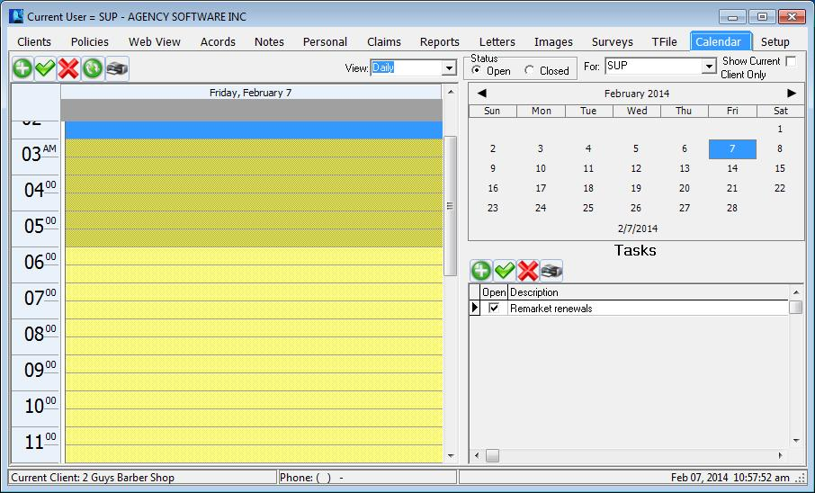You can view by Daily, Weekly & Monthly, by Status and by clients. The calendar listing shows Appointments & Alarms. The Tasks window on the lower right shows Tasks in Blue if the due date is in the future, Black for today & Red for past the due date.
Figure 45 – Calendar window
You can use the Add New Item icon or double click on the time slot to create a Tickler.
When you create or edit a tickler, you can set a visual alarm to “go off”, or pop up, at the date/time you set. EZAgent must be open in order for the alarm to go off, and if EZAgent is not open at the scheduled alarm time, the alarm will be displayed the next time you open EZAgent.
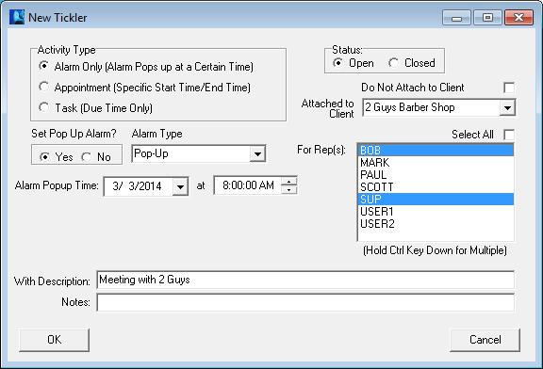Create a new tickler - When you click the Add New Tickler option and click Do It, the Tickler dialog box opens with your user name in the Rep box, and attached to the selected client. Set a date and time for the alarm and then enter a description and any notes about the tickler. In the Set Pop Up Alarm options, choose Yes or No (if you select No, there won’t be a reminder popping up). Click OK to save the tickler.
Figure 46 – Creating a tickler
You can create ticklers for other users (select the user name in the Set Tickler for Rep box) and the tickler will go off when that user is logged in to EZAgent.
You can also create a tickler that’s attached to a client other than the client currently selected in the Clients window. Select the client name you want in the Attached to Client box.
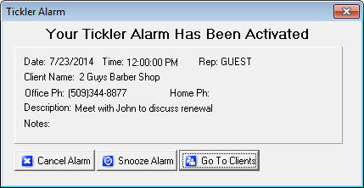
When a tickler alarm goes off - You can “snooze” the tickler to go off again later by clicking the Snooze button and setting a new time. Or you can close the tickler permanently by clicking the Cancel Alarm button.
Click the Go To Clients button to close the tickler and open the EZAgent Clients window. When you click this button, the tickler will reappear in a few seconds, and keep reappearing every few seconds until you click Cancel Alarm or Snooze. If you click Snooze and click Ok the Alarm will automatically be snoozed for 10 minutes, or you can set the alarm for another time or day.
Edit a tickler: To edit a tickler, either double-click that tickler in the list, or click the tickler in the list to select it, click the Edit Tickler option below the list, and click Do It. Make your edits and then click OK.
Delete a tickler: To delete a tickler, click the tickler in the list to select it, then click the Delete Tickler option, and click Do It. When queried if you’re sure, click Yes.
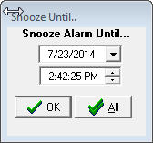
Snooze All feature: When a tickler alarm displays, if you click the Snooze button, on the snooze window there will be a Snooze All button. Click the Snooze All button after setting the date and time and that will snooze all ticklers that are due to that date and time.

Setup
During your initialization of EZAgent, you will want to spend some time entering your codes and choosing the appropriate settings for your agency.
Some of the settings on this tab have been covered in previous sections (Notes and Tickler for example).

Agency Information
The Agency Information is also the producer information that appears on your ACORD forms. This information comes initially from the information submitted during purchase to Agency Software. To change this information it must be submitted in writing by filling out the Change of Address form available on our website.

Coverage Classes
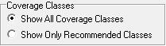
The coverage classes (lines of business) available from the Coverage Class drop-down in the policy is a default listing. By default you can add to that list by simply typing in the new entry with Show All Coverage Classes selected. The default list cannot be added to if Show Only Recommended Classes is selected.

Encrypt Client SSN’s
The Encrypt Client SSN’s option is designed to secure the client social security number on the Personal tab. Once checked it cannot be reversed and the social security numbers are only available one at a time by clicking the Decoded SSN button next to the SSN field.

Automatic Data Backups Configuration
In the # of Days Between Backups box you can set a schedule for automatic data backups. If, for example, you select 7, then every 7 days the first thing that happens when EZAgent is opened is a data backup. EZAgent creates a compressed backup file of all your EZAgent data and saves it in the EZAGENT\Data001\Backup folder. Since these backups are stored directly on your computer’s hard drive, they do not protect against hardware failure, fires or viruses. You MUST have an offsite backup method (i.e. tape backup, CD Burner or memory stick that you can take with you) available as your primary backup source.
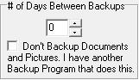
You can include the EZAgent backup in your Microsoft Scheduled Tasks so you can back up EZAgent at a time that's convenient for you. For instructions go to the Support page at agencysoftware.com.
If your agency is paperless, the data backups are likely to be slow and quite large, as the backup will by default cover the Pics folder which stores all of your agency’s images. You can suppress the images from the data backup by checking the option Don’t Backup Documents and Pictures, but first be sure that you get a regular offsite backup that includes the EZAGENT\Pics folder.

Companies Information Database
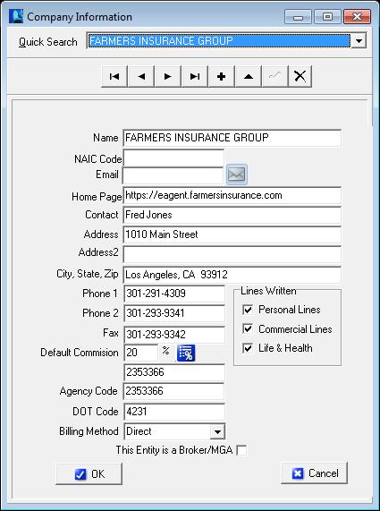
Click the Companies button (on the right side of the window) to open the Company Information window. The toolbar buttons will allow you to Add, Edit, Delete and scroll through companies.
Click the + (Insert Record) button to add a new company to your Companies database. Fill in the fields, and then click the check mark button to save your entries.
Figure 47 - Entering a new company

Company Commission Grid
To set up the Commission Grids for Companies, click on the Commission Grid icon (only available once the new company has been saved). This commission grid will automatically fill to the policy’s commission percentage when the criteria entered in the grid matches the policy information. Go to the correct company and click this button, then click the plus sign to add a Coverage Class for this company. Click the down arrow in the Coverage Class field and choose the first coverage class. Click the down arrow in the Transaction field, choosing New or Renewal, and then enter the Commission percentage. Click the check mark to post that entry to the commission grid.
Note: The commission grid is an override to the Default Commission % from the main screen for that company, so any % matching the default is unnecessary to enter into the commission grid screen.

Employees Information Database
On the Setup tab, click the Employees button to open the Employees window.
The toolbar at the top is like the rest of the toolbars in EZAgent – with the buttons, you can Add, Edit and Delete usernames and producers in EZAgent.
Note: You are limited to 5 users unless you purchase extra seats. You cannot delete a user, you’ll need to call Agency Software, Inc. and ask them to add a new user, or to replace a user you want deleted. Instead, when you need to change a user in EZAgent, select the employee that’s leaving and edit that record to change the username and password to the user you want to add as long as the Username was not paid commission in EZAgent. If they were paid commission contact your Account Representative or Tech Support to help you add the new user. (You do not need to enter a password, but using passwords makes the data in EZAgent more secure.)
To edit an employee record:
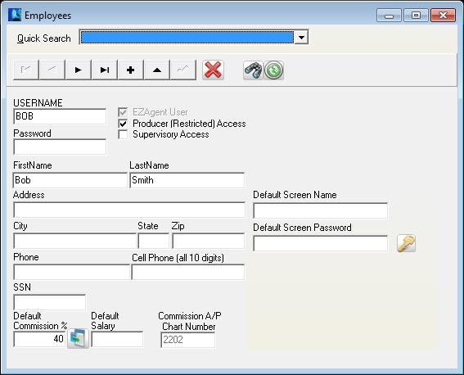
- Login as a user with supervisory access, and open the Employees information database.
Figure 48 - Employee information
- Use the scroll buttons at the top of the window to scroll to the employee whose data you want to change.
- Click the Edit Data button – the button that looks like a triangle.
- Edit the user data, and be sure you mark or clear the access check boxes to give that employee the kinds of access you want them to have.
- Producer (Restricted) Access allows a user to see only clients on the Client tab that have the Assigned Producer name the same as this User’s Username.
- Supervisory Access allows a user to change user data. The user will have the Agency Setup tab when they open EZAgent, and will have all the Management reports on the Reports tab. Supervisors also have access to delete records throughout EZAgent.
- Click the check mark button to save the edited employee data.
- Click the X button in the upper-right corner of the window to close it.
Delete Employee
Filter Employee List
Restore Employee List
Note: You can’t have duplicate employees entered in the Employees window – if you enter duplicate employee names, you’ll get a Key Violation error the next time you login.

Employee Passwords
The employee’s usernames and passwords may prefill into a company webpage while using the Webview tab. The Default Screen Name and Default Screen Password are for Farmers Website only. To setup the Usernames and passwords for the other companies click the key icon in the Employee screen while the employee is selected. Add an item by clicking the + on the toolbar and fill in the Company (must select from drop-down and Company Home Page must be set up to work) and enter the username and password information. Click the check mark to save.

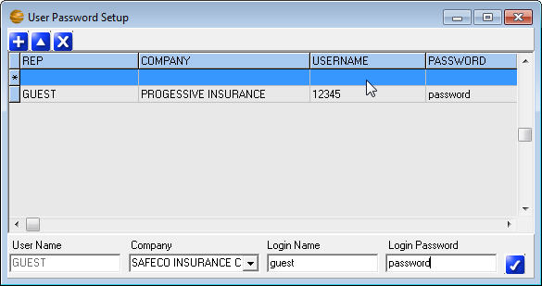
Demographics Categories
Figure 49 - Setting up employee passwords for WebView function
To set up the Demographic heading to display on the Personal tab, click the Demographics button and type in your desired headings in the Agency Defined Demographics window.

Skins Settings
The Skins button allows you to choose a theme. The listed themes change the colors of the program background.

Reset Grids
Many of the program windows, such as the grid on the Client tab, are customizable (you can move and resize the columns). The Reset Grids button resets all program grids to the original settings. You must exit and log back in for the reset to complete.

SECTION 4

TROUBLESHOOTING

EZAgent Slow to Open
Try disabling the anti-virus program on the local machine. If the program opens more quickly, the anti-virus is the problem. You need to set exclusions in your anti-virus program so that the anti-virus can run without interfering with your EZAgent database files. Go to the web site www.agencysoftware.com. On the Support page, click the link that reads “Program Running Slow or Locking Up” for more information on exclusions and details on other things to look for.

EZAgent will not open, no error
Often this means that there are multiple processes in the task manager. Open the Windows Task Manager (CTRL+ALT+DEL), click the Processes tab, and end any instance of EZAGENT you find. Try the program again, being sure to give it plenty of time (this happens due to system/network slowness).

User Can’t Delete Clients
User doesn’t have supervisory access. User needs supervisory access to delete clients in EZAgent.

User gets Key Violation when Logging In
Log in as a different user with supervisory access, and edit the Employees database (on the Agency Setup tab) to remove/edit duplicate employee names.

Client tab is blank for one user
Log in as a different user with supervisory access, and edit the Employees database (on the Setup tab). Browse to that employee and remove the check mark in Producer (Restricted) Access.

Cannot Perform Operation on Open Dataset
This error occurs in the ACORD window. It is preceded by an error showing characters and stating that those characters are not a valid integer. Trying to add an ACORD form after that message will generate this error. This means that some data in the ACORD forms has corrupted. Call Technical Support immediately and prepare to transfer the data to Agency Software for examination and correction of the corruption.

Index Out of Date
This error usually occurs when someone has used Ctrl-Alt-Delete to get out of the software or has shut down their computer while EZAGENT was running
- Close EZAgent on all machines
- Click Start, Programs, EZAgent for Windows, Keyfix.
- Allow Keyfix to run until you see the message "Rebuild Complete".

Forms will not open, giving error
If no forms are opening on a single workstation, the memory setting might need to be adjusted. Close EZAgent, browse to the EZAGENT folder, and open Techtools (Techtoolsv8 for Windows 8/10 users). Click the BDE Adjust tab, note the current setting on the left side, then click the 2000 button (if it was currently 2000 try a different setting). Close Techtools, return to EZAgent, and try opening a form again.

Unrecognized Tag in Mail Merge
This is an error message that is generated in the Letters window, when performing a mail merge, in which the fields specified to merge do not exist. If these fields were selected by using the “SELECT MERGE FIELD” buttons, corruption has occurred in your LETTERS window. Call EZAgent technical support.

Printer Doesn’t Print from EZAgent
This problem is most likely to occur when an agency is trying to print to a multifunction printer from EZAgent. There are some multifunction printers EZAgent will not print to. These include some Xerox WorkCenter XE series printers. There is no fix for this. The agency must print to a different printer.

Text Won’t Fit into Lines on Forms
This problem is usually caused by having Large fonts set on the particular computer that has the problem. The ACORD forms are not designed to run in a Large-fonts environment.
To change the font settings back to Normal:
- Right-click in an empty space on your computer desktop.
- On the shortcut menu, click Properties.
- In the Display Properties dialog box, click the Settings tab.
- On the Settings tab, click the Advanced button.
- On the General tab, you’ll see a box labeled Font Size or DPI Settings (depending on your version of Windows). The box probably has “Large” or “125%” or some similar setting (again, depending on your version of Windows).
- Click the arrow in the box to open a list of choices.
- Choose Normal, or choose Other and set 100%.
- Click OK to close every open dialog box. You may need to restart your computer (depending on your version of Windows).

Backups taking a long time
By default, the backup will take a copy of your Pics folder (containing all images). As this folder’s content grow, so does the time it takes to backup, and the size of the resulting backup. You can choose to not get a copy of the pics, or to schedule a task to have the backup run after hours. See the previous section on Backing Up for more information.

External Exception/Unknown Internal Operating System Errors
These messages indicate a network interrupt. The reason for these interrupts can vary network to network. Anything from aggressive antivirus, to a bad network card can cause these errors. See more about the potential issues by referring to the “Program Running Slow or Locking Up” document in the Support section at our website.

Report print is too small
Some reports have several fields (columns) of data, and all the fields will have to fit in one row across a single page. The more fields of data are displayed, the smaller the font will be (to fit it all into one row).
To make small print a little larger:
Rerun the report and select Landscape - When the report is printed in Landscape orientation, there is more page area for the long rows and the print is more readable.
Eliminate unnecessary fields - If the report print is still un-readably small, you can only increase the font size by eliminating some of the fields (columns) in the report.
Select multiple lines per record - You can opt to ‘break’ each row of data into multiple lines (although it is a little harder to read this way). The dialogue box to do this appears only when the report has reached a small font.
Save the report as a Mail Merge file - Open the saved csv file in Excel and then you can manipulate the page and font size to your desired format.

Index

A
Acord form menus
Edit 65
File 64
Options 66
Tools 65
View 65
Acord form options 55
Acord form toolbar 62
Acord form window 62
Acord forms
Add New Form 55
Delete Client’s Form 57
Duplicate Client’s Form 58
Edit Client’s Form 57
Entering data in forms 67
Mark Forms for Mass Print 59
Move Forms to Diskette 60
Print Mass Marked Forms 59
State-specific forms 57
Acords Window 55
Additional Interest 83
Agency Setup 121
Automatic backup schedule 122
Companies Information Database 123
Edit employees 125
Employee information 124
Users 124
Agency Software Printer 111
Apro Document Manager 102
Apro Setup Window 121
B
Backups 25, 122, 131
C
Calendar 118
Certificate Holders 67, 68
Add from Master List 72
Add new 68
Blanks 69
Button 67
Delete 74
Duplicates 69
Edit 72
Menu 68
Print certificates 74
Print list 76
Same holder, multiple jobs 70
Claims 90
Claims Window 90
Clients
Add a Client 35
Delete a Client 36
Edit a Client 38
Edit Client Information 36
Filter client list 38
Restore client list after filter 37
Clients Toolbar 36
Clients Window 34
Coverages 49
Class 49
Coverage 49
Deductible 50
Limit 49
Notes 50
Custom Report 93
Customer Demographics 89
D
Default Limits 50
Demographics 89
Document Manager 102
Adding files 104
Desktop icon 106, 111
Linking/attaching 103
PaperPort 109
Using linked/attached files 112
Drivers 80, 83
Drivers Database 80, 83
E
Email vii, 59, 64, 75, 83, 84, 85, 112, 113
Set up 84
E-mail doesn’t work 85
Emailing Forms 83
Equipment 79
Equipment Database 79
External Exception 131
F
Forms
Emailings 83
H
Help Files 28
I
Images 102
Images Window 102
L
Letters 97
Attach to client 100
Custom letters with merge fields 99
Merge client data 98
rtf file type 98
Letters Window 97
Logging in 24
M
Mailing labels 96
Mailing Labels 96
Mapping Letter Drives 18
N
Notes 86
Notes Window 86
P
Personal 88
Personal Window 88
Policies 41
1st Rep Name 47
1st Rep % of House 47
1st Rep Commission 48
2nd Rep % of House 47
2nd Rep Commission 48
2nd Rep Name 47
Add New Policy 44
Agency % of Premium 47, 48
Agency Income 48
Billing Method 47
Company 46
Coverages 49
Display Options 42
Down Payment 48
Effective Date 46
Expiration Date 46
First Payment Due 48
For Options 43
Installment Type 48
Net Premium 48
Non-Premium Items 47
Number of Payments 48
Policy Options 41
Policy Status 46
Premium Amount 47
Total Due 47
Policies Window 41
Property 80
Property List, Print 83
R
Reports 91, 97, 126
Custom 93
Delete 97
Edit 96
Mailing labels 96
Print too small 92, 131
Reports Window 91
rtf file type 98
S
Setup 15
Surveys 115
T
TFile 116
Display 117
Find Word or Phrase 116
Print history 116
TFile Window 116
Tickler
Alarm 120
Create new 119
Edit 120
Tickler Window 118
Troubleshooting
Agency Pro Slow to Open 128
Cannot Perform Operation on Open Dataset 129
Printer Doesn’t Print from Agency Pro 130
Text Won't Fit into Lines on Forms 130
Unrecognized Tag in Mail Merge 130
User Can’t Delete Clients 128, 129
User gets Key Violation when Logging In 128
TROUBLESHOOTING 128
U
Unknown Internal Operating System Errors 131
Updating 26
V
Vehicle 76
Vehicle List, Print 79
W
Web View
Login 53
Web View Toolbar 54
Window
Acords 55
Agency Setup 121
Claims 90
Clients 34
Images 102
Letters 97
Notes 86
Personal 88
Policies 41
Reports 91
TFile 116
Tickler 118

Files compatible with this feature of EZAgent must be saved as *.rtf file types. Files saved as *.doc files will not be recognized. Files saved with table formatting in a word processing program will be altered when saved as *.rtf files.

