EasyApps Professional
Product Manual



215 W. Commerce Dr.
Hayden, Idaho 83835
Sales & Technical Support 800.342.7327

License and Sales Agreement
This document is an agreement between you, the end user, and Agency Software, Inc. by initial installation and/or use of any of the programs which are part of Agency Software, Inc. (EasyApps, Easy Apps Professional, Par32, EasyApps Pro, and AgencyPro, herein after called the program). You are agreeing to become bound by the terms of all parts of this agreement. This agreement constitutes the complete agreement between you and Agency Software, Inc., and it may not be changed or terminated orally but only by an instrument in writing signed by the party against whom enforcement of any waiver, change, modification, extension, discharge or termination is sought.

GRANT OF LICENSE
In consideration of payment of the License Fee, which is a part of the price you paid for this product, Agency Software, Inc., as Licenser, grants to you, the Licensee, nonexclusive right to use and display this copy of the program at a single location.

OWNERSHIP OF THE PROGRAM
As licensee, you own the magnetic or other physical media on which the program is originally or subsequently recorded or fixed, but Agency Software, Inc. retains title and ownership of the program recorded on the original disk copy(ies) and all subsequent copies of the program, regardless of the form or media in which the original and other copies may exist. This license is not a sale of the original program or any copy.

USE RESTRICTIONS
As the Licensee, you may physically transfer the program from one computer to another provided that the program is used only by up to FIVE LICENSED USERS. A licensed user is defined as a single person to whom the software is licensed. This means that you may use the software on any computers associated with the single licensed user including office, home, notebook, and network computers. Branch offices, satellite offices, or multiple businesses sharing the same location are not covered under this agreement. Additional licenses for additional users may be purchased at an additional fee. Use of EasyApps Professional (EasyApps Pro) on a wide area network (WAN) or Thin Client environment is a violation of this agreement.

TRANSFER RESTRICTIONS
The program is licensed only to you, and may not be transferred to anyone without the prior written consent of Agency Software, Inc. Any authorized transferee of the program shall be bound by the terms and conditions of this agreement. In no event may you transfer, assign, rent, lease, sell or otherwise dispose of the program on either a temporary or permanent basis.
Agency Software, Inc.’s entire liability and your exclusive remedy as to the disk(s) shall be at Agency Software Inc.’s option, either (a) return of the purchase price, or (b) replacement of the disk(s) that do not meet the above-stated limited warranty and which is returned to Agency Software, Inc. with a copy of the receipt. If a failure of the disk had resulted from accident, abuse, or misapplication, Agency Software, Inc. shall have no responsibility to replace the disk(s) or refund the purchase price. Any replacement disk(s) will be warranted for the remainder of the original warranty period or thirty (30) days, whichever is longer.
IN NO EVENT WILL AGENCY SOFTWARE, INC. BE LIABLE FOR ANY DAMAGES INCLUDING LOST PROFITS, LOST SAVINGS, OR OTHER INCIDENTAL OR CONSEQUENTIAL DAMAGES RESULTING FROM THE USE OR INABILITY TO USE THE PROGRAM, EVEN IF AGENCY SOFTWARE INC. HAS BEEN ADVISED OF THE POSSIBILITY OF SUCH DAMAGES, OR FOR ANY CLAIM BY ANY OTHER PARTY.

Credits and Copyright
EasyApps® Professional
Program written by K. Mitchell McInelly
User’s Manual & Windows Help Files written by Julia Kelly
Much thanks to Ray Conger and Marla Obray for their advice and wisdom throughout this project
Copyright 1999-2015 by Agency Software, Inc.
All Rights Reserved
No part of this manual may be reproduced, transmitted, transcribed, stored in a retrieval-based system, or translated into any language, natural or automated, in any form or by any means, without the prior written consent and permission of an officer of Agency Software, Inc.
The software described in this manual is protected by the outlined copyright laws.
This manual could include technical inaccuracies or typographical errors. Changes are periodically made to the information herein. These changes may be incorporated in new additions of the manual which can be found at www.agencysoftware.com.
EasyApps Professional is a trademark of Agency Software, Inc.
ACORD is a registered Trademark of ACORD Corp.
Windows is a registered trademark of Microsoft Corp.

History of Agency Software, Inc.
Agency Software, Inc. (ASI), established in 1988, has been the forerunner of property & casualty insurance software since its inception date. Founded by James M. Carpenter and current President and CEO K. Mitch McInelly, ASI has an existing insurance user group that exceeds 20,000 agencies. With 70,000 insurance agents in the United States, ASI is proud to claim an installation base rate of nearly 26% of all agencies, and over 30% of all automated (PC based) agencies in the U.S.A. ASI has helped these agencies' users actuate their PC's for the purpose of increasing overall penetration of personal and commercial lines markets.
ASI has proven to be an invaluable asset to their agency users through the creation and support of an impressive library of insurance software products. These products include such industry standards as, PAR3, EasyApps, EasyApps Professional, EasyApps Pro, EZ Download Manager, EZ Download Plus, and AgencyPro.
1999 saw a landmark in insurance software in the form of Agency Software’s latest program, a full-fledged insurance agency management system appropriately titled AgencyPro. With careful attention to ergonomics and ease of use, AgencyPro provides maximum functionality.
With company focus, development, and marketing strategies aimed and addressed toward Property and Casualty insurance companies and their ever-changing needs, Agency Software, Inc. is committed to developing customized software systems for those carriers who share the common goal of increasing overall written premiums while decreasing errors and omissions exposure.

About Our Products
Our products create a central database for all your client information, and in some cases, direct access to insurance company web sites.
For years, agents have been populating their companies' databases with their own client information; now it's time to get that information back! Keep your client information in your own database as well as in the company database, and (with EasyApps Pro and AgencyPro) pull existing client information from the company database down into your database.
It is easy to transfer your customer information from Outlook into the Clients window; just drag the customer name from the Outlook window and drop it onto the program icon on your desktop.
Track your clients' policies, claims, personal data (family names, birthdays, etc.), and any notes you wish to permanently record about client interactions.
Run preloaded reports (not available in EasyApps), such as Commission by Rep and Customer by Expiration Date, or create your own custom reports for any specific data you want. Print mailing labels for any or all of the clients in your database.
You can also write letters to specific clients or create form letters for several clients, and attach those letters to specific clients so you can find them easily in the future. There are many pre-built marketing letters that you can either use as is or edit, and they are ready to merge with client data such as names, addresses, and personal and policy information.
The Tickler system allows you to set reminders, and an automatic transactional file that records every transaction anyone made.
In short, our products makes your work as an agent much more efficient and puts you in control of your clients' insurance needs!

Support Maintenance and Updates
To maintain support and product updates you must:
Have internet access – All updates are available by internet only.
Renew support fees – To continue support and updates you must pay an annual maintenance fee, for which you will be billed in advance. In addition, if you experience hardware technical problems, you must have an experienced technical person available to deal with our technical support team.

Contacting Support
If you suspect the problem is with your computer hardware, printer, or software unrelated to Agency Software programs, seek help from a local tech person.
If you feel the problem is related to your Agency Software program you can access technical resources or contact our technical support team through:
Website: www.agencysoftware.com
Email: support@agencysoftware.com
Telephone: 800.342.7327 ext. 30
Our support team will respond as quickly as possible considering the current call load, usually the same day, usually within the hour (during business hours of 7am to 4pm Pacific Time (pst), Monday through Thursday, and 7am to 3pm Friday. If you are hiring outside tech support, make sure to make an appointment with one of our tech team members in advance to minimize your costs for outside support. If your tech is on site, be sure to say so if you reach our voice mail during business hours.

Using this Manual
This manual has been designed to take you from initial installation to proficiency. When changes are made to this manual, the newest version will be available on our website at agencysoftware.com.

Table of contents
License and Sales Agreement ii
GRANT OF LICENSE ii
OWNERSHIP OF THE PROGRAM ii
USE RESTRICTIONS iii
TRANSFER RESTRICTIONS iii
Credits and Copyright iv
History of Agency Software, Inc. v
About Our Products vi
Support Maintenance and Updates vii
Contacting Support vii
Using this Manual viii
Table of contents 9
SECTION 1 - Technical Requirements
Server 14
Workstation 15
More Technical Information 15
User Rights 15
Network Attached Storage (NAS) Devices 16
Wide Area Networks 16
Backing Up 16
Qualified Technical Support 16
Data Storage Information 16
Updating the Program 17
Obtaining the update password 17
Accessing the update 17
PROGRAM INSTALLATION 18
Standalone Installation 18
Network Installation 20
Setting up the Network 21
Mapping Letter Drives 21
Initial Installation 23
Workstation Setup 24
Moving the Program 26
SECTION 2 28
Navigation 28
Help Files 28
List Boxes 28
Tabs 29
Toolbars 29
Scroll Bars 29
Moving Around in EasyApps Pro 29
SECTION 3 - PROGRAM FEATURES
The Clients Tab 33
Adding a Client 34
Editing Client Information 34
Deleting a Client 35
The Clients Toolbar 35
Emailing a Client 37
The Policies Tab 39
Policy Options 40
Display Options 41
For options 41
Using the Policies Window 42
Policy Notes 42
Attached Images 42
Add a New Policy 42
Coverages 47
The Limits Window 47
Setting Default Limits 48
The ACORDs Tab 49
ACORD Options 50
Duplicate Client’s Form 51
Mark Forms for Mass Print 52
Print Mass Marked Forms 53
Move Forms to Disk 53
The ACORD Formview Window 55
The Formview Toolbar 55
The ACORD Formview Dropdown Menus 57
Entering Client Information in ACORD Forms 61
Certificate Holders 61
Certificate Holders Menu 62
Adding Certificate Holders 62
Description of Operations 66
Editing Certificate Holders 66
Adding Certificate Holders from the Master List 66
Deleting Certificate Holders 68
Printing Certificates for Selected Cert Holders 68
Generate Cert Holder List 69
Close the Certificate Holders Menu 69
Vehicle Database 70
Enter Vehicles in the Vehicle Database 70
Fill a Form with Vehicle Information 71
Attach Vehicles to Specific Policies 71
Print a Vehicle List Report for a Client 72
Equipment Database 72
Add Equipment to the Equipment Database 73
Drivers Database 73
Add Drivers to the Drivers Database 73
Property Database 73
Enter Property in the Property Database 74
Fill a Form with Property Information 76
Print a Property List Report for a Client 77
Additional Interest Database 77
Emailing Forms 77
Setting Up Email 78
Sending an Email 79
The Notes Tab 80
The Personal Tab 83
The Reports Tab 84
Create a Custom Report 86
Create Mailing Labels 90
Edit a Report 90
Permanently Delete a Report 90
The Letters Tab 90
What’s In the Letters Window 90
Merge Client Data into a Letter 91
Creating Custom Merge Documents 93
Attaching Letters to Clients 94
The Surveys Tab 95
The Calendar Tab 96
The Setup Tab 99
Agency Information 99
Encrypt Client SSN’s 100
Automatic Data Backups Configuration 100
Companies Information Database 100
Employees Information Database 101
Appearance Settings 101
SECTION 4 - DATABASE UTILITIES
Backup 102
Restore 102
Keyfix 103
Agency Setup 103
SearchReplace 104
Merge 105
Password 106
SECTION 5 - TROUBLESHOOTING
EasyApps Pro Slow to Open 107
EasyApps Pro will not open, no error 107
Cannot Perform Operation on Open Dataset 107
Index Out of Date 108
Forms will not open, giving error 108
Printer Doesn’t Print from EasyApps Pro 108
Text Won’t Fit into Lines on Forms 108
External Exception/Unknown Internal Operating System Errors 109
Index 110

SECTION 1
INSTALLATION
This section will cover the product requirements and direct you through installing EasyApps Professional (EasyApps Pro) to either your local machine (as a standalone) or to a shared location to be accessed by the entire office.

Technical Requirements
The following technical requirements are what you must have to install and run EasyApps Pro. These system requirements and recommendations are subject to change as technology evolves.

Server
- 2.5+ Ghz Quad Core processor
- 8+ GB RAM
- 10 GB HD space free*
- 100 MBPS wired network** (Gigabit highly recommended)
- Windows Professional versions: Vista/Windows 7, Windows 8/10, Server 2008*** and Server 2012 (not Essentials versions)
- Internet connection (high-speed recommended)
- Video settings 256 colors or greater
- Internet Explorer 8.0 or better installed
- CD-ROM (at server/standalone)
*Initial HD space for program and database storage, this does not include document storage (which is likely to use up significantly more space as the agency goes paperless).
**Databases are prone to corruption over wireless networks.
***Not recommended for Terminal Services.

Workstation
- Pentium (2+ Ghz)
- 6+ GB RAM
- 100 MB HD space free*
- 100 MBPS wired network (Gigabit recommended)**
- Windows Professional versions (Vista/Windows 7, Windows 8/10)***
- Internet connection for technical support
- Internet Explorer 8.0 or better installed
- Installed default printer driver
*Initial HD space for program and database storage, this does not include document storage (which is likely to use up significantly more space as the agency goes paperless).
**If workstation accesses the program through the network.
***Windows 10 not tested.

More Technical Information
For best results please review the following information carefully prior to installation.

User Rights
For best results the user should be granted Administrative rights over the local machine and the network share (if applicable). If the workstation is running Vista or Windows 7 operating systems, the User Accounts Controls can be disabled (followed by restarting the workstation) prior to installation for easiest configuration. Please contact technical support for more information or other options.

Network Attached Storage (NAS) Devices
Network attached storage devices are not recommended. With no controller card, these devices are not a solution for multiple user configurations and may cause significant slowdowns of data retrieval.

Wide Area Networks
EasyApps Pro is not adaptable to wide area solutions, such as Terminal Services or cloud services (please read the copyright notice for more information).

Backing Up
Our programs have an option for Automatic Data Backups. These backups are written to the same location as your program data (in the Backup folder) and are not a valid backup solution for your program data. You MUST have an offsite backup method available as your primary backup source. We suggest backing up the entire program folder to an external location regularly, but making sure this is done while no one is in the program.

Qualified Technical Support
Your equipment needs to be properly configured and maintained by a qualified local technician.

Data Storage Information
The initial installation creates an EAPPW folder where all shared program data will be stored. This program folder will be typically located at the c:\ of a standalone or the root of a mapped network drive. All of our databases and executables are located inside of the EAPPW folder.

Updating the Program
We suggest doing monthly updates so you have available the most current Acord forms and product features. Our updates are available online only and must be done with no one in the program or forms.

Obtaining the update password
The update will ask for a password. The Get Current Password option in the Start Menu program group will check your support status at our servers (your support must be current to access the updates) and give you the current update password.
- From the Windows Start menu select Programs, then the EasyApps Pro program folder
- Select Get Current Password.
Alternatively, you can call to obtain the password. Call 800.342.7327 from your main line and select option 2.

Accessing the update
Make sure the program and all forms are closed on all workstations before starting the update.
- Go to www.agencysoftware.com
- Click the Updates heading
- Choose EasyApps Pro Updates from the Select Update drop down list
- Click the link reading:
“CLICK HERE TO START THE UPDATE INSTALLATION”
- Run the downloaded file and click Next on the Welcome screen
- In the Choose Destination Location check the location for accuracy and click Next
- Click Next on the Start Installation screen
- After the backup enter the password obtained
During the update process the program will:
- Download the most current features
- Run utilities
- End by opening up your start menu folder.

PROGRAM INSTALLATION
Installation procedures must be followed precisely. A faulty installation will produce negative results and possible loss of data. Qualified technical personnel should install the software.
NOTE: Due to an unlimited number of possible computer configurations, Agency Software, Inc. cannot be held responsible for loss of data under any circumstances. Data can be lost or become corrupted by means beyond our control.
The installation will attempt to connect to our server to verify your current support status, therefore, you may have to disable your firewall to allow this connection.

Standalone Installation
Use these directions to install a new copy of EasyApps Pro to a single computer. Use the Moving Program instructions when moving an existing installation from one standalone to another.
NOTE: Multiple datasets can only be combined (accounting cannot be combined) by Agency Software for a fee. If you intend to share the program over a network in the future, you may consider this when loading the program to multiple standalones.
- Place the EasyApps Pro CD (from the front cover of this manual) into the CD-ROM drive. The installation screen will appear
- Click EasyApps Pro
- In the Welcome screen, click Next
- In the Choose Destination Location screen, examine where the program will be installed (this defaults to C: drive). Change the drive if necessary, but do not change the folder name.
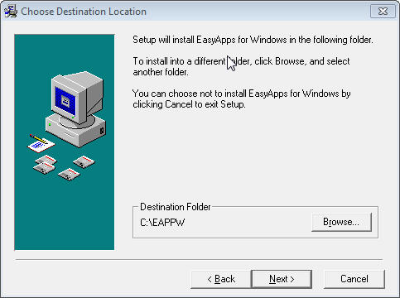
Figure 1 - Choose Destination Location
- In the Start Installation screen click Next.
- You will be asked to validate your agency information. Click OK and enter your agency’s 10 digit telephone number, click OK. (If you are unable to connect turn off your firewall and try again.) Your agency information will appear, if any of this information is incorrect please contact customer support for correction.
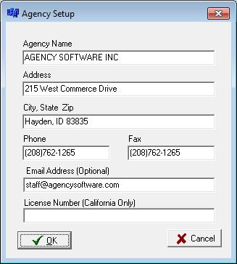
- The installation will begin and, when complete, the Start Menu program group will be displayed and the program shortcut(s) will appear on your desktop. You can now Exit the initial installation window and remove the CD.
Figure 2 - Agency Information
- Run an update following the Updating the Program instructions in the More Technical Information section.
- After the update run Techtools (TechtoolsV8 for Windows 8/10 computers) for supplemental install adjustments. The common adjustments depend on which version of Windows you are running.

If you are running Windows:
Vista & Windows 7 - click the tab to:
- Run as Admin – click the blue button to fix Vista and Windows 7
Windows 8/10 – Click the blue button on the first tab which will give further instruction if additional action is necessary.

Network Installation
Use these directions for the initial installation of EasyApps Pro to a network (or peer to peer) server. (Use the Moving Program instructions when moving an existing installation from one server to another.) The preferred setup is to a dedicated server (server is not used as a workstation), however, the program can be installed to a peer to peer server (a system someone also uses as a workstation).
NOTE: For best results in Vista and Windows 7, first disable User Account Controls and reboot prior to the installation.

Setting up the Network
Your network should be set up by a qualified network technician. Our program is loaded to a shared folder on a physical drive (see information on NAS devices in the Technical Requirements section) of the server computer (we would typically call the share ASI). Full control should be granted over the shared folder and all subdirectories to all users (Everyone).

Mapping Letter Drives
Drive letters should be mapped identically on the server and all workstations. These common network drives are mapped to the shared folder, not the EAPPW folder.
First, get the Full Computer Name of the server machine.
To find the Full Computer Name right-click the Computer (or My Computer) icon on the server machine and click Properties. Find the Computer Name (not the Computer Description) without the period that follows it. On Windows 7 it will be listed under Computer Name.
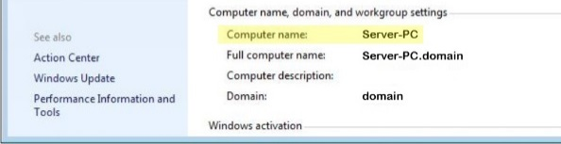
Figure 3 - Find Computer Name
Next you will map a network drive:
- Click with the right mouse button on the Computer (or My Computer) icon.
- Select Map Network Drive.
- Open the list in the Drive box and select the network drive letter you want to use (for example, Q:).
- In the Folder box, type the path to the drive where you will install the program (e.g., if you are going to install the database to the C:\ drive on the computer named Server-PC, you would enter \\Server-PC\C).
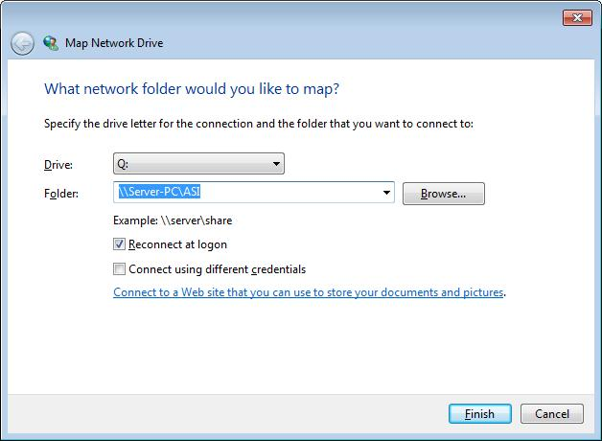
Figure 4 - mapping network drive that you just mapped.
Note: It is recommended to install to a shared folder (e.g., a folder named ASI) instead of the C: drive, in that case you would type \\Server-PC\ASI in the Folder box.
**Do not map to the product’s program folder**
- Click Finish. A window to the new mapped drive opens, and it reads Q:\ in the window’s title bar.
You are now ready to install the software to the drive

Initial Installation
- Place the program CD (from the front cover of this manual) into the CD-ROM drive. The installation screen will appear with options for your product.
- Click the name of the product you are installing.
- In the Welcome screen, click Next.
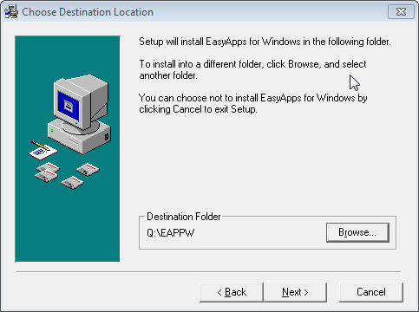
Figure 5 - Choose destination location
- In the Choose Destination Location screen, examine where the program will be installed (this defaults to C: drive). Change the drive if necessary, but do not change the folder name.
- In the Start Installation screen click Next.
- You will be asked to validate your agency information. Click OK and enter your agency’s 10 digit telephone number, click OK. (If you are unable to connect turn off your firewall and try again.) Your agency information will appear, if any of this information is incorrect please contact customer support for correction.
- The installation will begin and when complete the Start Menu program group will be displayed and the program shortcut(s) will appear on your desktop. You can now Exit the initial installation window and remove the CD.
- Run an update following the Updating the Program instructions in the More Technical Information section.
Figure 6 - Agency Information
If this is a peer to peer server you will also run as a workstation, follow the Workstation Setup instructions below.

Workstation Setup
The network drives should already be (identically) mapped as part of the Setting up the Network process in the Network Installation section of this manual.
Follow this procedure at each one of the workstations:
- Double-click the Computer icon to open the Computer window.
- In the Computer Window, double-click the mapped drive where you installed the program (in this example the Q: drive)
- Double-click to open the EAPPW folder
- Double-click the file named setupws.exe (that is setupws.exe not setupw.exe) Windows 8/10 workstations skip this step and continue to step 7
- Click Next in all the dialog boxes
- When the workstation setup is complete, a window of program icons appears on your desktop (your Start Menu program group). You can close this window at any time
- Run Techtools (TechtoolsV8 for Windows 8/10 computers) for supplemental installation adjustments. The common adjustments depend on which version of Windows you are running. If you are running Windows:
Vista & Windows 7 - click the tab to:
- Run as Admin – click the blue button to fix Vista and Windows 7
- Disable IE Security Warning - click the blue button
Windows 8/10 – Click the blue button on the first tab which will give further instruction if additional action is necessary.
You are now ready to run the program from the workstation by double-clicking on the icon on your desktop.
When you open EasyApps Pro on a workstation you are opening the database that you installed on the server. If the workstations were set up correctly, multiple users can open the database at multiple workstations at the same time, and all will see the same data.
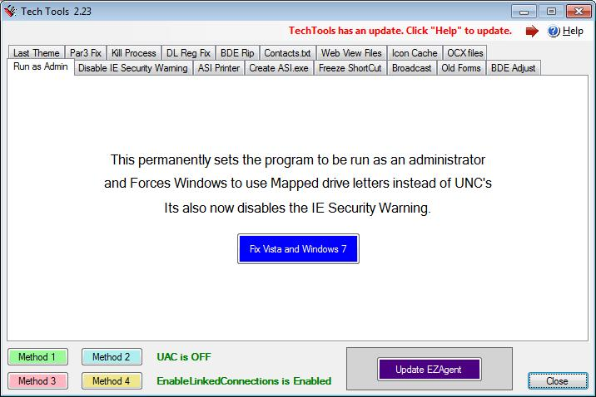
Figure 7 - Techtools

Moving the Program
The EasyApps Pro files are contained in the EAPPW folder. To transition to a new server (or standalone workstation) you must first copy the entire EAPPW folder from the old location to the new location.
If this is a network installation be sure to follow instructions in the Setting up the Network section to set up the new shared folder and map the network drives. The program folder then can be copied to the new shared folder on the new server.
Existing Workstation:
- Remap the common drive (let’s call it Q:) at the workstation to the new server’s shared folder (should be the same drive letter as the previous setup)
- Run Techtools.exe (or Techtoolsv8.exe if you run Windows 8/10) from the program folder and disable the IE warning if you get the “Publisher could not be verified” message opening the program.
If this is a new workstation follow the previous Workstation Setup instructions.

SECTION 2
HINTS & TIPS
Check out these techniques to quickly master navigation of EasyApps Pro, and for the most efficient ways to do things. We also recommend reviewing the online tutorials available at www.agencysoftware.com/Tutorials.

Navigation
EasyApps Pro uses common Windows navigation techniques and keystrokes, which allow you to move around within EasyApps Pro with great ease. Understanding and using these features will make your job much easier, speed up your work, and make using this program a pleasure.

Help Files
Help Files for many subjects are available. When you’re working in EasyApps Pro, no matter what tab (window) you have open, you can always press F1 to get help on that subject. The Help Files contain Hints & Tips, a comprehensive Index, and Help files for all main topics, although a few are limited in their scope. Improved Help Files will be made available with most updates. In the Help File click on the green underlined text to go straight to that main or sub-topic.

List Boxes
You’ll find many list boxes with dropdown arrows that allow you to open a list and select an entry. Some of these lists are codes in the system while others are comprised of entries that have been keyed into the field.

Tabs
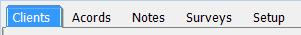
Click on a tab to open that window. If you can’t see all the tabs, either make the EasyApps Pro window wider, or click the arrow buttons at the right end of the tabs to scroll and display the hidden tabs at each end. You may not have all the tabs available if your User Account has limited access.

Toolbars
Most windows, and all ACORD forms, have Toolbars for your convenience. Learn what each button does and use them to save time.
When you point your mouse at a specific button, a screen tip with the button’s name appears – this will help you figure out which button does what.

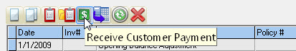
Scroll Bars
Scroll Bars appear at the right side and/or bottom of lists that exceed the current view. Scrolling up, down, right, or left will bring more information into view.

Moving Around in EasyApps Pro
EasyApps Pro will open to the Clients tab by default. The entire client list will be in view and the left side of the screen will display the information for the current client selected. You can select a new client by:

Typing in the first few letters
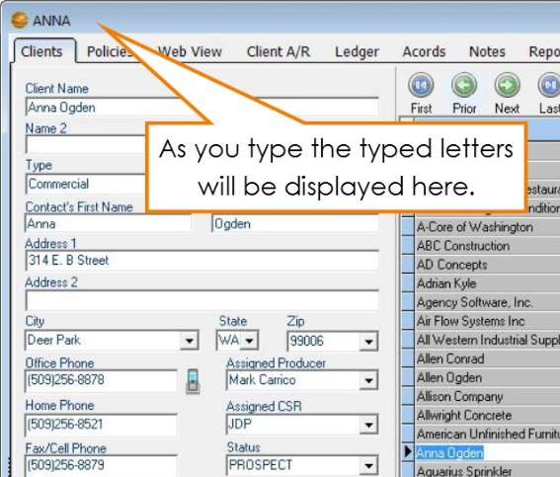
In many lists within EasyApps Pro, you can start typing the item you wish to look up. For instance, if you are on the Clients tab and you want to look up Anna Ogden you can type in A-N… and you will be taken to that area of the list while the typed letters will appear in the top left corner of the EasyApps Pro window. If all you have is an address, first put the list in Address order (see Sort by heading section on the next page) and then type in the first few numbers of the address. This is the easiest way to select a single client.
Figure 8 - Typing in your desired selection

Using the navigation icons
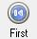
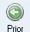
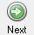
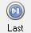
Throughout EasyApps Pro are variations of these icons that move you through the database either record by record, or jump from the current selection to the first or last records in the database.

Program search and filter utilities

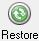
You can locate a certain value by using the search or filter utilities. The client filter, for instance, will clear the client detail window (the left side of the Clients tab that normally displays the current client information) and allow you to enter your filter criteria. Once your desired criteria has been entered, simply click the Filter icon again and the filter will apply to the client list, showing only the returned values. Click the Restore icon to release the filter and view all clients. The filter is a great way to display a group of clients. For instance, if you would like to view all clients in a certain city, click the Search icon, choose the city from the City drop-down, and click Search again. The client list will now show only clients in that city and the filter will display on the header bar.
This filter will carry into many client selection screens in the other marketing areas (and reports), allowing you to first place the desired filter, then run letters and reports based first on that filter. Be sure to remove this filter before attempting to run letters or reports on the entire database.
Figure 9 - Header bar displaying current filter

Sort by heading
In most tables and lists, if you click on a column heading (such as Address in the Clients tab), the list or table will be sorted by the entries in that column.
Also, when you click a column heading to sort, the sorted column will be shaded so that you can tell at a glance which column the table is sorted by.

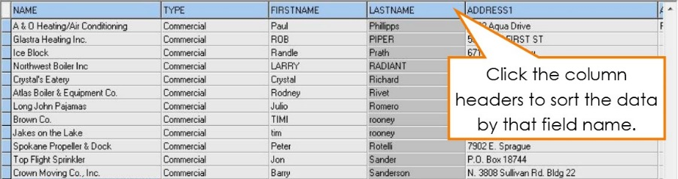
Using the keyboard
Figure 10 - Clients tab ordered by Last Name field
In most tables and lists, you can navigate through the data by using the arrows and navigation keys (Home, End, Page Up, and Page Down) keys on the keyboard.

SECTION 3

PROGRAM FEATURES

The Clients Tab
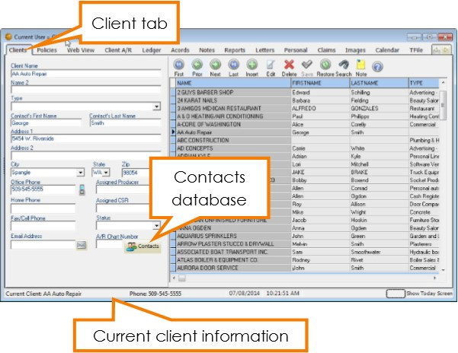
The Clients window is where you enter client information, such as client name, address, and phone numbers. EasyApps Pro always opens with the Clients window displayed. The client names are listed on the right side of the window, in the list, and the data for the selected client is displayed on the left side of the window. To open the Clients window from any other window in EasyApps Pro, click on the Clients tab at the top of the program window.
Figure 11 - Client tab
The status bar at the bottom of the EasyApps Pro program window always indicates the selected client name, their phone number, and the current date and time.
In the name list, columns other than the name column can be displayed by scrolling to the right in the horizontal scroll bar below the list.
You can reorder these columns by clicking on the column header and dragging to the left or right while holding down the mouse button. You may also sort by any of the columns by clicking the column header for that column.

Adding a Client
To add a client, click the + button above the client list. The client information fields on the left side of the window are emptied so that a new client’s information can be typed into the appropriate fields. You can use your Tab key to move between fields while entering client information or you can click in the field where you want to enter data.
Click on the Contacts button. Whichever contact you mark as Primary will automatically fill in the First Name, Last Name and phone number fields in the main client information screen.
You may list multiple contacts for this client by clicking the plus sign on the top toolbar to add an additional contact name or the plus on the bottom toolbar to add additional email addresses.
After all of the client’s information has been entered, click on the save button to save the information.

Editing Client Information
To edit client data, select the client’s name in the list on the right (click the client name to select it), and then click on the edit button to open that client’s record for editing. The selected client’s information appears on the left side of the window. Edit the data, and save your changes by clicking on the save button.

Deleting a Client
To delete a client, click the client’s name in the list on the right then click the delete button. Click Yes in the Delete This Client? message. That client’s data and forms are permanently removed from the database.

The Clients Toolbar
When you position the mouse over a specific button on the toolbar, the name of that button will appear in a “hint” screen.
The buttons, left to right, are:
 | First Record Selects the client name at the top of the list.
 | Prior Record Selects the next client above the selected client.
 | Next Record Selects the next client below the selected client.
 | Last Record Selects the client at the bottom of the client list.
 | Insert Record Creates a new client record, ready for data entry. Click the Post Edit button to finish and save the new client record.
 | Edit Record Select the client that you want to edit in the list, then click this button to edit the fields on the left. When done, click the Post Edit button to save the changes.
 | Delete Client Select the client you want to delete from the list on the right, and then click this button to delete the client. All entries in all modules for that client will be deleted from your system. A confirmation box will appear before the client can actually be deleted.
 | Post Edit Permanently posts the change to the database while adding or editing a client’s record.
 | Restore Client List Restore the full client list after filtering.
 | Filter Client Database Click on the magnifying glass button to clear all fields on the left. Type in your search criteria in any fields, and then click the Filter Client Database button again. The client list will be filtered to show only those clients who match your search criteria and most reports will show results only for this filtered list of clients.
 | Add a Sticky Note to Client Click on the yellow sticky note to add a note that will appear whenever this client record is brought up.
 | Print labels Click the printer to print a sheet of labels for clients in the current view.
 | Start Tutorial This button will start the tutorial for the current window if you have the EasyApps Pro CD in your CD-ROM drive, or if you have loaded the tutorials to your hard drive. If the tutorials are not available, Windows Help Files will appear instead.
Tip: Instead of scrolling down to find a client in a long list, you can jump to a specific area in the clients list by pressing a key (or two or three) on your keyboard. For example, suppose you want to find a client whose name is listed as Longhorn Barbecue. To jump to the first name that begins with the letters LON, click in the clients list, and then type ‘LON’ on your keyboard.

Emailing a Client
You can use the EasyApps Pro E-mail feature to email clients directly from EasyApps Pro through your email provider.
You need: Either Outlook configured on your local workstation, or you need your SMTP server name, user name, password, protocol and port number (if one is required for outgoing mail). You can get all this information from your Internet Service Provider (ISP) or from reviewing your Account settings in your email program. If you use Outlook simply check Send through Outlook to have the email sent directly through Outlook and show up in Outlook’s Sent Items folder. If you do not use Outlook follow the directions below to configure your outgoing email.

Setting up Email:
- Click the  icon next to the client Email Address field.
- The Email form opens.

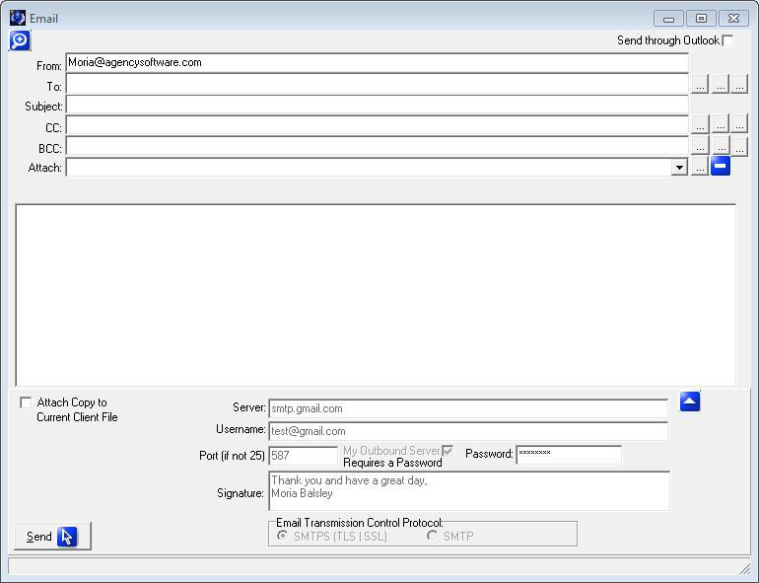
Figure 12 - Configure/Send an email
- Click the ▲ button to access the setup information and enter your server information in the fields provided.
- In the Signature field you can enter up to six lines of text (if you are sending through Outlook you will want to enter this information prior to checking the Send through Outlook box).
- Enter your email address in the From: field at the top of the window.
- Test the email by entering a test account (or your own) in the To: field, entering a Subject, and clicking Send.

Sending Email:

Email Lookups
At the end of the To:, CC:, and BCC: fields are lookup options. The three lookup buttons access different email databases.
- The first accesses email addresses listed on the Clients tab. This lookup is filter sensitive (which means that you can filter your database to return only email addresses of the filtered clients), but by default will show all email addresses for all clients allowing you to Check All if you wish to email everyone.
- The second lookup icon accesses the email addresses entered into the Contacts database.
- The third lookup accesses the email addresses listed on the Company setup.
Note: In the case of mass emails you may want to use the BCC field so the recipients did not see other recipient’s email addresses).

Attach
You can click the lookup icon next to the Attach: field and select any file you wish to attach to the email.
Attach Copy to Current Client File
If you check the box Attach Copy to Current Client File prior to sending an email it will attach in the Attachment database which you can access by clicking the icon in the top left corner of the Email screen. When you click this icon you can view or resend the attached emails from the Email History window.

The Policies Tab
Click on the Policies tab to open the Policies window. The Policies window serves as a database for Quote/Binder/Policy Status. On the Clients window, choose the customer or add the customer for whom you want to enter a policy then click the Policy tab to see policies specific to that client. You will notice that current policies will be displayed in black, while expired and closed policies will be displayed in red.
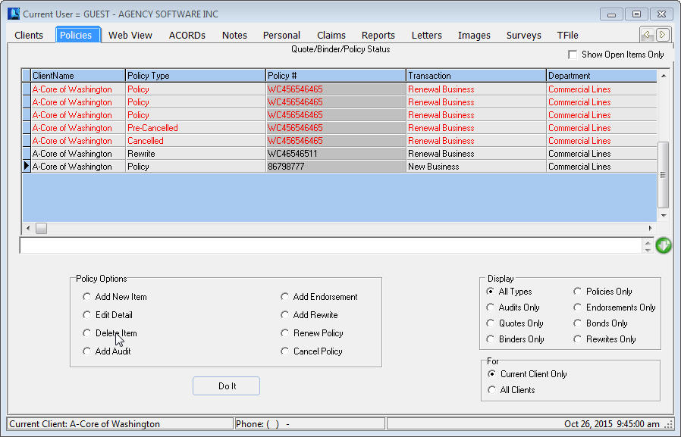
Figure 13 - Policy tab

Policy Options
Be sure to use your policy options as you are entering your policy information. Many of these options will draw the information from the selected policy to save you time entering information. These policy options are:
Add New Item - Add a quote/binder/policy/endorsement
Edit Detail - Edit the details of a selected quote/binder/policy/endorsement
Delete Item - Delete the selected quote/binder/policy/endorsement
Add Audit - Create a new audit
Add Endorsement - Create a new endorsement
Renew Policy - Renew the selected policy
Reinstate Policy - Reinstates the selected policy
Add Rewrite - Rewrite the selected policy
Cancel Policy - cancel the selected policy

After you select a Policy option, click the Do It button to proceed.

Display Options
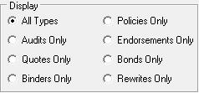
The display options are to limit the view of the policies window to the type of your choice. For instance, if you only want to see policies, not endorsements or audits, you click Policies only. Here are the display options:
The Display Current Items Only checkbox, located in the top right corner of the Policy tab, allows you to limit the view to open, current term policies. When you check this box any policies that are expired or have policy status closed will be hidden. With this box checked the other tabs for this client will only show items attached or created for the current policies displayed on the Policy tab. To see items that are attached or created from expired or closed policies simply un-check the Show Open Items Only check box.

For options
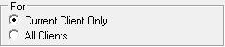
These options filter the list to display only the policies for the current client, or all the policies for all the clients in the database.
Note: You can only create a new policy, quote, binder, or endorsement if Current Client Only option is selected in the For option.

Using the Policies Window
You’ll find procedures for working with policies in the following sections.

Sorting and Finding Policies
Like the Client Grid, you can sort the Policies grid by any field simply by clicking on the column header. You can then search that column by typing in the first few letters of what you are looking for.
If you are trying to locate a client by policy number you can click the All Clients radio button in the For box (which will display all policies for all clients) then order the grid by Policy #. You then can type in the policy number you are looking for.

Policy Notes
The Expand Policy Notes icon on the right of the policies screen is used to enter policy specific notes. Clicking this icon will toggle between the notes area expanding and contracting in size. To add a new policy note, simply start typing in this area.

Attached Images
The View Attached Images icon above the policy grid displays only when you have selected a policy with attached images. Clicking this icon will display a list of those attached images.

Add a New Policy
When you choose Add New Item from the Policy Window and click the Do It button, the Policy Detail screen is displayed.
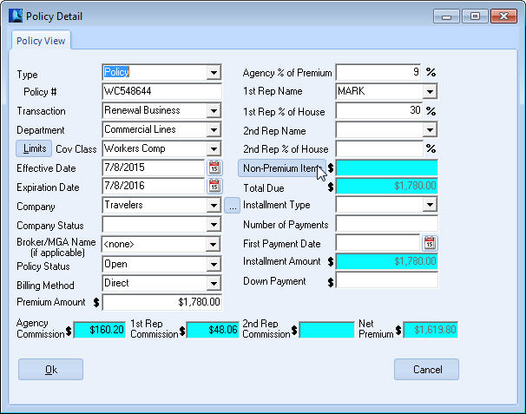
NOTE: The policy screen may display two (2) tabs on the top. The Policy View shows the policy detail information. The Download View is only available on policies downloaded with our Download Plus module. Contact your Sales Rep for information about the Download Plus.
Figure 14 - Entering a policy
When filling in the policy it is important to fill in the field using the drop down arrows. On the right end of a box, click the arrow to open a list of choices, then click the entry you want in the list.
The blue fields are automatically calculated, but typically can be overwritten.
Policy Fields:
Type – Typically Policy, but select the appropriate selection from the dropdown list
Policy - Type the Policy or Bond Number (depending on type)
Transaction - Important for New Business reporting
Department - Important for departmental reporting
Limits Button - Opens the Coverage’s window (see Coverages section).
Coverage Class - Choose your entry from the list. You can add to this list by typing in an entry (if Show All Coverage Classes is selected on the Agency Setup tab).
Effective Date - Click the button on the right. A calendar appears with the current date selected. Click OK to accept that date, or click to select a different date and then click OK. You can also type the date instead of using the calendar.
Expiration Date - Click the button on the right. A calendar appears with the date one year from the effective date selected. Click OK to accept that date, or select a different date and then click OK. You can also type the date instead of using the calendar.
Company - Choose your entry from the list. (The button to the right of the dropdown box opens the Company Database for entering or editing the companies in this list but only if you have Supervisory access in the EasyApps Pro Employee database).
Broker/MGA Name: Fill if you write this policy through a brokerage.
Note: The field after Company may display as Broker/MGA Name - choose your entry from the list (same as Company) if a broker is used. The only companies that will appear in this list are those that are marked as a broker in the company record on the Agency Setup tab. You can leave this at the default <none> if the billing company is the same as the company chosen.
Policy Status - Choose your entry from the list, must be Open to post accounting.
Billing Method - The entry defaults from the Company Setup database, but you can change it by selecting a different entry in the list.
Premium Amount - Type the Pure Premium amount.
Agency % of Premium - This is where you enter the commission rate. This is pre-defined in Company Setup, but can be changed or added if needed.
1st Rep Name - Choose your entry from the list. The list comes from the Employees database in the Agency Setup tab, and can only be changed there.
1st Rep % of House - Percent of agency commission due to rep.
2nd Rep Name - This is for ‘split’ commissions. Choose your entry from the list. The list comes from the Employees database in the Agency Setup tab, and can only be changed there.
2nd Rep % of House - Pre-defined in Employee Setup, but can be changed or added if needed.
Non-Premium Items - Click the button to add Non-Premium Items such as Agency Management Fees, Policy Fees, or Taxes. Use the down arrow on your keyboard for additional lines. Supervisory users can click the Setup button to set up their own non-premium items. Once you click ok, the blue field will auto-calculate with the sum of the non-premium items.
Total Due - Auto-Calculated field. On an agency billed policy this field should equal the total of your premium plus fees and taxes (the amount the customer owes you).
Installment Type - Choose your entry from the list, or leave blank for annual.
Number of Payments - Auto-Calculates from Installment Type, but can be changed.
First Payment Date - Click the button on the right. A calendar appears with the current date selected. Click OK, or select another date and then click OK.
Installment Amount - Auto-Calculate field.
Down Payment - Type the Down Payment amount being deposited.
Agency Commission - Auto-Calculated field.
1st Rep Commission - Auto-Calculated field.
2nd Rep Commission - Auto-Calculated field.
Net Premium - Auto-Calculated field.
When you’re done, click OK to save your entries. This record will be added to the current client.

Coverages
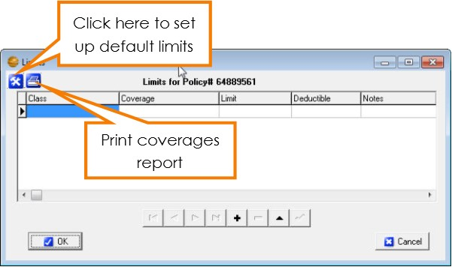
The Limits window is where the coverages for the client’s policy are entered. To open this window, click the Limits button to the left of the Coverage Class box on the policy detail screen. Information entered in the Limits window will automatically fill into your ACORD forms as long as the ACORD form being added or edited has a specific field for those coverages and you use the drop down list when adding the Class and Coverage in the Limits window.
Figure 15 - Limits window with option for default setup and print coverages report

The Limits Window

Class
This specifies which class of coverage you are going to use. It also specifies the types of forms into which the information can prefill. To select a coverage class, click in the Class box, click on the down arrow that appears in the box, then select the appropriate type. You will have to select a class for each line item entered.

Coverage
The choices that appear in this dropdown list are filtered depending on what Class you have selected in the Class field. To select a coverage type, click in the Coverage box, then click on the down arrow that appears in the box, and then select the appropriate type.

Limit
Enter the amount of the limits for the selected coverage.

Deductible
You can enter a deductible amount, or you can leave this field blank.

Notes
This field allows you to enter any additional notes about the specified coverage.

Coverages Report
Click the printer icon to print the limits in the form of a Coverages Report.

Setting Default Limits
Use the Tool button to open the Set Limit Defaults Window. Here you can set default values to Limit and Deductible.
The Auto field requires an ‘*’ asterisk to be active. This will allow any row with an asterisk to fill in the previous Limit window when that class is selected.
Rows without the ‘*’ asterisk will only fill in the Default values when the coverage is selected in the Limit Window.
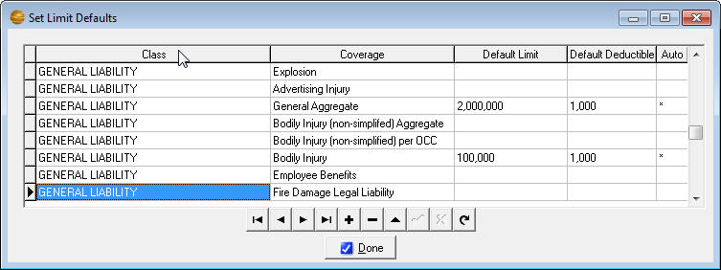
Figure 16 - Setting up default coverage limits
In the above example, the first two (2) GENERAL LIABILITY rows will auto fill when GENERAL LIABILITY is first selected in the Limits window. The third row would only fill in the defaults when the coverage, “Automatic Coverage for Newly Acquired” is selected in the Limit window.
When you’re done, click the ‘Done’ button to save your default values.
When you’re done selecting Limits, click the OK button to save your entries. These limits will be added to the current client policy.

The ACORDs Tab
Click on the Acords tab to open the Acords window. The Acords window contains all the ACORD forms for the selected client, and allows you to add, edit, or delete forms for that client. The forms list is blank until you add forms for that client.
The data in the Create Date column is automatic – you cannot change it. You can type short notes about specific forms by clicking the Add Note icon and typing your note in the Acord Note window. When done your note will display in the note field and can be edited by clicking the Add Note icon again.

ACORD Options
This section explains the various options in the lower pane of the Acord window.

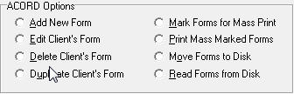

Add New Form
When you select the Add New Form option and click the “Do It” button, the Add New ACORD Forms window appears. This window displays all available ACORD forms in alphabetical order.
This list is first-key sensitive – to jump quickly to a specific point in the alphabetical list, you only need to press a letter key on your keyboard. For instance, if you need to add a Workers Comp form, press “WOR” on your keyboard. The first form starting with ‘WOR’ is selected. You may then scroll down, page down, or arrow down to the Workers Comp form. Select the form you want, and click OK to open the form.
You also can click the Number header on this screen and type in the ACORD form number you are looking for.
Use the options below the list to filter the more than 600+ ACORD forms to a more manageable list.
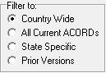
- The Country Wide option filters the list to display all the forms that are NOT state-specific.
- The State Specific option filters the list to show just the forms that are specific to a particular state (after you select the State Specific option, select the state you want in the list box that appears to the right).
- The All Current ACORDs option removes the filters and displays the entire list of current ACORD forms.
- The Prior Versions will show prior versions of select accord forms, such as the Certificate of Liability and Evidence of Property.

Edit Client’s Form
Edit an existing ACORD form for the current client. Select a form from the list of existing forms, select Edit Client’s Form, and then click “Do It.” The selected form will appear and you may edit as needed. (You can also double click the form you wish to edit.)

Delete Client’s Form
Delete an existing ACORD form for the current client. Select a form from the list of existing forms, select Delete Client’s Form, and then click “Do It.” You will be prompted if this is what you really want to do. The selected form will be deleted from the current client.

Duplicate Client’s Form
If you wish to create an exact duplicate of a different client’s ACORD form for the client you have selected, click on the Acords tab and then select “Duplicate Client’s Form.” The DupAcordForm dialog box opens with a list of all the clients in the database and all their forms.
- Scroll down to select the client and the form you wish to duplicate for the open client. You can often find the form you want more easily if you sort the list by Name or Form Name or Create Date (by clicking on the appropriate column heading).
- After you select the form you want to duplicate, click OK.
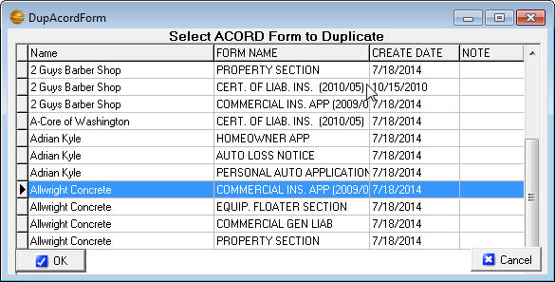
Note: When you duplicate an existing form year after year, you run the risk of using outdated, non-current forms. A better approach is to add a new form of the type you are renewing, and then use the Prefill Form From Another button (at the top of the new form) to fill the new, current form with the data in the old, expiring form and then make the changes for the renewal term.
Figure 17 - Duplicate an Acord from a different client

Mark Forms for Mass Print
You can send several forms from several different clients to the printer, pdf, or email all at once with the Mark Forms For Mass Print option.
- Choose a client, then click the Acords tab and click the Mark Forms For Mass Print option. Click the Do It button, click to mark the forms you want to print, and click OK.
- Then choose another client, click the Acords tab, click the Mark Forms For Mass Print option, click the Do It button, click to mark the forms you want to print, and click OK.
- When you’ve selected all the clients’ forms you want to mass print, you’re ready to use the Print Mass Marked Forms option.

Print Mass Marked Forms
- Select any client and click the Acords tab. Click the Print Mass Marked Forms option, and click Do It.
- A Print Preview of all the marked forms opens. Click the Print button in the toolbar and send the forms to your printer, or if you have email setup, click on File and Email and it will email all those forms at once.
- After the forms are sent to the printer or emailed, you’ll be asked if you want to unmark the forms for mass printing – click Yes.

Move Forms to Disk
If you want to move a specific client’s data and forms to an EasyApps Pro database on another computer (perhaps a computer at home, or a different standalone database in your office) you can use the Move Forms To Disk and Read Forms From Disk options to do this.
The procedure is to move clients and their forms, one client at a time. To use the Move Forms To Disk option:
- On the Clients window, select a client whose data and forms you want to move.
- Click the Acords tab. In the Acord Form Options section, click the Move Forms to Disk option and click the Do It button. A window listing the client’s forms will appear.
- Select each form you want to move by clicking the form name (if you want to de-select a form, click that form name again) or you can click the Mark All button to move all their forms. When you’ve selected all the forms you want to move, click the OK button.
- In the Save As dialog box, choose your desired location and click Save. A file that contains the client’s data and forms will be saved with the client’s name.

Read Forms from Disk
After you have transferred the files to the other computer and are ready to move the clients and their forms into the other database, follow these steps to use the Read Forms from Disk option:
- Open EasyApps Pro and click on the Acords tab for any client.
- In the Acord Form Options section, click the Read Forms from Disk option. An Open Account dialog box opens so you can located the transferred files..
- In the Open Account dialog box, click a client filename, then click Open. The client data and forms are imported, and a message tells you “ACORD forms successfully imported from Disk!”.
- Repeat steps 3 through 4 for each client file on the CD or Flash Drive.

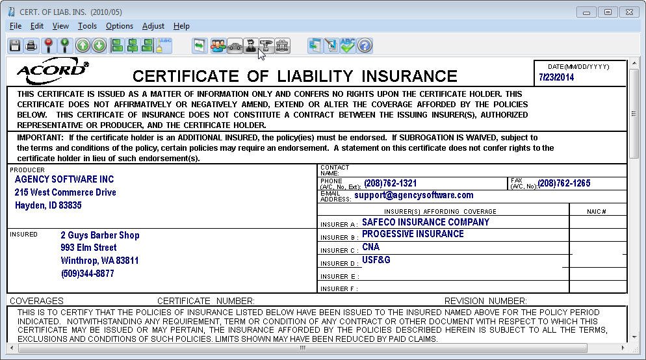
The ACORD Formview Window

The Formview Toolbar
The Formview toolbar appears at the top of the open form. When you place your mouse over a Formview toolbar button, the name of the button appears. The buttons, left to right, are as follows:
 | Save Form saves your current work while you work in the open form. When you finish working in a form and close it, all your work is automatically saved.
 | Print prints the open form.
 | Increase Form View makes the form bigger on the screen
 | Decrease Form View makes the form smaller on the screen.
 | Go To Previous Page goes forward one page in a multi-page form..
 | Go To Next Page goes back one page in a multi-page form.
 | Left Justify left-aligns text in the selected field.
 | Center Justify center-aligns text in the selected field.
 | Right Justify right-aligns text in the selected field.
 | Font Selection lets you select a different font for the selected field.
 | Toggle Expanded Fields allows you to type more in a field than would normally fit. If you have a lot of data, this process can take several minutes
 | Cert Holder’s Menu accesses certificate holders database; lets you add, edit, delete, and print certificate holders.
 | Vehicle Menu accesses vehicles database; lets you add, edit, delete, and prefill vehicle information for vehicle forms.
 | Drivers Menu accesses drivers database; lets you add, edit and delete drivers to prefill to ACORD forms that contain driver information.
 | Equipment Menu accesses equipment database; lets you add, edit and delete equipment to prefill to ACORD forms that contain equipment information.
 | Property Menu accesses property database; lets you add, edit, delete, and prefill property information for property forms
 | Additional Interest Menu accesses additional interests database; lets you add, edit, delete, and prefill interests to specific forms
 | Pre-Fill Form From Another will fill a new form with data from existing forms, including prior forms certificate holders.
 | Electronic Signature lets you put your electronic signature on a form before you print, e-mail, or fax the form.
 | Spell Checker will correct spelling errors.
 | Help has general instructions for filling out forms.

The ACORD Formview Dropdown Menus

File . . .
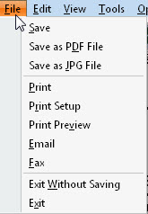
Save - saves the changes in the open form without closing it.
Save As PDF File - saves the form as a PDF image file.
Save As JPG File - saves the form as a JPG image file.
Print - opens the Print dialog box so you can print the ACORD form.
Print Setup - opens the Print dialog box to change print settings.
Print Preview - shows how the document will look when printed.
E-mail - allows you to send a form in an e-mail message directly from EasyApps Pro.
Note: Email must be setup first (see Emailing Forms section).
Fax - allows you to send the form to your fax software.
Exit Without Saving - closes the form without saving your changes.
Exit - closes the form and saves all changes you’ve made.

Edit . . .
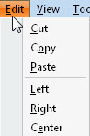
Cut/Copy/Paste - are standard windows commands to cut, copy, and paste text.
Left/Right/Center - are used to justify text within the selected field.

View. . .
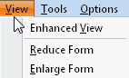
Enhanced View - toggles the form display between the Draft view and the Camera view. Enhanced View (Camera View) provides the most accurate view of what the form will look like when printed.
Reduce Form and Enlarge Form - allow you to adjust the magnification of the form on your screen.
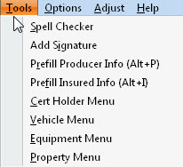
Toggle Floating Menu - Will show or hide a small menu allowing you next page and print utilities (made for PDF forms).

Tools. . .
Spell Checker - opens the Spell Check dialog to check your text for errors.
Add Signature will place an electronic graphic representation of your signature (in your own handwriting), if you have taken steps to create your electronic signature.
Note – Signatures must be created as 300x60 dpi Bitmap (.bmp) images. These can be ordered from Agency Software using the Electronic Signature Order Form available from the support page at agencysoftware.com.
PreFill Producer Info - automatically pre-fills your current agency information onto the form. This is handy if you have changed your agency information and are opening old forms that have your old info on them.
PreFill Insured Info - pre-fills the insured’s current information if you’re opening an old form and their information has changed.
Cert Holder Menu - opens the certificate holder options dialog (see the Certificate Holder section below).
Vehicle Menu - opens that client’s vehicle list (see the Vehicle Database section below).

Options . . .
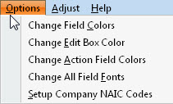
Change Field Colors - changes the color of all data entry fields.
Change Edit Box Color - changes the color of the active field (the field in which you’re typing).
Change Action Field Colors - changes the color of action fields. When you right-click in an action field, something pertinent to that field happens (such as an appropriate dialog box opening up).
Change All Field Fonts - allows you to change the font of the data you type on the form. The changed font only lasts until you close the form.
Reset to Default Font and Color – Resets to original settings.
Setup Company NAIC Codes – Click to enter NAIC code for company, which saves to the Company Setup.

Adjust . . .
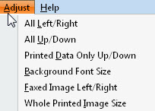
All Left/Right - moves the printed form image to the left or right on the page.
All Up/Down - moves the printed form image up or down on the page.
Printed Data Only Up/Down - moves the data you entered up or down in the printed form.
Background Font Size – adjusts background fonts.
Faxed Image Left/Right – moves the faxed form image to the left or right on the page.
Whole Printed Image Size – prints the entire form larger or smaller to better fit the page.
All Left Right Printer Only – adjust printing alignment

Help. . .
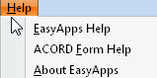
EasyApps Pro Help - provides program help for creating forms. EasyApps Pro is the ACORD form module of EasyApps Pro and is available as a stand-alone program.
ACORD Form Help - provides systematic instructions for filling out specific forms. Not all forms have a help file.
About EasyApps Pro - displays the software version number and the Agency Software, Inc. address and telephone information.

Entering Client Information in ACORD Forms
Data entry in an ACORD form is much like data entry in the Clients window. You can move from field to field using your arrow keys, tab key, or mouse, and edit data using the Insert, Backspace, and Delete keys. You can use your mouse to move the scroll bar (right side of screen) to move up and down the form.
The first thing you will notice when you open an ACORD form is that some of your work has already been done for you. Fields for your agency name and address have been filled in with the data you entered during installation and the client name and address information has been filled in with the information from the Clients window.

Certificate Holders
The ACORD certificate forms allow you to have multiple certificate (cert) holders for a single certificate (so you can type in a single certificate and print separate certificates for each certificate holder all in one operation).
If the Certificate Holders Menu button is displayed in color, it means that the form can support multiple certificate holders. If the button appears grayed out, it means that the form doesn’t support multiple certificate holders.

Certificate Holders Menu
Here are some things you need to know about working with certificate holders and entering cert holder information in certificates.
You can type certificate holder and description of operations information in the boxes in the lower-left corner of the certificate, but if you type the information directly in the form on-screen, you won’t be able to use the Cert Holders Menu to set up and print the certificate for multiple cert holders. You’ll only be able to print that certificate for a single cert holder.
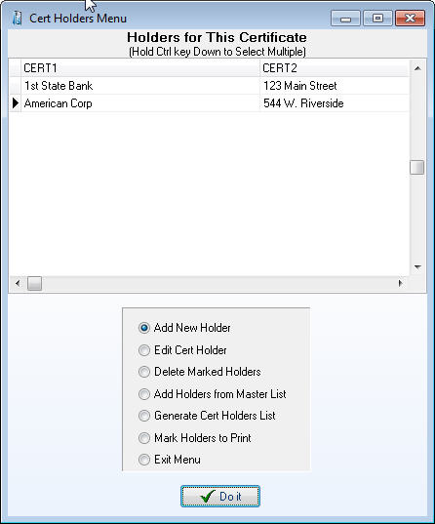
If you have more than one cert holder for a certificate, use the Cert Holders Menu instead.
Figure 18 - Cert holder menu

Adding Certificate Holders
To add a certificate holder, click the Cert Holders Menu icon.
In the Certificate Holder Menu select the Add New Holder option and click the Do It button.
The Certificate Holder Detail dialog box appears. Type the certificate holder’s name and address information in the dialog box.
Note: You cannot have two cert holders in the same certificate with identical names and addresses. If you need to issue multiple certificates to the same cert holder for different jobs, see the sidebar “Same Cert Holder, Multiple Jobs” (below) to learn how.
Enter the “Description of Operations” information in the Override Description of Operations box (if different than the master form), and click the Done button. The cert holder name, address, and operations information will not appear on the form on-screen, but it will be printed when that certificate holder is marked for printing.
The Description of Operations database can hold commonly used descriptions of operations. Access this database from anywhere the displayed icon appears.
This button sends saved information to the cert holder description field.
This button saves the information in the current cert holder description field for use later.
This button will add a blank record if you want to type the description in manually to pre-load the descriptions.
This button will delete the text in the description. All of the description is deleted, not just what is highlighted.
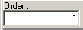
The Order field is used to place the descriptions into the order you want them in so the most used descriptions can be at the top. This is in ascending order and is entered by the User.
The font adjustment is used for changing the font size in the description field to allow for more data. The minimum font size is 7.
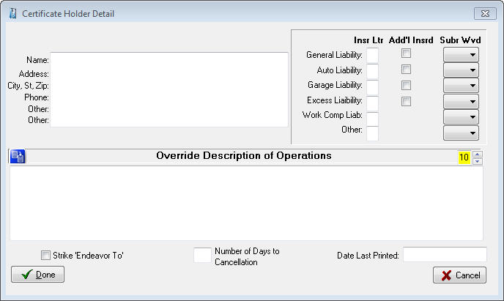
When you click Done, a new certificate holder is added to the certificate.
Figure 19 – Adding a new certificate holder
Tip: If you need to enter a nearly identical name and address block for a different cert holder, you don’t need to retype it. Instead, select the text you need to duplicate, then right-click the selected text and click Copy on the shortcut menu. Then close the Certificate Holder Detail window, add a new cert holder (or edit a cert holder), right-click in the box where the copied text should go, and click Paste on the shortcut menu.

Same Cert Holder, Multiple Jobs
Suppose you have a client, perhaps a construction company, who needs to issue several certificates (for different jobs) to the same cert holder. But you can’t enter cert holders with identical names and addresses in the same cert… so what do you do?
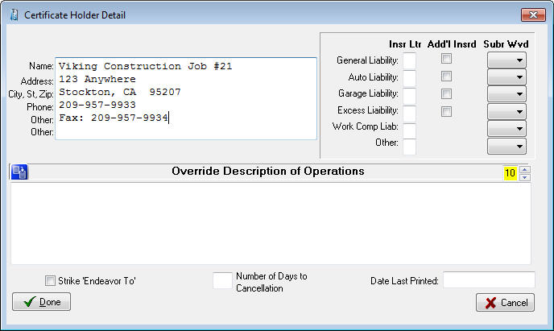
Try this: Add a new cert holder, but enter a job number at the end of the Name line (as shown below).
Figure 20 - Modify certificate holder name to allow for duplicate holders
This keeps the Name and Address field combination (really the Cert1 and Cert2 fields) from being duplicated, and you can print all the certificates you need for the same cert holder’s different jobs. The resulting printed certificate entry looks like this:
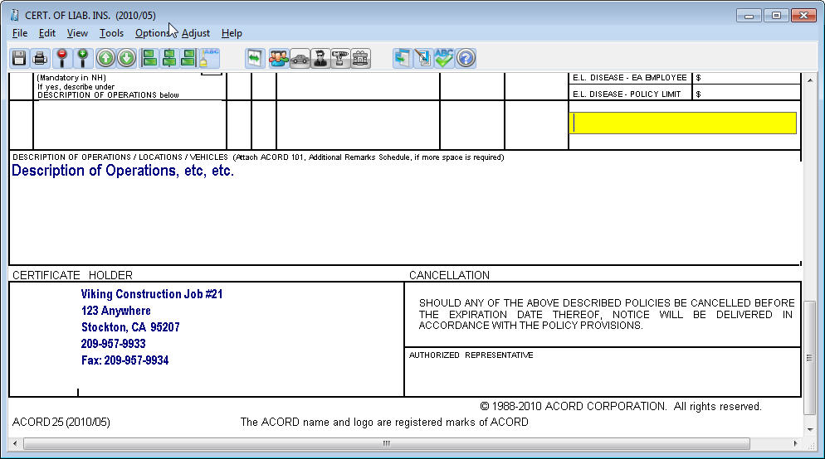
Figure 21 - Certificate holder information will prefill with information entered in the Cert Holders Menu

Description of Operations
The latest version of the Certificate of Liability holds six lines of text in the Description of Operations field. If you have more text than fits in this field you can reduce the font size as low as 7 and use the Additional Remarks (ACORD 101) for overflow.

Editing Certificate Holders
To edit or modify existing certificate holders, do the following:
- Click the Cert Holders Menu button (the button that shows a person walking out of an envelope).
- Click the name of the cert holder you want to edit.
- Select the Edit Cert Holder option on the Cert Holders Menu, and click Do It.
- Make your edits, then click the Done button.

Adding Certificate Holders from the Master List
The EasyApps Pro database has a Master List that holds all the certificate holders for all the certificates in the database. If a certificate holder has already been added for one certificate or client, you can add that same cert holder to another certificate (for the same client or for another client) by choosing it from the Master List.
To add an existing cert holder from the Master List to the open certificate, select the Add Holders from Master List option on the Certificate Holder menu, and then click Do It. The Master Cert Holder List appears, showing all of the certificate holders for all of your clients.
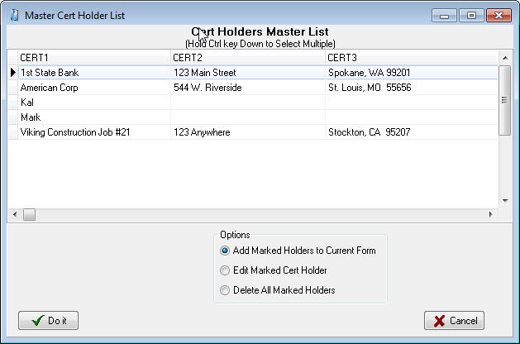
In this dialog box, click the cert holder name with your mouse to mark them, you can hold your CTRL key down to select multiple holders, click the Add Marked Holders to Current Form option, and then click Do It. The marked cert holders will be added to the cert holder list for the open certificate.
Figure 22 - Master Cert Holder database
Note: There cannot be any blank certificate holders in the Cert Holders Menu list. If you see a blank certificate holder name at the top of the list, you’ll get a Key Violation error the next time you try to add a new cert holder. You MUST delete the blank cert holder (click in the blank cert holder name, then click the Delete Marked Holders option and click Do It). If you delete cert holders from the Master List, they’ll be deleted from all certificates. To delete a cert holder from just one certificate, open that certificate and delete the cert holder using the Certificate Holders Menu.

Deleting Certificate Holders
- Open the Cert Holders Menu.
- Select the Delete Marked Holders option.
- Select the names of the cert holder(s) you wish to delete. (You can mark multiple holders by holding the Ctrl key down as you click the names.)
- Click the Do It button. EasyApps Pro will ask if you really want to delete the certificate holder – click Yes. The cert holder is deleted from the open certificate.

Printing Certificates for Selected Cert Holders
You can print a certificate for a single cert holder or for multiple cert holders (but don’t try to send more than 10 at a time to your printer). To print certificates for cert holders:
In the open certificate, click the Cert Holders Menu button. In the Cert Holders Menu, select the Mark Holders to Print option and then click the Do It button.
The Mark Holders to Print dialog box appears (shown below). Double click the selected box for each cert holder you want to print to highlight it. If you want to mark all the certificate holders with one click, click the Mark/Unmark All check box (click the check box again to unmark all the cert holders).
Click OK. You will be asked if you want to start printing marked certificate holders now.
If you wish to print select Yes and the Print dialog box for your printer appears – you can print multiple copies of each certificate by entering the number of copies in the Numbers of Copies box. Then click OK to print.
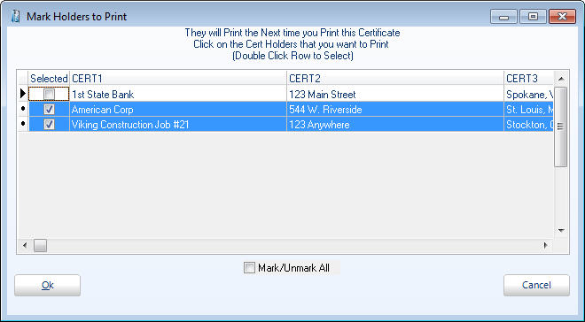
Click No to print to utilize other options, such as email or save to PDF. You will be viewing the form (unfilled with selected holders) and can select Save as PDF File or Email from the File menu.
Figure 23 - Mark holders to prefill to certificate for printing
After you close the form, you will be asked if you want to unmark all the holders you have marked for printing. Click Yes.

Generate Cert Holder List
To generate a printable list of certificate holders for the open certificate, select the Generate Cert Holder List option on the Certificate Holders Menu, and click Do It.

Close the Certificate Holders Menu
To close the Certificate Holders Menu, select the Exit Menu option, and click Do It.

Vehicle Database
The Vehicle Database stores vehicle information by client and allows entered information to be pre-filled on ACORD forms such as ID cards, Vehicle Schedules, and other auto applications. If the Vehicle Menu button (the car button) is fully colored (not grayed out), it means the open form has access to the vehicle database.

Enter Vehicles in the Vehicle Database
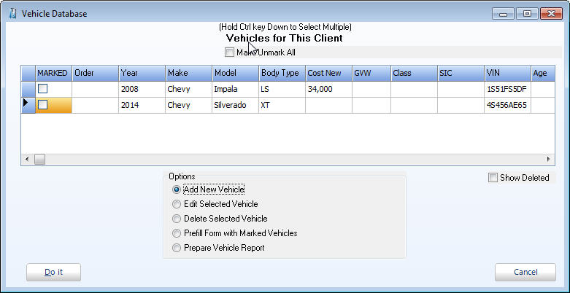
To open the vehicle database, click on the Vehicle Menu button (the red car button). The Vehicle Database dialog box opens.
Figure 24 - Vehicle menu
To add a vehicle, click the Add New Vehicle option and then click the Do It button. The Vehicle Detail dialog box appears.
Fill in all vehicle information, and then click OK. The Vehicle Database reappears.
Once you have entered all of your vehicles for your client, you can manipulate the order in which they print by updating the ‘Order’ column on the Vehicle Database.

Fill a Form with Vehicle Information
To prefill the open form with information for a specific vehicle, click the vehicle to highlight it. To select more than one vehicle, hold down the Ctrl key while clicking on the vehicles.
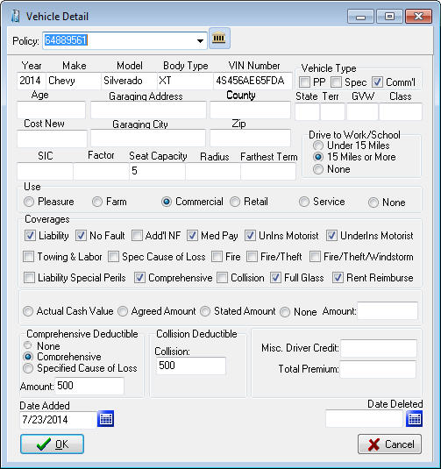
Then click the Prefill Form with Marked Vehicles option and click Do It. The vehicle data is filled into the open form.
Figure 25 - Adding a vehicle
Note: You can only prefill the number of vehicles that the specific open form has spaces for, with the exception of Auto ID cards. In Auto ID cards, you can prefill up to 10 vehicles at a time, and EasyApps Pro will create the number of ID cards required for those vehicles as long as you use the Order number.
Note: If the Auto ID Card form is more than one page, when you prefill vehicles it will only create one form with one vehicle at a time.

Attach Vehicles to Specific Policies
You can also attach vehicles to specific polices when adding new vehicles on the Vehicle Detail screen. When you click the car icon on the toolbar of an Auto form, or you click the Vehicle button on the Personal tab, click on Add New Vehicle and Do It to get the Vehicle Detail screen. At the top of this screen is a policy drop down list so you can attach this vehicle to a specific policy.

Print a Vehicle List Report for a Client
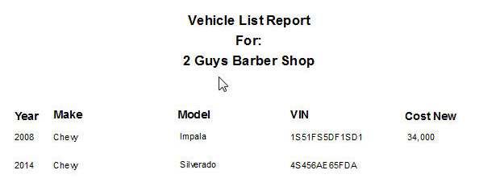
A vehicle list report is a printable list of all vehicles associated with the current client. To create it, open the Vehicle Database, then click the Prepare Vehicle Report option and click the Do It button.
Figure 26 - Vehicle report lists all vehicles

Equipment Database
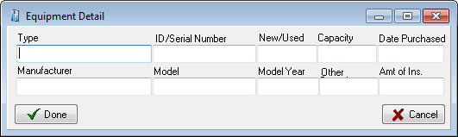
The Equipment Database stores equipment information and allows entered information to be pre-filled on ACORD forms. If the Equipment Menu button (gears button) is fully colored (not grayed out), it means the open form has access to the equipment database.
Figure 27 - Add equipment

Add Equipment to the Equipment Database
Click the ‘Add New Equipment’ option and the following screen appears
Click ‘Done’ when finished. From the equipment menu you can Add/Edit/Delete/Prefill forms and print an Equipment Report.

Drivers Database
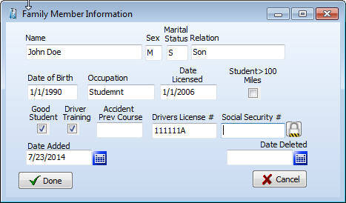
The Drivers Database stores driver information by client and allows entered information to be pre-filled on ACORD forms such as Business Auto Section, and other driver applications. If the Drivers Database button (the steering wheel button) is fully colored (not grayed out), it means the open form has access to the drivers database.
Figure 28 - Add new driver

Add Drivers to the Drivers Database
Click the ‘Add New Driver’ option and the Driver Detail screen appears.
From the drivers menu Add, Edit, Delete, Prefill, and Prepare a Drivers Report are available, similar to the Vehicles Menu.

Property Database
The Property Database stores property information by client and allows entered information to be pre-filled on ACORD forms such as Homeowners Application, Commercial Insurance Application and the Dwelling Fire Application. If the Property Menu button (the house button) is fully colored (not grayed out), it means the open form has access to the property database.
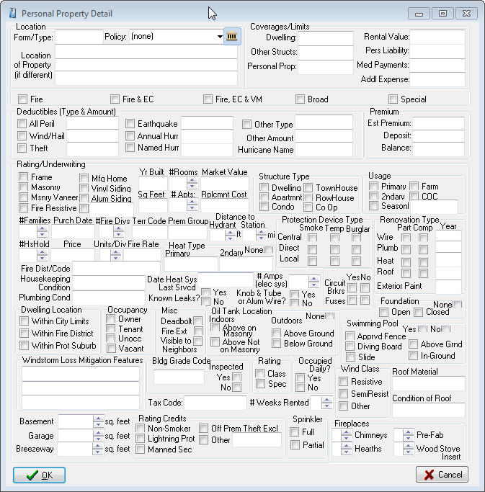
Either the Personal Property or the Commercial Property dialog box opens depending on the Acord application being used.
Figure 29 - Add new personal property

Enter Property in the Property Database
To open the Property Database, click on the Property Menu button (the house button). The Property dialog box opens.
Figure 30 - Add new personal property
The Personal Property and Commercial Property dialog box looks and works the same except for the title.
To add property, click the Add New Property option and then click the Do It button. The Property Detail dialog box appears.
Fill in all property information, and then click OK. The Property Dialog reappears.
Once you have entered all of your properties for your client, you can manipulate the order in which they print by updating in the ‘Order’ column on the Property Dialog window.

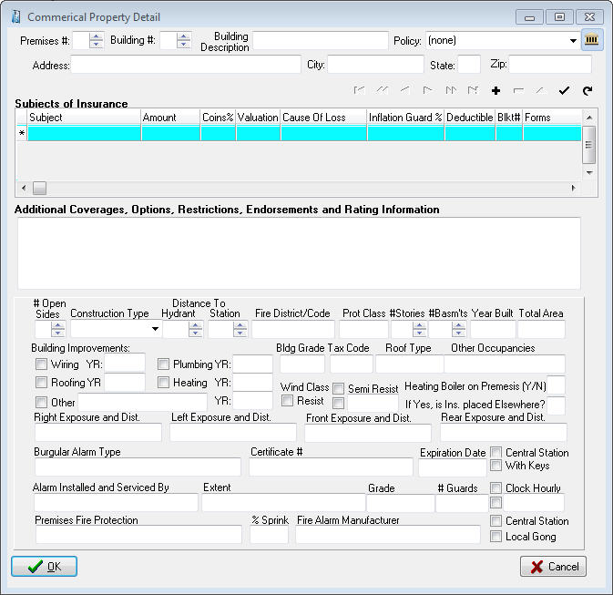
Fill a Form with Property Information
Figure 31 - Add new commercial property
To prefill the open form with information for a specific property, click the property to highlight it. To select more than one property, hold down the Ctrl key while clicking on the properties.
Then click the Prefill Form with Marked Properties option and click ‘Do It’. The property data is filled into the open form.
Note: You can only prefill the number of properties or buildings that the specific open form has spaces for.

Print a Property List Report for a Client
A property report is a printable list of all properties associated with the current client. To create it, open the Property Database, then click the Prepare Property Report option and click the Do It button.

Additional Interest Database
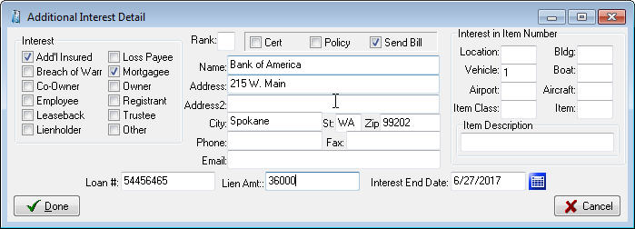
The Additional Interest Database stores information on the additional interest on the assets of the policy holder. This information can be pre-filled to ACORD forms such as the Additional Interest schedule, as well as drawn into the invoice as the billed party.
Click the ‘Add New Interest’ option and the Additional Interest Detail screen appears. Click Done when finished. From the Additional Interests menu you can Add, Edit, Delete, and Prefill similar to the Vehicles or Drivers menus.

Emailing Forms
The Email feature sends forms, saved as PDF or JPG files, directly from EasyApps Pro through your e-mail provider. This must be properly configured using your email provider settings.

Setting Up Email
To set up to email from EasyApps Pro you need to collect your email service information. The required information is:
- Outgoing SMTP server name
- User name
- Port number
- Password (if one is required for outgoing mail).
You can get all this information from your Internet Service Provider (ISP).
Note: Outlook users can simply check the Send through Outlook box and enter their signature information (optional).
To set up email:
- Open any ACORD form, and click File – Email.
- The Email Form dialog box opens with the saved file name in the Attachments box.
- Click the Email Setup button (the button with the gears).
- In the Email Setup dialog box, fill in your ISP information and click OK.
- If your email provider requires a secure connection, you can select SMTPS and enter the specific port given to you by your email provider.
Common gmail settings:
- Server is smtp.gmail.com
- Select SMTPS (select this before setting the port)
- Enter Port 587
These settings may change as your ISP makes configuration changes.
- In the Signature area you can add a Default Signature. There is room for 6 lines of information that will appear at the bottom of each email.
- The Password box is for the password your ISP requires for sending outgoing mail. Not all ISPs require outgoing mail passwords – if yours does not require a password, leave this box blank and uncheck My Outbound Server Requires a Password box.
- Click OK

Sending an Email
From the Acord form select File – Email (after adding signatures and prefilling any pertinent information):
- Enter the recipient address in the To: box.
- In the large box, enter any message text you want to send the recipient.
- Click the Send Email button.
Note: You can attach more files to your message by clicking the ellipsis button (at the right end of the Attachments box), and selecting the files you want to attach.
If EasyApps Pro email doesn’t work for you, you can save your forms as JPG or PDF files by clicking File – Save As PDF (or File – Save As JPG), and then attach the saved files to a message in your outside email program.

The Notes Tab
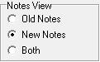
EasyApps Pro now offers two modes for the notes window. The first is the original notes that were written to a single page listing the notes by date. These are referred to now as the Old Notes. To print these you either had to print ALL the notes or highlight what you want and copy / paste to a word document to print a section.
In the Agency Setup tab you can select a global preference to have Old Notes, New Notes or Both.
The “Both” option allows you to view Old Notes without the ability to Add and to view New Notes with adding ability. So you can add notes in the New Note format, but be able to view all the notes previously entered in the Old Note format.

Operation of Old Notes

Click the Notes tab to view the Notes window.
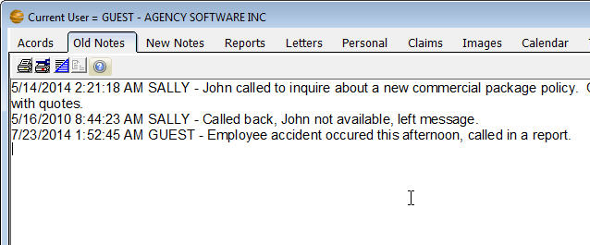
To start a new note, click the New Notes icon. The New Notes window opens.
Figure 32 - Old Notes tab displaying notes entered
Notes are automatically time-and-date stamped, and your login user name is entered. You’ll find buttons for formatting your note text, as well as print, cut, copy, and paste buttons, on the toolbar. Type your note in this window, then click the Commit button.

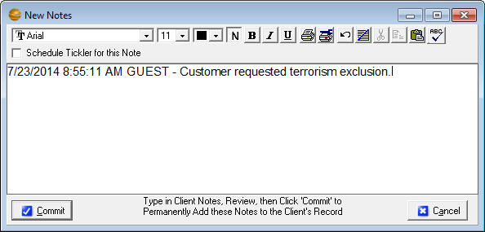
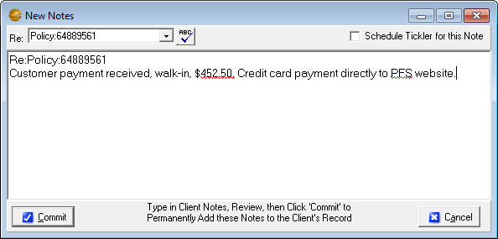
Operation of the New Notes
Figure 32 - New note entry from Old Notes tab
Figure 33 - New note entry from the New Notes tab
The new notes are stored in a database as one (1) note per record. This allows the ability to categorize and print the notes per User and per date range.
Click on the Notes tab to view the New Notes window
To add a note, click on the button from the Notes (or New Notes) tab. The New Notes entry window opens.
If the note applies to a policy you can select it in the Re: field
Notes are automatically time-and-date stamped, and your login user name is entered.
- Click the Spell Checker button to correct spelling
- Check the Tickler checkbox to add a tickler for this note
- Type your note in the body of the note record.
- Click the Commit button to permanently accept the record after reviewing your entries.
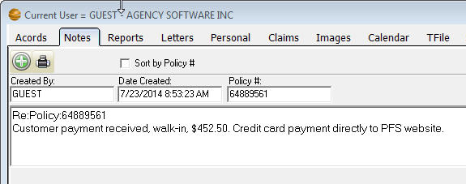
You can run reports on New Notes by clicking the Print Notes icon. The Print Notes window allows you to print by date, user, and client, or combinations of these filters.
Figure 33 - New Notes tab
Note: On either of the mode of notes, clicking the Commit button posts the note and makes it read-only (meaning it cannot be edited or deleted). This is for E&O protection. Do not click the Commit button until the note is complete and correct. If you DO make a mistake entering a client’s notes, you will have to add another entry below it stating your correction.

The Personal Tab
The Personal tab is where you can record personal data about your clients – such as the names and birthdays of their family members. As always, start by selecting the client’s name in the Clients tab.
Click on the Personal tab to view the personal information pertaining to the selected client. To add a record to the Family Members list, click the Insert Record button (the + button) in the toolbar below the list. Fill in the client’s family members, and personal data about them, on the left. Click the Post Edit button (the check-mark button) to save the record.
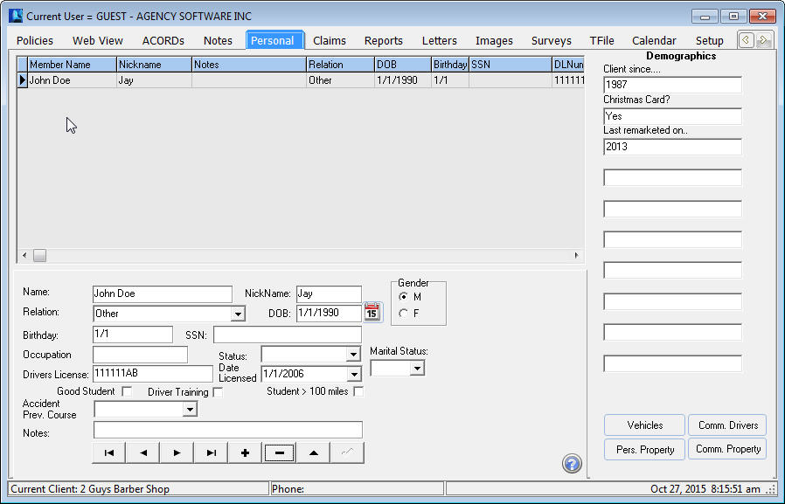The Customer Demographics entries on the right apply to the client, not to the specific family members.
Figure 34 - Personal tab
When you first install EasyApps Pro, the field headings are undefined in the Customer Demographics list. Headings for the demographics categories (up to 10) can be assigned from the Demographics button on the Setup tab. Once you have assigned the demographics categories, the headings will appear on this window and can be used for reporting and marketing.
The toolbar at the bottom of the window allows for adding, editing, and deleting records in the Family Members list. The toolbar has the same functionality as similar toolbars throughout EasyApps Pro.
Also on the Personal tab are a set of buttons allowing quick access to the form schedules for Vehicles, Personal Property, Commercial Drivers, and Commercial Property.

The Reports Tab
Click the Reports tab to open the list of reports. In the Reports window, you’ll find all the default reports that come with EasyApps Pro.
These reports are ready to be used. They can be edited, which requires some understanding of SQL language, and you can also create your own reports with some understanding of how databases relate.

Select the report you wish to run then click the Do It button (or double-click the report name).
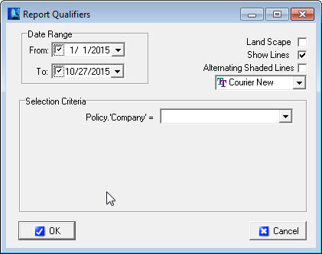
The Report Qualifier window opens allowing you to enter the report criteria. Options in the Selection Criteria box typically must be entered to run the report. Display options are listed in the upper corner (Landscape, Show Lines, Alternating Shaded Lines, and font adjustment).
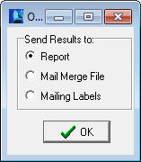
Once you have entered the criteria and click OK, an Options box appears for the output method of the report. This allows you to create a Report, a Mail Merge File as a comma delimited file (*.csv), or Mailing Labels (if the report has the required mailing label fields).
Report - allows you to preview or send directly to the printer
Mail Merge Files - can be used by most spreadsheet, word or database programs
Mailing Labels - will create 3 x 10 mailing labels (3 across, 10 down). The report requires the Client Name, First Name, Last Name, Address1, City, State and Zip to create the labels. This is used when labels are needed for specific criteria such as for expired policies.

If the print is too small
Some reports have several fields (columns) of data, and all the fields will have to fit in one row across a single page. The more fields of data are displayed, the smaller the font will be (to fit it all into one row).
To make small print a little larger:
Rerun the report and select Landscape - When the report is printed in Landscape orientation, there is more page area for the long rows and the print is more readable.
Eliminate unnecessary fields - If the report print is still un-readably small, you can only increase the font size by eliminating some of the fields (columns) in the report.
Select multiple lines per record - You can opt to ‘break’ each row of data into multiple lines (although it is a little harder to read this way). The dialogue box to do this appears only when the report has reached a small font.
Save the report as a Mail Merge file - Open the saved csv file in Excel and then you can manipulate the page and font size to your desired format.

The Report Preview Window Toolbar
In the Report Preview window toolbar (across the top of the window) you have various Zoom buttons to change your view of the report, and buttons to move from page to page in a multi-page report, print the report, and exit the report viewer window.

Create a Custom Report
You can create your own custom reports to show whatever specific data you choose.
To create a custom report (you must have Supervisory access) select the ***Custom Report*** report name at the top of the reports list, and click Do It. In the Query Wizard window that opens, you’ll build your custom report.
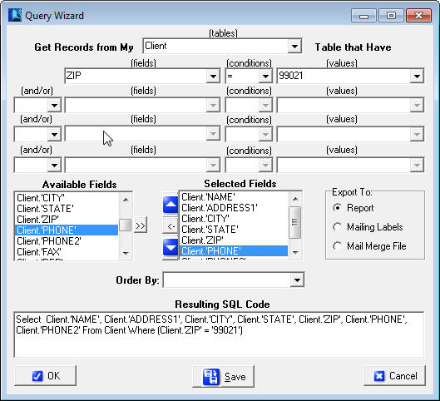The next steps will guide you through creating a custom report listing client names and phone numbers for clients in your zip code area.
Figure 35 - Setting up a report for client by zip code
- In the Get Records from My box (at the top of the window), select Client.
- Next you’ll enter the criteria that determine which clients will be listed in the report – specifically, the clients with your local zip code.
- In the first line of three boxes, in the (fields) box, select ZIP
- In the (conditions) box, select =
- In the (values) box, type your local zip code. In this example we enter 99021, because I have many clients with that zip code.
- In the Available Fields list, double-click each field you want to display in your report. In this example, I’ll select Client.’Name’, Client.’Address1’, Client.’City’, Client.’State’, Client.’Zip’, Client.’Phone’, and Client.’Phone2’. Keep in mind the more fields you choose the smaller the print on the report will be.
As you double-click each field name, it appears in the Selected Fields list. To delete a field from the Selected Fields list, click the field name and the click the Remove Selected Field button (between the red arrows that point up and down).
- If you want the records in your report to be listed in a specific order, open the Order By list and choose the field name by which you want to sort the list. The figure below shows this example report set up and ready to run.
You can also 'Subtotal' and 'Group By' rows of your reports together. An example of this would be to create a new report for all policies, Subtotaling premium volume, then Grouping By Company. Note that you need to ‘ORDER BY’ the same field you ‘Grouped By’ for it to work.
- Click the OK button.
- The Report Setup box opens next, with the Preview option selected. Click OK to open a preview of the report before you print it.
- After you close or print the report, you will be returned to the Query Wizard. If you want to save this report, to use again, click the Save button. Give the report a name you’ll recognize later, select Marketing in the Report Category box, and click OK. Then click Cancel in the Query Wizard. The report is added to the list to run at a future date.
Note: In addition to creating this report to ONLY run for clients in ZIP CODE = 99021, you can greatly enhance the functionality of this report by choosing ‘:Value1’, ‘:Value2’, ‘:Value3’ (or ‘:FromDate’ and ‘:ToDate’ if dealing with date fields) in each of the values dropdowns. Choosing these variables instead of hard-coding the value ‘99021’ means that the program will stop and ask you what criteria you want to run the report each time you run the report.
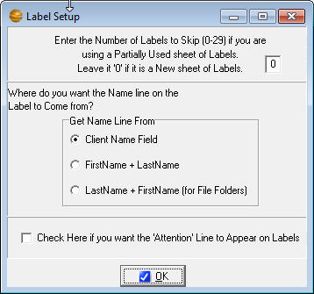
The report you create is nothing more than a set of instructions, called a SQL statement. This tells EasyApps Pro to retrieve the data you specified every time you run the report. This means that every time you run the report, you get the data that is currently in the database when you run it.
Figure 36 - Setting up labels

Create Mailing Labels
To create mailing labels, your report must have the fields, Client Name, Client First Name, Client Last Name, Address1, City, State, and Zip. When you run the report choose Mailing Labels from the options menu, and you will get the label setup screen.
Note: If you filter your client list on the Clients window before you create mailing labels, the labels will be created only for the names in the filtered client list.

Edit a Report
Any report, including most default reports that came with EasyApps Pro, can be edited if you understand SQL. If you don’t understand SQL, it’s easier to create a new report and delete the old one.

Permanently Delete a Report
To permanently delete a report, either default or custom, select the report name in the Reports window, and click the Permanently Remove Selected Report button above the blue reports list.
Note: Once you delete a report, it’s gone forever. Agency Software technical support can replace default reports for you, but this will also delete any custom reports you’ve created. So be very sure you want to delete a report permanently before you do it.

The Letters Tab
Click on the Letters tab to open the Letters window. This window has all the features of most modern word processors.

What’s In the Letters Window
There are several insurance-specific letters included in EasyApps Pro. These letters are ready for merging with your client data. You can also edit these letters to customize them, and then save the default letter with your customized changes, or save the changed letter with a new file name so you don’t lose the original default letter.
- To open default letters that come with EasyApps Pro (or custom letters you have created and saved in EasyApps Pro) click File, then click Open. A window opens to the Docs folder in the EAPPW folder. Click the name of the letter you want to open, then click the Open button.
- To create new custom letters click File, then click New. Follow the procedures in the Creating Custom Mail Merge Letters section below.
- To save changes to an open letter click File, then Save.
- To save a letter with a new file name (as a new letter) click File, then click Save As, and give the letter file a new name.
- To close the open letter click File, then click Close.

Merge Client Data into a Letter
EasyApps Pro allows you to merge your agency and client information into several preinstalled letters, or create your own letter in either EasyApps Pro or a word processor and then merge your data into it.
To merge data into a document that shipped with EasyApps Pro, start by opening that document (the merge fields are already in place in these documents).
Select the client(s) you wish to merge into the letter by clicking the Select Clients to Mail Merge button. This brings up a box with a list of your clients in it. Click to select the clients you want to include. (Select multiple clients by holding down the Ctrl key while clicking on the clients).
Click the OK button. Multiple identical documents are created, each filled with the merged client data.
Print the merged documents by clicking the Print button (or click File, then Print).
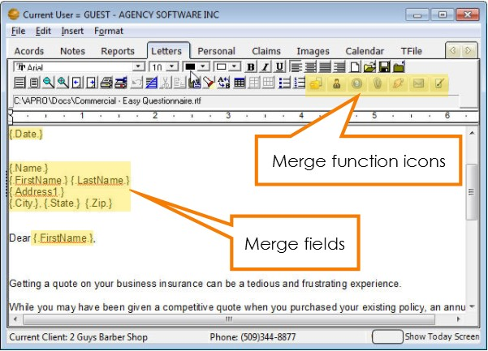
After you print the documents, click File, then click Close to close the merged document without saving it.
Figure 37 - Letters tab
Note: Do not save the letter after you merge client data into it. Doing so will overwrite the original letter containing merge fields, and you won’t be able to use that letter as a merge-able file again.

Creating Custom Merge Documents
EasyApps Pro allows you to merge your agency and client information into custom documents that you create.
Click File, then click New. The window is the same, but the program knows you have started to create a new file.
Type your new letter/document. Wherever you want to enter merge data (such as client name, agency name, date, phone, policy#, etc.), click to place the cursor at that point and then click the Insert Merge Field button. (You can also click Insert, then click Merge Field.)
Scroll down and select the merge field you want to insert, and click OK. When you run the merge in the finished letter, the program will replace each merge field with the corresponding client information in the database.
A merge field consists of a field name from the database, surrounded by periods and curly brackets. You cannot create your own merge fields – the names must be identical to field names in the EasyApps Pro database.
When you finish your document and all merge fields have been entered, save the new document by clicking on the Save button (or click File, then Save).
In the Save As dialog box, enter a name in the File Name box. The document is saved in the Docs folder in the EASYAPPS PRO folder.
To merge data into this document for printing, follow steps 2 through 5 in the Merge Client Data into a Letter section above.
Note: Do not save the letter after you merge client data into it. Doing so will overwrite the letter containing merged fields.

Attaching Letters to Clients
When you attach a letter to a client, the document is linked to that client so you can find it again very quickly when that client is selected in the Clients window.
To link a letter to a client first make sure the client is selected (listed as the Current Client in the bottom left corner). In the Letters window, open or create a letter and merge the data into it (using the procedures in the previous sections).
Click File, then click Save As to save the merged letter as a new file with all the merged data in it. In the Save As dialog box, give the file a new name. It’s saved in the Docs folder in the EASYAPPS PRO folder.
Click the Add/View Attachments for This Client button (it looks like a paper clip). The Attached Documents window appears.
To attach the current letter to this client, select the Attach Copy of Item to Client option, and click the OK button.
A window opens asking you to enter a description for this document (the description appears in the Description column in the Attached Documents window). In the box, type a description that identifies the document and click OK.
The date, description, and filename for this document will appear in the Attached Documents window after you click OK and then click the Add/View Attachments For This Client button again.
To open and then edit or print letters you have already attached to this client, click the Add/View Attachments button. Click the letter you want to open, then click the Edit Selected Item option and click OK.
To delete the attached letter from the client, click the Delete Link To Attachment option. The document will no longer appear in the Attached Documents window, but the document file will still be saved in the Docs folder in the EASYAPPS PRO folder.
To close the Attached Documents window without attaching, opening, or deleting any documents, click the X button in the upper-right corner of the window.
Note: An alternative to attaching to the letters window is to attach to the image tab by printing the merged letter to the Agency Software Printer. This will create a PDF file and attach it to the Images tab.

The Surveys Tab
Click the Surveys tab to open the Surveys window. There are more than 200 Business Specific Survey Questionnaires in EasyApps Pro. Most Survey Questionnaires are 7 – 10 pages long and contain a checklist of items that will certainly help reduce your E&O risk – and possibly uncover underwriting credits. Use the scroll bar on the right side of the list of survey titles to locate the survey you want. Double-click on the survey title to display it in the window. When you have the survey you want open, click the print button to print it. You can take the survey with you when you go to an insured site, and enter information right on the pages.
You can edit surveys to better suit your agency. Click in the survey text and edit it as you would in a word processor. Use the scroll bar on the right of the open survey window to scroll through the entire survey.
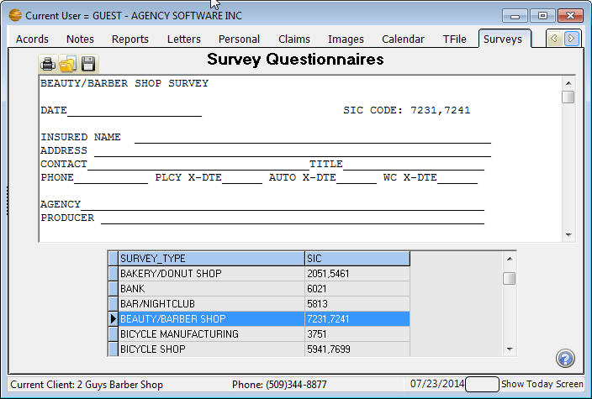
The three buttons in the upper-left corner are Print Survey, Open Saved Survey (which opens surveys you’ve saved under a new name), and Save as New Survey (which saves a survey under a new name).
Figure 38 - New survey added to the Survey tab

The Calendar Tab
Ticklers are reminders you set for yourself or other users, for any reason you like – appointments, birthdays, To Do items, or anything else for which you want a reminder.
You can display by Open Status and Clients. Click the box on the From & To dates to activate and use a date range. The Tickler options allow the creation and editing of Ticklers
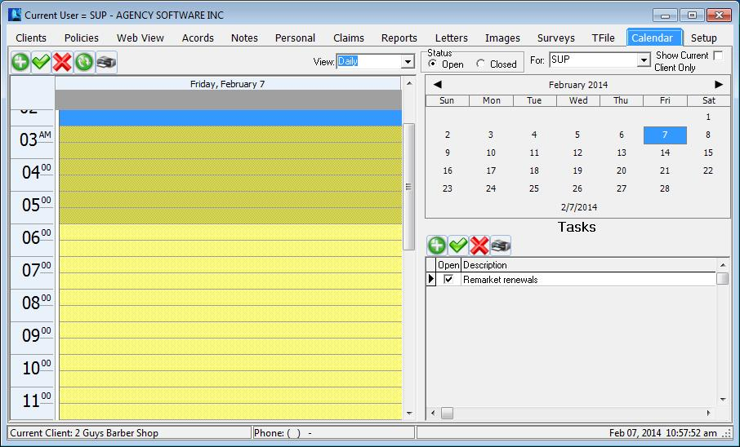You can view by Daily, Weekly & Monthly, by Status and by clients. The calendar listing shows Appointments & Alarms. The Tasks window on the lower right shows Tasks in Blue if the due date is in the future, Black for today & Red for past the due date.
Figure 39 - Calendar tab
You can use the Add New Item icon or double click on the time slot to create a Tickler.
When you create or edit a tickler, you can set a visual alarm to “go off”, or pop up, at the date/time you set. EasyApps Pro must be open in order for the alarm to go off, and if EasyApps Pro is not open at the scheduled alarm time, the alarm will be displayed the next time you open EasyApps Pro.
Create a new tickler - When you click the Add New Tickler option and click Do It, the Tickler dialog box opens with your user name in the Rep box, and attached to the selected client. Set a date and time for the alarm and then enter a description and any notes about the tickler. In the Set Pop Up Alarm options, choose Yes or No (if you select No, there won’t be a reminder popping up). Click OK to save the tickler.
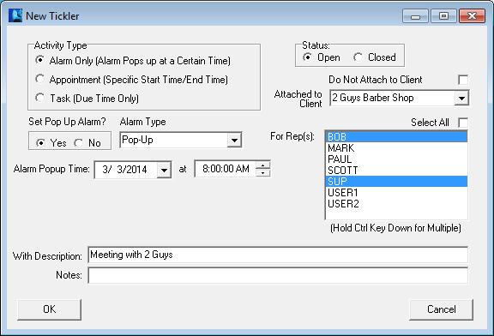You can create ticklers for other users (select the user name in the Set Tickler for Rep box) and the tickler will go off when that user is logged in to EasyApps Pro.
Figure 40 – Creating a tickler
You can also create a tickler that’s attached to a client other than the client currently selected in the Clients window. Select the client name you want in the Attached to Client box.
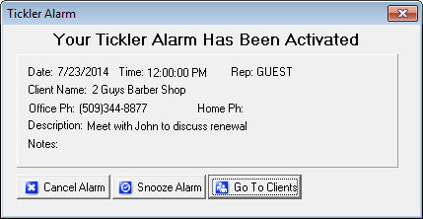
When a tickler alarm goes off - You can “snooze” the tickler to go off again later by clicking the Snooze button and setting a new time. Or you can close the tickler permanently by clicking the Cancel Alarm button.
Click the Go To Clients button to close the tickler and open the EasyApps Pro Clients window. When you click this button, the tickler will reappear in a few seconds, and keep reappearing every few seconds until you click Cancel Alarm or Snooze. If you click Snooze and click Ok the Alarm will automatically be snoozed for 10 minutes, or you can set the alarm for another time or day.
Edit a tickler: To edit a tickler, either double-click that tickler in the list, or click the tickler in the list to select it, click the Edit Tickler option below the list, and click Do It. Make your edits and then click OK.
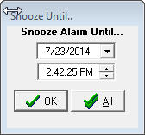
Delete a tickler: To delete a tickler, click the tickler in the list to select it, then click the Delete Tickler option, and click Do It. When queried if you’re sure, click Yes.
Snooze All feature: When a tickler alarm displays, if you click the Snooze button, on the snooze window there will be a Snooze All button. Click the Snooze All button after setting the date and time and that will snooze all ticklers that are due to that date and time.

The Setup Tab
Click the Setup tab to review and adjust your settings and code tables.

Agency Information
The Agency Information is also the producer information that appears on your ACORD forms. This information comes from the information submitted during purchase to Agency Software. You can change the Agency Information by submitting the Change of Address form (found on the support page at agencysoftware.com) to Agency Software.

Encrypt Client SSN’s
The Encrypt Client SSN’s option is designed to secure the client social security number on the Personal tab. Once checked it cannot be reversed and the social security numbers are only available one at a time by clicking the Decoded SSN button next to the SSN field.

Automatic Data Backups Configuration
In the # of Days Between Backups box you can set a schedule for automatic data backups. If, for example, you select 7, then every 7 days the first thing that happens when EasyApps Pro is opened is a data backup. EasyApps Pro creates a compressed backup file of all your EasyApps Pro data and saves it in the EAPPW\Backup folder. Since these backups are stored directly on your computer’s hard drive, they do not protect against hardware failure, fires or viruses. You MUST have an offsite backup method (i.e. tape backup, CD Burner or memory stick that you can take with you) available as your primary backup source.
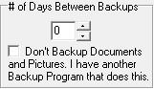
You can include the EasyApps Pro backup in your Microsoft Scheduled Tasks so you can back up EasyApps Pro at a time that's convenient for you. For instructions go to the Support page at agencysoftware.com.

Companies Information Database
Click the Companies button (on the right side of the window) to open the Company Information window. The toolbar buttons will allow you to Add, Edit, Delete and scroll through companies.
Click the + (Insert Record) button to add a new company to your Companies database. Fill in the fields, and then click the check mark button to save your entries.

Employees Information Database
On the Agency Setup tab, click the Employees button to open the Employees window.
The toolbar at the top is like the rest of the toolbars in EasyApps Pro – with the buttons, you can Add, Edit and Delete usernames and producers in EasyApps Pro.
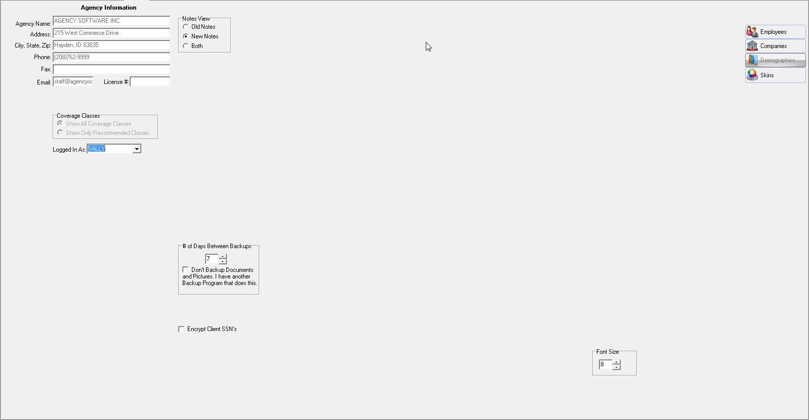
Once your employees have been entered you can choose the appropriate employee from the Logged In As drop down on the Setup tab. This will automatically enter the user’s name as they add notes in the program.

Appearance Settings
The Skins button allows you to choose a theme. The listed themes change the colors of the program background.

SECTION 4

DATABASE UTILITIES
Several maintenance utilities have been included with EasyApps Pro. These utilities and instructions for their use are noted below, beginning with the Backup utility. We start there purposefully, as these utilities mast be ran with care (there is no undo).

Backup
Select this option from the EasyApps Pro menu on your Windows Start menu (or from the Utility folder on the Windows 8 or 10 desktop) to perform a data backup. This icon launches the EAPPW\Backup.exe program. The backup is best done while no one is in the program or Acord forms.
For a smaller, data only backup check the box labeled ‘Skip Pictures and Documents…”, click OK. The next screen allows you to place and name the backup file. By default it will be placed in the EAPPW\Backup folder. Click OK.
This creates a .bxx file titled the date it was done (by default). This file can be copied from the original location and restored using the Restore instructions below.

Restore
Select this option from the EasyApps Pro menu on your Windows Start menu (or from the Utility folder on the Windows 8 or 10 desktop) to perform a data restore from a backup taken previously (see instructions in Section 1 on Moving the Program). This icon launches the EAPPW\Restore.exe program. The restore is best done while no one is in the program or Acord forms.
WARNING: This utility will overwrite all your current EasyApps data.
Once you launch the Restore utility, enter the password of ‘idaho’, then locate the backup you wish to restore (a valid .bak or .bxx file created from EasyApps Pro). In the Restore window confirm that the data path points to the correct data folder (EXE: C:\EAPPW\DATA\) and click OK.
Once the restore is complete exit the Restore utility and run the Keyfix (instructions below).

Keyfix
The Keyfix utility will rebuild all of your index files on the system databases. Utilize this function after restoring, or when receiving an “Index out of date” or “Cannot perform this operation on a closed dataset” message.
- Close EasyApps Pro on all machines
- Click Start, Programs, EasyApps Pro, Keyfix (or from the Utility folder on the Windows 8 or 10 desktop), click the Start button
- Allow Keyfix to run until you see the message "Rebuild Complete".

Agency Setup
Select the Agency Setup option from the EasyApps Pro menu on your Windows Start menu (or from the Utility folder on the Windows 8 or 10 desktop) to update your agency information to what Agency Software has on file or to update your email or fax number. This icon launches the EAPPW\Setupw.exe program.

Enter your 10 digit agency phone number (your main number listed in our records), then click OK. This will pull in your agency information and update the Setup information and main Acord information within EasyApps Pro.
If this utility cannot connect, disable your firewall (specifically port 1163) then try relaunching Agency Setup.
If the setup information on our record is incorrect you can submit a change of address by utilizing the form at agencysoftware.com/support/forms/.
Forms that have been created before an agency information change can be updated to the current information by choosing “Update Producer Info” on the Acord form (ALT+P).

SearchReplace
SearchReplace is a global change utility that can change one entry to another for all matching instances within the database. For instance, say that some of your CSR’s have entered policies under the CPKG coverage class, while others have entered them under Comm. Package. This utility allows you to clean up this fragmentation for a more consistent database and cleaner reports.
WARNING: There is no undo and it is wise to first get a backup.
Access the utility by browsing to EAPPW and opening SearchReplace.exe. Select the table from Change All Records in Table field (the EAPPW\Data\policy.db table in our example), choose the one you want replaced in the From Value (CPKG), enter what you want those instances change to in the To Value (Comm. Package), click OK to eliminate all instances of the From Value and change them to the To Value. This utility is case sensitive.
The Change Partial Matches field can be utilized to change all instances starting with a certain value to the value specified. For instance, say I have Progressive listed in my policy’s company field several different ways (Progressive County Mutual, Progressive Insurance, etc.). I can list the From Value as Progress and the To Value as Progressive. This will change all companies starting with Progress to Progressive.

Merge
The Merge utility allows you to merge data from one client into another, then deletes the originating client. A good example situation in which you would use this utility is when two of your clients marry and you want to merge them into a single client (or household).
WARNING: There is no undo and it is wise to first get a backup.
Access the utility by browsing to EAPPW and opening Merge.exe. On the left side is the header “Merge Detail from this client…”; select the client you want to remove from this side of the utility. On the right side is the header “Into this Client”; select the client you want to keep, who will retain both clients’ data. Click the double arrow button in the middle of the utility and wait (DO NOT CLICK TWICE, this may take a minute).
Once you refresh your client list the client you kept will have all of the data (policies, notes, personal items, Acord forms, etc.) of both clients, and the client from which you merged will be gone.

Password
The Password (of Get Current Password) allows current users to obtain the current update password. Select the Get Current Password option from the EasyApps Pro menu on your Windows Start menu (or from the Utility folder on the Windows 8 or 10 desktop).
If this utility cannot connect, disable your firewall (specifically port 1163) then try relaunching.

SECTION 5

TROUBLESHOOTING

EasyApps Pro Slow to Open
Try disabling the anti-virus program on the local machine. If the program opens more quickly, the anti-virus is the problem. You need to set exclusions in your anti-virus program so that the anti-virus can run without interfering with your EasyApps Pro database files. Go to the web site www.agencysoftware.com. On the Support page, click the link that reads “Program Running Slow or Locking Up” for more information on exclusions and details on other things to look for.

EasyApps Pro will not open, no error
Often this means that there are multiple processes in the task manager. Open the Windows Task Manager (CTRL+ALT+DEL), click the Processes tab, and end any instance of eappw.exe you find. Try the program again, being sure to give it plenty of time (this happens due to system/network slowness).

Cannot Perform Operation on Open Dataset
This error occurs in the ACORD window. It is preceded by an error showing characters and stating that those characters are not a valid integer. Trying to add an ACORD form after that message will generate this error. This means that some data in the ACORD forms has corrupted. Call Technical Support immediately and prepare to transfer the data to Agency Software for examination and correction of the corruption.

Index Out of Date
This error usually occurs when someone has used Ctrl-Alt-Delete to get out of the software or has shut down their computer while EZApps was running
- Close EasyApps Pro on all machines
- Click Start, Programs, EasyApps Pro, Keyfix.
- Allow Keyfix to run until you see the message "Rebuild Complete".

Forms will not open, giving error
If no forms are opening on a single workstation, the memory setting might need to be adjusted. Close EasyApps Pro, browse to the EAPPW folder, and open Techtools (Techtoolsv8 for Windows 8/10 users). Click the BDE Adjust tab, note the current setting on the left side, then click the 2000 button (if it was currently 2000 try a different setting). Close techtools, return to EasyApps Pro, and try opening a form again.

Printer Doesn’t Print from EasyApps Pro
This problem is most likely to occur when an agency is trying to print to a multifunction printer from EasyApps Pro. There are some multifunction printers EasyApps Pro will not print to. These include some Xerox WorkCenter XE series printers. There is no fix for this. The agency must print to a different printer.

Text Won’t Fit into Lines on Forms
This problem is usually caused by having Large fonts set on the particular computer that has the problem. The ACORD forms are not designed to run in a Large-fonts environment.
To change the font settings back to Normal:
- Right-click in an empty space on your computer desktop.
- On the shortcut menu, click Properties.
- In the Display Properties dialog box, click the Settings tab.
- On the Settings tab, click the Advanced button.
- On the General tab, you’ll see a box labeled Font Size or DPI Settings (depending on your version of Windows). The box probably has “Large” or “125%” or some similar setting (again, depending on your version of Windows).
- Click the arrow in the box to open a list of choices.
- Choose Normal, or choose Other and set 100%.
- Click OK to close every open dialog box. You may need to restart your computer (depending on your version of Windows).

External Exception/Unknown Internal Operating System Errors
These messages indicate a network interrupt. The reason for these interrupts can vary network to network. Anything from aggressive antivirus, to a bad network card can cause these errors. See more about the potential issues by referring to the “Program Running Slow or Locking Up” document in the Support section at our website.

Index

A
Acord form menus
Adjust 60
Edit 58
File 57
Help 60
Options 59
Tools 58
View 58
Acord form options 50
Acord form toolbar 55
Acord form window 55
Acord forms
Add New Form 50
Delete Client’s Form 51
Duplicate Client’s Form 51
Edit Client’s Form 51
Entering data in forms 61
Mark Forms for Mass Print 52
Move Forms to Diskette 53
Print Mass Marked Forms 53
State-specific forms 51
Acords Window 49
Additional Interest 77
Agency Setup 99
Automatic backup schedule 100
Companies Information Database 100
Employee information 101
Users 101
Apro Setup Window 99
B
Backups 16, 100
C
Calendar 96
Certificate Holders 61, 62
Add from Master List 66
Add new 62
Blanks 64
Button 61
Delete 68
Duplicates 63
Edit 66
Menu 62
Print certificates 68
Print list 69
Same holder, multiple jobs 64
Certificates, Print 68
Clients
Add a Client 34
Delete a Client 35
Edit a Client 37
Edit Client Information 34
Filter client list 36
Restore client list after filter 36
Clients Toolbar 35
Clients Window 33
Coverages 47
Class 47
Coverage 48
Deductible 48
Limit 48
Notes 48
Custom Report 86
Customer Demographics 83
D
Default Limits 48
Demographics 83
Drivers 73, 77
Drivers Database 73, 77
E
Email viii, 53, 57, 69, 77, 78, 79
Set up 78
E-mail doesn’t work 79
Emailing Forms 77
Equipment 73
Equipment Database 72
External Exception 109
F
Forms
Emailings 77
H
Help Files 28
L
Letters 90
Attach to client 94
Custom letters with merge fields 93
Merge client data 91
rtf file type 91
Letters Window 90
M
Mailing labels 90
Mailing Labels 90
N
Notes 80
Notes Window 80
P
Personal 83
Personal Window 83
Policies 39
1st Rep Name 45
1st Rep % of House 45
1st Rep Commission 46
2nd Rep % of House 45
2nd Rep Commission 46
2nd Rep Name 45
Add New Policy 42
Agency % of Premium 45, 46
Agency Income 46
Billing Method 45
Company 44
Coverages 47
Display Options 41
Down Payment 46
Effective Date 44
Expiration Date 44
First Payment Due 46
For Options 41
Installment Type 46
Net Premium 46
Non-Premium Items 45
Number of Payments 46
Policy Options 40
Policy Status 45
Premium Amount 45
Total Due 46
Policies Window 39
Property 73
Property List, Print 77
R
Reports 84, 90
Custom 86
Delete 90
Edit 90
Mailing labels 90
Print too small 85
Reports Window 84
rtf file type 91
S
Surveys 95
T
Tickler
Alarm 98
Create new 97
Edit 99
Tickler Window 96
Troubleshooting
Agency Pro Slow to Open 107
Cannot Perform Operation on Open Dataset 107
Printer Doesn’t Print from Agency Pro 108
Text Won't Fit into Lines on Forms 108
User Can’t Delete Clients 108
TROUBLESHOOTING 102, 107
U
Unknown Internal Operating System Errors 109
V
Vehicle 70
Vehicle List, Print 72
W
Window
Acords 49
Agency Setup 99
Clients 33
Letters 90
Notes 80
Personal 83
Policies 39
Reports 84
Tickler 96

Files compatible with this feature of EasyApps Pro must be saved as *.rtf file types. Files saved as *.doc files will not be recognized. Files saved with table formatting in a word processing program will be altered when saved as *.rtf files.

