DIRECT BILL RECONCILIATION
We have redesigned the Direct Bill Reconciliation window to make it more user friendly.
Direct Bill Reconciliation is done from the Ledger window. Click the dollar button on the tool bar on the Ledger tab (Receive Direct Bill Payment) to enter the Direct Bill Reconciliation window.
In Date Commission Check Deposit, enter the date you want the deposit for this commission check to be entered in your Cash Account, choose the Company to Reconcile, and enter the amount of the Commission Check in the Commission Check Amount field.
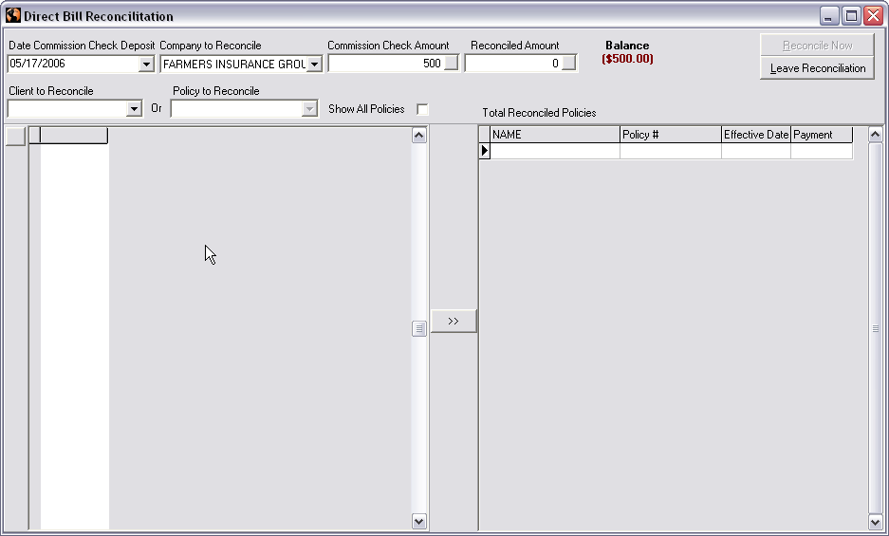
In Client to Reconcile, click the down arrow and the drop down list will show only the clients that have direct bill policies with the company you chose in Company to Reconcile. Once you choose a client from the Client to Reconcile drop down list, the window on the left will show only that client’s direct bill policies for the company chosen in Company to Reconcile. You can also click the down arrow in Policy to Reconcile and that will show a list of all the policy numbers for the direct bill company chosen in Company to Reconcile, so you can choose by policy number which policies you would like to reconcile. Both of these drop down boxes, Client to Reconcile and Policy to Reconcile, are first key sensitive so you can just start typing the client name or policy number with drop down list down and it will take you as close to what you typed as it can.
After you choose a client, that client’s direct bill policies that you have not been paid your commission on, will be listed on the left side of the window under the client’s name or if you chose from the Policy to Reconcile drop down you will have the correct policy listed on the left side of the window. To reconcile a policy if you were paid in full, double click that policy line item on the left, and that will fill in the Payment field with the Amount Due, then click the double arrows in the middle of the window to move the Payment amount to the right side of the window to indicate it’s reconciled. If you were only paid part of your commission you can type the amount you were paid in the Payment field and then click the double arrows in the middle of the window and that will move that Payment amount to the right side of the window to indicate the portion you were paid on those policies.
AgencyPro will show how much you have reconciled so far in the Reconciled Amount field. When you double click on a line item on the left, to indicate you were paid in full, it will change the No in the All Paid column to Yes. If you are only receiving part of your commission that field will say No until you are paid in full and the policy is reconciled in full.
The Reconcile Now button will be available when the Reconciled Amount matches the Commission Check Amount. Clicking the Reconcile Now button will post the deposit for the amount of your commission check into the Cash Account on the Ledger tab. The item’s you received part of your commission on will still be in the Direct Bill Reconciliation window the next time you go in to do Direct Bill Reconciliation and the Amount Due field will reflect the amount that is left due your agency. Any policies that were reconciled in full will not show up in the Direct Bill Reconciliation window again.
If you reconciled a policy and moved it to the right side of the window and then decide you didn’t want to reconcile that policy or you need to change the amount, you can by either double clicking on the line item on the left side of the window again, after choosing the client whose policy it is, to change the amount paid back to zero and then click the double arrow button in the middle and that will take it off the right side, or you can change the Payment amount on the left side to zero and click the double arrow buttons in the middle and it will remove that amount from the reconciliation and take it off the right side of the window.
At any time you can click the Leave Reconciliation button and the system will automatically save what has been reconciled so far. When you return to the Direct Bill Reconciliation window you will need to re-enter Date Commission Check Deposit, choose the Company to Reconcile and enter the Commission Check Amount, and all the policies that were reconciled previously for that specific company will still be reconciled so you can finish the reconciliation.
There is a button with a magnifying glass on the left side of the window. This button will take you to the policy detail window for whatever policy line item you are on, on the left side of the window. If you need to make an adjustment to a policy, you can do so from this button. The first thing you need to look at if you want to make a change to a direct bill policy from the Direct Bill Reconciliation window is what the Amount Due on the left side of the window is. If that amount matches the Agency Commission amount on the policy detail window (bottom left) after clicking the magnifying glass, then it’s ok to make any changes and regenerate accounting. If they don’t match that means you’ve already received a partial payment on that policy and if you regenerate accounting, you will have to re-reconcile what was already reconciled. Be careful about regenerating direct bill policies that have already had some commission reconciled.
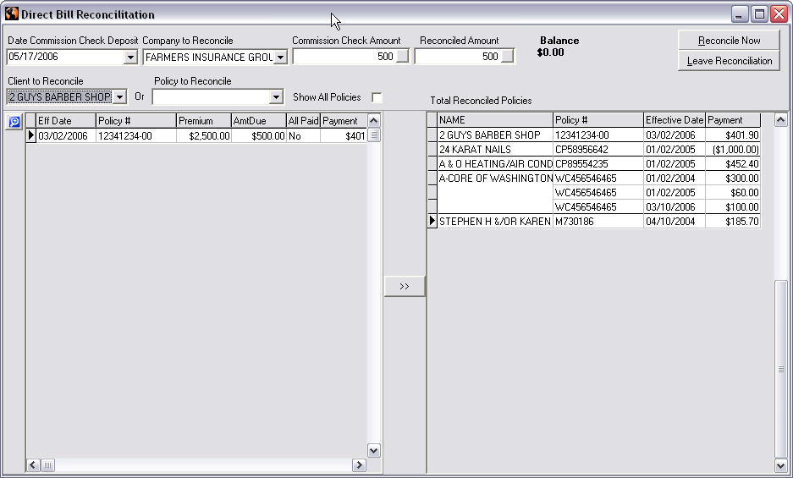
NOTE: Direct Bill Reconciliation is not mandatory when on a Cash basis accounting method if you do not pay producers a portion of your agency’s commission. Simply enter the deposit in the Cash account for the amount of the commission check and in Transaction Detail allocate the deposit to a commission income chart number. If you add your deposit in the Cash Account, Do Not reconcile Direct Bill or you will duplicate your income.

Direct Bill Reconciliation is also not mandatory when on one of the Accrual basis accounting methods. Just add the deposit to your Cash account for the amount of your commission check and in Transaction Detail allocate the deposit to that companies A/R chart number (as long as those direct bill policies are entered in AgencyPro with the commission on them). When on one of the Accrual basis accounting methods, the system posts the policy upon saving; therefore, creating a receivable due from the company. Recording the deposit to the Companies A/R chart number will reduce that receivable to show the company has paid you if you don’t want to do Direct Bill Reconciliation.

