`
AgencyPro for Windows
Product Manual



215 W. Commerce Dr.
Hayden, Idaho 83835
Sales & Technical Support 800.342.7327

License and Sales Agreement
This document is an agreement between you, the end user, and Agency Software, Inc. By initial installation and/or use of any of the programs which are part of Agency Software, Inc. (EasyApps, Par32, and AgencyPro, herein after called the program). You are agreeing to become bound by the terms of all parts of this agreement. This agreement constitutes the complete agreement between you and Agency Software, Inc., and it may not be changed or terminated orally but only by an instrument in writing signed by the party against whom enforcement of any waiver, change, modification, extension, discharge or termination is sought.

GRANT OF LICENSE
In consideration of payment of the License Fee, which is a part of the price you paid for this product, Agency Software, Inc., as Licenser, grants to you, the Licensee, nonexclusive right to use and display this copy of the program at a single location.

OWNERSHIP OF THE PROGRAM
As licensee, you own the magnetic or other physical media on which the program is originally or subsequently recorded or fixed, but Agency Software, Inc. retains title and ownership of the program recorded on the original disk copy(ies) and all subsequent copies of the program, regardless of the form or media in which the original and other copies may exist. This license is not a sale of the original program or any copy.

USE RESTRICTIONS
As the Licensee, you may physically transfer the program from one computer to another provided that the program is used only by up to FIVE LICENSED USERS. A licensed user is defined as a single person to whom the software is licensed. This means that you may use the software on any computers associated with the single licensed user including office, home, notebook, and network computers. Branch offices, satellite offices, or multiple businesses sharing the same location are not covered under this agreement. Additional licenses for additional users may be purchased at an additional fee.

TRANSFER RESTRICTIONS
The program is licensed only to you, and may not be transferred to anyone without the prior written consent of Agency Software, Inc. Any authorized transferee of the program shall be bound by the terms and conditions of this agreement. In no event may you transfer, assign, rent, lease, sell or otherwise dispose of the program on either a temporary or permanent basis.
Agency Software, Inc.’s entire liability and your exclusive remedy as to the disk(s) shall be at Agency Software Inc.’s option, either (a) return of the purchase price, or (b) replacement of the disk(s) that do not meet the above stated limited warranty and which is returned to Agency Software, Inc. with a copy of the receipt. If a failure of the disk had resulted from accident, abuse, or misapplication, Agency Software, Inc. shall have no responsibility to replace the disk(s) or refund the purchase price. Any replacement disk(s) will be warranted for the remainder of the original warranty period or thirty (30) days, whichever is longer.
IN NO EVENT WILL AGENCY SOFTWARE, INC. BE LIABLE FOR ANY DAMAGES INCLUDING LOST PROFITS, LOST SAVINGS, OR OTHER INCIDENTAL OR CONSEQUENTIAL DAMAGES RESULTING FROM THE USE OR INABILITY TO USE THE PROGRAM, EVEN IF AGENCY SOFTWARE INC. HAS BEEN ADVISED OF THE POSSIBILITY OF SUCH DAMAGES, OR FOR ANY CLAIM BY ANY OTHER PARTY.

Credits and Copyright
AgencyPro® for Windows
Program written by K. Mitchell McInelly
User’s Manual & Windows Help Files written by Julia Kelly
Much thanks to Ray Conger and Marla Obray for their advice and wisdom throughout this project
Copyright 1999-2014 by Agency Software, Inc.
All Rights Reserved
No part of this manual may be reproduced, transmitted, transcribed, stored in a retrieval-based system, or translated into any language, natural or automated, in any form or by any means, without the prior written consent and permission of an officer of Agency Software, Inc.
The software described in this manual is protected by the outlined copyright laws.
This manual could include technical inaccuracies or typographical errors. Changes are periodically made to the information herein. These changes may be incorporated in new additions of the manual which can be found at www.agencysoftware.com.

History of Agency Software, Inc.
Agency Software, Inc. (ASI), established in 1988, has been the forerunner of property & casualty insurance software since its inception date. Founded by James M. Carpenter and current President and CEO K. Mitch McInelly, ASI has an existing insurance user group that exceeds 20,000 agencies. With 70,000 insurance agents in the United States, ASI is proud to claim an installation base rate of nearly 26% of all agencies, and over 30% of all automated (PC based) agencies in the U.S.A. ASI has helped these agencies' users actuate their PC's for the purpose of increasing overall penetration of personal and commercial lines markets.
ASI has proven to be an invaluable asset to their agency users through the creation and support of an impressive library of insurance software products. These products include such industry standards as, PAR3, EasyApps, EasyApps Professional, EZAgent, EZ Download Manager, EZ Download Plus, and AgencyPro.
1999 sees a landmark in insurance software in the form of Agency Software’s latest program, a full-fledged insurance agency management system appropriately titled AgencyPro for Windows. With careful attention to ergonomics and ease of use, AgencyPro provides maximum functionality.
With company focus, development, and marketing strategies aimed and addressed toward Property and Casualty insurance companies for the new millennium and beyond, Agency Software, Inc. is committed to developing customized software systems for those carriers who share the common goal of increasing overall written premiums while decreasing errors and omissions exposure.

About Our Products
Our products create a central database for all your client information; and in some cases, direct access to insurance company web sites.
For years, agents have been populating their companies' databases with their own client information; now it's time to get that information back! Keep your client information in your own database as well as in the company database, and (with EZAgent and AgencyPro) pull existing client information from the company database down into your database.
It is easy to transfer your customer information from Outlook into the Clients window; just drag the customer name from the Outlook window and drop it onto the program icon on your desktop.
Track your clients' policies, claims, personal data (family names, birthdays, etc.), and any notes you wish to permanently record about client interactions.
Run preloaded reports (not available in EasyApps), such as Commission by Rep and Customer by Expiration Date, or create your own custom reports for any specific data you want. Print mailing labels for any or all of the clients in your database.
You can also write letters to specific clients or create form letters for several clients, and attach those letters to specific clients so you can find them easily in the future. There are many pre-built marketing letters that you can either use as is or edit, and they are ready to merge with client data such as names, addresses, and personal and policy information.
The Tickler system allows you to set reminders, and an automatic transactional file that records every transaction anyone made.
In short, our products makes your work as an agent much more efficient and puts you in control of your clients' insurance needs!

Support Maintenance and Updates
To maintain support and product updates you must:
Have internet access – All updates are available by internet only.
Renew support fees – To continue support and updates you must pay an annual maintenance fee, for which you will be billed in advance. In addition, if you experience hardware technical problems, you must have an experienced technical person available to deal with our technical support team.

Contacting Support
If you suspect the problem is with your computer hardware, printer, or software unrelated to Agency Software programs, seek help from a local tech person.
If you feel the problem is related to your Agency Software program you can access technical resources or contact our technical support team through:
Website: www.agencysoftware.com
Email: support@agencysoftware.com
Telephone: 800.342.7327 ext. 30
Our support team will respond as quickly as possible considering the current call load, usually the same day, usually within the hour (during business hours of 7am to 4pm Pacific Time (pst), Monday through Friday). If you are hiring outside tech support, make sure to make an appointment with one of our tech team members in advance to minimize your costs for outside support. If your tech is on site, be sure to say so if you reach our voice mail during business hours.

Using this Manual
This manual has been designed to take you from initial installation to proficiency. When changes are made to this manual, the newest version will be available on our website at agencysoftware.com.

Table of contents

License and Sales Agreement ii
GRANT OF LICENSE ii
OWNERSHIP OF THE PROGRAM ii
USE RESTRICTIONS iii
TRANSFER RESTRICTIONS iii
Credits and Copyright iv
History of Agency Software, Inc. v
About Our Products vi
Support Maintenance and Updates vii
Contacting Support vii
Using this Manual viii
SECTION 1 - INSTALLATION
Technical Requirements 16
Server 16
Workstation 17
More Technical Information 17
User Rights 17
Network Attached Storage (NAS) Devices 18
Wide Area Networks 18
Backing Up 18
Qualified Technical Support 18
Data Storage Information 19
Updating the Program 19
Obtaining the update password 19
Accessing the update 20
PROGRAM INSTALLATION 20
Standalone Installation 21
Network Installation 23
Setting up the Network 23
Mapping Letter Drives 23
Initial Installation 25
Workstation Setup 27
Moving the Program 29
SECTION 2 – HINTS & TIPS
Navigation 31
Help Files 31
List Boxes 31
Tabs 32
Toolbars 32
Scroll Bars 32
Moving Around in AgencyPro 32
SECTION 3 - PROGRAM FEATURES
The Today Screen 36
The Clients Tab 37
Adding a Client 39
Editing Client Information 39
Deleting a Client 39
The Clients Toolbar 40
The Web View Tab 41
How to Use the Web View Window 42
The Web View Toolbar 44
The Policies Tab 45
Policy Options 46
Display Options 47
For options 47
Additional Details for Using the Policies Window 48
Add a New Policy 48
Required Fields 49
Optional Fields 50
Coverages 53
The Limits Window 53
Setting Default Limits 54
The Client A/R Tab 55
Hiding Paid Items 58
The Ledger Tab 58
Accounts 58
Ledger Tools and Navigation 60
Adding Ledger Entries 61
Printing Checks 63
Making Deposits 64
Direct Bill Reconciliation 66
Payables 70
Account Transfer 72
Bank Reconciliation 72
Editing/Voiding Ledger Entries 73
General Ledger Access 74
The ACORDs Tab 75
ACORD Options 75
Duplicate Client’s Form 77
Mark Forms for Mass Print 79
Print Mass Marked Forms 79
Move Forms to Disk 79
The ACORD Formview Window 81
The Formview Toolbar 82
The ACORD Formview Dropdown Menus 83
Entering Client Information in ACORD Forms 87
Certificate Holders 88
Certificate Holders Menu 88
Adding Certificate Holders 89
Description of Operations 92
Editing Certificate Holders 93
Adding Certificate Holders from the Master List 93
Deleting Certificate Holders 94
Printing Certificates for Selected Cert Holders 95
Generate Cert Holder List 96
Close the Certificate Holders Menu 97
Vehicle Database 97
Enter Vehicles in the Vehicle Database 97
Fill a Form with Vehicle Information 98
Attach Vehicles to Specific Policies 99
Print a Vehicle List Report for a Client 99
Equipment Database 99
Add Equipment to the Equipment Database 100
Drivers Database 100
Add Drivers to the Drivers Database 101
Property Database 101
Enter Property in the Property Database 101
Fill a Form with Property Information 103
Print a Property List Report for a Client 103
Emailing Forms 104
Setting Up Email 104
Sending an Email 106
The Notes Tab 106
The Reports Tab 110
Create a Custom Report 112
Create Mailing Labels 115
Edit a Report 116
Permanently Delete a Report 116
The Letters Tab 116
What’s In the Letters Window 116
Merge Client Data into a Letter 117
Creating Custom Merge Documents 118
Attaching Letters to Clients 120
The Personal Tab 122
The Claims Tab 123
The Images Tab 124
The AgencyPro Document Manager 124
Adding Files with the Document Manager 127
Adding Files from the Images Window 127
Adding Files with the Desktop Document Manager Icon 129
Adding Files from ScanSoft™ PaperPort 9 132
Adding Files using the Agency Software Printer 134
Using Your Attached or Linked Files in AgencyPro 135
The Tickler/Calendar Tab 137
Change Your View of Ticklers 141
The TFile Tab 141
Date Range Display Options 143
Manually Add a TFile Item 143
The Surveys Tab 144
The Agency Setup Window 145
Agency Information 145
Coverage Classes 146
Encrypt Client SSN’s 146
Automatic Data Backups Configuration 146
Setting Global Messages 147
Companies Information Database 147
Company Commission Grid 150
Employees Information Database 150
Employee (Rep) Commission 152
Employee Passwords 153
Demographics Categories 154
Appearance Settings 154
Reset Grids 154
SECTION 4 - ACCOUNTING SETUP AND WORKFLOW
Accounting Setup 155
Setting up your Accounting Basis 155
Chart of Accounts 156
Opening Balances 160
Policy Entry 162
Differences in Billing Method 163
Rules of Policy Entry 164
Entering a Policy 165
Downloaded Policies 170
Editing a Policy 170
Agency Bill Workflow 171
Billing the Client 171
Accepting the Client Payment 172
Paying the Company 173
Agency Bill Commission 174
Direct Bill Workflow 176
Direct Bill Reconciliation 176
Alternatives to Direct Bill Reconciliation 177
Accepting the Client Payment 178
Month End Procedure 179
Bank Reconciliation 179
Confirm Trial Balance is In Balance 179
Run and Proof Reports 181
Paying Rep (Producer) Commission 182
Journal Entries 184
Close Books (Year End process) 184
Year End Adjustments 185
Policy Purge 185
Accounting Work-Arounds 186
Policy Financing 186
Cancellations and Return Premium 187
A/R Adjustments 190
Company Payment Modifications 194
SECTION 5 - TROUBLESHOOTING
AgencyPro Slow to Open 196
AgencyPro will not open, no error 196
User Can’t Delete Clients 196
User gets Key Violation when Logging In 196
Client tab is blank for one user 197
Cannot Perform Operation on Open Dataset 197
Index Out of Date 197
Forms will not open, giving error 197
Unrecognized Tag in Mail Merge 198
Printer Doesn’t Print from AgencyPro 198
Text Won’t Fit into Lines on Forms 198
Backups taking a long time 199
External Exception/Unknown Internal Operating System Errors 199
Report print is too small 199
Index 201

The EZ Download Manager Instruction Manual may be added as a supplemental manual to the back of this document.

SECTION 1
INSTALLATION
This section will cover the product requirements and direct you through installing AgencyPro to either your local machine (as a standalone) or to a shared location to be accessed by the entire office.

Technical Requirements
The following technical requirements are what you must have to install and run AgencyPro. These system requirements and recommendations are subject to change as technology evolves.

Server
- Pentium (2+ Ghz)
- 4+ GB RAM
- 1 GB HD space free*
- 100 MBPS network (Gigabit highly recommended)
- Wired network**
- Windows Professional versions: XP, Vista/Windows 7, Windows 8, Server 2003, Server 2008, Small Business Server (Small Business Server not Recommended for Terminal Services)
- Internet connection (high-speed recommended)
- Video settings 256 colors or greater
- Internet Explorer 8.0 or better installed
- CD-ROM (at server/standalone)
*Initial HD space for program and database storage, this does not include document storage (which is likely to use up significantly more space as the agency goes paperless).
**Databases are prone to corruption over wireless networks.

Workstation
- Pentium (2+ Ghz)
- 1+ GB RAM
- 100 MB HD space free*
- 100 MBPS network card (Gigabit recommended)**
- Wired network**
- Windows Professional versions (XP, Vista/Windows 7, Windows 8)
- Internet connection for technical support
- Video settings 256 colors or greater
- Minimum screen resolution of 800x600
- Internet Explorer 8.0 or better installed
- Installed default printer driver
*Initial HD space for program and database storage, this does not include document storage (which is likely to use up significantly more space as the agency goes paperless).
**If workstation accesses the program through the network.

More Technical Information
For best results please review the following information carefully prior to installation.

User Rights
For best results the user should be granted Administrative rights over the local machine and the network share (if applicable). If the workstation is running Vista or Windows 7 operating systems, the User Accounts Controls can be disabled (followed by restarting the workstation) prior to installation for easiest configuration. Please contact technical support for more information or other options.

Network Attached Storage (NAS) Devices
Network attached storage devices are not recommended. With no controller card, these devices are not a solution for multiple user configurations and may cause significant slowdowns of data retrieval.

Wide Area Networks
AgencyPro is adaptable to wide area solutions, such as Terminal Services or cloud services (please read the copyright notice for more information). These wide area solutions must be properly configured to support program functionality. For more information please contact customer support.

Backing Up
Our programs have an option for Automatic Data Backups. These backups are written to the same location as your program data (in the Backup folder) and are not a valid backup solution for your program data. You MUST have an offsite backup method available as your primary backup source. We suggest backing up the entire program folder to an external location regularly, but making sure this is done while no one is in the program.

Qualified Technical Support
Your equipment needs to be properly configured and maintained by a qualified local technician.

Data Storage Information
The initial installation creates an APRO folder where all shared program data will be stored. This program folder will be typically located at the c:\ of a standalone or the root of a mapped network drive. All of our databases and executables are located inside of the APRO folder.
*AgencyPro SQL files are located in an APROSQL folder. SQL installation instructions are not provided in this section of the manual. Please see the insert for more information.

Updating the Program
We suggest doing monthly updates so you have available the most current Acord forms and product features. Our updates are available online only and must be done with no one in the program or forms.

Obtaining the update password
The update will ask for a password. The Password option in the Start Menu program group will check your support status at our servers (your support must be current to access the updates) and give you the current update password.
- From the Windows Start menu select Programs, then the AgencyPro for WIndows program folder
- Select Password.
Alternatively, you can call to obtain the password. Call 800.342.7327 from your main line and select option 2.

Accessing the update
Make sure the program and all forms are closed on all workstations before starting the update.
- Go to www.agencysoftware.com
- Click the Updates heading
- Choose AgencyPro Updates from the Select Update drop down list
- Click the link reading:
“CLICK HERE TO START THE UPDATE INSTALLATION”
- Run the downloaded file and click Next on the Welcome screen
- In the Choose Destination Location check the location for accuracy and click Next
- Click Next on the Start Installation screen
- After the backup enter the password obtained
During the update process the program will:
- Download the most current features
- Run utilities
- End by opening up your start menu folder.

PROGRAM INSTALLATION
Installation procedures must be followed precisely. A faulty installation will produce negative results and possible loss of data. Qualified technical personnel should install the software.
NOTE: Due to an unlimited number of possible computer configurations, Agency Software, Inc. cannot be held responsible for loss of data under any circumstances. Data can be lost or become corrupted by means beyond our control.
The installation will attempt to connect to our server to verify your current support status, therefore, you may have to disable your firewall to allow this connection.

Standalone Installation
Use these directions to install a new copy of AgencyPro to a single computer. Use the Moving Program instructions when moving an existing installation from one standalone to another.
NOTE: Multiple datasets can only be combined (accounting cannot be combined) by Agency Software for a fee. If you intend to share the program over a network in the future, you may consider this when loading the program to multiple standalones.
- Place the AgencyPro for Windows CD (from the front cover of this manual) into the CD-ROM drive. The installation screen will appear
- Click AgencyPro Demo
- In the Welcome screen, click Next
- In the Choose Destination Location screen, examine where the program will be installed (this defaults to C: drive). Change the drive if necessary, but do not change the folder name.
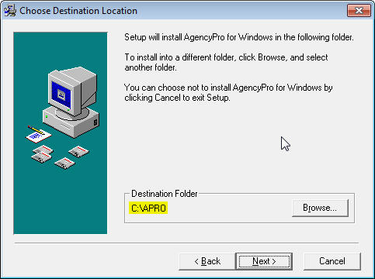
Figure 1 - Choose Destination Location
- In the Start Installation screen click Next.
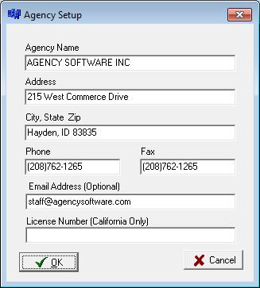
- You will be asked to validate your agency information. Click OK and enter your agency’s 10 digit telephone number, click OK. (If you are unable to connect turn off your firewall and try again.) Your agency information will appear, if any of this information is incorrect please contact customer support for correction.
Figure 2 - Agency Information
- The installation will begin and, when complete, the Start Menu program group will be displayed and the program shortcut(s) will appear on your desktop. You can now Exit the initial installation window and remove the CD.
- Run an update following the Updating the Program instructions in the More Technical Information section.
- After the update run Techtools (TechtoolsV8 for Windows 8 computers) for supplemental install adjustments. The common adjustments depend on which program you are installing and which version of Windows you are running.

If you are running Windows:
XP - click the tab to:
- ASI Printer – click Install ASI Printer
Vista & Windows 7 - click the tab to:
- Run as Admin – click the blue button to fix Vista and Windows 7
- ASI Printer – click Install ASI Printer (available only for AgencyPro & EZAgent)
Windows 8 – Click the blue button on the first tab which will give further instruction if additional action is necessary, then install the ASI Printer from the third tab.

Network Installation
Use these directions for the initial installation of AgencyPro to a network (or peer to peer) server. (Use the Moving Program instructions when moving an existing installation from one server to another.) The preferred setup is to a dedicated server (server is not used as a workstation), however, the program can be installed to a peer to peer server (a system someone also uses as a workstation).
NOTE: For best results in Vista and Windows 7, first disable User Account Controls and reboot prior to the installation.

Setting up the Network
Your network should be set up by a qualified network technician. Our program is loaded to a shared folder on a physical drive (see information on NAS devices in the Technical Requirements section) of the server computer (we would typically call the share ASI). Full control must be granted over the shared folder and all subdirectories to all users (Everyone).

Mapping Letter Drives
Drive letters should be mapped identically on the server and all workstations (very important for imaging purposes). These common network drives are mapped to the shared folder, not the Agency Software program folder.
First, get the Full Computer Name of the server machine.
To find the Full Computer Name right-click the Computer (or My Computer) icon on the server machine and click Properties. On XP click the Computer Name tab. You want the Computer Name (not the Computer Description) without the period that follows it. On Windows 7 it will be listed under Computer Name.
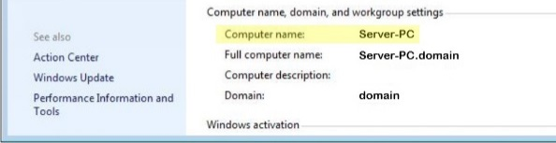
Figure 3 - Find Computer Name
Next you will map a network drive:
- Click with the right mouse button on the Computer (or My Computer) icon.
- Select Map Network Drive.
- Open the list in the Drive box and select the network drive letter you want to use (for example, Q:).
- In the Folder box, type the path to the drive where you will install the program (e.g., if you are going to install the database to the C:\ drive on the computer named Server-PC, you would enter \\Server-PC\C).
Note: It is recommended to install to a shared folder (e.g., a folder named ASI) instead of the C: drive, in that case you would type \\Server-PC\ASI in the Folder box.
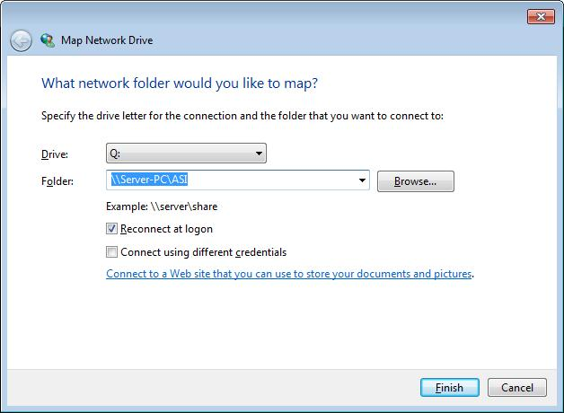
Figure 4 - Mapping network drive
**Do not map to the product’s program folder**
- Click Finish. A window to the new mapped drive opens, and it reads Q:\ in the window’s title bar.
You are now ready to install the software to the drive that you just mapped.

Initial Installation
- Place the program CD (from the front cover of this manual) into the CD-ROM drive. The installation screen will appear with options for your product.
- Click the name of the product you are installing.
- In the Welcome screen, click Next.
- In the Choose Destination Location screen, examine where the program will be installed (this defaults to C: drive). Change the drive if necessary, but do not change the folder name.
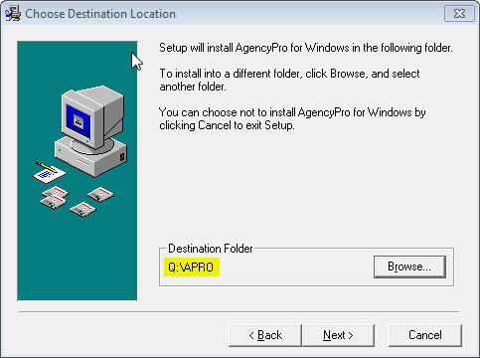
Figure 5 - Choose destination location
- In the Start Installation screen click Next.
- You will be asked to validate your agency information. Click OK and enter your agency’s 10 digit telephone number, click OK. (If you are unable to connect turn off your firewall and try again.) Your agency information will appear, if any of this information is incorrect please contact customer support for correction.
Figure 6 - Agency Information
- The installation will begin and when complete the Start Menu program group will be displayed and the program shortcut(s) will appear on your desktop. You can now Exit the initial installation window and remove the CD.
- Run an update following the Updating the Program instructions in the More Technical Information section.
If this is a peer to peer server you will also run as a workstation, follow the Workstation Setup instructions below.

Workstation Setup
The network drives should already be (identically) mapped as part of the Setting up the Network process in the Network Installation section of this manual.
Follow this procedure at each one of the workstations:
- Double-click the Computer (or My Computer) icon to open the Computer window. (In Windows XP, you may need to click the Start button and then click the My Computer icon on the Start menu)
- In the Computer Window, double-click the mapped drive where you installed the program (in this example the Q: drive)
- Double-click to open the APRO folder
- Double-click the file named setupws.exe (that is setupws.exe not setupw.exe) Windows 8 workstations skip this step and continue to step 7
- Click Next in all the dialog boxes
- When the workstation setup is complete, a window of program icons appears on your desktop (your Start Menu program group). You can close this window at any time
- Run Techtools (TechtoolsV8 for Windows 8 computers) for supplemental installation adjustments. The common adjustments depend on which version of Windows you are running. If you are running Windows:
XP - click the tab to:
- Disable IE Security Warning - click the blue button
- ASI Printer – click Install ASI Printer
Vista & Windows 7 - click the tab to:
- Run as Admin – click the blue button to fix Vista and Windows 7
- Disable IE Security Warning - click the blue button
- ASI Printer – click Install ASI Printer
Windows 8 – Click the blue button on the first tab which will give further instruction if additional action is necessary, then install the ASI Printer from the third tab.
You are now ready to run the program from the workstation by double-clicking on the icon on your desktop.
When you open AgencyPro on a workstation you are opening the database that you installed on the server. If the workstations were set up correctly, multiple users can open the database at multiple workstations at the same time, and all will see the same data.

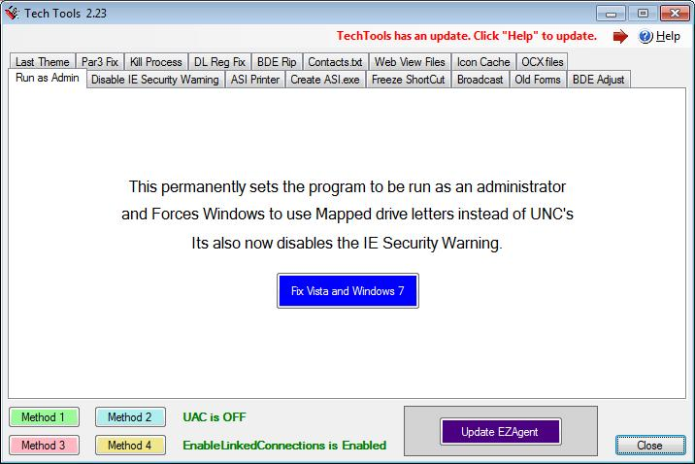
Figure 7 - Techtools

Moving the Program
The AgencyPro files are contained in the APRO folder. To transition to a new server (or standalone workstation) you must first copy the entire APRO folder from the old location to the new location.
If this is a network installation be sure to follow instructions in the Setting up the Network section to set up the new shared folder and map the network drives. The program folder then can be copied to the new shared folder on the new server.
Existing Workstation:
- Remap the common drive (let’s call it Q:) at the workstation to the new server’s shared folder (should be the same drive letter as the previous setup)
- Run Techtools.exe (or Techtoolsv8.exe if you run Windows 8) from the program folder and disable the IE warning if you get the “Publisher could not be verified” message opening the program.
If this is a new workstation follow the previous Workstation Setup instructions.

SECTION 2
HINTS & TIPS
Check out these techniques to quickly master navigation of AgencyPro for Windows, and for the most efficient ways to do things. We also recommend reviewing the online tutorials available at www.agencysoftware.com/Tutorials.

Navigation
AgencyPro uses common Windows navigation techniques and keystrokes, which allow you to move around within AgencyPro with great ease. Understanding and using these features will make your job much easier, speed up your work, and make using this program a pleasure.

Help Files
Help Files for many subjects are available. When you’re working in AgencyPro, no matter what tab (window) you have open, you can always press F1 to get help on that subject. The Help Files contain Hints & Tips, a comprehensive Index, and Help files for all main topics, although a few are limited in their scope. Improved Help Files will be made available with most updates. In the Help File click on the green underlined text to go straight to that main or sub-topic.

List Boxes
You’ll find many list boxes with dropdown arrows that allow you to open a list and select an entry. Some of these lists are codes in the system while others are comprised of entries that have been keyed into the field.

Tabs
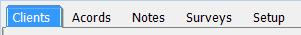
Click on a tab to open that window. If you can’t see all the tabs, either make the AgencyPro window wider, or click the arrow buttons at the right end of the tabs to scroll and display the hidden tabs at each end. You may not have all the tabs available if your User Account has limited access.

Toolbars
Most windows, and all ACORD forms, have Toolbars for your convenience. Learn what each button does and use them to save time.
When you point your mouse at a specific button, a screen tip with the button’s name appears – this will help you figure out which button does what.

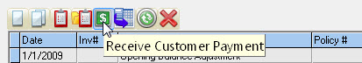
Scroll Bars
Scroll Bars appear at the right side and/or bottom of lists that exceed the current view. Scrolling up, down, right, or left will bring more information into view.

Moving Around in AgencyPro
AgencyPro will open to the Clients tab by default. The entire client list will be in view and the left side of the screen will display the information for the current client selected. You can select a new client by:

Typing in the first few letters
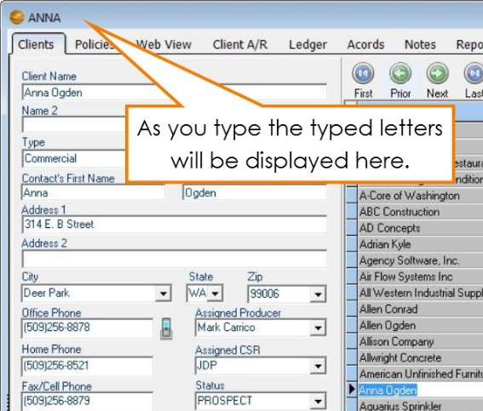
In many lists within AgencyPro, you can start typing the item you wish to look up. For instance, if you are on the Clients tab and you want to look up Anna Ogden you can type in A-N… and you will be taken to that area of the list while the typed letters will appear in the top left corner of the AgencyPro window. If all you have is an address, first put the list in Address order (see Sort by heading section on the next page) and then type in the first few numbers of the address. This is the easiest way to select a single client.
Figure 8 - Typing in your desired selection

Using the navigation icons
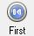
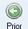


Throughout AgencyPro are variations of these icons that move you through the database either record by record, or jump from the current selection to the first or last records in the database.

Program search and filter utilities

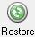
You can locate a certain value by using the search or filter utilities. The client filter, for instance, will clear the client detail window (the left side of the Clients tab that normally displays the current client information) and allow you to enter your filter criteria. Once your desired criteria has been entered, simply click the Filter icon again and the filter will apply to the client list, showing only the returned values. Click the Restore icon to release the filter and view all clients. The filter is a great way to display a group of clients. For instance, if you would like to view all clients in a certain city, click the Search icon, choose the city from the City drop-down, and click Search again. The client list will now show only clients in that city and the filter will display on the header bar.
Figure 9 - Header bar displaying current filter
This filter will carry into many client selection screens in the other marketing areas (and reports), allowing you to first place the desired filter, then run letters and reports based first on that filter. Be sure to remove this filter before attempting to run letters or reports on the entire database.

Sort by heading
In most tables and lists, if you click on a column heading (such as Address in the Clients tab), the list or table will be sorted by the entries in that column.
Also, when you click a column heading to sort, the sorted column will be shaded so that you can tell at a glance which column the table is sorted by.

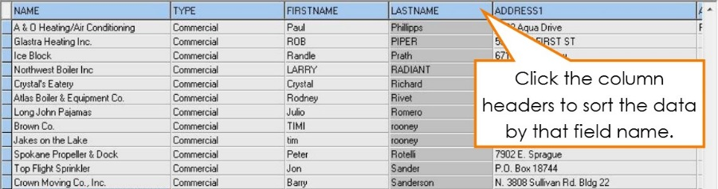
Using the keyboard
Figure 10 - Clients tab ordered by Last Name field
In most tables and lists, you can navigate through the data by using the arrows and navigation keys (Home, End, Page Up, and Page Down) keys on the keyboard.

Searching by Policy
If you need to identify the client by policy number, you can go into the Policies tab (under any client), click the All Clients button in the For box (bottom right corner), and then sort all of the policies in Policy # order by clicking that heading. Now type in the first few numbers (or letters) of that client’s policy number and it will take you to that area of the list.

SECTION 3

PROGRAM FEATURES

The Today Screen
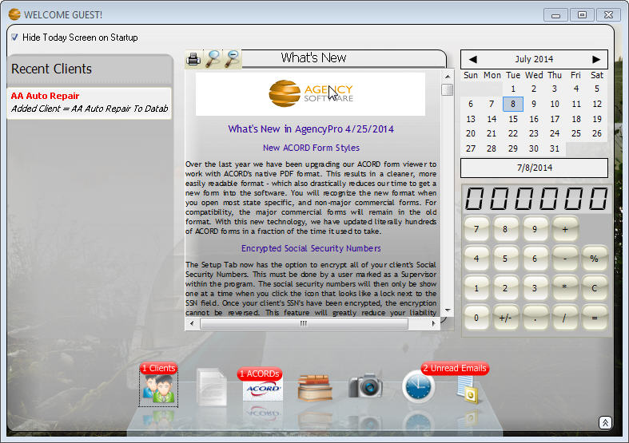
The first thing you are likely to see after you have opened the AgencyPro program will be the Today screen.
Figure 11 - Today Screen shows you what you have recently worked on
The first time you enter the Today screen you won’t see much, but as you begin using your AgencyPro system, you will see your activity listed. The Today screen tightly integrates with your transaction filing system to keep track of recent changes to Client, Policy, ACORD, Notes, Image and Tickler records. To use the Today screen click on the appropriate icon along the bottom of the Today screen and the last 20 entries will prefill along the left. Items marked in Red will be things that were worked on today – and will be counted in the red status indicator above the icons along the bottom. You can then double click the record along the left to be immediately transported to that Client record, Policy, ACORD form, Note, Image, or Tickler.
You can change the currently selected day by clicking the calendar at the upper right of the screen. This will then show you all of the current records for the selected day.
A ‘What’s New’ section in the middle of the Today screen shows recent AgencyPro enhancements, and a calculator is provided to the right for your convenience. If you close it, you can reopen the Today screen by clicking or sliding the ‘Show Today Screen’ slider along the very bottom-right of your AgencyPro program window.
You can start AgencyPro without the Today screen by clicking the ‘Hide Today Screen on Startup’ checkbox in the upper-left corner of the Today screen. You can always re-open the Today screen and uncheck this box if you decide you want it to pop up when you start AgencyPro.

The Clients Tab
The Clients window is where you enter client information, such as client name, address, and phone numbers. AgencyPro always opens with the Clients window displayed. The client names are listed on the right side of the window, in the list, and the data for the selected client is displayed on the left side of the window. To open the Clients window from any other window in AgencyPro, click on the Clients tab at the top of the program window.
The status bar at the bottom of the AgencyPro program window always indicates the selected client name, their phone number, and the current date and time.
In the name list, columns other than the name column can be displayed by scrolling to the right in the horizontal scroll bar below the list.
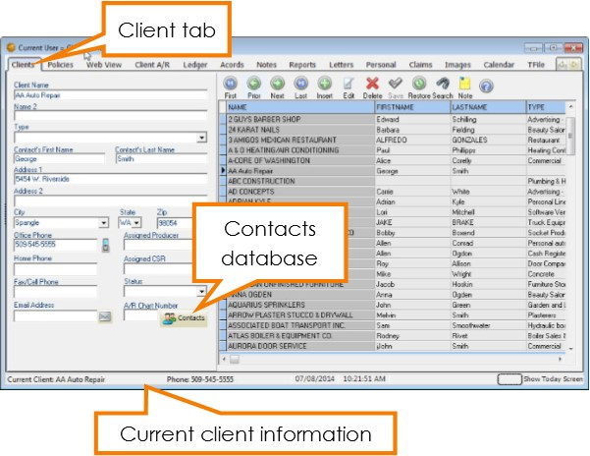
You can reorder these columns by clicking on the column header and dragging to the left or right while holding down the mouse button. You may also sort by any of the columns by clicking the column header for that column.
Figure 12 - Client tab

Adding a Client
To add a client, click the + button above the client list. The client information fields on the left side of the window are emptied so that a new client’s information can be typed into the appropriate fields. You can use your Tab key to move between fields while entering client information or you can click in the field where you want to enter data.
Click on the Contacts button. Whichever contact you mark as Primary will automatically fill in the First Name, Last Name and phone number fields in the main client information screen.
You may list multiple contacts for this client by clicking the plus sign on the top toolbar to add an additional contact name or the plus on the bottom toolbar to add additional email addresses.
After all of the client’s information has been entered, click on the save button to save the information.

Editing Client Information
To edit client data, select the client’s name in the list on the right (click the client name to select it), and then click on the edit button to open that client’s record for editing. The selected client’s information appears on the left side of the window. Edit the data, and save your changes by clicking on the save button.

Deleting a Client
To delete a client, click the client’s name in the list on the right then click the delete button. Click Yes in the Delete This Client? message. That client’s data and forms are permanently removed from the database.

The Clients Toolbar
When you position the mouse over a specific button on the toolbar, the name of that button will appear in a “hint” screen.
The buttons, left to right, are:

 | First Record Selects the client name at the top of the list.
 | Prior Record Selects the next client above the selected client.
 | Next Record Selects the next client below the selected client.
 | Last Record Selects the client at the bottom of the client list.
 | Insert Record Creates a new client record, ready for data entry. Click the Post Edit button to finish and save the new client record.
 | Edit Record Select the client that you want to edit in the list, then click this button to edit the fields on the left. When done, click the Post Edit button to save the changes.
 | Delete Client Select the client you want to delete from the list on the right, and then click this button to delete the client. All entries in all modules for that client will be deleted from your system. A confirmation box will appear before the client can actually be deleted.
 | Post Edit Permanently posts the change to the database while adding or editing a client’s record.
 | Restore Client List Restore the full client list after filtering.
 | Filter Client Database Click on the magnifying glass button to clear all fields on the left. Type in your search criteria in any fields, and then click the Filter Client Database button again. The client list will be filtered to show only those clients who match your search criteria and most reports will show results only for this filtered list of clients.
 | Add a Sticky Note to Client Click on the yellow sticky note to add a note that will appear whenever this client record is brought up.
 | Start Tutorial This button will start the tutorial for the current window if you have the AgencyPro CD in your CD-ROM drive, or if you have loaded the tutorials to your hard drive. If the tutorials are not available, Windows Help Files will appear instead.
Tip: Instead of scrolling down to find a client in a long list, you can jump to a specific area in the clients list by pressing a key (or two or three) on your keyboard. For example, suppose you want to find a client whose name is listed as Longhorn Barbecue. To jump to the first name that begins with the letters LON, click in the clients list, and then type ‘LON’ on your keyboard.

The Web View Tab
The Web View window is where AgencyPro can make online policy access much easier. The Web View window:
- Opens the web page of the insurance company of the policy you have selected (must set up home pages under Company in Agency Setup tab).
- Will log you in automatically to some company websites. (You must set up usernames and passwords under Employees in Agency Setup tab and it must be a compatible company website, which you can find on our Download Partners list at www.agencysoftware.com).
- May find the currently selected client or policy, if they are already an insured with that company.
- Allows you to get a snapshot of the page you are on, which saves as a PDF file in the Images tab.
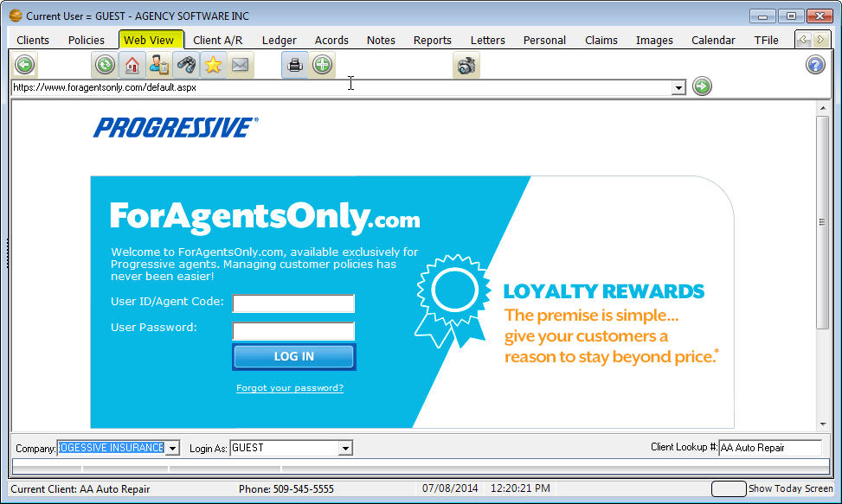
Figure 13 - WebView tab accessing Progressive site

How to Use the Web View Window
The Web View window works most efficiently when you have the insurance company and their web page URL entered in the Companies form in the Agency Setup window, and you have your login name and password for that company web page entered in the Screen Name and Screen Password boxes in your Employees form in the Agency Setup window. See the Agency Setup Window section to learn more.
1. Select your client in the Clients window by clicking their name.
2. Click the Policy tab and select the policy in question
3. Click the Web View tab.
The Web View window opens the web page for the company entered on your policy.
If you want to open a different company's web page, select the company name from the Company list box in the lower-left corner of the Web View window. Note: Only companies with URLs entered in the Agency Setup window's Companies form appear in this list.
The company name is displayed in the Company list box. Your user name is displayed in the Login As box. The Client Lookup # box displays the selected client's first policy number, or the client name if they have no policies in AgencyPro yet.
4. If your AgencyPro Employee form has the appropriate name and password entered in the Password database, the Web View window will try to automatically log you in at the company site.
If your AgencyPro Employee Password form does not have a Username or Password entered correctly you can enter your login name and password yourself and log in to the company web page.
5. AgencyPro will try to find the selected client automatically in the company web page using the client's policy number selected in the AgencyPro Policies tab.

The Web View Toolbar
When you position the mouse over a specific button on the toolbar, the name of that button appears in a tooltip.
The buttons, left to right, are:
 | Back Opens the previous web page
 | Forward Opens the next web page you opened
 | Stops loading the current page
 | Refresh Refreshes the current page with current data
 | Home Opens the company website Home page
 | Search Opens the Google search page
 | Favorites Opens the Favorites folder
 | E-mail Opens an AgencyPro e-mail message, addressed to the current client, that uses your e-mail program to send
 | Open Outlook Folders
 | Print Opens the Print dialog box so you can print the page to the printer you choose
 | Open a New Instance of Browser Opens a new browser window so you can open a different web page without leaving the page you have open in the Web View window - the new browser window appears minimized in the lower-left corner of your computer screen; you can open up to two more browser windows
 | Help and Tutorial If the AgencyPro Tutorial CD is in your drive, the tutorial for the Web Page window plays - if the CD is not in the drive, a help file opens
 | Snapshot will capture the entire current web page to a PDF file in the client’s Image tab. (Must have ASI Printer set up on each workstation.)
In the Web View toolbar is a standard browser Address bar with a Go button on the right end. You can type any URL in the Address bar and click Go to open that web page, and then use the Web View toolbar's Back and Forward buttons to move between all the pages you've opened.

The Policies Tab
Click on the Policies tab to open the Policies window. The Policies window serves as a database for Quote/Binder/Policy Status. When your Trial Balance equals –0– after entering your opening balances, you are ready to enter policies for your clients. On the Clients window, choose the customer or add the customer for whom you want to enter a policy then click the Policy tab to see policies specific to that client. You will notice that current policies will be displayed in black, while expired and closed policies will be displayed in red.
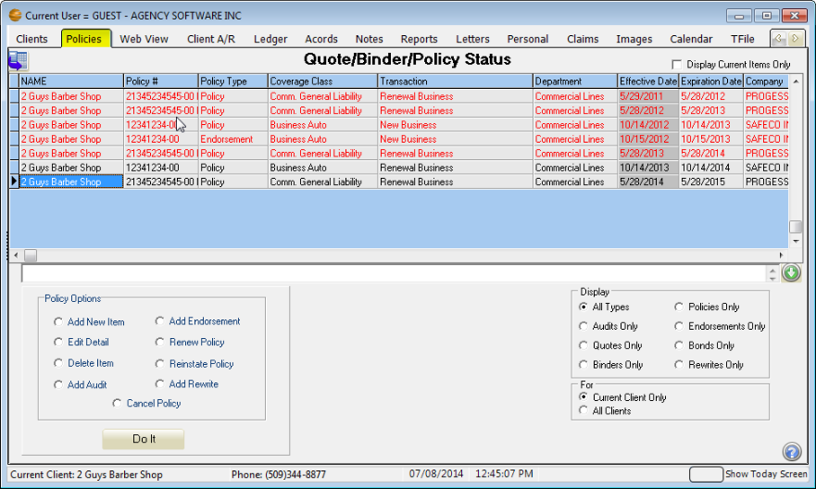
Figure 14 - Policy tab

Policy Options
Be sure to use your policy options as you are entering your policy information. Many of these options will draw the information from the selected policy to save time entering information. These policy options are:
Add New Item - Add a quote/binder/policy/endorsement
Edit Detail - Edit the details of a selected quote/binder/policy/endorsement
Delete Item - Delete the selected quote/binder/policy/endorsement
Add Audit - Create a new audit
Add Endorsement - Create a new endorsement
Renew Policy - Renew the selected policy
Reinstate Policy - Reinstates the selected policy
Add Rewrite - Rewrite the selected policy
Cancel Policy - cancel the selected policy

After you select a Policy option, click the Do It button to proceed.

Display Options
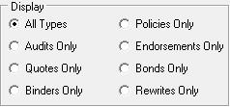
The display options are to limit the view of the policies window to the type of your choice. For instance, if you only want to see policies, no endorsements or audits, you click Policies only. Here are the display options:
The Display Current Items Only checkbox, located in the top right corner of the Policy tab, allows you to limit the view to open, current term policies. When you check this box, any policies that are expired or have policy status closed, will be hidden. With this box checked the other tabs for this client will only show items attached or created for the current policies displayed on the Policy tab. To see items that are attached or created from expired or closed policies simply un-check the Display Current Items Only check box.

For options
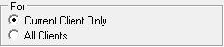
These options filter the list to display only the policies for the current client, or all the policies for all the clients in the database.
Note: You can only create a new policy, quote, binder, or endorsement if Current Client Only option is selected in the For option.

Additional Details for Using the Policies Window
The icons you may find on this window, depending on your user access, are the Transaction Detail button, which displays any accounting that may have posted against the policy selected, Attached Docs, which displays any attached images specific to the selected policy, or the Upload to EZLynx icon if you have the EZLynx integration set up and you are highlighted on an auto or home policy.
You’ll find procedures for working with policies in the following sections.

Add a New Policy
When you choose Add New Item from the Policy Window and click the Do It button, the Policy Detail screen is displayed.
NOTE: The policy screen may display two (2) tabs on the top. The Accounting View shows the policy detail information. The Download View is only available on policies downloaded with our Download Plus module. Contact your Sales Rep for information about the Download Plus.
When filling in the policy it is important to fill in the field using the drop down arrows. On the right end of a box, click the arrow to open a list of choices, then click the entry you want in the list.
The blue fields are automatically calculated.

Required Fields
Figure 15 - Entering a policy
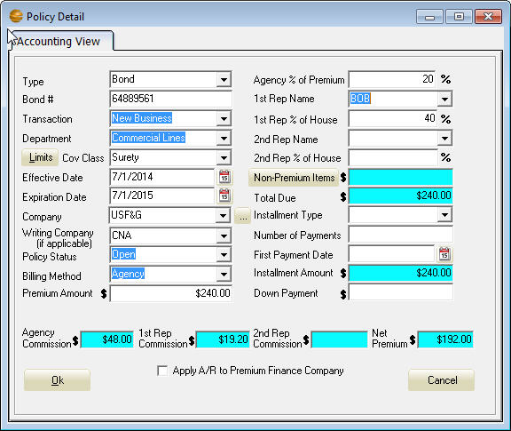
The left side of the Policy Detail window are the required fields (with the exception of the Writing Company field). These fields are:
Type – Typically Policy, but select the appropriate selection from the dropdown list
Policy - Type the Policy or Bond Number (depending on type)
Transaction - Important for New Business reporting
Department - Important for departmental reporting as well as income classification
Limits Button - Opens the Coverage’s window (see Coverages section).
Coverage Class - Choose your entry from the list. You can add to this list by typing in an entry if Show All Coverage Classes is selected on the Agency Setup tab.
Effective Date - Click the button on the right. A calendar appears with the current date selected. Click OK to accept that date, or click to select a different date and then click OK. You can also type the date instead of using the calendar.
Expiration Date - Click the button on the right. A calendar appears with the date one year from the effective date selected. Click OK to accept that date, or select a different date and then click OK. You can also type the date instead of using the calendar.
Company - Choose your entry from the list. (The button to the right of the dropdown box opens the Company Database for entering or editing the companies in this list but only if you have Supervisory access in the AgencyPro Employee database).
Policy Status - Choose your entry from the list, must be Open to post accounting.
Billing Method - The entry defaults from the Company Setup database, but you can change it by selecting a different entry in the list.
Premium Amount - Type the Pure Premium amount.

Optional Fields
Fill in only what you need on the options fields of the Policy Detail window.
Writing Company - This is where you type in the company you would like to appear on the Acord form if different then then Company entry.
Note: The field after Company may display as Broker/MGA Name - Choose your entry from the list (same as Company) if a broker is used. The only companies that will appear in this list are those that are marked as a broker in the company record on the Agency Setup tab. You can leave this at the default <none> if the billing company is the same as the company chosen.
Agency % of Premium - This is where you enter the commission rate. This is pre-defined in Company Setup, but can be changed or added if needed.
1st Rep Name - Choose your entry from the list. The list comes from the Employees database in the Agency Setup tab, and can only be changed there.
1st Rep % of House - Pre-defined in Employee Setup, but can be changed or added if needed.
2nd Rep Name - This is for ‘split’ commissions. Choose your entry from the list. The list comes from the Employees database in the Agency Setup tab, and can only be changed there.
2nd Rep % of House - Pre-defined in Employee Setup, but can be changed or added if needed.
Non-Premium Items - Click the button to add Non-Premium Items such as Agency Management Fees, Policy Fees, or Taxes. Use the down arrow on your keyboard for additional lines. Supervisory users can click the Setup button to set up their own non-premium items. Once you click ok, the blue field will auto-calculate with the sum of the non-premium items.
Total Due - Auto-Calculated field. On an agency billed policy this field should equal the total of your premium plus fees and taxes (the amount the customer owes you).
Installment Type - Choose your entry from the list, or may leave blank for annual.
Number of Payments - Auto-Calculates from Installment Type, but can be changed.
First Payment Date - Click the button on the right. A calendar appears with the current date selected. Click OK, or select another date and then click OK.
Installment Amount - Auto-Calculate field.
Down Payment - Type the Down Payment amount being deposited.
Agency Commission - Auto-Calculated field.
1st Rep Commission - Auto-Calculated field.
2nd Rep Commission - Auto-Calculated field.
Net Premium - Auto-Calculated field.
When you’re done, click OK to save your entries. This record will be added to the current client.
The resulting postings from the policy entry depends on how the policy is set up and your selected accounting method. More information on policy entry is provided in the Accounting section.

Coverages
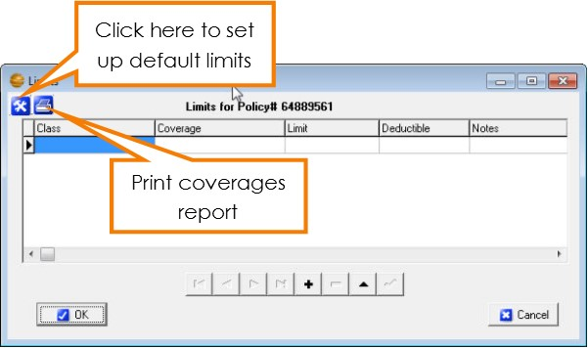
The Limits window is where the coverage’s for the client’s policy are entered. To open this window, click the Limits button to the left of the Coverage Class box on the policy detail screen. Information entered in the Limits window will automatically fill into your ACORD forms as long as the ACORD form being added or edited has a specific field for those coverages and you use the drop down list when adding the Class and Coverage in the Limits window.
Figure 16 - Limits window with option for default setup and print coverages report

The Limits Window

Class
This specifies which class of coverage you are going to use. It also specifies the types of forms into which the information can prefill. To select a coverage class, click in the Class box, and then click on the down arrow that appears in the box, and then select the appropriate type. You will have to select a class for each line item entered.

Coverage
The choices that appear in this dropdown list are filtered depending on what Class you have selected in the Class field. To select a coverage type, click in the Coverage box, then click on the down arrow that appears in the box, and then select the appropriate type.

Limit
Enter the amount of the limits for the selected coverage.

Deductible
You can enter a deductible amount, or you can leave this field blank.

Notes
This field allows you to enter any additional notes about the specified coverage.

Coverages Report
Click the printer icon to print the limits in the form of a Coverages Report.

Setting Default Limits
Use the Tool button to open the Set Limit Defaults Window. Here you can set default values to Limit and Deductible.
The Auto field requires an ‘*’ asterisk to be active. This will allow any row with an asterisk to fill in the previous Limit window when that class is selected.
Rows without the ‘*’ asterisk will only fill in the Default values when the coverage is selected in the Limit Window.
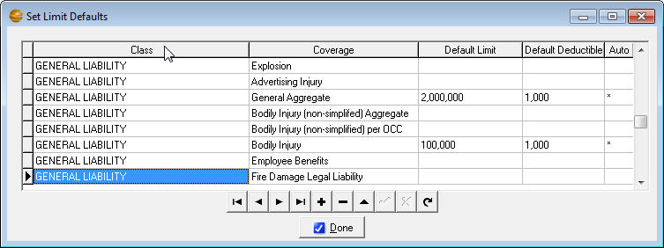
Figure 17 - Setting up default coverage limits
In the above example, the first two (2) GENERAL LIABILITY rows will auto fill when GENERAL LIABILITY is first selected in the Limits window. The third row would only fill in the defaults when the coverage, “Automatic Coverage for Newly Acquired” is selected in the Limit window.
When you’re done, click the ‘Done’ button to save your default values.
When you’re done selecting Limits, click the OK button to save your entries. These limits will be added to the current client policy.

The Client A/R Tab
Click on the Client A/R tab to open the Client A/R window. All client payments are taken here.
Agency billed premium and payment postings are listed in the Client AR tab. (The functionality of this section depends on your accounting basis access in the Employee section on the Agency Setup tab and more specific information is available in the Accounting Workflow document provided during accounting training, or available in the manuals section on our website.) Installment invoices, down payments and finance credits are other examples, which are applied to the client’s accounts receivable from the information entered in the Policies window. Account aging is shown at the bottom of the screen.
Figure 18 - The Client A/R window keeps track of agency bill balances
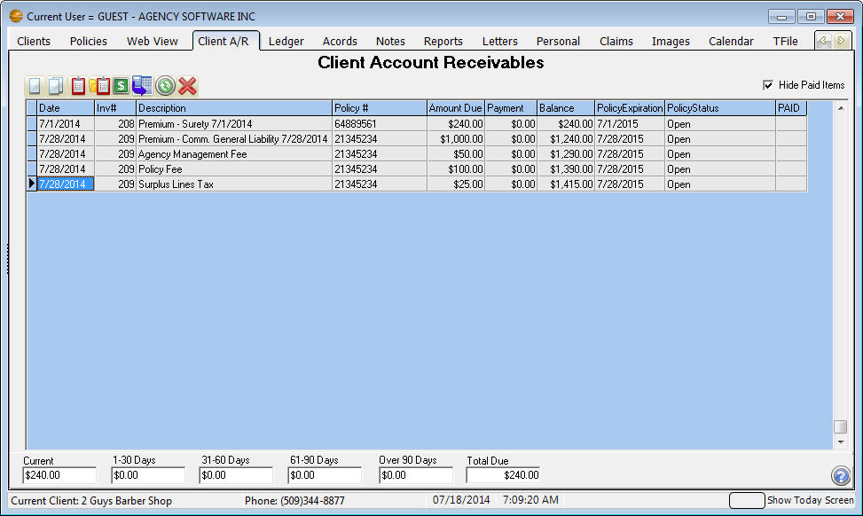
 | Generate Invoices – The invoice will pull all line items for the selected invoice number, so if payment has the same invoice number it is also included, showing the balance outstanding.
 | Generate All Invoices – Click to print invoices for all customers or part of your customer list, for all invoices between the date range entered.
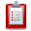 | Generate this Statement – The statement will show all transactions for a client with a current balance since their last zero balance.
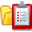 | Generate All Statements – Click this button to print statements for all customers with current balances, as of the date entered.
Receive Customer Payment – Record customer payments by entering the date, the amount paid, and choosing a policy from the dropdown list. The Accounting Workflow Document received during training (or available on the website) will go into further detail on client payment and billing scenarios.
Note: The policy for which you are receiving the payment must be made accounting ready. If the policy does not have all required fields correctly completed, applying a payment to that policy may force this payment to post incorrectly. If the Policy is direct bill the payment will not be recorded on your Client AR information.
A/R Adjustments are available from the payment window and the functionality depends on your selected accounting method. See the Accounting section for additional information on adjustments.
 | Recalculate All – Performs a balance recalculation of the current client’s A/R
 | Delete Transactions – May not be available if the user logged on does not have supervisory access from the Employee button on the Agency Setup tab. Anytime you delete transactions you will want to make sure all sides of the transaction is deleted. For assistance in corrections contact Technical Support.
 | View Transaction Detail for Current Policy – Click a line item to select it, and then click the View Transaction Detail for Current Policy button. The Transaction Detail window opens, showing only the details for the policy that is selected. If endorsements have been combined with that policy, the Transaction Detail will only include the policy installment.

Hiding Paid Items
The Paid column on the Client A/R tab allows you the option to mark items as paid and hide them from view. To mark an item as paid, simply double click in the Paid column on the item you wish to mark, which will place the value ‘True’ in the field. Double clicking a second time will mark the item ‘False’ (which is the same as blank). Items marked as paid will not show on the statement and can be hidden from view by checking Hide Paid Items.
Note: For statement balances to appear correctly you must make sure that the items you mark as paid total to zero.

The Ledger Tab
Click the Ledger tab to open the Ledger window (only users with accounting access can see this tab). This is where you access your agency’s bank accounts (and sometimes credit cards). You can change active account by clicking the Drop Down list next to the word ‘Accounts’ in the upper right-hand corner of the screen.

Accounts
AgencyPro comes with two preset accounts; Cash and Checking. The Cash account is a holding account for undeposited funds. Any receipts taken will post to Cash waiting for a deposit to be done, and when ready to do a deposit, you will mark the items from the cash account to make up your deposit slip. The Checking account cannot be altered so is generally utilized as the agency’s main operations account.
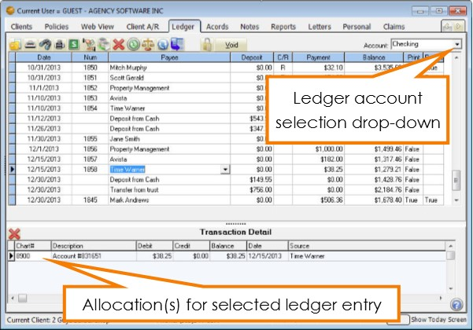
Figure 19 - The checking account in the ledger tab

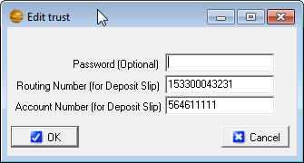
The New/Edit Account icon allows you to create a new Ledger account or to change password and routing number information for existing accounts.
Figure 20 - Editing existing account
When editing an existing account to add a routing/account number or a password, simply double click the existing account name in the Open Account window (and if passworded already, enter the password).
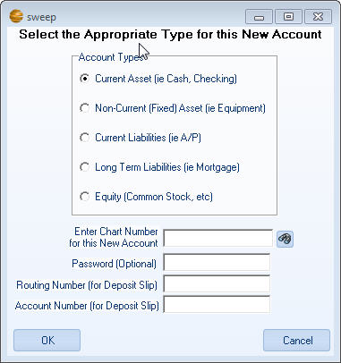
When adding an account, type the name (keep it short and simple, if there is more than one word, put an underscore or dash between the words) in the File Name and click Open. Set the Account Type appropriately (Current Asset for a bank, Current Liabilities for a credit card, etc.), enter an unused chart number in the appropriate range (a lookup is provided for a current chart of account review), and fill in any desired password, routing, or account number information. Click OK to save and the added account will appear in the Account drop-down list.
Note: Adding accounts is very rarely done. Agency Software accounting support staff would gladly assist in adding accounts to ensure appropriate setup.

Ledger Tools and Navigation
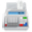
Calculator - Click here to use the calculator.

Find Transaction - Find any transaction in the currently selected account.
Delete Transaction - Deletes the selected transaction.
Recalculate All - Updates the balance in the current Account. You can click the Date, Number, and Payee column headings to sort by these individual fields. After changing a view, you must click the Recalculate All button to update the balance for the changed view.

Detailed Recalculate - Verifies all the entries in the account you are in on the Ledger tab to assure valid dates on the Transaction Detail (may take some time to complete).

Order by Header
Any of the ledger’s headers can be clicked to order the ledger entries by that selection. For instance, if you wish to view the ledger in order by check number, click the Num column header.

Adding Ledger Entries
When making a payment from AgencyPro, you must first determine if it is policy related. Policy related entries are done through the appropriate sub-ledgers. For instance, returning premium to a client would be done through the Client A/R and result in a check in the chosen ledger. A check for an account current payment would be done through the Payables. These policy related entries will self-allocate, so you should not have to find the proper allocation accounts.
Non-policy payments, on the other hand, are entered directly into the desired ledger. An example of these entries are vendor payments, such as a monthly rent payment. To add a new entry, first make sure you are in the proper ledger and:
- Use your keyboard down arrow from the last entry in the ledger
- Use your keyboard Insert key
- Tab through the end of the last line in the ledger.
The new line will assume today’s date, you can modify this. When you tab to the next field the Num field will automatically populate the next available check number. You can correct this, or simply delete if this is an EFT entry.
The Payee field drop down will list any payees paid from this ledger in the past. If this is a repeat entry, selecting the payee from the list will attempt to duplicate the last payment (allowing you to modify amounts and allocations if needed).
Enter the amount of the payment and the next tab will take you to the lower portion of the screen, the Transaction Detail. This is where you allocate this payment (the account offset). The Chart# drop-down list is a chart of accounts look-up. Select the appropriate account and modify the debit or credit (if necessary). Use the keyboard down-arrow or tab through the end of the last line to add multiple allocation lines. Use the CTRL key to toggle to the top (will error if the allocation total does not match the payment amount).
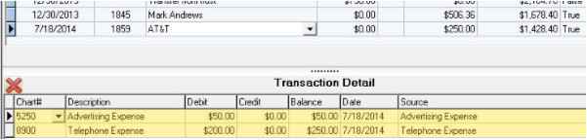
Most payments will automatically be marked True to print. If you do not wish to print this check, use the space bar to toggle to False.
Figure 21 - Vendor payment with multiple allocations
When entering a payroll check, double click in the Payroll column of that entry to mark as True. This makes these checks available from the Payroll Ledger Report, allowing easy reporting and accumulation of payroll entries.
Note: Non-policy deposit items, such as contingency bonuses, are added in this same manner into the Cash account.

Printing Checks
AgencyPro is designed to support individual or batch check printing. There are several check formats to choose from while printing checks, but the QuickBooks style is the most common and functional.
Ledger entries marked True in the Print column are checks currently set to print. Entries marked False (or left blank) will not print. You can toggle this entry by double-clicking (or using your space bar) in the Print field.
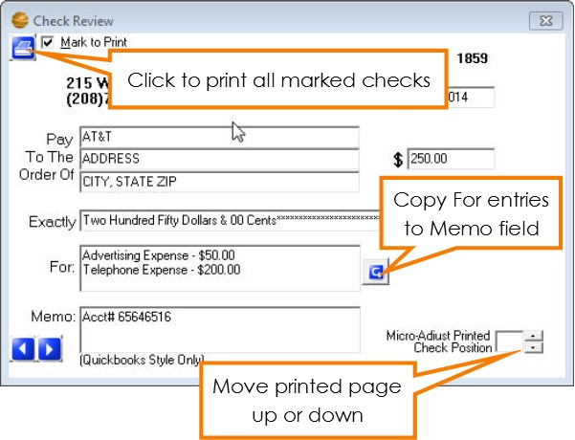
When you click the View Check icon, the selected item will be displayed and allow you to modify the address, memo, and allocations which will appear on the printed check. The right and left arrows allow you to move to the previous or next ledger entries without leaving this form, and if you wish to mark or unmark the viewed entry you can use the Mark to Print check box.
Figure 22 - Check review form, edit detail prior to printing
Note: To print checks from AgencyPro you must have pre-printed, pre-numbered check forms which match one of the provided formats. To limit wasted resources, it is recommended to mark a check True to print and first print to plain paper to match up to your check proof (prior to ordering check stock).

Making Deposits
AgencyPro is designed to hold all receipts in the Cash account. When you get ready to make a deposit you first go into the Cash account to verify the items on your deposit slip have been entered through their various origins. Keep in mind that any payment coming from a customer needs to be entered through the Client A/R tab, which creates an entry in Cash. Any commission payment coming from a company (if you will be reconciling) is created during the direct bill reconciliation process. Other receipts that are not policy related may be taken by adding a new line manually in the Cash ledger (see Adding Ledger Entries). EFT deposits are handled using this same procedure. Once the item(s) being deposited are present, follow these instructions to make your deposit.

- Click the Make Deposit icon on the toolbar. This filters the view to only undeposited items.
- Mark all items that are being deposited on this one deposit slip by double clicking in the X/D column on each entry to be included on this deposit. This will mark the entry with an X and include it in the Total Deposit amount.
- Mark any items that are Cash receipts by double clicking in the Cash field to mark the entry as True.
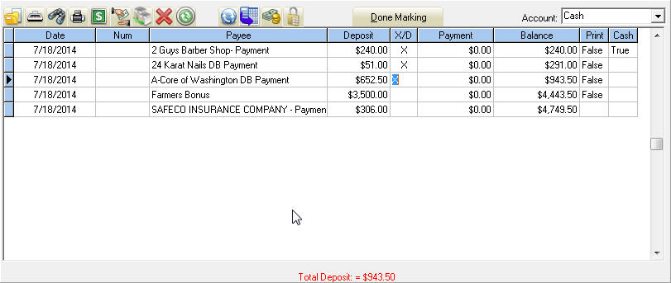
- Confirm the Total Deposit amount at the bottom of the screen is the amount of the deposit being made to this account.
- Click Done Marking and choose the account you are depositing to, the type of deposit, and the date of deposit.
- Optional: Click Print Deposit Slip for the deposit slip and detail report.
- Click OK to finalize the deposit.
You can reprint the deposit slip/report by selecting the deposit line in the Cash ledger and clicking the Show Report of Deposited Items icon.
Note: The Cash account balance should only reflect the total of the items currently un-deposited. When all deposits have been made the balance should be zero and all items should have a “D” in the X/D field.

Direct Bill Reconciliation
An option within our system is to reconcile your company commission statements through the Direct Bill Reconciliation ledger. This ledger is designed to track policies that have been entered in the system and the commission received on them.
- From the ledger tab click the Receive Direct Bill Payment icon
- Enter the date you are receiving the check in the Date Commission Check Deposit field
- Choose the company from whom you are receiving the commission check in the Company to Reconcile field
- Enter the total amount of commissions received in the Commission Check Amount field. (If this payment has been increased by a non-commission item or reduced by an expense such as MVR, enter the total of commissions received and see the accounting section on Mixed Commission Payments). If the company is requesting payment for return commission enter the amount as a negative number.
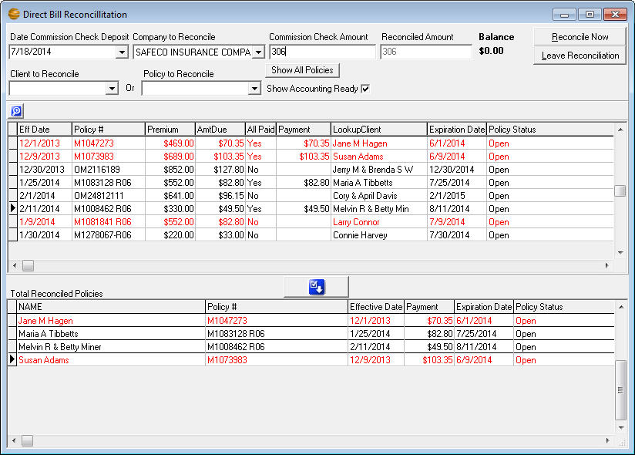
- Apply payment toward the item(s) on your commission statement from the policy list in the middle pane:
Figure 23 - Reconciling a direct bill commission statement
- Full payment - If the item shows in the list and the AmtDue matches the commission received on your statement simply double-click on the line. This will change the Payment to the full amount of the commission and the All Paid to Yes, eliminating the item from the ledger the next time you go to reconcile this company.
- Partial Payment - If the item shows in the list correctly for the full term but you are only receiving partial commission on this check, enter the amount of commission you are receiving in the Payment field, leaving the All Paid at No so it will be available on the next reconciliation.
- Correction of Policy - If the policy was entered incorrectly you can click the magnifying glass to bring up the policy to amend it. You must regenerate for the changes to be saved. (See note on regenerating accounting* below)
- Clearing items in which payment has been applied - If an item is listed in the bottom pane that should not be there you can clear it by locating it in the top pane and making the payment amount zero.
- Clearing items that will never be reconciled - If an item was from prior to the start of your accounting system click the magnifying glass and place an ‘R’ in the DB Reconciled field at the bottom of the policy window, click OK and no to regenerate. The item will no longer be available in the Direct Bill Reconciliation.
- Move the paid items to the lower pane, which will add up in the Reconciled Amount field.
If there are items on your statement that are missing from the Direct Bill Reconciliation ledger you can either:
Click the Show All Policies check box and, if you find the item, make sure to open the policy with the magnifying glass and correct it so it is accounting ready
- Or -
Leave the Reconciliation to go to the Client and then Policy to either enter it or make it Accounting Ready. All reconciled items will be saved when you return to the Direct Bill Reconciliation and choose the company.
Note: *When regenerating accounting on a direct bill policy you may want to first be sure that prior reconciliation has not been applied toward the policy (by looking for commission on the transaction detail). When an item is reconciled and then regenerated it clears all prior commission payments that had been posted against it. For this reason it is recommended to make changes to policies that have been reconciled by additional entry, such as an endorsement. If you must change a policy that has had commission posted against it, you must also re-reconcile that policy’s commission on that same date for the same amount as originally reconciled. You may want to choose Yes to Reverse entry in Cash, which will show you specifically what to re-reconcile.
- Once the Commission Check Amount field and the Reconciled Amount field match you can click Reconcile Now. This will post an entry against each policy you have reconciled and will place a deposit in the Cash account. If the amount was a negative number for return commission it will ask you which account you would like your check to be issued from.
NOTE: While the Direct Bill Reconciliation process is recommended, it is not mandatory unless you wish to track producer commission on a Cash accounting method. Optionally, you may enter the deposit in the Cash account for the amount of the commission check and manually allocate the deposit. This allocation depends on your accounting method and policy processing. Your procedure should be determined during your initial accounting training sessions.

Payables
The Accounts Payable sub-ledger in AgencyPro is designed to keep track of what you owe your companies, producers or other various current liabilities.
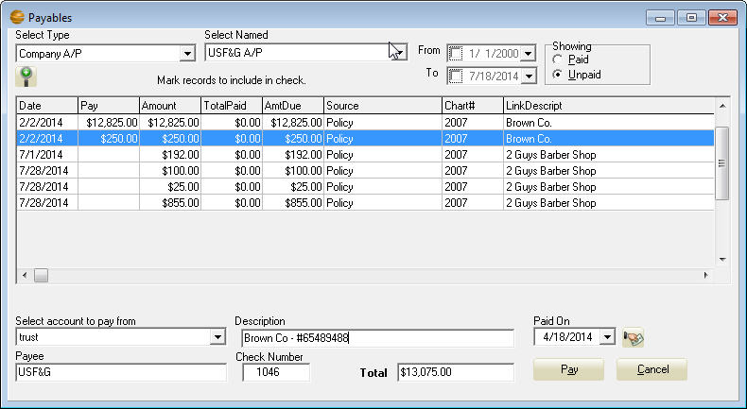
Figure 24 - Paying a company through the payables sub-ledger
From the Ledger tab select the payables icon. From the Select Type drop-down choose the type of payable you wish to pay. From the Select Name drop-down choose the sub account you wish to pay. The items available for payment will appear in the Payables window.
To view Policy details for a specific item, select the item and click on the edit policy icon.
To pay the entire amount owed toward an item double-click on the line. If you wish to apply a partial payment, you can right-click the line and type in the amount you wish to apply. To pay all available items on the ledger click the Pay All icon. You can click this icon again to toggle all items to unpaid.
Once the items you wish to pay are marked, the Total field should reflect the amount of the payment you are making. Select the Account you are writing the check from (or the Cash account if this is a receipt for a negative statement), edit the Description, Date, Payee and Check Number if necessary, and then click Pay to finalize the payment. This will create an entry in whichever ledger you chose.
Note: Once an item has been paid you will not be able to regenerate accounting on that policy. All changes must be done by endorsement.

Payable Reports
From the Reports tab you can run:
- Company Payables - Shows all unpaid items due to companies
- Rep Payables - Shows all unpaid items due to producers
- Paid Report - Shows the payments made. To run this report highlight in the ledger any entry generated from the Payables. You will see the Show Report of what is paid icon appear on the toolbar which will generate the Paid Report for that particular payment
Note: If the Company and Rep Payables reports do not appear in your reports listing, open the User Defined Report and choose any table from the tables drop-down. Click Save and type in 'Company Payables' for the report description, choose Accounting for the category and click OK. Click Save again and type in 'Rep Payables' for the report description, choose Accounting for the category and click OK. Click Cancel on the User Defined Report to return to the Reports tab.

Opening Balances
If you have initial opening balance entries from your accounting setup, or have recently run Close Books, you will want to generate opening balance entries by clicking the icon in the Payables window (or in the Chart of Accounts window under Agency Setup). This step creates a record in the Payables sub-ledger representing this past balance in which you can apply payment toward.


Account Transfer
To transfer money between accounts, begin in the ledger account from which you want to transfer the money from. Click the Account Transfer button, indicate the account to transfer to, enter the amount of the transfer or deposit, enter the appropriate date, and click OK. The system automatically transfers the money to the account indicated.

Bank Reconciliation
You can reconcile your monthly bank statement in AgencyPro to assure that your bank and the AgencyPro ledgers match. To reconcile your bank select the account you wish to reconcile and click the Balance Account icon. Enter the ending statement balance from your bank statement and click OK. You will see a line of balances appear above the Transaction Detail section representing the status of your reconciliation. Clear items that appear on your bank statement by double-clicking the entry in the C/R column; a C will appear and the item added/subtracted from the Difference at the bottom. Continue to clear until the difference is 0.00.
To get a report (you must do this prior to clicking Done Balancing) of the cleared items go to the Reports tab, select and run the Register Report. Select the account in question and click OK. Choose ‘C’ for the Reconciled field and make sure the date range would encompass any items that have been cleared in your account.
Review and troubleshoot any unreconciled items then click Done Balancing to complete the reconciliation. The C’s will change to R’s.

Opening Balances
Usually the first reconciliation is the most difficult, as the opening balance should represent the beginning balance of the statement if you began your books, but can also be mid-month.
- If this is your first AgencyPro bank reconciliation and the Opening Balance matches your statement ending balance, simply clear it and your bank reconciliation should balance when complete.
- If the Opening Balance represents some items that hadn’t cleared to date you will need to break your Opening Balance into two lines. For instance, if you had a $1000 opening balance that included a $50 check that had not cleared to date, change the original opening balance to $1050 (in the Transaction Detail as well) and create a second opening balance line for a $50 payment (with the same date and allocation account). This may also occur after closing the books.

Editing/Voiding Ledger Entries
Items in the ledger accounts can be modified, and sometimes voided. However, entries sourcing from a sub-ledger (such as a customer payment for instance) should not be modified directly from the ledgers, as they will then put your accounting out of balance.
These sub-ledger items can be identified by the brackets <> around the account number. If the entry in question has a bracketed account number in the allocation, then the correction must come from the source. For further assistance in making corrections, please contact Agency Software Support.
If the item was created directly in the ledger (the allocation is un-bracketed) you can edit by first clicking the Unlock icon, then modifying the entry.
After any correction, it is recommended to run the Transaction Detail Report for the day(s) affected to make sure the report ending balance remains zero.

General Ledger Access
The Transaction Detail window provides accounting users easy access to general ledger account data. Open this window by clicking the Access General Ledger icon.
You can type in (or select from the drop-down list) the desired GL Account, and all the transactions will be displayed, as well as the resulting balance.
This is also where you access the Journal Entry and an easy way to access the Chart of Accounts from the ledger without leaving in the middle of an entry.
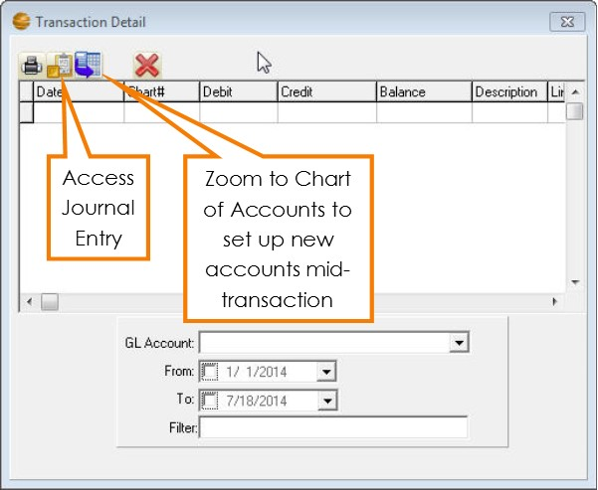
Figure 25 - Transaction detail window

The ACORDs Tab
Click on the Acords tab to open the Acords window. The Acords window contains all the ACORD forms for the selected client, and allows you to add, edit, or delete forms for that client. The forms list is blank until you add forms for that client.
The data in the Create Date column is automatic – you cannot change it. You can type short notes about specific forms by clicking in the Note column for that form and typing your entry.

ACORD Options
This section explains the various options in the lower pane of the Acord window.

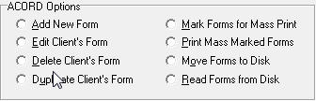

Add New Form
When you select the Add New Form option and click the “Do It” button, the Add New ACORD Forms window appears. This window displays all available ACORD forms in alphabetical order.
This list is first-key sensitive – to jump quickly to a specific point in the alphabetical list, you only need to press a letter key on your keyboard. For instance, if you need to add a Workers Comp form, press “WOR” on your keyboard. The first form starting with ‘WOR’ is selected. You may then scroll down, page down, or arrow down to the Workers Comp form. Select the form you want, and click OK to open the form.
You also can click the Number header on this screen and type in the ACORD form number you are looking for.
Use the options below the list to filter the more than 600+ ACORD forms to a more manageable list.
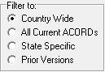
- The Country Wide option filters the list to display all the forms that are NOT state-specific.
- The State Specific option filters the list to show just the forms that are specific to a particular state (after you select the State Specific option, select the state you want in the list box that appears to the right).
- The All Acords option removes the filters and displays the entire list of ACORD forms.
- The Prior Versions will show prior versions of select accord forms, such as the Certificate of Liability and Evidence of Property.
After selecting a form, you may be asked which policy you would like to prefill from, if this client has policies. The Coverages sections of the policy, as well as some other policy information, may be prefilled in the form, depending on what type of form you have selected. In addition, selecting a policy from this window will allow you to keep all of the ACORD forms for one policy separate from similar ACORD forms for different policies.
Note: The default selection on the Attach Policy screen is None. When reopening a filled form, selecting None will ensure that the form information is not overwritten with reselected policy information.

Edit Client’s Form
Edit an existing ACORD form for the current client. Select a form from the list of existing forms, select Edit Client’s Form, and then click “Do It.” The selected form will appear and you may edit as needed.

Delete Client’s Form
Delete an existing ACORD form for the current client. Select a form from the list of existing forms, select Delete Client’s Form, and then click “Do It.” You will be prompted if this is what you really want to do. The selected form will be deleted from the current client.

Duplicate Client’s Form
If you wish to create an exact duplicate of a different client’s ACORD form for the client you have selected, click on the Acords tab and then select “Duplicate Client’s Form.” The DupAcordForm dialog box opens with a list of all the clients in the database and all their forms.
- Scroll down to select the client and the form you wish to duplicate for the open client. You can often find the form you want more easily if you sort the list by Name or Form Name or Create Date (by clicking on the appropriate column heading).
- After you select the form you want to duplicate, click OK.
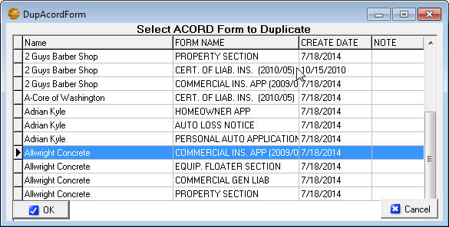
Note: When you duplicate an existing form year after year, you run the risk of using outdated, non-current forms. A better approach is to add a new form of the type you are renewing, and then use the Prefill Form From Another button (at the top of the new form) to fill the new, current form with the data in the old, expiring form and then make the changes for the renewal term.
Figure 26 - Duplicate an Acord from a different client

Mark Forms for Mass Print
You can send several forms from several different clients to the printer, pdf, or email all at once with the Mark Forms For Mass Print option.
- Choose a client, then click the Acords tab and click the Mark Forms For Mass Print option. Click the Do It button, click to mark the forms you want to print, and click OK.
- Then choose another client, click the Acords tab, click the Mark Forms For Mass Print option, click the Do It button, click to mark the forms you want to print, and click OK.
- When you’ve selected all the clients’ forms you want to mass print, you’re ready to use the Print Mass Marked Forms option.

Print Mass Marked Forms
- Select any client and click the Acords tab. Click the Print Mass Marked Forms option, and click Do It.
- A Print Preview of all the marked forms opens. Click the Print button in the toolbar and send the forms to your printer or if you have email setup, click on File and Email and it will email all those forms at once.
- After the forms are sent to the printer or emailed, you’ll be asked if you want to unmark the forms for mass printing – click Yes.

Move Forms to Disk
If you want to move a specific client’s data and forms to an AgencyPro database on another computer (perhaps a computer at home, or a different standalone database in your office) you can use the Move Forms To Disk and Read Forms From Disk options to do this.
The procedure is to move clients and their forms, one client at a time, onto a CD or Flash Drive, then take the CD or Flash Drive to the other computer and move the clients and their forms into the other database one at a time.
To use the Move Forms To Disk option:
- Put a blank CD or Flash Drive in the drive
- On the Clients window, select a client whose data and forms you want to move.
- Click the Acords tab. In the Acord Form Options section, click the Move Forms to Disk option and click the Do It button. A window listing the client’s forms will appear.
- Select each form you want to move by clicking the form name (if you want to de-select a form, click that form name again) or you can click the Mark All button to move all their forms. When you’ve selected all the forms you want to move, click the OK button.
- In the Save As dialog box, click Save. A file that contains the client’s data and forms will be saved with the client’s name.
- Repeat steps 2 through 5 for each client whose forms you want to move.
- If you are using a CD, you will have to ‘burn files to CD’.

Read Forms from Disk
After you take the disc to the other computer and are ready to move the clients and their forms into the other database, follow these steps to use the Read Forms from Disk option:
- Put the disk or CD into your disk drive.
- Open AgencyPro and click on the Acords tab for any client.
- In the Acord Form Options section, click the Read Forms from Disk option. An Open Account dialog box displays the files you moved to the disc.
- In the Open Account dialog box, click a client filename, then click Open. The client data and forms are imported, and a message tells you “ACORD forms successfully imported from Disk!”.
- Repeat steps 3 through 4 for each client file on the CD or Flash Drive.
Note: You don’t need a CD or Flash Drive if you’re moving files to a different database across a network. When the Save As box appears navigate to a folder where you can save or open the files.

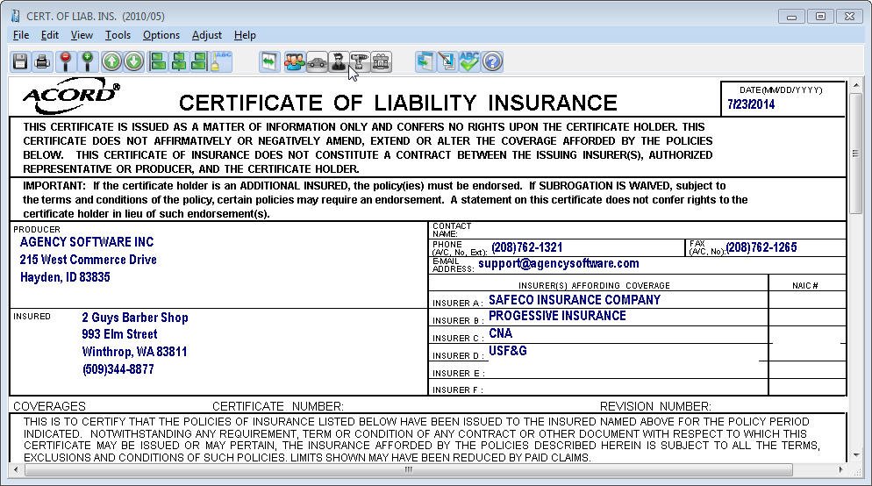
The ACORD Formview Window

The Formview Toolbar
The Formview toolbar appears at the top of the open form. When you place your mouse over a Formview toolbar button, the name of the button appears. The buttons, left to right, are as follows:
 | Save Form saves your current work while you work in the open form. When you finish working in a form and close it, all your work is automatically saved.
 | Print prints the open form.
 | Increase Form View makes the form bigger on the screen
 | Decrease Form View makes the form smaller on the screen.
 | Go To Previous Page goes forward one page in a multi-page form..
 | Go To Next Page goes back one page in a multi-page form.
 | Left Justify left-aligns text in the selected field.
 | Center Justify center-aligns text in the selected field.
 | Right Justify right-aligns text in the selected field.
 | Font Selection lets you select a different font for the selected field.
 | Toggle Expanded Fields allows you to type more in a field than would normally fit. If you have a lot of data, this process can take several minutes
 | Cert Holder’s Menu accesses certificate holders database; lets you add, edit, delete, and print certificate holders.
 | Vehicle Menu accesses vehicles database; lets you add, edit, delete, and prefill vehicle information for vehicle forms.
 | Drivers Menu accesses drivers database; lets you add, edit and delete drivers to prefill to ACORD forms that contain driver information.
 | Equipment Menu accesses equipment database; lets you add, edit and delete equipment to prefill to ACORD forms that contain equipment information.
 | Property Menu accesses property database; lets you add, edit, delete, and prefill property information for property forms
 | Pre-Fill Form From Another will fill a new form with data from existing forms, including prior forms certificate holders.
 | Electronic Signature lets you put your electronic signature on a form before you print, e-mail, or fax the form.
 | Spell Checker will correct spelling errors.
 | Help has general instructions for filling out forms.

The ACORD Formview Dropdown Menus

File . . .
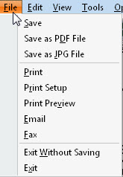
Save - saves the changes in the open form without closing it.
Save As PDF File - saves the form as a PDF image file.
Save As JPG File - saves the form as a JPG image file.
Print - opens the Print dialog box so you can print the ACORD form.
Print Setup - opens the Print dialog box to change print settings.
Print Preview - shows how the document will look when printed.
E-mail - allows you to send a form in an e-mail message directly from AgencyPro.
Note: Email must be setup first (see Emailing Forms section).
Fax - allows you to send the form to your fax software.
Exit Without Saving - closes the form without saving your changes.
Exit - closes the form and saves all changes you’ve made.

Edit . . .
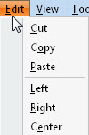
Cut/Copy/Paste - are standard windows commands to cut, copy, and paste text.
Left/Right/Center - are used to justify text within the selected field.

View. . .
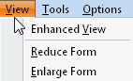
Enhanced View - toggles the form display between the Draft view and the Camera view. Enhanced View (Camera View) provides the most accurate view of what the form will look like when printed.
Reduce Form and Enlarge Form - allow you to adjust the magnification of the form on your screen.
Toggle Floating Menu - Will show or hide a small menu allowing you next page and print utilities (made for PDF forms).

Tools. . .
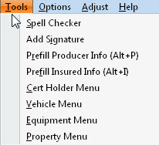
Spell Checker - opens the Spell Check dialog to check your text for errors.
Add Signature will place an electronic graphic representation of your signature (in your own handwriting), if you have taken steps to create your electronic signature.
Note – Signatures must be created as 300x60 dpi Bitmap (.bmp) images. These can be ordered from Agency Software using the Electronic Signature Order Form available from the support page at agencysoftware.com.
PreFill Producer Info - automatically pre-fills your current agency information onto the form. This is handy if you have changed your agency information and are opening old forms that have your old info on them.
PreFill Insured Info - automatically pre-fills the insured’s current information if you’re opening an old form and their information has changed.
Cert Holder Menu - opens the certificate holder options dialog (see the Certificate Holder section below).
Vehicle Menu - opens that client’s vehicle list (see the Vehicle Database section below).

Options . . .
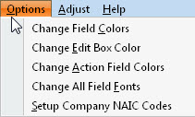
Change Field Colors - changes the color of all data entry fields.
Change Edit Box Color - changes the color of the active field (the field in which you’re typing).
Change Action Field Colors - changes the color of action fields. When you right-click in an action field, something pertinent to that field happens (such as an appropriate dialog box opening up).
Change All Field Fonts - allows you to change the font of the data you type on the form. The changed font only lasts until you close the form.
Reset to Default Font and Color – Resets to original settings.
Setup Company NAIC Codes – Click to enter NAIC code for company, which saves to the Company Setup.

Adjust . . .
All Left/Right - moves the printed form image to the left or right on the page.
All Up/Down - moves the printed form image up or down on the page.
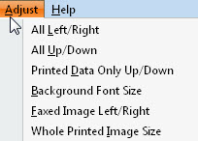
Printed Data Only Up/Down - moves the data you entered up or down in the printed form.
Background Font Size – Adjusts background fonts.
Faxed Image Left/Right moves the faxed form image to the left or right on the page.
Whole Printed Image Size prints the entire form larger or smaller to better fit the page.
All Left Right Printer Only – Adjust printing alignment

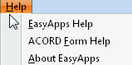
Help. . .
EasyApps Help - provides program help for creating forms. EasyApps is the ACORD form module of AgencyPro and is available as a stand-alone program.
ACORD Form Help - provides systematic instructions for filling out specific forms. Not all forms have a help file.
About EasyApps - displays the software version number and the Agency Software, Inc. address and telephone information.

Entering Client Information in ACORD Forms
Data entry in an ACORD form is much like data entry in the Clients window. You can move from field to field using your arrow keys, tab key, or mouse, and edit data using the Insert, Backspace, and Delete keys. You can use your mouse to move the scroll bar at the right to move up and down the form.
The first thing you will notice when you open an ACORD form is that some of your work has already been done for you. Fields for your agency name and address have been filled in with the data you entered during installation and the client name and address information has been filled in with the information from the Clients window.

Certificate Holders
The ACORD certificate forms allow you to have multiple certificate holders for a single certificate (so you can type in a single certificate and print separate certificates for each certificate holder all in one operation).
If the Certificate Holders Menu button is displayed in color, it means that the form can support multiple certificate holders. If the button appears grayed out, it means that the form doesn’t support multiple certificate holders.

Certificate Holders Menu
Here are some things you need to know about working with certificate holders and entering cert holder information in certificates.
You can type certificate holder and description of operations information in the boxes in the lower-left corner of the certificate, but if you type the information directly in the form on-screen, you won’t be able to use the Cert Holders Menu to set up and print the certificate for multiple cert holders. You’ll only be able to print that certificate for a single cert holder.
If you have more than one cert holder for a certificate, use the Cert Holders Menu instead.

Adding Certificate Holders
To add a certificate holder, click the Cert Holders Menu icon
In the Certificate Holder Menu select the Add New Holder option and click the Do It button.
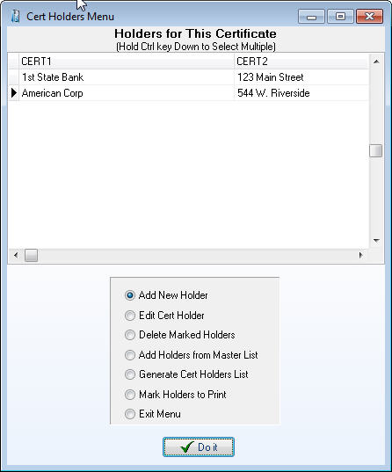
The Certificate Holder Detail dialog box appears. Type the certificate holder’s name and address information in the dialog box.
Figure 27 - Cert holder menu
Note: You cannot have two cert holders in the same certificate with identical names and addresses. If you need to issue multiple certificates to the same cert holder for different jobs, see the sidebar “Same Cert Holder, Multiple Jobs” (below) to learn how.
Enter the “Description of Operations” information in the Override Description of Operations box, and click the Done button. The cert holder name, address, and operations information will not appear on the form on-screen, but it will be printed when that certificate holder is marked for printing.
The Description of Operations database can hold commonly used descriptions of operations. Access this database from anywhere the displayed icon appears.
This button sends saved information to the cert holder description field.
This button saves the information in the current cert holder description field for use later.
This button will add a blank record if you want to type the description in manually to pre-load the descriptions.
This button will delete the text in the description. All of the description is deleted, not just what is highlighted.
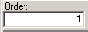
The Order field is used to place the descriptions into the order you want them in so the most used descriptions can be at the top. This is in ascending order and is entered by the User.
The font adjustment is used for changing the font size in the description field to allow for more data. The minimum size is 7.
When you click Done, a new certificate holder is added to the certificate.

Note: There cannot be any blank certificate holders in the Cert Holders Menu list. If you see a blank certificate holder name at the top of the list, you’ll get a Key Violation error the next time you try to add a new cert holder. You MUST delete the blank cert holder (click in the blank cert holder name, then click the Delete Marked Holders option and click Do It).
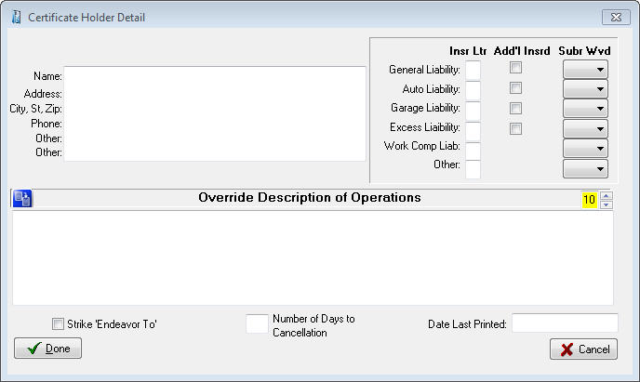
Note: If you need to enter a nearly identical name and address block for a different cert holder, you don’t need to retype it. Instead, select the text you need to duplicate, then right-click the selected text and click Copy on the shortcut menu. Then close the Certificate Holder Detail window, add a new cert holder (or edit a cert holder), right-click in the box where the copied text should go, and click Paste on the shortcut menu.
Figure 28 – Adding a new certificate holder

Same Cert Holder, Multiple Jobs
Suppose you have a client, perhaps a construction company, who needs to issue several certificates (for different jobs) to the same cert holder. But you can’t enter cert holders with identical names and addresses in the same cert… so what do you do?
Try this: Add a new cert holder, but enter a job number at the end of the Name line (as shown below).
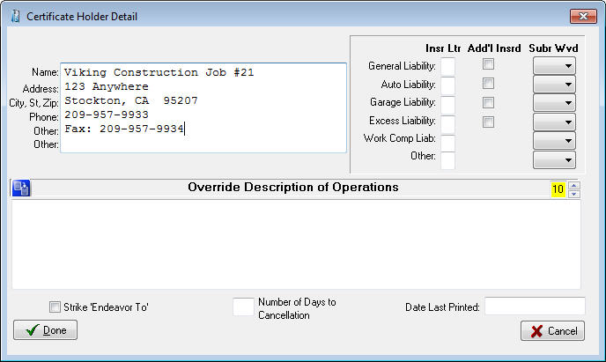
This keeps the Name and Address field combination (really the Cert1 and Cert2 fields) from being duplicated, and you can print all the certificates you need for the same cert holder’s different jobs. The resulting printed certificate entry looks like this:
Figure 29 - Modify certificate holder name to allow for duplicate holders
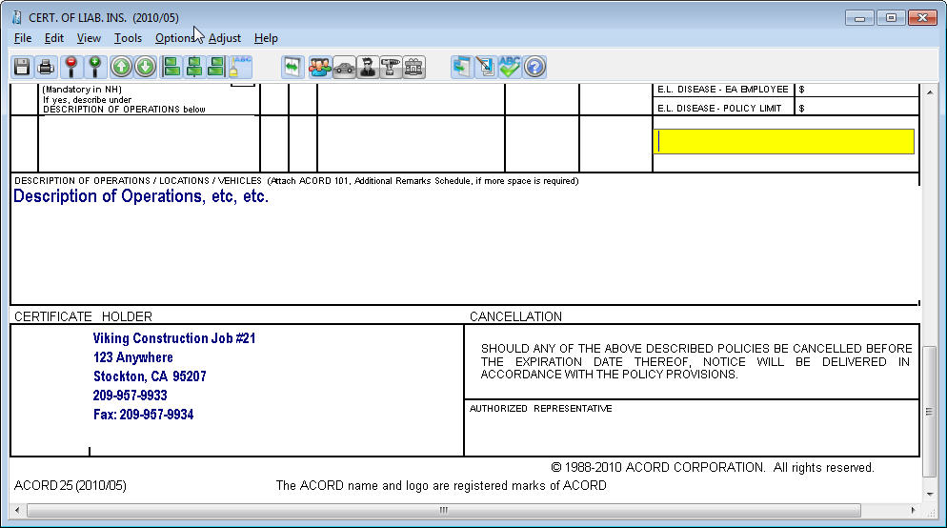
Figure 30 - Certificate holder information will prefill with information entered in the Cert Holders Menu

Description of Operations
The latest version of the Certificate of Liability holds five lines of text in the Description of Operations field. If you have more text than fits in this field you can reduce the font size as low as 7.

Editing Certificate Holders
To edit or modify existing certificate holders, do the following:
- Click the Cert Holders Menu button (the button that shows a person walking out of an envelope).
- Click the name of the cert holder you want to edit.
- Select the Edit Cert Holder option on the Cert Holders Menu, and click Do It.
- Make your edits, then click the Done button.

Adding Certificate Holders from the Master List
The AgencyPro database has a Master List that holds all the certificate holders for all the certificates in the database. If a certificate holder has already been added for one certificate or client, you can add that same cert holder to another certificate (for the same client or for another client) by choosing it from the Master List.
To add an existing cert holder from the Master List to the open certificate, select the Add Holders from Master List option on the Certificate Holder menu, and then click Do It. The Master Cert Holder List appears, showing all of the certificate holders for all of your clients.
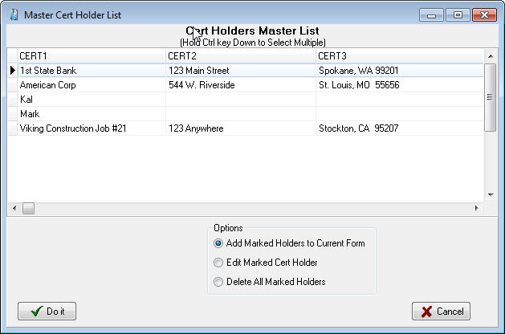
In this dialog box, click cert holder name with your mouse to mark them, you can hold your CTRL key down to select multiple holders, click the Add Marked Holders to Current Form option, and then click Do It. The marked cert holders will be added to the cert holder list for the open certificate.
Figure 31 - Master Cert Holder database
Note: There cannot be any blank certificate holders in the Cert Holders Menu list. If you see a blank certificate holder name at the top of the list, you’ll get a Key Violation error the next time you try to add a new cert holder. You MUST delete the blank cert holder (click in the blank cert holder name, then click the Delete Marked Holders option and click Do It). If you delete cert holders from the Master List, they’ll be deleted from all certificates. To delete a cert holder from just one certificate, open that certificate and delete the cert holder using the Certificate Holders Menu.

Deleting Certificate Holders
- Open the Cert Holders Menu.
- Select the Delete Marked Holders option.
- Select the names of the cert holder(s) you wish to delete. (You can mark multiple holders by holding the Ctrl key down as you click the names.)
- Click the Do It button. AgencyPro will ask if you really want to delete the certificate holder – click Yes. The cert holder is deleted from the open certificate.

Printing Certificates for Selected Cert Holders
You can print a certificate for a single cert holder or for multiple cert holders (but don’t try to send more than 10 at a time to your printer). To print certificates for cert holders:
In the open certificate, click the Cert Holders Menu button. In the Cert Holders Menu, select the Mark Holders to Print option and then click the Do It button.
The Mark Holders to Print dialog box appears (shown below). Double click the selected box for each cert holder you want to print to highlight it. If you want to mark all the certificate holders with one click, click the Mark/Unmark All check box (click the check box again to unmark all the cert holders).
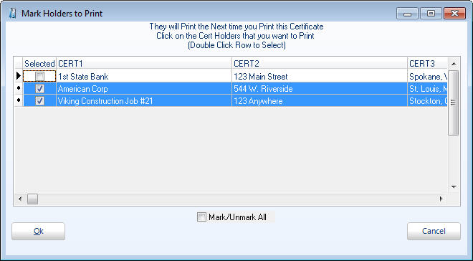
Click OK. You will be asked if you want to start printing marked certificate holders now.
Figure 32 - Mark holders to prefill to certificate for printing
If you wish to print select Yes and the Print dialog box for your printer appears – you can print multiple copies of each certificate by entering the number of copies in the Numbers of Copies box. Then click OK to print.
Click No to print to utilize other options, such as email or save to PDF. You will be viewing the form (unfilled with selected holders) and can select Save as PDF File or Email from the File menu.
After you close the form, you will be asked if you want to unmark all the holders you have marked for printing. Click Yes.

Generate Cert Holder List
To generate a printable list of certificate holders for the open certificate, select the Generate Cert Holder List option on the Certificate Holders Menu, and click Do It.

Close the Certificate Holders Menu
To close the Certificate Holders Menu, select the Exit Menu option, and click Do It.

Vehicle Database
The Vehicle Database stores vehicle information by client and allows entered information to be pre-filled on ACORD forms such as ID cards, Vehicle Schedules, and other auto applications. If the Vehicle Menu button (the car button) is fully colored (not grayed out), it means the open form has access to the vehicle database.

Enter Vehicles in the Vehicle Database
To open the vehicle database, click on the Vehicle Menu button (the red car button). The Vehicle Database dialog box opens.
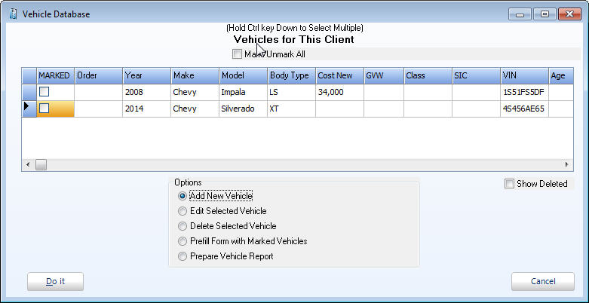
To add a vehicle, click the Add New Vehicle option and then click the Do It button. The Vehicle Detail dialog box appears.
Figure 33 - Vehicle menu
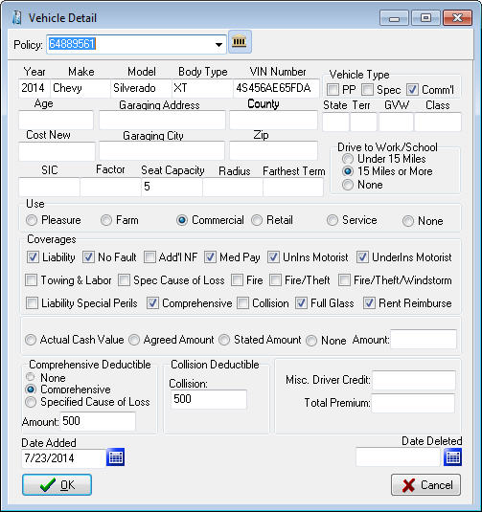
Fill in all vehicle information, and then click OK. The Vehicle Database reappears.
Once you have entered all of your vehicles for your client, you can manipulate the order in which they print by updating the ‘Order’ column on the Vehicle Database.
Figure 34 - Adding a vehicle

Fill a Form with Vehicle Information
To prefill the open form with information for a specific vehicle, click the vehicle to highlight it. To select more than one vehicle, hold down the Ctrl key while clicking on the vehicles.
Then click the Prefill Form with Marked Vehicles option and click Do It. The vehicle data is filled into the open form.
Note: You can only prefill the number of vehicles that the specific open form has spaces for, with the exception of Auto ID cards. In Auto ID cards, you can prefill up to 10 vehicles at a time, and AgencyPro will create the number of ID cards required for those vehicles as long as you use the Order number.
Note: If the Auto ID Card form is more than one page, when you prefill vehicles it will only create one form with one vehicle at a time.

Attach Vehicles to Specific Policies
You can also attach vehicles to specific polices when adding new vehicles on the Vehicle Detail screen. When you click the car icon on the toolbar of an Auto form, or you click the Vehicle button on the Personal tab, click on Add New Vehicle and Do It to get the Vehicle Detail screen. At the top of this screen is a policy drop down list so you can attach this vehicle to a specific policy.

Print a Vehicle List Report for a Client
A vehicle list report is a printable list of all vehicles associated with the current client. To create it, open the Vehicle Database, then click the Prepare Vehicle Report option and click the Do It button.
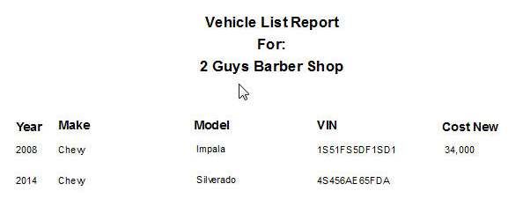
Figure 35 - Vehicle report lists all vehicles

Equipment Database
The Equipment Database stores equipment information and allows entered information to be pre-filled on ACORD forms. If the Equipment Menu button (gears button) is fully colored (not grayed out), it means the open form has access to the equipment database.

Add Equipment to the Equipment Database
Click the ‘Add New Equipment’ option and the following screen appears
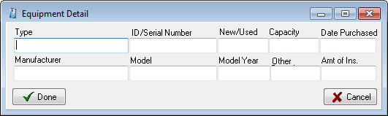
Click ‘Done’ when finished. From the equipment menu you can Add/Edit/Delete/Prefill forms and print an Equipment Report.
Figure 36 - Add equipment

Drivers Database
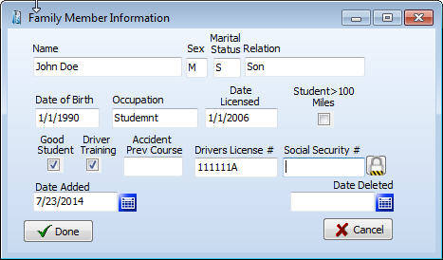
The Drivers Database stores driver information by client and allows entered information to be pre-filled on ACORD forms such as Business Auto Section, and other driver applications. If the Drivers Database button (the steering wheel button) is fully colored (not grayed out), it means the open form has access to the drivers database.
Figure 37 - Add new driver

Add Drivers to the Drivers Database
Click the ‘Add New Driver’ option and the Driver Detail screen appears.
From the drivers menu Add, Edit, Delete, Prefill, and Prepare a Drivers Report are available, similar to the Vehicles Menu.

Property Database
The Property Database stores property information by client and allows entered information to be pre-filled on ACORD forms such as Homeowners Application, Commercial Insurance Application and the Dwelling Fire Application. If the Property Menu button (the house button) is fully colored (not grayed out), it means the open form has access to the property database.
Either the Personal Property or the Commercial Property dialog box opens depending on the Acord application being used.

Enter Property in the Property Database
To open the Property Database, click on the Property Menu button (the house button). The Property dialog box opens.
The Personal Property and Commercial Property dialog box looks and works the same except for the title.
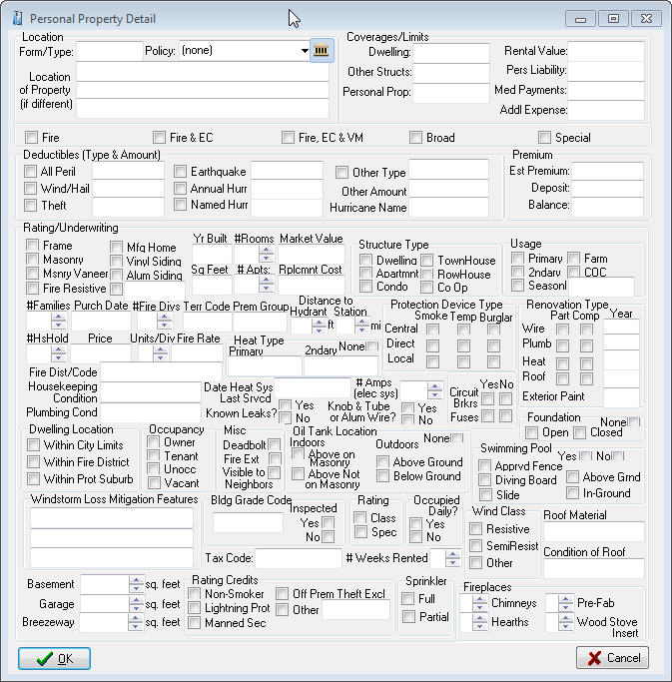
To add property, click the Add New Property option and then click the Do It button. The Property Detail dialog box appears.
Figure 38 - Add new personal property
Fill in all property information, and then click OK. The Property Dialog reappears.
Once you have entered all of your properties for your client, you can manipulate the order in which they print by updating in the ‘Order’ column on the Property Dialog window.

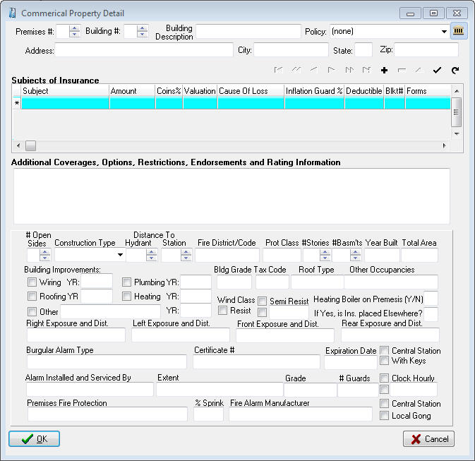
Fill a Form with Property Information
Figure 39 - Add new commercial property
To prefill the open form with information for a specific property, click the property to highlight it. To select more than one property, hold down the Ctrl key while clicking on the properties.
Then click the Prefill Form with Marked Properties option and click ‘Do It’. The property data is filled into the open form.
Note: You can only prefill the number of properties or buildings that the specific open form has spaces for.

Print a Property List Report for a Client
A property report is a printable list of all properties associated with the current client. To create it, open the Property Database, then click the Prepare Property Report option and click the Do It button.

Additional Interest Database
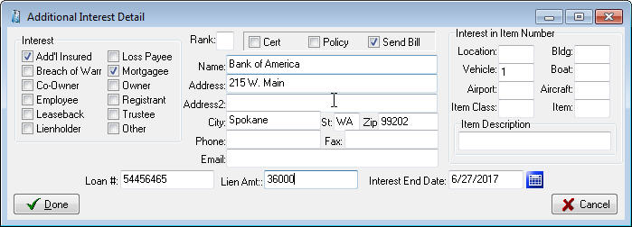
The Additional Interest Database stores information on the additional interest on the assets of the policy holder. This information can be pre-filled to ACORD forms such as the Additional Interest schedule, as well as drawn into the invoice as the billed party.
Click the ‘Add New Interest’ option and the Additional Interest Detail screen appears. Click Done when finished. From the Additional Interests menu you can Add, Edit, Delete, and Prefill similar to the Vehicles or Drivers menus.

Emailing Forms
The Email feature sends forms, saved as PDF or JPG files, directly from AgencyPro through your e-mail provider. This must be properly configured using your email provider settings.

Setting Up Email
To set up to email from AgencyPro you need to collect your email service information. The required information is:
- Outgoing SMTP server name
- User name
- Port number
- Password (if one is required for outgoing mail).
You can get all this information from your Internet Service Provider (ISP).
Note: Outlook users can simply check the Send through Outlook box and enter their signature information (optional).
To set up email:
- Open any ACORD form, and click File – Email.
- The Email Form dialog box opens with the saved file name in the Attachments box.
- Click the Email Setup button (the button with the gears).
- In the Email Setup dialog box, fill in your ISP information and click OK.
- If your email provider requires a secure connection, you can select SMTPS and enter the specific port given to you by your email provider.
Common gmail settings:
- Server is smtp.gmail.com
- Select SMTPS (select this before setting the port)
- Enter Port 587
These settings may change as your ISP makes configuration changes.
- In the Signature area you can add a Default Signature. There is room for 6 lines of information that will appear at the bottom of each email.
- The Password box is for the password your ISP requires for sending outgoing mail. Not all ISPs require outgoing mail passwords – if yours does not require a password, leave this box blank and uncheck My Outbound Server Requires a Password box.
- Click OK

Sending an Email
From the Acord form select File – Email (after adding signatures and prefilling any pertinent information):
- Enter the recipient address in the To: box.
- In the large box, enter any message text you want to send the recipient.
- Click the Send Email button.
Note: You can attach more files to your message by clicking the ellipsis button (at the right end of the Attachments box), and selecting the files you want to attach.
If AgencyPro email doesn’t work for you, you can save your forms as JPG or PDF files by clicking File – Save As PDF (or File – Save As JPG), and then attach the saved files to a message in your outside email program.

The Notes Tab
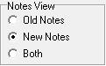
AgencyPro now offers two modes for the notes window. The first is the original notes that were written to a single page listing the notes by date. These are referred to now as the Old Notes. To print these you either had to print ALL the notes or highlight what you want and copy / paste to a word document to print a section.
In the Agency Setup tab you can select a global preference to have Old Notes, New Notes or Both.
The “Both” option allows you to view Old Notes without the ability to Add and New Notes with adding ability. So you can add notes in the New Note format, but be able to view all the notes previously entered in the Old Note format.

Operation of Old Notes
Click the Notes tab to view the Notes window.
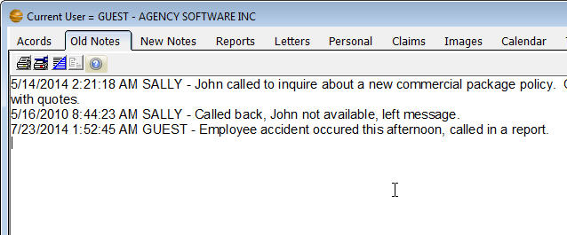

To start a new note, click the New Notes icon . The New Notes window opens.
Figure 40 - Old Notes tab displaying notes entered
Notes are automatically time-and-date stamped, and your login user name is entered. You’ll find buttons for formatting your note text, as well as print, cut, copy, and paste buttons, on the toolbar. Type your note in this window, then click the Commit button.

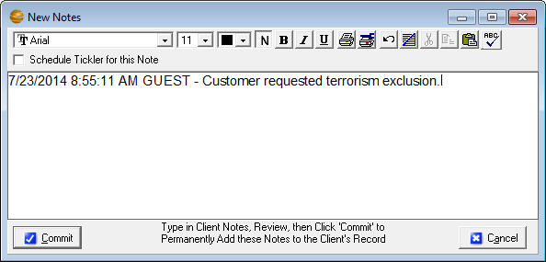
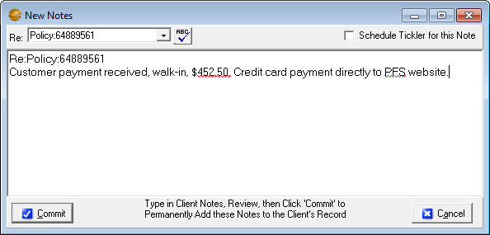
Operation of the New Notes
Figure 41 - New note entry from Old Notes tab
Figure 42 - New note entry from the New Notes tab
The new notes are stored in a database as one (1) note per record. This allows the ability to categorize and print the notes per User and per date range.
Click on the Notes tab to view the New Notes window
To add a note, click on the button from the Notes (or New Notes) tab. The New Notes entry window opens.
If the note applies to a policy you can select it in the Re: field
Notes are automatically time-and-date stamped, and your login user name is entered.
- Click the Spell Checker button to correct spelling
- Check the Tickler checkbox to add a tickler for this note
- Type your note in the body of the note record.
- Click the Commit button to permanently accept the record after reviewing your entries.
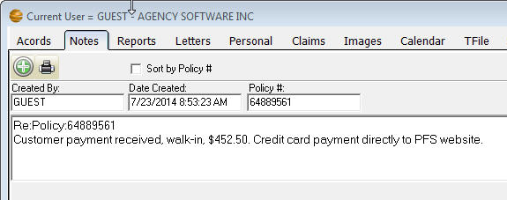
You can run reports on New Notes by clicking the Print Notes icon. The Print Notes window allows you to print by date, user, and client, or combinations of these filters.
Figure 43 - New Notes tab
Note: On either of the mode of notes, clicking the Commit button posts the note and makes it read-only (meaning it cannot be edited or deleted). This is for E&O protection. Do not click the Commit button until the note is complete and correct. If you DO make a mistake entering a client’s notes, you will have to add another entry below it stating your correction.

The Reports Tab
Click the Reports tab to open the list of reports. In the Reports window, you’ll find all the default reports that come with AgencyPro (depending on your user security level).
These reports are ready to be used. They can be edited, which requires some understanding of SQL language, and you can also create your own reports with some understanding of how databases relate.

Select the report you wish to run then click the Do It button (or double-click the report name).
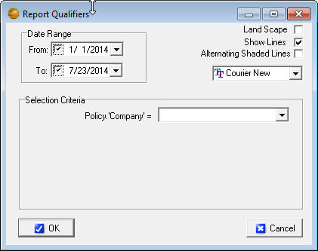
The Report Qualifier window opens allowing you to enter the report criteria. Options in the Selection Criteria box typically must be entered to run the report. Display options are listed in the upper corner (Landscape, Show Lines, Alternating Shaded Lines, and font adjustment).
Once you have entered the criteria and click OK, an Options box appears for the output method of the report. This allows you to create a Report, a Mail Merge File as a comma delimited file (*.csv), or Mailing Labels (if the report has the required mailing label fields).
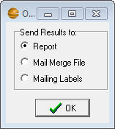
Report - Allows you to preview or send directly to the printer
Mail Merge Files - can be used by most spreadsheet, word or database programs
Mailing Labels - will create 3 x 10 mailing labels (3 across, 10 down). The report requires the Client Name, First Name, Last Name, Address1, City, State and Zip to create the labels. This is used when labels are needed for specific criteria such as for expired policies.

If the print is too small
Some reports have several fields (columns) of data, and all the fields will have to fit in one row across a single page. The more fields of data are displayed, the smaller the font will be (to fit it all into one row).
To make small print a little larger:
Rerun the report and select Landscape - When the report is printed in Landscape orientation, there is more page area for the long rows and the print is more readable.
Eliminate unnecessary fields - If the report print is still un-readably small, you can only increase the font size by eliminating some of the fields (columns) in the report.
Select multiple lines per record - You can opt to ‘break’ each row of data into multiple lines (although it is a little harder to read this way). The dialogue box to do this appears only when the report has reached a small font.
Save the report as a Mail Merge file - Open the saved csv file in Excel and then you can manipulate the page and font size to your desired format.

The Report Preview Window Toolbar
In the Report Preview window toolbar (across the top of the window) you have various Zoom buttons to change your view of the report, and buttons to move from page to page in a multi-page report, print the report, and exit the report viewer window.

Create a Custom Report
You can create your own custom reports to show whatever specific data you choose.
To create a custom report (you must have Supervisory access) select the ***Custom Report*** report name at the top of the reports list, and click Do It. In the Query Wizard window that opens, you’ll build your custom report.
The next steps will guide you through creating a custom report listing client names and phone numbers for clients in your zip code area.
- In the Get Records From My box (at the top of the window), select Client.
- Next you’ll enter the criteria that determine which clients will be listed in the report – specifically, the clients with your local zip code.
- In the first line of three boxes, in the (fields) box, select ZIP
- In the (conditions) box, select =
- In the (values) box, type your local zip code. In this example we enter 99021, because I have many clients with that zip code.
- In the Available Fields list, double-click each field you want to display in your report. In this example, I’ll select Client.’Name’, Client.’Address1’, Client.’City’, Client.’State’, Client.’Zip’, Client.’Phone’, and Client.’Phone2’. Keep in mind the more fields you choose the smaller the print on the report will be.
As you double-click each field name, it appears in the Selected Fields list. To delete a field from the Selected Fields list, click the field name and the click the Remove Selected Field button (between the red arrows that point up and down).
- If you want the records in your report to be listed in a specific order, open the Order By list and choose the field name by which you want to sort the list. The figure below shows this example report set up and ready to run.
You can also 'Subtotal' and 'Group By' rows of your reports together. An example of this would be to create a new report for all policies, Subtotaling premium volume, Grouping By Company. Note that you need to ‘ORDER BY’ the same field you ‘Grouped By’ for it to work.
- Click the OK button.
- The Report Setup box opens next, with the Preview option selected. Click OK to open a preview of the report before you print it.
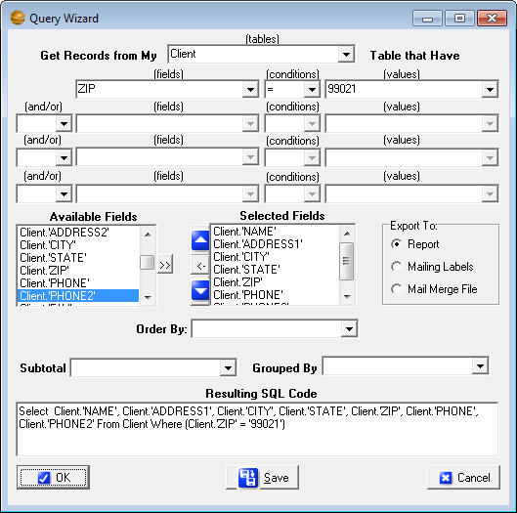
- After you close or print the report, you will be returned to the Query Wizard. If you want to save this report, to use again, click the Save button. Give the report a name you’ll recognize later, select Marketing in the Report Category box, and click OK. Then click Cancel in the Query Wizard. The report is added to the list to run at a future date.
Figure 44 - Setting up a report for client by zip code
Note: In addition to creating this report to ONLY run for clients in ZIP CODE = 99021, you can greatly enhance the functionality of this report by choosing ‘:Value1’, ‘:Value2’, ‘:Value3’ (or ‘:FromDate’ and ‘:ToDate’ if dealing with date fields) in each of the values dropdowns. Choosing these variables instead of hard-coding the value ‘99021’ means that the program will stop and ask you what criteria you want to run the report each time you run the report.
The report you create is nothing more than a set of instructions, called a SQL statement. This tells AgencyPro to retrieve the data you specified every time you run the report. This means that every time you run the report, you get the data that is currently in the database when you run it.

Create Mailing Labels
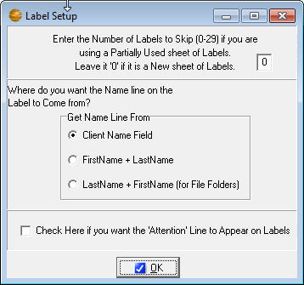
To create mailing labels, your report must have the fields, Client Name, Client First Name, Client Last Name, Address1, City, State, and Zip. When you run the report choose Mailing Labels from the options menu, and you will get the label setup screen.
Figure 45 - Setting up labels
Note: If you filter your client list on the Clients window before you create mailing labels, the labels will be created only for the names in the filtered client list.

Edit a Report
Any report, including most default reports that came with AgencyPro, can be edited if you understand SQL. If you don’t understand SQL, it’s easier to create a new report and delete the old one.

Permanently Delete a Report
To permanently delete a report, either default or custom, select the report name in the Reports window, and click the Permanently Remove Selected Report button above the blue reports list.
Note: Once you delete a report, it’s gone forever. Agency Software technical support can replace default reports for you, but this will also delete any custom reports you’ve created. So be very sure you want to delete a report permanently before you do it.

The Letters Tab
Click on the Letters tab to open the Letters window. This window has all the features of most modern word processors.

What’s In the Letters Window
There are several insurance-specific letters included in AgencyPro. These letters are ready for merging with your client data. You can also edit these letters to customize them, and then save the default letter with your customized changes, or save the changed letter with a new file name so you don’t lose the original default letter.
- To open default letters that come with AgencyPro (or custom letters you have created and saved in AgencyPro) click File, then click Open. A window opens to the Docs folder in the Apro folder. Click the name of the letter you want to open, then click the Open button.
- To create new custom letters click File, then click New. Follow the procedures in the Creating Custom Mail Merge Letters section below.
- To save changes to an open letter click File, then Save.
- To save a letter with a new file name (as a new letter) click File, then click Save As, and give the letter file a new name.
- To close the open letter click File, then click Close.

Merge Client Data into a Letter
AgencyPro allows you to merge your agency and client information into several preinstalled letters, or create your own letter in either AgencyPro or a word processor and then merge your data into it.
To merge data into a document that shipped with AgencyPro, start by opening that document (the merge fields are already in place in these documents).
Select the client(s) you wish to merge into the letter by clicking the Select Clients to Mail Merge button. This brings up a box with a list of your clients in it. Click to select the clients you want to include. (Select multiple clients by holding down the Ctrl key while clicking on the clients).
Click the OK button. Multiple identical documents are created, each filled with the merged client data.
Print the merged documents by clicking the Print button (or click File, then Print).
After you print the documents, click File, then click Close to close the merged document without saving it.
Note: Do not save the letter after you merge client data into it. Doing so will overwrite the original letter containing merge fields, and you won’t be able to use that letter as a merge-able file again.

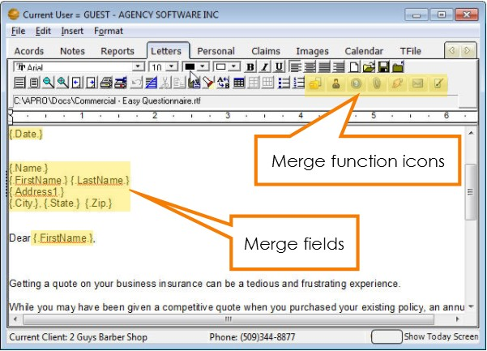
Creating Custom Merge Documents
Figure 46 - Letters tab
AgencyPro allows you to merge your agency and client information into custom documents that you create.
Click File, then click New. The window is the same, but the program knows you have started to create a new file.
Type your new letter/document. Wherever you want to enter merge data (such as client name, agency name, date, phone, policy#, etc.), click to place the cursor at that point and then click the Insert Merge Field button. (You can also click Insert, then click Merge Field.)
Scroll down and select the merge field you want to insert, and click OK. When you run the merge in the finished letter, the program will replace each merge field with the corresponding client information in the database.
A merge field consists of a field name from the database, surrounded by periods and curly brackets. You cannot create your own merge fields – the names must be identical to field names in the AgencyPro database.
When you finish your document and all merge fields have been entered, save the new document by clicking on the Save button (or click File, then Save).
In the Save As dialog box, enter a name in the File Name box. The document is saved in the Docs folder in the Apro folder.
To merge data into this document for printing, follow steps 2 through 5 in the Merge Client Data into a Letter section above.
Note: Do not save the letter after you merge client data into it. Doing so will overwrite the letter containing merged fields.

Attaching Letters to Clients
When you attach a letter to a client, the document is linked to that client so you can find it again very quickly when that client is selected in the Clients window.
To link a letter to a client first make sure the client is selected (listed as the Current Client in the bottom left corner). In the Letters window, open or create a letter and merge the data into it (using the procedures in the previous sections).
Click File, then click Save As to save the merged letter as a new file with all the merged data in it. In the Save As dialog box, give the file a new name. It’s saved in the Docs folder in the Apro folder.
Click the Add/View Attachments For This Client button (it looks like a paper clip). The Attached Documents window appears.
To attach the current letter to this client, select the Attach Copy of Item to Client option, and click the OK button.
A window opens asking you to enter a description for this document (the description appears in the Description column in the Attached Documents window). In the box, type a description that identifies the document and click OK.
The date, description, and filename for this document will appear in the Attached Documents window after you click OK and then click the Add/View Attachments For This Client button again.
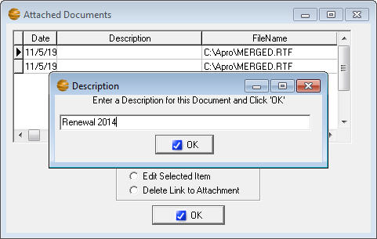
Figure 47 - Attaching a letter to the client
To open and then edit or print letters you have already attached to this client, click the Add/View Attachments button. Click the letter you want to open, then click the Edit Selected Item option and click OK.
To delete the attached letter from the client, click the Delete Link To Attachment option. The document will no longer appear in the Attached Documents window, but the document file will still be saved in the Docs folder in the Apro folder.
To close the Attached Documents window without attaching, opening, or deleting any documents, click the X button in the upper-right corner of the window.
Note: An alternative to attaching to the letters window is to attach to the image tab by printing the merged letter to the Agency Software Printer. This will create a PDF file and attach it to the Images tab.

The Personal Tab
The Personal tab is where you can record personal data about your clients – such as the names and birthdays of their family members. As always, start by selecting the client’s name in the Clients tab.
Click on the Personal tab to view the personal information pertaining to the selected client. To add a record to the Family Members list, click the Insert Record button (the + button) in the toolbar below the list. Fill in the client’s family members, and personal data about them, on the left. Click the Post Edit button (the check-mark button) to save the record.
The Customer Demographics entries on the right apply to the client, not to the specific family members.
When you first install AgencyPro, the field headings are undefined in the Customer Demographics list. Headings for the demographics categories (up to 10) can be assigned from the Demographics button on the Agency Setup tab. Once you have assigned the demographics categories, the headings will appear on this window and can be used for reporting and marketing.
The toolbar at the bottom of the window allows for adding, editing, and deleting records in the Family Members list. The toolbar has the same functionality as similar toolbars throughout AgencyPro.
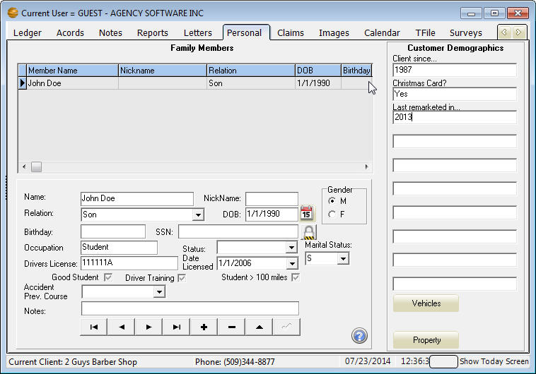
Also on the Personal tab is a Property button to enter Personal Properties and a Vehicle button to enter Vehicles.
Figure 48 - Personal tab

The Claims Tab
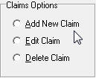
Click the Claims tab to open the Claims window. Use the Claims window to keep records of the selected client’s claims.
Add a New Claim. The current customer’s name is shown at the bottom of the window. Click the Add New Claim option, then click Do It. On the claim entry screen, enter a Claim number. Click the down arrow in the Policy Number box, and choose a policy number from the list. When you choose the policy number, the Company information for that policy will prefill in the Claim Detail window. Enter the appropriate data in any remaining fields, and click the check mark to post/save, then OK to close the window.
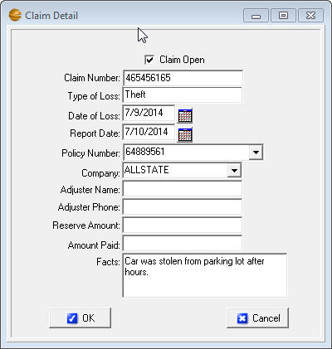
Edit a Claim. Select the claim you want to edit, then click the Edit Claim option and click Do It. In the Claim Detail window, make your changes and click OK.
Delete a Claim. Select the claim you want to delete, then click the Delete Claim option and click Do It. When asked if you are sure, click Yes (unless you change your mind – then click No).

The Images Tab
Click the Images tab to open the Images window. What happens in the Images window is a function of the Apro Document Manager or the Agency Software Printer driver.

The AgencyPro Document Manager
With the Document Manager, you can attach any kind of electronic document to any specific client in your AgencyPro database. Do you have a letter, a picture, or a spreadsheet that you want to attach to a specific client so that you can quickly locate and open that particular file? Now you can do exactly that with the AgencyPro Document Manager.

What the Document Manager Can Do for You
The Document Manager is designed to attach or link specific files in your computer to specific clients in your AgencyPro database.
You can attach all kinds of files to specific clients: any scanned image, forms saved as PDF or JPG files, text documents (such as a Word file), spreadsheets (such as an Excel workbook), and pictures of any kind.
When you select a specific client on the Clients tab, all the attached or linked files for that client are listed on the Images tab.

What’s the Difference between Linking and Attaching?
Attaching creates a separate copy of the file for the database. Any changes you make to the attached copy in the database are made only in the attached copy – they don’t change the original file.
Linking creates a link to the original file. If you open a linked file and make changes, your changes appear in the original file.
Whether the file is linked or attached, if it’s a graphics file (specifically a BMP or JPG file) you can see the file image in the Image Preview pane on the right side of the Images window.
The files are easy to open. You can either double-click the name of the file in the Title pane (on the left side of the window), or double-click the image in the Image Preview pane (on the right side of the window). Double-clicking in either pane opens the file in its native program.

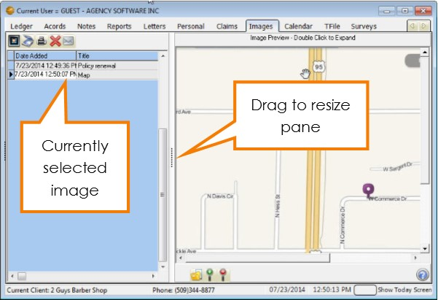
What’s a Native Program, and Can I Change It?
Figure 49 - Images tab
A file’s native program is the program in which the file normally opens in your computer. For example, if your computer normally opens a BMP (bitmap) picture in the Microsoft Photo Editor, then that is the BMP file’s native program – and when you double-click to open that particular file in the AgencyPro Images window, that file opens in the Microsoft Photo Editor. Likewise, any PDF file opens in its native program, which is always the Adobe Acrobat Reader. (The native program is often referred to as the file type or the file association.)
To change the file association – the native program in which a file opens – open any folder window, such as the My Documents folder.
- In Windows XP or Windows 2000, click the Tools menu.
In Windows 98, click the View menu. In Vista and Windows 7 click on Organize.
- Click the Folder Options command. In the Folder Options dialog box, click the File Types or View tab. A long list of file extensions (the 2-, 3-, or 4-letter extensions that appear after the period at the end of filenames) appears in the Registered File Types pane.
- Scroll down the list and select the file extension for which you want to change the association (e.g., BMP or JPG). When you click the extension to select it, the Details pane tells you what program that file type currently opens in.
- Click the Change button and select a different program in which to open the file, then click OK. All files that have that particular extension will open in the program you selected.

Adding Files with the Document Manager
There are several ways to add files to the Images window in AgencyPro. You can:
- Add files with the buttons on the Images window in AgencyPro
- Use the Document Manager icon on your desktop (even when AgencyPro is closed)
- Add scanned files directly from your ScanSoft PaperPort 9.0 scanning software
- Add files by clicking the Snapshot button in the Webview tab
- Print any printable item using the Agency Software Printer
- Use the Save button in the Client A/R invoice.

Adding Files from the Images Window
To add a new file when you have AgencyPro open:
- On the Clients window, select the client to whom you want to attach the file.
- Click the Images window to open the Images page.
- Click the Load New Image button.
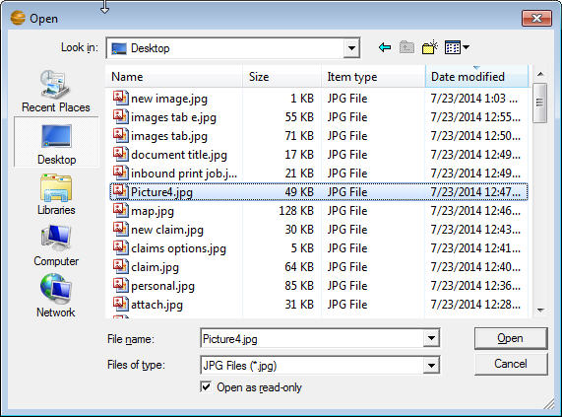
- In the Open dialog box that appears, navigate to the folder where the file is saved.
Figure 50 - Browse for image to attach
- Click the file name, and click the Open button.
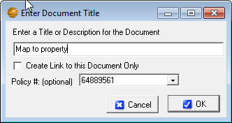
- The Enter Document Title box appears. Enter a document title – this is the title that will appear in the Title pane in the Images window (so make it something you’ll recognize).
- If you want to link to the file rather than create a copy, click the Create Link to this Document Only check box to mark it.
Note: If you link a document, make sure others in your office have access to that location or they will not be able to open the document in AgencyPro.
- If you want to attach a copy of the file, leave the check box clear and AgencyPro will make a copy of that file so everyone that has access to AgencyPro will have access to that document.
- If you wish to link the image to an existing policy, drop down the list and select the policy number. This will allow the image to be viewed from the Policy tab.
- Click OK.
The file is linked or attached, the title you typed appears in the Title pane, and the image (if it’s a BMP, JPG, or PDF file) appears in the Image Preview pane.

Adding Files with the Desktop Document Manager Icon
To put the Document manager icon on your desktop, open the network drive where AgencyPro is installed, then open the Apro folder, right-click the file named DocMgr.exe and select Send To then Desktop.
The Document Manager icon will then be on your desktop. You can attach or link a file to a client by dragging the file’s icon onto the Document Manager icon.
Note: You cannot run the Document Manager by double-clicking the icon – you can only drag-and-drop file icons onto it.
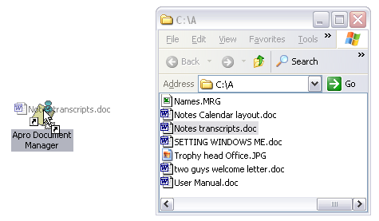
Drag the file icon and drop it on the Document Manager icon
You can drag the file’s icon from the desktop, or from a folder window. When you drop the dragged icon, the Document Importer window opens.
Note: If you want to use the Document Manager icon to attach or link an e-mail message, you must first drag-and-drop the e-mail message from your e-mail program onto the desktop first, then drag-and-drop the e-mail icon from the desktop onto the Document Manager icon. You cannot drag the email directly from the email program to the document manager.
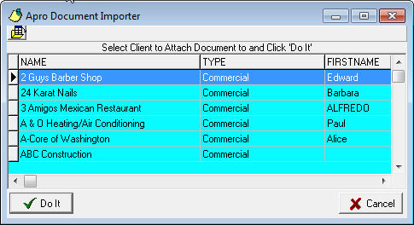
Figure 51 - Choosing a client after dropping a file on the Document Manager Desktop icon
- In this window, navigate to the client to whom you want to attach the file. All the techniques you can use for finding the right client in AgencyPro’s Clients window will work here, too – for example, type the first few letters of the client name, or scroll to a different column and click the column header to sort by that column.
- Select the client name, and click the Do It button. You can use any techniques you normally use in the Clients page to navigate to your client (e.g., type the first few letters of the client name to jump to that part of the list).
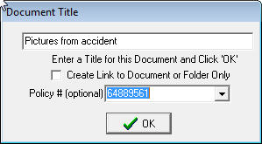
- In the Enter Document Title box that appears, enter a document title – this is the title that will appear in the Title pane in the Images window.
If you want to link to the original file rather than create a copy, click the Create Link to this Document Only check box to mark it. If you want to attach a copy of the file, leave the check box clear.
Note: If you drag a desktop shortcut to your Document Manager icon, it doesn’t matter whether you attach or link – you are attaching or linking a shortcut rather than the actual file, and opening the file from within AgencyPro will always run that shortcut and open the original file.
If you wish to link the image to an existing policy, drop down the list and select the policy number. This will allow the image to be viewed from the Policy tab.
- Click OK. The file is linked or attached, the title you typed appears in the Title pane, and the image (if it’s a BMP or JPG file) appears in the Image Preview pane as displayed above.
Note: If AgencyPro is open when you attach a file using the desktop Document Manager icon, the newly-added file will not be immediately visible in the Images window. Click the Clients tab, then click the Images tab again, and you’ll see the newly attached file in the list.

Adding Files from ScanSoft™ PaperPort 9
If you have a ScanSoft™ PaperPort 9 scanner, you can attach or link scanned files to your AgencyPro clients directly from the PaperPort window.
After you install the AgencyPro Document Manager, you’ll see a Document Manager icon in the Send To bar (the programs toolbar at the bottom of the PaperPort window) the next time you open it. If you don’t see the Document Manager icon, click the Arrow buttons on either side of the Send To bar to scroll more program icons into view.
If you still don’t see the Document Manager icon in the Send To bar, click Tools – Refresh Send To Bar. If that doesn’t add the Document Manager icon to the Send To bar, click Tools – Send To Options, and in the Send To Options dialog box, scroll to select the Document Manager icon and then mark the Include Icon On Send To Bar check box.
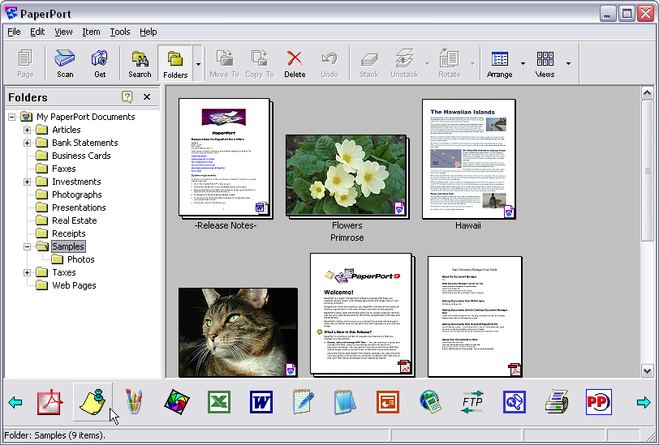
Document Manager Icon
Arrow Button
After you scan a document into PaperPort, you can use the Document Manager icon on the Send To bar to send the new file to AgencyPro.
Tip: When you install ScanSoft ™ PaperPort, a new button (the Print To PaperPort button) appears in Microsoft Word, in the Standard toolbar. After you create and save a document in Word, you can click the Print To PaperPort button in the Standard toolbar to add the open document to PaperPort, and from the PaperPort window you can add the file to the AgencyPro Document Manager.
- Select the icon for the document in the PaperPort window, then click the Document Manager icon in the Send To bar.
- Select the client name, and click the Do It button. You can use any techniques you normally use in the Clients page to navigate to your client (e.g., type the first few letters of the client name to jump to that part of the list).
- In the Enter Document Title box, enter a document title. If you want to link to the original file rather than create a copy, click the Create Link to This Document Only check box to mark it.
If you want to attach a copy of the file, leave the check box clear.
- Click OK.
The file is linked or attached, the title you typed appears in the Title pane, and the image (if it’s a BMP, JPG, or PDF file) appears in the Image Preview pane.

Adding Files using the Agency Software Printer
ASI Printer Setup must be done at each workstation by running the appropriate ASIPRINTER file at each workstation for that user to have access to the Agency Software Printer and use the Snapshot button in Webview. The ASI Printer is installed using the Techtools utility available from the Apro folder.
After you install the ASI Printer you will have it available in your printer selection. If you choose the Agency Software Printer while on an outside document, email, website, etc. (you must be logged into AgencyPro while using this feature) it will ask which client you would like to attach the image to.
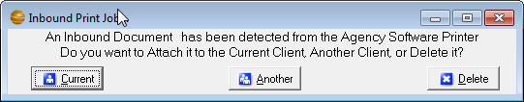
This will create a PDF file in the Images tab of the selected client. Next you will get the same Document Title windows you get when attaching images directly from the Images tab, where you will give the document a Title and you can attach this image to a specific policy.
Figure 52 - Select client for image attachment
Another way of using the Agency Software Printer is by clicking the Snapshot icon from the Web View tab, which will capture the entire current page displayed in Web View to a PDF file in the Images tab.

Using Your Attached or Linked Files in AgencyPro
Now that you have files in the Images window in AgencyPro, here are some things you can do with them.
Want to take a quick look at a form you’ve saved in the client’s Images window while you’re talking to your client? Select the client name, click the Images window, select the file title in the left pane and open it.
Whether a file is linked or attached, you can open it by:
- Double-clicking the file title in the Title pane on the left side of the Images page
- Clicking the title to select it, then double-clicking in the Image Preview pane on the right side of the Images page
Note: Only BMP, PDF and JPG images can be viewed in the Image Preview pane – other graphics files (such as Email and TIF files) cannot be viewed in the Image Preview pane, but can be opened in their native programs by double-clicking in the Image Preview pane.
Graphic images will be stretched to fit in the Image Preview window. If the picture has unusual proportions, it will be stretched out of shape in the Image Preview pane.
If the picture in the Image Preview is too big to see all at once, use the scroll bars to scroll to hidden parts of the picture, and/or use the Zoom buttons below the image pane to magnify or reduce the image view.
If your file opens in the wrong program, or tries to open in a program you don’t have, see the Images Window section to change the file association.
The Images toolbar appears at the top of the open form. When you place your mouse over a toolbar button, the name of the button appears. The buttons, left to right, are as follows:
 | The Load Image button loads files from your computer into the Images page
 | The Image Processing button activates your scanner
 | The Print Image button sends the selected file to the printer
 | The Delete Image button deletes the file from the client’s Images page.
 | Email Customer button opens up an email with the image already attached
Want to open a non-graphic file, such as an attached letter, and work on it? Either double-click the file title on the left, or double-click in the Image Preview pane on the right.
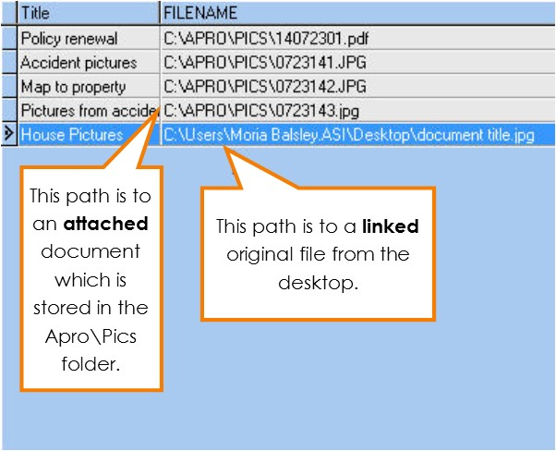
To change the spelling of a file title, click the title name in the list and type your changes, then click on a different title to save your changes. The list will be instantly re-alphabetized.
Figure 53 - Image path comparison; linked vs. attached
To see the location of the file, drag the horizontal scroll button at the bottom of the Title pane to the right. You’ll see the FILENAME column, showing the path to each file.

The Tickler/Calendar Tab
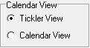
Ticklers are reminders you set for yourself or other users, for any reason you like – appointments, birthdays, To Do items, or anything else for which you want a reminder.
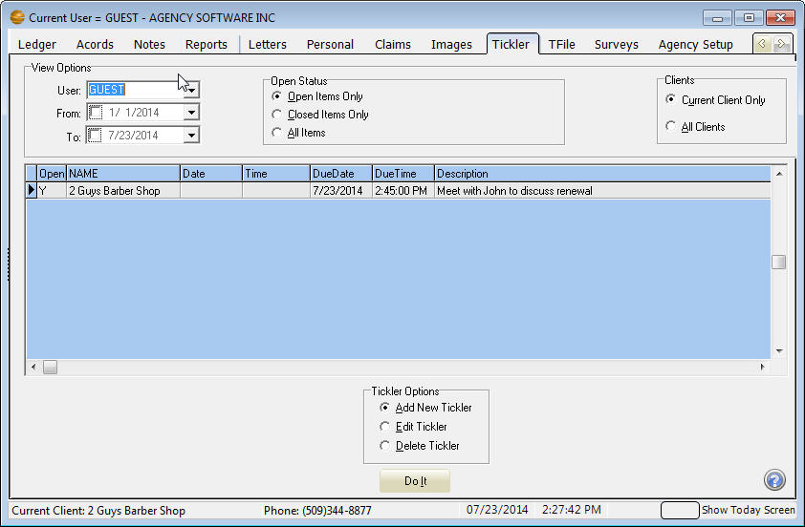
There are two views for Ticklers, Tickler View and Calendar View. The preferred view is set in the Agency Setup tab as a global setting for all users. The tab and tab layout displayed reflects your currently selected setting.
Figure 54 - Tickler view
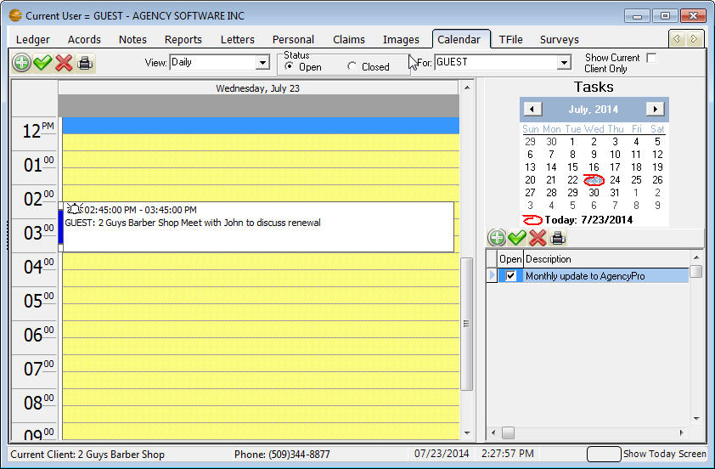
You can display by Open Status and Clients. Click the box on the From & To dates to activate and use a date range. The Tickler options allow the creation and editing of Ticklers
Figure 55 - Calendar view
You can view by Daily, Weekly & Monthly, by Status and by clients. The calendar listing shows Appointments & Alarms. The Tasks window on the lower right shows Tasks in Blue if the due date is in the future, Black for today & Red for past the due date.
Figure 56 - This screen is the same no matter the view settings
You can use the Add New Item icon or double click on the time slot to create a Tickler.
When you create or edit a tickler, you can set a visual alarm to “go off”, or pop up, at the date/time you set. AgencyPro must be open in order for the alarm to go off, and if AgencyPro is not open at the scheduled alarm time, the alarm will be displayed the next time you open AgencyPro.
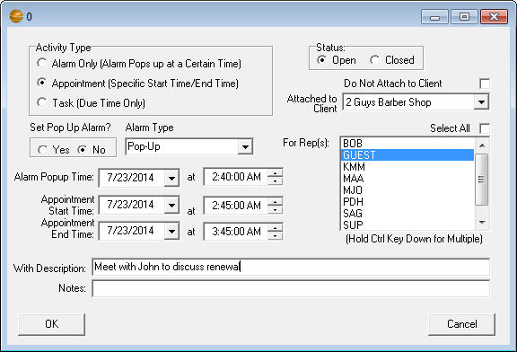
Create a new tickler - When you click the Add New Tickler option and click Do It, the Tickler dialog box opens with your user name in the Rep box, and attached to the selected client. Set a date and time for the alarm and then enter a description and any notes about the tickler. In the Set Pop Up Alarm options, choose Yes or No (if you select No, there won’t be a reminder popping up). Click OK to save the tickler.
You can create ticklers for other users (select the user name in the Set Tickler For Rep box) and the tickler will go off when that user is logged in to AgencyPro.
You can also create a tickler that’s attached to a client other than the client currently selected in the Clients window. Select the client name you want in the Attached To Client box.
When a tickler alarm goes off - You can “snooze” the tickler to go off again later by clicking the Snooze button and setting a new time. Or you can close the tickler permanently by clicking the Cancel Alarm button.
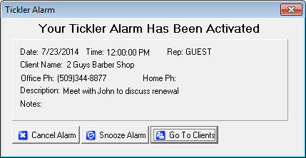
Click the Go To Clients button to close the tickler and open the AgencyPro Clients window. When you click this button, the tickler will reappear in a few seconds, and keep reappearing every few seconds until you click Cancel Alarm or Snooze. If you click Snooze and click Ok the Alarm will automatically be snoozed for 10 minutes, or you can set the alarm for another time or day.
Edit a tickler: To edit a tickler, either double-click that tickler in the list, or click the tickler in the list to select it, click the Edit Tickler option below the list, and click Do It. Make your edits and then click OK.
Delete a tickler: To delete a tickler, click the tickler in the list to select it, then click the Delete Tickler option, and click Do It. When queried if you’re sure, click Yes.
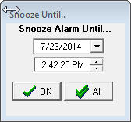
Snooze All feature: When a tickler alarm displays, if you click the Snooze button, on the snooze window there will be a Snooze All button. Click the Snooze All button after setting the date and time and that will snooze all ticklers that are due to that date and time.

Change Your View of Ticklers
The options at the top of the Tickler window control which ticklers are displayed in the list.
- In the User box, you can choose to display ticklers for specific users, or for all AgencyPro users.
- In the From and To boxes, you can choose the date range of ticklers to display. If you clear the check boxes, you’ll see all the ticklers ever created for the selected User name.
- In the Open Status options, you can limit the list to just open ticklers, just closed ticklers, or all ticklers regardless of status.
- In the Clients options, you can choose to display the ticklers for the currently selected client or for all the clients in the database.

The TFile Tab
Transactional filing automatically tracks changes made in the AgencyPro software. It is intended as a way to replace your existing file cabinet.
Click on the TFile tab to view the TFile window.
There are three buttons at the upper-left corner of the transactions list: Manually Add New TFile Item, Print History File, and Find a Word or Phrase in History. The middle of the window lists all AgencyPro transactions, depending upon the display choices selected at the bottom of the window.
Manually Add New TFile Item Opens the Add TFile Item window in which you can manually enter AgencyPro transactions (see below to learn more).
Print History File Creates a printed list of the displayed transactions (Tip: Print the report in Landscape mode instead of Portrait for a more readable report.).
Find a Word or Phrase in History Searches all columns in the displayed transactions for the word or phrase you type – the Locate Field Value box, shown below gives you options for your search. See window below.

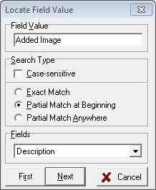
Transactions Display Options:
Current Client Only - Displays transactions involving the client currently selected in the Clients window within the selected date range.
All Transactions - Displays all AgencyPro transactions within the selected date range.

Date Range Display Options
Today Only - Displays transactions performed today for the client selected in the Transactions options.
All Dates - Displays transactions for all dates for the client selected in the Transactions options.
Date Range - Displays transactions for the selected date range for the client selected in the Transactions options.

Manually Add a TFile Item
If you click the Manually Add New TFile Item button you will open the Add TFile Item window.
Date Automatically current, but you can change it if you need to.
- Time Automatically current, but you can change it if you need to.
- By User Logged-in user name.
- Client Choose client name from dropdown list.
- Policy Choose Policy # from dropdown list (the entire list of policy numbers appears – when you select a policy number, the client name is filled in).
- Description Type a description of the transaction.
Click OK to save the entry and return to the TFile window, or click Cancel if you decide not to save the transaction.
Note: Transactions cannot be deleted (unless you are closing your agency’s books at the end of the year). Otherwise they are permanent. This is for your E&O protection. Therefore, the TFile should not be used as a Notes file or a Tickler file for clients. Use either the Notes window or the Tickler/Calendar window to record information that’s not transaction-related.

The Surveys Tab
Click the Surveys tab to open the Surveys window. There are more than 200 Business Specific Survey Questionnaires in AgencyPro. Most Survey Questionnaires are 7 – 10 pages long and contain a checklist of items that will certainly help reduce your E&O risk – and possibly uncover underwriting credits. Use the scroll bar on the right side of the list of survey titles to locate the survey you want. Double-click on the survey title to display it in the window. When you have the survey you want open, click the print button to print it. You can take the survey with you when you go to an insured site, and enter information right on the pages.
You can edit surveys to better suit your agency. Click in the survey text and edit it as you would in a word processor. Use the scroll bar on the right of the open survey window to scroll through the entire survey.
The three buttons in the upper-left corner are Print Survey, Open Saved Survey (which opens surveys you’ve saved under a new name), and Save as New Survey (which saves a survey under a new name).

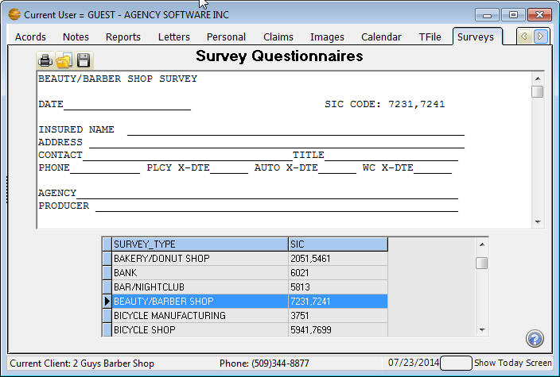
The Agency Setup Window
Figure 57 - New survey added to the Survey tab
Click the Agency Setup tab to open the Agency Setup window. During your initialization of AgencyPro, you will want to spend some time entering your codes and choosing the appropriate settings for your agency.
Some of the settings on this tab have been covered in previous sections (Notes and Tickler for example). See the Accounting Workflow section for more information on:
- Accounting Basis
- Chart of Accounts
- Brokers/Writing Companies

Agency Information
The Agency Information is also the producer information that appears on your ACORD forms, invoices, statements, checks, etc. This information comes initially from the information submitted during purchase to Agency Software. You can change the Agency Information on the setup tab, but it is also recommended to submit the change to Agency Software using the Change of Address form available from our website.

Coverage Classes
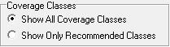
The coverage classes (lines of business) available from the Coverage Class drop-down in the policy is a default listing. By default you can add to that list by simply typing in the new entry with Show All Coverage Classes selected. The default list cannot be added to if Show Only Recommended Classes is selected.

Encrypt Client SSN’s
The Encrypt Client SSN’s option is designed to secure the client social security number on the Personal tab. Once checked it cannot be reversed and the social security numbers are only available one at a time by clicking the Decoded SSN button next to the SSN field.

Automatic Data Backups Configuration
In the # of Days Between Backups box you can set a schedule for automatic data backups. If, for example, you select 7, then every 7 days the first thing that happens when AgencyPro is opened is a data backup. AgencyPro creates a compressed backup file of all your AgencyPro data and saves it in the Apro\Data001\Backup folder. Since these backups are stored directly on your computer’s hard drive, they do not protect against hardware failure, fires or viruses. You MUST have an offsite backup method (i.e. tape backup, CD Burner or memory stick that you can take with you) available as your primary backup source.
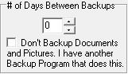
You can include the AgencyPro backup in your Microsoft Scheduled Tasks so you can back up AgencyPro at a time that's convenient for you. For instructions go to the Support page at agencysoftware.com.
If your agency is paperless, the data backups are likely to be slow and quite large, as the backup will by default cover the Pics folder which stores all of your agency’s images. You can suppress the images from the data backup by checking the option Don’t Backup Documents and Pictures, but first be sure that you get a regular offsite backup that includes the Apro\Pics folder.

Setting Global Messages
The global messages at the bottom of the Agency Setup window are automatically printed at the bottom of each statement and invoice that you generate from the Client A/R window. You can change these messages to suit your business – just edit the message and click the Save button to the right.
If you have preprinted letterhead that you use for printed statements and invoices, check the Suppress Agency Info… box.

Companies Information Database
Click the Companies button (on the right side of the window) to open the Company Information window. The toolbar buttons will allow you to Add, Edit, Delete and scroll through companies.
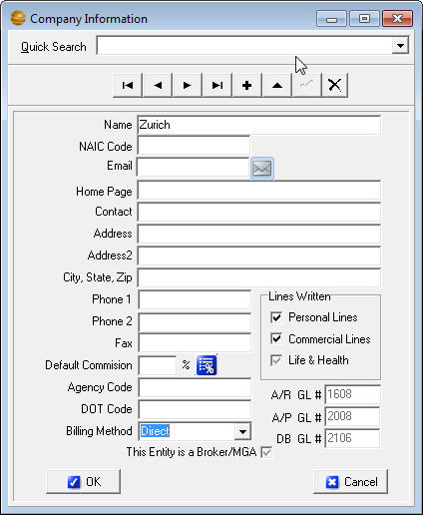
Click the + (Insert Record) button to add a new company to your Companies database. Fill in the fields, and then click the check mark button to save your entries.
Figure 58 - Entering a new company
Enter only one record per company or broker. Avoid entering company records for companies in which you do not have a direct appointment or do any accounting with. You will get a chance to enter writing companies on the policy. Each record you enter will generate several accounts in the chart of accounts to be utilized for accounting posting (depending on the billing method and lines chosen during company set up).

Company Fields
Name (required) – This field is the main company code. Format this field as if you were writing it in a letter for future marketing capability, or like you would want written on a check you might send to the company.
NAIC Code – The company NAIC code can fill to the Acord form and assist in automatic identification of the company during download.
Email – Enter the email address for the main company contact.
Home Page – Enter the web address for this company’s agent logon page. This is the site WebView will look up for this company.
Contact – Enter the main company contact.
Address fields – This information will prefill to both the Acords and to a printed check.
Phone and Fax fields – Enter the company contact information.
Default Commission % (recommended) – Enter the company’s most common commission percentage. This percentage will fill to the policy (unless the policy matches an entry in the commission grid).
Agency Code – Enter the code assigned your agency by the company.
DOT Code – Enter the company’s DOT code.
Billing Method (required) – Choose the company’s billing method from the drop down list. If this company does both agency and direct bill, choose initially Direct, and codes will be generated for both billing methods (all companies are set up to support agency billing regardless of your choice in this field).
Lines Written – Check any lines you might write with this company. Each line you check will generate a corresponding income account in that income category.
This Entity is a Broker/MGA – If the company you are adding is a Broker, check this box.

Company Commission Grid
To set up the Commission Grids for Companies, click on the Commission Grid icon (only available once the new company has been saved). This commission grid will automatically fill to the policy’s commission percentage when the criteria entered in the grid matches the policy information. Go to the correct company and click this button, then click the plus sign to add a Coverage Class for this company. Click the down arrow in the Coverage Class field and choose the first coverage class. Click the down arrow in the Transaction field, choosing New or Renewal, and then enter the Commission percentage. Click the check mark to post that entry to the commission grid.
Note: The commission grid is an override to the Default Commission % from the main screen for that company, so any % matching the default is unnecessary to enter into the commission grid screen.

Employees Information Database
On the Agency Setup tab, click the Employees button to open the Employees window.
The toolbar at the top is like the rest of the toolbars in AgencyPro – with the buttons, you can Add, Edit and Delete usernames and producers in AgencyPro.
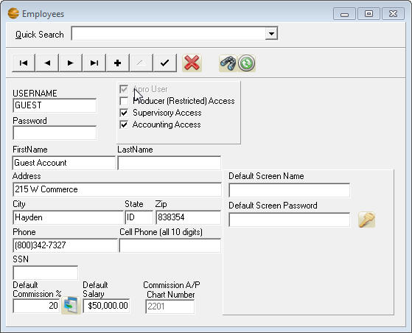
Note: You are limited to 5 users unless you purchase extra seats. You cannot delete a user, you’ll need to call Agency Software, Inc. and ask them to add a new user, or to replace a user you want deleted. Instead, when you need to change a user in AgencyPro, select the employee that’s leaving and edit that record to change the username and password to the user you want to add as long as the Username was not paid commission in AgencyPro. If they were paid commission contact your Account Representative or Tech Support to help you add the new user. (You do not need to enter a password, but using passwords makes the data in AgencyPro more secure.)
Figure 59 - Employee information
To edit an employee record:
- Login as a user with supervisory access, and open the Employees information database.
- Use the scroll buttons at the top of the window to scroll to the employee whose data you want to change.
- Click the Edit Data button – the button that looks like a triangle.
- Edit the user data, and be sure you mark or clear the access check boxes to give that employee the kinds of access you want them to have.
- Producer (Restricted) Access allows a user to see only clients on the Client tab that have the Assigned Producer name the same as this User’s Username.
- Supervisory Access allows a user to change user data. The user will have the Agency Setup tab when they open AgencyPro, and will have all the Management reports on the Reports tab. Supervisors also have access to delete records throughout AgencyPro.
- Accounting Access allows the user access to the Ledger tab and all the Accounting reports on the Reports tab.
- Click the check mark button to save the edited employee data.
- Click the X button in the upper-right corner of the window to close it.
Delete Employee
Filter Employee List
Restore Employee List
Note: You can’t have duplicate employees entered in the Employees window – if you enter duplicate employee names, you’ll get a Key Violation error the next time you login.

Employee (Rep) Commission
The Employee’s Default Commission % will automatically prefill into the policy screen, if that employee is chosen as one of the Reps. It is not mandatory to fill this in.
A Commission A/P Chart Number will automatically be created in the General Ledger for each new employee. This is where AgencyPro tracks the commission owed to the producer.
To set up an employee commission grid, click the Set more default commissions icon and a Rep Commissions window will open. Click the plus sign, and choose a Transaction at the bottom and enter the percentage and click the check mark to the right to post that record. If you enter a Default Commission % on the main screen for that producer, this commission grid will override that percentage when it matches the entered value from the grid.

Employee Passwords
The employee’s usernames and passwords may prefill into a company webpage while using the Web View tab. The Default Screen Name and Default Screen Password are for Farmers Website only. To setup the Usernames and passwords for the other companies click the key icon in the Employee screen while the employee is selected. Add an item by clicking the + on the toolbar and fill in the Company (must select from drop-down and Company Home Page must be set up to work) and enter the username and password information. Click the check mark to save.

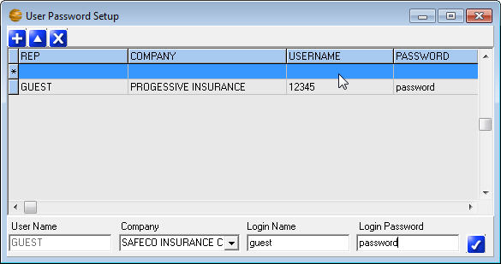
Demographics Categories
Figure 60 - Setting up employee passwords for WebView function
To set up the Demographic heading to display on the Personal tab, click the Demographics button and type in your desired headings in the Agency Defined Demographics window.

Appearance Settings
The Appearance button allows you to choose a theme. The listed themes change the colors of the program background.

Reset Grids
Many of the program windows, such as the grid on the Client tab, are customizable (you can move and resize the columns). The Reset Grids button resets all program grids to the original settings. You must exit and log back in for the reset to complete.

SECTION 4

ACCOUNTING SETUP AND WORKFLOW
This section is designed to assist with the accounting start up and documentation of the regular accounting workflow. More detailed information on tab function (and screen shots) can be found in the previous Program Features section.
New customers are offered four one hour training sessions. It is recommended to first become familiar with the Client and Policy functions (through training or tutorial) before utilizing the accounting training. These sessions are designed to support you through your first month of accounting entry. If you are just beginning, contact Technical Support to schedule your first session.

Accounting Setup
During the setup process, make sure to utilize Agency Software support and your accounting trainer for any questions you have.

Setting up your Accounting Basis
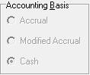
An accounting method must be selected prior to doing accounting in the system. While the AgencyPro accounting workflow is only slightly different, the way the general ledger posts is vastly different per method:
- On an Accrual basis (GAAP recommended) the policy and income posts when earned (as of the effective date of the policy). The Client A/R functions will allow the agency to collect payments on account and do various account adjustments. Modified Accrual works the same but allows installment policies to post installment by installment instead of posting the entire policy as of the effective date. Agencies who do mostly agency bill are likely to want an accrual basis.
- Cash basis accounting will post income only when the payment is applied. This means you must have a policy in place to apply payment toward. There are no receivable postings and what you see on the Client A/R is only notation until it has a payment applied toward it. Agencies that pay producers based only on what they receive are likely to want a cash basis.
This is the first thing discussed during accounting training, and will typically be set at the same time as the opening balances and chart of accounts setup. You will not be able to change your accounting method mid-year without starting your accounting over.

Chart of Accounts
The Chart of Accounts is a listing of your accounts. AgencyPro comes with a default chart of accounts, which can be customized to the agency’s needs. During the initial training an accounting setup is offered, which will customize the chart of accounts to reflect your existing chart of accounts as closely as possible.
If you do not have an existing chart of accounts, the default can be altered to add any necessary accounts as you begin to do accounting in AgencyPro. Check with your accountant or bookkeeper for further guidance on appropriate account entry.
Note: The Chart of Accounts should be as complete as possible before any accounting entries are made.
To view, add to, or edit the existing accounts in the Chart of Accounts click the Chart of Accounts button in the Agency Setup tab. Accounts that are used or system accounts cannot be deleted. You can print this Chart of Accounts by clicking the printer button in the upper-left corner.

Adding Accounts
Though most accounts will likely be there from the initial accounting setup or company and employee entry, you may find the need to add an account in the future. Non-ledger accounts are added by first scoping out the existing account to find an available account in the desired range, then clicking the Add button at the bottom of the Chart of Accounts window. The Add Chart Item window appears with the following fields:
Name (required) – Name this account appropriately.
Chart Number (required) – Enter an unused number in the desired range, or the chart number of a header account if created a sub-account.
Sub-Chart Number (required) – Usually the same number as the Chart Number unless this is a sub-account under a header account.
Opening Balance – Typically leave this blank unless this account is part of the opening balance entry (see Opening Balances section below).
Tax Description (required) – This is the category in which the account will be listed on your financial statements. You can type in a custom entry but the entry must contain the main category word spelled correctly (Assets, Liabilities, Equity, Income, or Expense).
Notes – Enter an account notation here.
Because account entry happens so rarely, calling support for assistance in adding or editing accounts is recommended.
Note: Ledger accounts are not added in the Chart of Accounts window. See the Ledger section for more information on adding ledger accounts.

Preset Accounts
The following accounts are preset and cannot be altered.
1000 (Cash) – Ledger account that holds undeposited funds.
1050 (Checking) – Ledger account typically utilized for main operating account.
1100 (Client A/R) – Sub-ledger header account for client receivables. As agency bill policies are added, individual client sub accounts will be created. Only the Accrual method will utilize these accounts, posting the amount due from the client on agency bill policies.
1600 (Company A/R) – Sub-ledger header account for company commissions receivable. As companies are added, individual company sub accounts will be created. Only Accrual method will utilize these accounts, posting the commission due from the company on direct bill policies.
2000 (Company A/P) - Sub-ledger header account for company accounts payable. As companies are added, individual company sub accounts will be created. The net due to the company on an agency bill policy will be tracked in this account series.
2100 (Direct Bill Payable) - Sub-ledger header account for direct bill customer payments due. As companies are added, individual company sub accounts will be created for only those with Direct selected in the Billing Method field. Customer payments on direct bill policies flow through this account.
2200 (Commissions Due) - Sub-ledger header account for rep accounts payable. As employees are added, individual producer sub accounts will be created. The commission due to the producer will be tracked in this account series.
3100 (Retained Earnings) – This equity account retains your past year’s profit/loss. This account is posted to during the Close Books process.
4100 (Commercial Lines Income) – The sub accounts are created by adding a company with Commercial Lines checked in the Lines Written box. Commercial Lines policy commission will post to this account.
4200 (Personal Lines Income) - The sub accounts are created by adding a company with Personal Lines checked in the Lines Written box. Personal Lines policy commission will post to this account.
4300 (Life & Health Income) - The sub accounts are created by adding a company with Life & Health checked in the Lines Written box. Life & Health policy commission will post to this account.
5100 (Commission Expense) – These accounts are the offset to the rep payable postings. The account utilized depends on the department selected on the policy.
9998 (Over/Short Expense) – This account will be automatically utilized if the program finds out of balance transactions.
9999 (Account Transfer) – This account is used for program account transfer functions and deposits. The balance should remain zero.

Opening Balances
Accounting information does not convert into Agency Pro, therefore the balances are typically started through opening balance entries. A brand new agency will simply begin with their initial deposit, but if you have been running your accounting you will need to choose a day to begin.

Choosing a start date
Some agencies choose to start at the beginning of their fiscal year, while others will choose a day mid-year (normally corresponding with a bank statement) so as to not repeat work in the management system.
What will be needed to determine your opening balances is a trial balance and any corresponding sub-ledger detail reports from the date you will be starting Agency Pro accounting.

Entering Opening Balances
The opening balances entered depends on your accounting method, the balances coming over, and several other factors. This can be quite complicated, as different systems post in different fashions, and it is recommended to approach this in training or obtain the assistance of your accountant.
Chart of Accounts – All companies, producers with existing balances must first be added through the Company or Employee windows (to generate the sub-ledger account). The existing trial balance will be entered in the Chart of Accounts Opening Balance field (including company and employee sub-ledger balances). Once all balances have been entered, print the report (using the printer icon on the Chart of Accounts window) and confirm the end total is zero. From the Opening Balance Effective: field choose the start date of your accounting. If sub-ledger balances were entered an icon will appear in the top right corner. Click this icon to set these balances in the appropriate sub-ledgers. These steps are normally done for you during the accounting setup offered in training.
Ledgers – In each ledger with an existing balance, an item will be entered for the opening balance, allocating it to the account in brackets (<1050> for example). This step is normally done with the accounting trainer in the second training session. Be sure to reference the Ledger tab section for instructions on adding ledger accounts.
Client A/R – Here is where you start to see the difference between Cash and Accrual. This step is normally started with the accounting trainer in the second training session.
Cash: In the Chart of Accounts, any Client A/R balance being carried over needs to be transferred to another account. Most agencies will set up another account for existing balances in the Asset range, then move the balance from 1100 to the account they created. To enter existing receivables, create agency bill policies reflecting the amount currently owed.
Accrual: From the Clients tab select the client who carries an existing balance and click on the Client A/R tab. Click the Receive Customer Payment icon, then the Make A/R Adjustments icon. Choose Opening Balance Adjustment from the Type of Adjustment field, choose your chosen start date in the Date of Adjustment field, and type in the amount of the client’s balance (positive or negative balances as they were on the chosen start date) in the Amount of Adjustment field. This (1) creates a chart number for the client and (2) enters the balance on their Client A/R.
After entering all your opening balances, go to the Reports tab and print a Trial Balance. The balance at the bottom should equal zero.

Policy Entry
AgencyPro accounting is policy driven, which means the actual accounting flow starts with the client and policy entry.
Note: Prior to policy entry make sure your Companies and Employees have been set up correctly in the Agency Setup tab, and that account numbers have been generated on those setup screens and the proper Accounting Method has been set.

Differences in Billing Method
The postings behave very differently depending on the Billing Method selected on the policy.

Agency Bill
- Will post entry to Client A/R tab so you may print an invoice or statement
- Postings split between the Company A/P and the Commission Income accounts depending on the Agency % of Premium indicated on the policy (and between the Producer Commission Payable and Commission Expense accounts if a Rep1 or Rep2 was named and given a % of commission)
- Typically collected by the agency and paid net to the company (in some cases premium is financed and only a down payment is collected)
- Fees and Taxes are billed under Non-Premium items to be collected by the agency.

Direct Bill
- Does not show on Client AR tab and system does not track premium owed
- Payments applied to direct bill policies are pass-through entries meant to have no residual effect on the accounting
- Commission comes in from commission only payment from company and is posted through Direct Bill Reconciliation
- Non-Premium Items will not post to accounting as fees and taxes are generally not billed by the agency.

Rules of Policy Entry
Correct policy entry is very important as this is the beginning of your accounting workflow. The policy tells the system how to handle the accounting.
More about general policy entry and detail on each policy field can be found in the Policy tab section.
Use the Policy Options to create the policy entry – Most policy options work off of the selected policy to create a new entry. Do not just open and change an existing entry or you will lose the accounting from the past.
Use the drop-down list – These lists are code look-ups necessary to post proper accounting. Utilize these lists whenever they are available (Cov. Class and Writing Company lists can be added to manually, by typing in the desired entry).
Fill all required fields – These fields must be filled out to post accounting: Type, Policy#, Transaction, Department, Cov. Class, Effective & Expiration Date, Company, Policy Status, Billing Method, and Premium.
Policy Status must be Open – to post initial accounting (the cancellation feature is an exception, as it will post and change the cancellation to Closed).
Only fill what is necessary on the right side of the policy – These are your option policy fields. While the Agency % of Premium should be filled out with the commission you will receive on this policy, the Rep fields should not be filled unless there is a producer you must pay.

Entering a Policy
Once the client has been entered into the Clients tab, move to the Policies tab and select Add New Item (assuming this is a new client and the initial policy entry). Click Do It.
A blank Policy Detail screen opens. Start filling out the screen by using the drop-down lists.
- In the Type field choose Policy (all of these behave the same except for Quote, which will not post accounting or report on most reports).
- Type in the policy number (or TBD if not yet assigned).
- Choose New Business in Transaction, as this policy is in its first year.
- Choose the appropriate department.
- Look for the appropriate line of business in the Cov Class list. If not present you can add it by shrinking the drop-down list and typing it in.
- Use the calendar, or type in the Effective Date (format: XX/XX/XXXX).
- Use the calendar for the Expiration Date and it will annualize the policy automatically (Pers. Auto will automatically be semi-annual).
- Choose the company (this is the company that you pay or that pays you). If not present click the adjacent button to set up the company.
- If you wish for a different company to fill to the Acord you can enter in the Writing Company field. To add to this field simply click the drop-down list, then shrink the drop-down list and you can type in the field the company you wish to add.
Note: You may find this field displays as Broker/MGA. This means that you are set to Broker/MGA on the Agency Setup tab and that your Writing Company would go in the Company field and the billing company would go in the Broker/MGA field (if different than the company). This setup requires that both writing companies and billing companies are set up in the Companies database, and is not the recommended method for agencies new to AgencyPro. Contact support for further discussion.
- Select Open from the Policy Status drop-down.
- The Billing Method must be appropriately selected (and will automatically fill from the Companies default selection), see the previous section, Differences in Billing Method, for more information.
- In the Premium Amount field you will type in the pure premium (premium without fees or taxes).
- The Agency % of Premium field is the amount of commission you will retain or receive on this policy. This field will prefill if a default was entered on the Companies setup, or if the policy matches an entry in the company commission grid. Otherwise you can manually populate this with the commission rate you will receive on this policy. You can also delete this % and type a flat amount in the blue Agency Commission field (bottom left corner) that is normally automatically calculated.
- 1st & 2nd Rep and % fields are normally populated only if you have a producer you are paying part of your commission to. The drop-down is a list of usernames from the Employee setup (add to Employees in the Agency Setup if the selection is not available in the drop-down list). Once a rep is selected, any default or employee commission grid will prefill to the % of House field. The rep commission calculates from the Agency Commission (if the agency is getting $100 in commission and the rep is assigned 25%, it will calculate $25 in the Rep Commission field at the bottom of the screen). Like the % of Premium field, this can be altered or deleted and a flat rate typed into the blue Rep Commission field that is normally automatically calculated. If the Rep is to receive a portion of a non-premium item (such as an Agency Management Fee) you must calculate what they are to receive, delete the % of House, and enter manually at the bottom of the window.
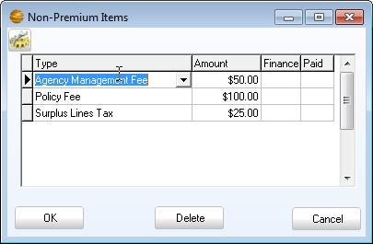
- The blue Non-Premium Items field is automatically calculated from items entered in the Non-Premium Items window. Click the Non-Premium Items button and list all fees and taxes individually in this screen. A default list is provided, however, you can click the Set Up Non-Premium Items button to add, edit, or delete items in this list, or to see how the current items are configured. There are three possible kinds of non-premium items:
Figure 61 - Non-Premium items listing
  - Income – Posts to an ‘Other Income’ account created during creation of the non-premium item
  - Company Payable – Posts to the billing company listed on the main policy window
  - Other Payable – Posts to an ‘Other Payable’ account created during creation of the non-premium item.
- Choose the appropriate type from the Type field and type in the amount. The Finance field only needs to be set to True if this is an installment billed policy (you are allowing the client to pay you in installments) and you want this fee divided by the installment schedule. Leave the Paid field blank. Add another non-premium line by tabbing through the end of the line or using the down arrow on your keyboard. When all non-premium items are entered click OK.
- The Total Due field should now equal the total premium due (due to you on Agency Bill, due to the Company on Direct Bill).
- The Installment Type and Number of Payments will only need populated if you are allowing the client to pay you this premium in installments (see the financing section for more on finance policies). If that is the case you can choose the payment schedule in the Installment Type (Quarterly for instance) and then select the Number of Payments (4). Once you click OK to the Policy Detail window you will see the Installment Grid, where you can manually adjust the dates and amounts of the installment postings.
- The First Payment Date field is normally left blank. However, if this is an audit (effective in past terms), or the due date of the policy is different than the effective date, you can enter the due date here.
- The Down Payment field is normally left blank. This field is left over from past financing and installment work-arounds, and will affect the bank account if populated.
- The Apply A/R to Premium Finance Company checkbox only appears on agency bill policies. This will only be utilized for agency bill policies in which you will not handle premium (no chargeback cancellations for instance). Check this box to waive all client A/R premium to the company payable. See the following Policy Financing in the Accounting Work-Arounds section for more detailed information on financing a policy.
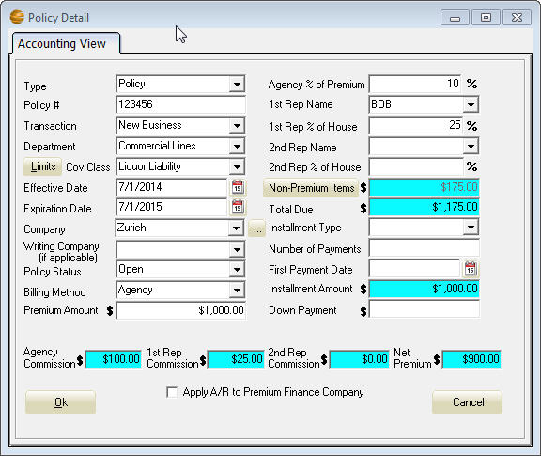
- The DB Rec? field only appears on direct bill policies. When you generate accounting initially it populated automatically with a ‘No’, meaning the commission has not been received. A ‘Yes’ indicates that this is part of a commission statement that has not been finalized, and an ‘R’ indicates that the commission has been received in full.
Figure 62 - Our completed policy in this example

Downloaded Policies
If you utilize the Download module then clients and policies will be created in the database. The download procedure includes a review of your daily download (running the Download – All Companies report and checking all the entries). These downloaded entries will not automatically affect your accounting, as they must be manually made ‘accounting ready’. This involves:
- Going to the policy screen and checking the policy (and correcting if necessary)
- Changing the policy status to Open
- Click OK and answer Yes to Regenerate Accounting (and all corresponding messages).
This policy is now accounting ready and will appear in the appropriate ledgers and sub-ledgers.

Editing a Policy
A policy can be changed and regenerated without issue if:
- The policy has not been paid in the payables
- The direct bill policy has not had commission payment applied
- The billing method is not being changed on a policy in which a customer payment has been applied.
Open the policy by selecting the policy, clicking Edit Detail, then click Do It (or double click the policy). Change the necessary fields and click Ok. You will be asked to regenerate accounting. Only a Yes answer will post your changes to the accounting.
If any of the circumstances above are met, other messages will be received during regeneration of the policy.
Note: If this was a direct bill policy that has had commission payments applied, the system will attempt to reverse the entry in the cash account. This entry will be a place holder for the commission you must then re-reconcile.

Agency Bill Workflow
The agency bill policy is typically billed (or a portion of it is billed if financed) to the client by the agency. The client pays the agency, and the commission is retained from that payment.

Billing the Client
Once the agency bill policy is entered, the Total Due will post to the Client A/R tab with each billable line listed individually and matching invoice numbers. To generate an invoice click the first icon on the Client A/R tab and make sure the Invoice Number matches the one you wish to print.
The Invoice window opens, allowing you to modify the invoice as needed (edit detail, add or delete lines, etc.). Any edits will not be saved to the Client A/R postings, so clicking the Save Invoice to Images icon will allow a copy to be saved (as a PDF file) to the Images tab. The Print Invoice icon will bring up the report preview screen where you can select the printer icon to print.
Another way to bill the client is by statement. The third icon on the Client A/R tab will generate a statement for the current client. The statement includes all unpaid items since the client’s last zero balance, so would be the appropriate choice for clients with multiple policies or who have made partial payments. Just like the invoice, the statement can be modified prior to printing.
Both invoice and statement options have a Batch feature (the second and fourth icons on the Client A/R tab). These batch features allow you to print all invoices or all statements within the selected criteria.
You can read more about these features in the previous Client A/R tab section of this manual. More on policy financing can be found in the Accounting Work-Arounds section.

Accepting the Client Payment
All client payments are taken the same way, by clicking the Receive Customer Payment icon on the Client A/R. This opens the Client Payment window. The fields on this window are:
Date of Payment (required) – Enter the date the payment was received
Amount of Payment (required)
Apply to Which Policy:
Cash (required) – If on a cash basis you must apply every client payment toward a specific policy. If the client is paying multiple policies, you must break up the payment and apply it to each individual policy.
Accrual – While it is recommended to break the payment up per policy, you can leave this field blank to apply on account.
Check Number (optional) – Enter a check number, type in more detail, or check the Cash box if this is a cash payment.
Invoice Number (optional) – The policy posting in the background will reflect the invoice number for reference, but can be left blank.
Fill in the appropriate fields and click OK to post the payment. The payment will reduce the balance shown on the Client A/R and will show in the Cash account to be deposited (see the Ledger tab section for information on Making Deposits).

Paying the Company
The next natural step in the agency bill workflow is to pay the company the net portion of the premium. This is where you begin to see a difference between accounting methods (Cash vs. Accrual), though the method for paying the company is the same.
To pay your company select the payables icon from the Ledger tab. From the Select Type drop-down choose Company A/P (or Other A/P for those non-premium items posted as Other Payables). From the Select Name drop-down choose the company you wish to pay.
The items available for payment will appear in the Payables window. (If on a Cash basis these items will only show if a client payment has been taken against the policy and will show the date of the client payment.)
This is where you can proof the policy to be sure it was entered correctly and paid properly. If the amount is different than the amount on the company invoice you can research the policy by either clicking the Edit Policy icon or leaving the Payables window and going to the client account.
To pay the entire amount owed toward an item double-click on the line. If you wish to apply a partial payment, you can right-click the line and type in the amount you wish to apply. To pay all available items on the ledger click the Pay All icon. You can click this icon again to toggle all items to unpaid.
Once the items you wish to pay are marked, the Total field should reflect the amount of the payment you are making. Select the Account you are writing the check from (or the Cash account if this is a receipt for a negative statement), edit the Description, Date, Payee and Check Number if necessary, and then click Pay to finalize the payment. This will create an entry in whichever ledger you chose.
Note: Once an item has been paid you will not be able to regenerate accounting on that policy. All changes must be done by endorsement.
After the payable has been paid you can print the check and the corresponding Paid Item report from the Ledger tab. (See the Ledger tab section for more detailed instructions on these processes).

Agency Bill Commission
This is where the real difference between accounting methods (Cash vs. Accrual) comes into play. At this point in the workflow, the commission postings have already occurred for both methods and are attached to the policy detail. These happened when:
Accrual – The policy posted. The commission and payable postings occur on the effective date (or first payment date if one was selected) on the policy.
Cash – The customer payment was received. All postings are generated during payment based on the amount of the payment. If the payment taken was a partial payment, only partial commission will have posted.
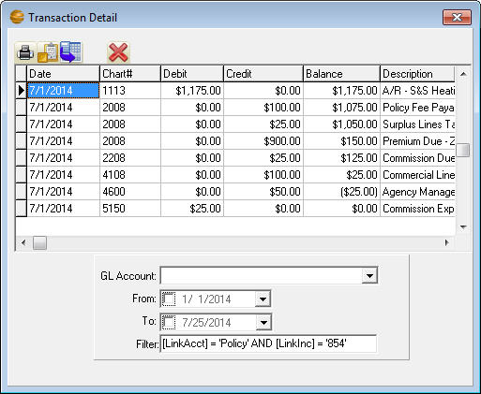
The policy specific postings can be viewed for deeper understanding by clicking the Transaction Detail icon from either the Policy or Client A/R tab with the policy in question selected. This will display all accounting posted against the selected policy.
Figure 63 - Policy specific general ledger postings
Many agencies will deposit all agency bill payments to their Trust or Premium account, and transfer their commission retained back to their Operating account. Some agencies do this at the time of deposit, while others will do a batch transfer on a monthly basis. Either way, this transfer is a simple transfer of funds (using the Account Transfer feature from the Ledger tab while in the Trust account), and does not affect an actual income account, as the income is posted on the policy itself.
If on a cash accounting basis, determining a monthly commission transfer amount can be done with a simple report because commission posts only when payment is received. Contact support to add an “Agency bill commission for trust transfer” report to your Accounting report listing, and run the report on a regular (and not overlapping) basis (after first running the month end proofing process recommended in the Month End Procedure section).
On an accrual accounting basis you can determine what commissions you are holding in trust only by first determining what premium you are holding, and the balance you began with. Because this requires a detailed audit of the bank balance, client A/R, and company payables, many agencies find it simpler to transfer commission at the time of client payment.

Direct Bill Workflow
The direct bill policy is typically billed to the client by the carrier. The main focus of the accounting on the direct bill policy is to track commission paid to the agency.

Direct Bill Reconciliation
Once the policy has been posted, the commission due from the carrier will typically be tracked through the Direct Bill Reconciliation (detailed instructions available in the previous Ledger tab section under Program Features). Reconciling your direct bill allows you to:
- Ensure the policy entry is correct
- Pay producers based on the commission payment paid (Cash accounting method only)
- Track policies that have not been paid to you by the company.
The Direct Bill Reconciliation screen will list all policies that have commission due for you to apply either full or partial payment. If partial payment is applied, the amount due listed will reflect the outstanding balance.
The reconciled statement will result in a deposit entry in the Cash ledger to be deposited. A negative statement will result in a check to the company in whichever ledger you selected after clicking Reconcile Now.
See the Ledger tab section for information on Making Deposits and Printing Checks.

Alternatives to Direct Bill Reconciliation
To understand your alternatives to Direct Bill Reconciliation, you must first understand how your commission account is affected during the processing of the policies and statements.
Your commission postings are very different per accounting method:
Accrual – The entire commission posts against the Company A/R account (1600 series) when the policy is generated to the accounting, as of the effective date (or first payment date if one was selected) on the policy. When the Direct Bill Reconciliation is finalized the receivable is reduced by the amount the company paid.
Cash – The commission posts when the Direct Bill Reconciliation is finalized (as of the date entered on the reconciliation screen).
Because of these differences, it is best to discuss your alternatives with Agency Software support and determine your best process for recording commission.

Accepting the Client Payment
All client payments are taken the same way, by clicking the Receive Customer Payment icon on the Client A/R. This opens the Client Payment window. The fields on this window are:
Date of Payment (required) – Enter the date the payment was received
Amount of Payment (required)
Apply to Which Policy:
Cash (required) – If on a cash basis you must apply every client payment toward a specific policy. If the client is paying multiple policies, you must break up the payment and apply it to each individual policy.
Accrual – While it is recommended to break the payment up per policy, you can leave this field blank to apply on account.
Check Number (optional) – Enter a check number, type in more detail, or check the Cash box if this is a cash payment.
There is no need to input invoice number.
Fill in the appropriate fields and click OK to post the payment. The program will offer a receipt you can either print or close, then offer to Write the Check to the Company. It is recommended to select Yes, as the program will enter a payment (EFT by default) in the ledger of your choice.
You will then have an item in your Cash ledger available to include in your next deposit, and a payment item representing your payment to the company. If this payment needs to be a printed payment, you can change the Print field to True and enter the appropriate check number, then use the Print Check feature to generate a printed check.
More detailed information on checks and deposits can be found in the Ledger tab section of Program Features.

Month End Procedure
Proofing your ledgers and reports, transferring agency bill commission, then paying Reps (producers) is the end of the monthly accounting workflow.

Bank Reconciliation
Making sure your ledgers are complete and accurate is the starting point of the month-end proofing. The Cash account should reflect only the items remaining to deposit and all ledgers should be reconciled (using the Bank Reconciliation procedure in the Ledger tab section) to the bank statements, being sure to review any unreconciled items. This step confirms that the ledger balances are accurate.

Confirm Trial Balance is In Balance
Run a Trial Balance and look at the final figure; this should be zero.
If you are out of balance go to the Ledger tab, click the date header on the title bar to put in date order and then the Recalculate Ledger Balances icon on each ledger account, then rerun the trial balance and check again.
If you are still out of balance you will need to pinpoint the days of the errors by running the Transaction Detail Report and looking at the difference on the last page of the report. Typically you will run this month to month until you find a month that has a difference and then run week by week, taking it down to day by day until you find a particular day that holds a difference. Once you have it down to a single day with a difference you can start looking for the reason(s) for that difference. Here are some things to look for:
Red – Any red items indicate an unbalanced ledger entry. The Transaction Detail Report is organized to list the ledgers page by page. If the allocation for a ledger entry shows in red it either doesn’t balance to the ledger entry or it doesn’t have a valid chart number. Either way go into the ledger, select the appropriate account, and correct the allocation appropriately.
Invalid Accounts – Listed at the very beginning of the Chart of Accounts section, if an invalid account is listed it is likely tied to a policy that was not completely accounting ready. To find this policy you may need to note the Inc number and reference it in the Transaction Detail window of the policy screen. To do this go to the Policy tab, highlight any policy, click the book icon and replace the LinkInc number in the bottom field with the Inc number you noted from the report. Double-click the Inc number you just typed in and that policy’s information will be listed for you to find this account. Many times the policy just needs to be opened, all fields on the left made valid and the accounting to be regenerated.
Direct bill Reconciliation – A bracketed allocation on a check or deposit indicate the other side of the transaction is handled at the policy level. For instance, if you have done a direct bill reconciliation, the cash deposit will have a bracketed 1600 account entry and the Chart of Accounts section should have corresponding entries to the income account for that company that add up to that same amount. Keep in mind that a single direct bill reconciliation can be posted to multiple income accounts for the company if they do both commercial and personal lines on a single statement. The total of the income allocations should add up to the amount of the deposit in cash.
Customer Payments – Again, these will come into the ledger as bracketed allocations. If this was an agency billed policy then the offsetting allocations to the deposit (or check) should be a split between the payables and income accounts. On a direct bill policy the offset should be a credit to the 2100 account for the company.
By finding and fixing these out of balance issues, you will likely gain insight into the Agency Pro accounting workflow and what potential workflow issues you may have in your agency. It is recommended you check your balances regularly to insure correct financial statement balances. If you need help tracking down or defining an out of balance issue, call Customer Support for further assistance.

Run and Proof Reports
It is recommended to review certain reports periodically to assure your workflow is correct and to stay aware of the state of your books. These reports include:
Aged Receivables – Assure the customer receivables look in order, you may also want to print statements for customers who owe. The detail and access to the statement is on the Client A/R tab.
Company Payables and Rep Payables – Assure that the company and producer payables reports reflect correctly what is currently owed to the companies and producers.
Balance Sheet – Review account balances for correctness. The 1600 account range should not hold balances if you are on a Cash basis. The 2100 account ranges should not hold balances regularly. The 2000 accounts should only hold what you currently owe to your account current companies. Also, the Cash account should only reflect what you hold to deposit. You may also wish to use this report to compare your financial status to past years.
Income Statement – Review account balances for correctness and to analyze net profit or loss. You may also wish to compare these figures to prior periods for historical results. The Account Transfer account should not regularly report (should always hold a zero balance).
Once these reports have been reviewed and deemed accurate, you have completed your month cycle and should be able to sleep at night knowing you have a good handle on your accounting and data entry.

Paying Rep (Producer) Commission
Once all else is correct, you are ready to pay any rep commission you might owe to your producers. This is done through the Payables module available in the Ledger tab.
To pay your Reps select the payables icon from the Ledger tab. From the Select Type drop-down choose Commissions Due. From the Select Name drop-down choose the Rep (producer) you wish to pay.
The items available for payment will appear in the Payables window. (If on a Cash basis these items will only show if a payment has been taken against the policy and will show the date of the client or company commission payment.)
To pay the entire amount owed toward an item double-click on the line. If you wish to apply a partial payment, you can right-click the line and type in the amount you wish to apply. To pay all available items on the ledger click the Pay All icon. You can click this icon again to toggle all items to unpaid.
Once the items you wish to pay are marked, the Total field should reflect the amount of the payment you are making. Select the Account you are writing the check from (or the Cash account if this is a receipt for a negative statement), edit the Description, Date, Payee and Check Number if necessary, and then click Pay to finalize the payment. This will create an entry in whichever ledger you chose.
Note: Once an item has been paid you will not be able to regenerate accounting on that policy. All changes must be done by endorsement.
After the payable has been paid you can print the check and the corresponding Paid Item report from the Ledger tab. (See the Ledger tab section for more detailed instructions on these processes).

Journal Entries
To access a journal entry select the Access General Ledger icon from the Policy, Client A/R or Ledger tab. Click the Journal Entry icon. The top portion of the entry is a different layout, but same functionality as the grid below. Simply choose the first account number you wish to affect and type in the amount as a debit or credit, adjusting the date and description as needed. For the remaining entries, schedule those in the grid below. The balance will be the opposite of the amount in the top section and must be zero to save the journal entry, click OK to post.

Close Books (Year End process)
The close books procedure can be ran at any time during your year, as it allows you to select the range of dates that will be closed. The average agency will wait to close books until they have reconciled all outstanding past year items in the ledgers and have performed any past year adjusting journal entries. Some agencies close prior to that and must make adjustments for outstanding items in reconciliation (see Bank Reconciliation procedure above) and year end journal entries must be done to both agencies.
The close books procedure automatically closes any income and expense during the selected period to the Retained Earnings account. It also will clear the transaction detail posting within that date range, leaving any asset, liability and equity accounts with an opening balance reflecting the total to the date of closing.
This procedure also allows you the option of closing past detail for the ledger accounts, client A/R, and TFile events. Most agencies want to first create an archive agency to allow them the opportunity to view these closed entries. Some agencies may also wish to take this opportunity to purge past policies and reset their file for scanning for optimal performance. Full close books instructions can be found at our website or you can call support to schedule the close to be performed by a representative.

Year End Adjustments
Many agencies keep their books open until their adjustments have come back from their accountant and then close the books for their last fiscal year. This eliminates the need to do the adjustments in both the 001 and the prior year agencies.
If you have already closed the books and you are doing adjustments, first do your journal entry in the prior year agency and reprint your year-end financials. Then do the entries in your 001 agency, substituting the retained earnings account for any income or expense account entries.

Policy Purge
If you would also like to purge past policies through a certain effective date range, this is an opportune time to do so. This is a function that must be ran by Customer Support, so please call the support number provided below for more information.
Please contact Customer Support if you have any questions, issues, or would like to schedule a time for support’s assistance in closing at (800)342-7327.

Accounting Work-Arounds
There are many different accounting scenarios that you may deal with, and AgencyPro is designed to allow flexibility in processing which enables you to handle these unusual cases. Below are some solutions to some of the more common accounting oddities you may run into.

Policy Financing
Follow these instructions to apply financing to an agency bill financed policy, where generally you are expected to collect the down payment, retain the commission, and pay the net to the company. There are two main finance scenarios below:

Finance company pays the carrier directly
If you receive only the down payment from the client and the finance company forwards their portion directly to the carrier, follow these instructions to reduce the Client A/R and Company A/P by the amount being financed.
On the policy, in the Non-Premium Items window, add a Finance Credit (if one is not available from the Type drop-down, click the Set Up Non-Premium Items button to add one, choosing Company Payable as the Type) and enter the total amount financed (not including the fees charged to the client by the finance company) as a negative number.
When you click OK on the Non-Premium Items window, the Total Due on the policy should equal the amount you are to collect for the client’s down payment. Click OK to post the policy and then you can bill the client as normal from the Client A/R tab.

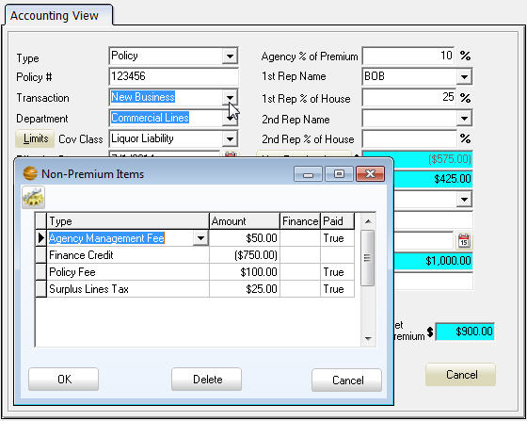
Finance company pays agency
Figure 64 - Financed policy with down payment due
If the finance company pays the agency, then you will post the entire premium as if it were not financed, and then manipulate the invoice to add the finance credit as a dummy billing. This way you can receive both the customer down payment and the finance payment on the Client A/R tab.

Third Party Billing
If you need to bill someone other than the client, you can utilize the Additional Interests database to enter a billing party. In the Acord tab add an Additional Interest form and click the Additional Interests icon. Add a new Additional Interest with the desired billing information and be sure to mark the Send Bill box. In the Client A/R click the invoice you wish to print and you will see next to the client information the same Additional Interests icon. When you click this you can then select your desired billing party.

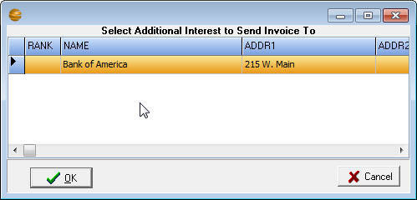
Figure 65 - Select second party billee from the Additional Interests withing the invoice

Cancellations and Return Premium
When a policy cancels, the program’s cancellation feature will do several things at once. To cancel a policy, highlight the policy that is cancelling in the Policies tab and choose Cancel Policy in the Policy Options box. Click Do It.
The Cancel Policy window appears with your cancellation options. The Flat Rate option will assume the effective date is the cancellation date and the Short Rate and Pro Rata options will assume today’s date. Adjust this to the appropriate cancellation date and the system will:
- Close the original policy and change the Policy Type to Pre-Cancelled (this policy can no longer be altered)
- Create a negative entry with a guessed return premium
- Open this entry so you can manipulate the numbers prior to saving the cancellation.
Once the policy has been cancelled, you will see two lines listed; one positive (the original) and one negative that net out to the earned premium.
The postings are essentially the same as the regular policy postings. If the policy is direct bill then the Direct Bill Reconciliation will show a credit item to be reconciled. If the policy was agency bill:
The Client A/R will show a credit posting which you can return to the client by negative payment, or leave on account to offset another policy.
Cash – To offset to another policy you must take a negative payment (to the Cash ledger) against the cancellation, and an offsetting positive payment against the policy you wish to apply the credit toward.
Accrual – Rather than applying a negative payment, use a Cancellation Refund Adjustment, available in the A/R Adjustments accessible through the Client Payment window.

No Charge-back Return (Financed Cancellations)
When a financed policy cancels, many times the carrier sends the gross return to the finance company and requests the commission returned from the agency. In this case you can check the box at the bottom on the cancellation policy to Apply A/R to Premium Finance Company. If the cancellation had been posted previously you will have to change the Policy Status to Open to get the correction to post.
This will offset the credit on the Client A/R, leaving you owing nothing to the client, and offset the credit in the Company A/P, leaving you owing the company the cancellation commission.

Payments sent directly to the company
If the customer (or mortgage company) sent the client payment directly to the company, rather than to you, you can waive the Client A/R balance by checking the box at the bottom on the policy to Apply A/R to Premium Finance Company and regenerate accounting (may have to click in the Premium field to get the policy to regenerate).
This will offset the premium on the Client A/R, leaving the client owing nothing on the policy, and offset the amount owed in the Company A/P, leaving you owed the commission from the company.

A/R Adjustments
Non-policy tracking on the Client A/R is sometimes necessary. This is one of the biggest areas of procedural difference between the Cash and Accrual accounting methods. Each process below has a separate procedure per accounting method.

Direct Bill Payment Advances
If you pay a direct bill premium payment on behalf of the client, you will likely want to track this payment on the Client A/R until the client has paid you back. This is done by:
Accrual – On the Client A/R tab select the Payment Reversal Adjustment available in the A/R Adjustments (accessible through the Client Payment window). Enter the date and amount of the payment advanced for the client (policy is optional), and click OK. Select the account this payment was taken from. This will place a charge on the Client A/R and a check (to the client) in the ledger account you chose. Simply edit the check to reflect the company as the Payee. When the customer pays, be sure to apply on account (leave the policy field blank), and the client’s A/R balance will be reduced.
Cash – From the ledger where the payment was withdrawn enter a payment and allocate it to the 2100 account for that specific company. To place a notation on the Client A/R (optional), do a Cash Client A/R Adjustment (click the A/R Adjustments button accessible through the Client Payment window) for the amount of the advance on the date of the advance. Once saved, change the description on this line (if necessary) to reflect that this was an advance to the company. When you receive the payment from the customer take the payment against the direct bill policy, saying No to Write the Check to Company, then delete the Cash Client A/R Adjustment from the Client A/R.

NSF Payments
When a customer payment is returned NSF you must adjust your ledger likewise and may also need to record bank fees.
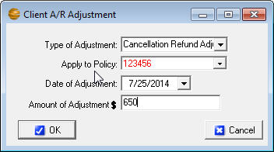
Accrual - First you must reverse the payment by using the Payment Reversal Adjustment. This will place a debit back on the Client A/R and a reversal in the ledger of your choice. If you intend to charge the client a fee for the NSF, you can use the NSF Charge Adjustment, which will place a debit on the Client A/R and ask for an offset, which would typically be a fee income account. When the client pays, be sure to apply on account by leaving the policy field blank.
Figure 66 - Refunding return premium to a client on an accrual accounting method
Cash - You will need to enter a reversal in the bank, but may also wish to add a notation to the Client A/R of the customer to show they owe you for this NSF and fees. Before making this adjustment you will want to be sure to add an account number in the Chart of Accounts for NSF Charge Backs, typically in the Current Asset range (account number 1700 for example).

Adjusting the Ledger - Go into the ledger the charge was withdrawn from and add a new line for the amount of the payment that was charged back. Allocate this payment to the NSF Charge Back account. If you intend to charge the client for the bank fee you may repeat this process to record the fee in the ledger.

Notating Client A/R (Optional) - If you would like to be sure this appears on the Aged Receivables go into the client’s A/R tab and do a Cash Client A/R Adjustment (click the A/R Adjustments button accessible through the Client Payment window)and adjust the date and the amount to match your NSF ledger entries, click OK. You may also edit the description on this line to read NSF Charge Back, etc.

Receiving Payment on NSF - When taking the payment from the customer it must be handled directly through the Cash account rather than through the Client A/R. Go into the ledger to the Cash account and add a deposit line, allocating this payment to the NSF Charge Back account. This should clear that particular balance from that account. If you have notated the Client A/R with a Cash Client A/R adjustment you will want to reverse it in the same manner (by a negative adjustment, dating it the date of the payment and editing the description to notate that this was a customer payment made), or delete it.

Bad Debt or Small Balance Write Off
You may need to write a client balance off from time to time. Whether it is because the account was under or over paid by a few pennies, or if the account is uncollectible, you will use this process to remove the balance.
Accrual – Do a General Account Adjustment (click the A/R Adjustments button accessible through the Client Payment window) for the amount you wish to adjust your Client A/R balance. When you click OK, choose the appropriate account number (bad debt expense, over/short, etc).
Cash – Apply a payment toward the policy that was over or under paid (a negative payment if necessary, selecting the Cash account). In the Cash ledger edit the resulting item, zero out the deposit (or payment) amount, in the Transaction detail add a new line for the offset of the original bracketed line, using the appropriate account (bad debt expense, over/short, etc).
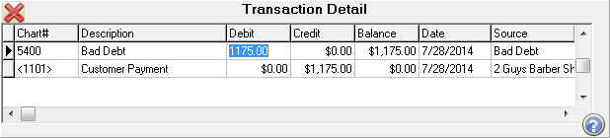
Figure 67 - Cash basis bad debt entry from client payment item in Cash

Company Payment Modifications
The following are some less ordinary company scenarios you may run into.

Combined Statements
Occasionally a company may pay you by mixed agency bill/direct bill statements. To account for these statements you must know what portion is agency bill and which portion is direct, and first go to reconcile the direct bill portion of your statement, entering the Commission Check Amount as the amount of the direct bill commission you are receiving on the statement (if the commission is negative, choose the Cash account).
From the Cash ledger, edit the resulting items and zero out the deposit (or payment) amount. In the transaction detail, add a new line to offset the original line, using the Company A/P account number (20xx) of the company you are paying, and entering in the Description Field “Commission”.
Open the Payables, and you will now have that commission total to include on your payable payment.

Advance Company A/P Payment
When making a payment to a company on behalf of the client, simply enter a manual check to the company allocated to the appropriate liability account (2000 range if agency billed and 2100 range if direct bill). When the customer comes in and pays apply it as usual in the Client A/R toward the policy. If it is a direct bill payment choose No when asked to write the check.

Additions/Withholdings from Commission Payment
Occasionally a company may pay bonuses along with your commission statement or withhold expenses, such as MVR, from a statement. To account for these you must first reconcile the actual amount of commissions received in the Direct Bill Reconciliation. Once the deposit is in cash you can modify the Deposit amount, press the CTRL key then the down arrow for a new Transaction Detail line. Enter the chart number of the item being appended to this deposit (EXE: MVR Expense, Bonus Income, Etc.), and enter the amount of the amendment. Press the CTRL key again and it should let you out of the Transaction Detail without error if in balance.

SECTION 5

TROUBLESHOOTING

AgencyPro Slow to Open
Try disabling the anti-virus program on the local machine. If the program opens more quickly, the anti-virus is the problem. You need to set exclusions in your anti-virus program so that the anti-virus can run without interfering with your AgencyPro database files. Go to the web site www.agencysoftware.com. On the Support page, click the link that reads “Program Running Slow or Locking Up” for more information on exclusions and details on other things to look for.

AgencyPro will not open, no error
Often this means that there are multiple processes in the task manager. Open the Windows Task Manager (CTRL+ALT+DEL), click the Processes tab, and end any instance of Apro you find. Try the program again, being sure to give it plenty of time (this happens due to system/network slowness).

User Can’t Delete Clients
User doesn’t have supervisory access. User needs supervisory access to delete clients in AgencyPro.

User gets Key Violation when Logging In
Log in as a different user with supervisory access, and edit the Employees database (on the Agency Setup tab) to remove/edit duplicate employee names.

Client tab is blank for one user
Log in as a different user with supervisory access, and edit the Employees database (on the Agency Setup tab). Browse to that employee and remove the check mark in Producer (Restricted) Access.

Cannot Perform Operation on Open Dataset
This error occurs in the ACORD window. It is preceded by an error showing characters and stating that those characters are not a valid integer. Trying to add an ACORD form after that message will generate this error. This means that some data in the ACORD forms has corrupted. Call Technical Support immediately and prepare to transfer the data to Agency Software for examination and correction of the corruption.

Index Out of Date
This error usually occurs when someone has used Ctrl-Alt-Delete to get out of the software or has shut down their computer while APRO was running
- Close AgencyPro on all machines
- Click Start, Programs, AgencyPro for Windows, Keyfix.
- Allow Keyfix to run until you see the message "Rebuild Complete".

Forms will not open, giving error
If no forms are opening on a single workstation, the memory setting might need to be adjusted. Close AgencyPro, browse to the Apro folder, and open Techtools (Techtoolsv8 for Windows 8 users). Click the BDE Adjust tab, note the current setting on the left side, then click the 2000 button (if it was currently 2000 try a different setting). Close techtools, return to AgencyPro, and try opening a form again.

Unrecognized Tag in Mail Merge
This is an error message that is generated in the Letters window, when performing a mail merge, in which the fields specified to merge do not exist. If these fields were selected by using the “SELECT MERGE FIELD” buttons, corruption has occurred in your LETTERS window. Call AgencyPro technical support.

Printer Doesn’t Print from AgencyPro
This problem is most likely to occur when an agency is trying to print to a multifunction printer from AgencyPro. There are some multifunction printers AgencyPro will not print to. These include some Xerox WorkCenter XE series printers. There is no fix for this. The agency must print to a different printer.

Text Won’t Fit into Lines on Forms
This problem is usually caused by having Large fonts set on the particular computer that has the problem. The ACORD forms are not designed to run in a Large-fonts environment.
To change the font settings back to Normal:
- Right-click in an empty space on your computer desktop.
- On the shortcut menu, click Properties.
- In the Display Properties dialog box, click the Settings tab.
- On the Settings tab, click the Advanced button.
- On the General tab, you’ll see a box labeled Font Size or DPI Settings (depending on your version of Windows). The box probably has “Large” or “125%” or some similar setting (again, depending on your version of Windows).
- Click the arrow in the box to open a list of choices.
- Choose Normal, or choose Other and set 100%.
- Click OK to close every open dialog box. You may need to restart your computer (depending on your version of Windows).

Backups taking a long time
By default, the backup will take a copy of your Pics folder (containing all images). As this folder’s content grow, so does the time it takes to backup, and the size of the resulting backup. You can choose to not get a copy of the pics, or to schedule a task to have the backup run after hours. See the previous section on Backing Up for more information.

External Exception/Unknown Internal Operating System Errors
These messages indicate a network interrupt. The reason for these interrupts can vary network to network. Anything from aggressive antivirus, to a bad network card can cause these errors. See more about the potential issues by referring to the “Program Running Slow or Locking Up” document in the Support section at our website.

Report print is too small
Some reports have several fields (columns) of data, and all the fields will have to fit in one row across a single page. The more fields of data are displayed, the smaller the font will be (to fit it all into one row).
To make small print a little larger:
Rerun the report and select Landscape - When the report is printed in Landscape orientation, there is more page area for the long rows and the print is more readable.
Eliminate unnecessary fields - If the report print is still un-readably small, you can only increase the font size by eliminating some of the fields (columns) in the report.
Select multiple lines per record - You can opt to ‘break’ each row of data into multiple lines (although it is a little harder to read this way). The dialogue box to do this appears only when the report has reached a small font.
Save the report as a Mail Merge file - Open the saved csv file in Excel and then you can manipulate the page and font size to your desired format.

Index

A
Account Transfer 72
Acord form menus
Adjust 86
Edit 84
File 83
Help 87
Options 86
Tools 85
View 85
Acord form options 75
Acord form toolbar 82
Acord form window 81
Acord forms
Add New Form 76
Delete Client’s Form 77
Duplicate Client’s Form 77
Edit Client’s Form 77
Entering data in forms 87
Mark Forms for Mass Print 79
Move Forms to Diskette 79
Print Mass Marked Forms 79
State-specific forms 76
Acords Window 75
Additional Interest 104
Advance 194
Agency Bill 163
Accrual/Modified Accrual 162
Agency Setup 145
Automatic backup schedule 146
Companies Information Database 147
Edit employees 151
Employee information 150
Global messages 147
Opening Balances 160
Users 150
Agency Software Printer 134
Apro Document Manager 124
Apro Setup Window 145
B
Backups 18, 146, 199
Bad Debt 193
Bank Reconciliation 72
C
Calendar 137
Cancellations 188
Certificate Holders 88
Add from Master List 93
Add new 89
Blanks 90
Button 88
Delete 94
Duplicates 89
Edit 93
Menu 88
Print certificates 95
Print list 96
Same holder, multiple jobs 91
Certificates, Print 95
Chart of Accounts 72, 74, 145, 156, 157, 158, 161, 162, 180, 181, 192
Claims 123
Claims Window 123
Client A/R
Delete Transactions 57
Generate All Statements 56
Generate Invoices 56
Generate this Statement 56
Receive Customer Payment 56
View Transaction Detail for Current Policy 57
Client A/R Window 55
Client Payment 178
Clients
Add a Client 39
Delete a Client 39
Edit Client Information 39
Filter client list 41
Restore client list after filter 41
Clients Toolbar 40
Clients Window 37
Close Books 184
Combined Statements 194
Coverages 53
Class 53
Coverage 54
Deductible 54
Limit 54
Notes 54
Custom Report 112
Customer Demographics 122
D
Default Limits 54
Demographics 122
Deposits 64
Direct Bill Reconciliation 66
Document Manager 124
Adding files 127
Desktop icon 129, 134
Linking/attaching 125
PaperPort 132
Using linked/attached files 135
Drivers 100, 104
Drivers Database 100, 104
E
Email vii, 79, 84, 96, 104, 105, 106, 135, 136, 149
Set up 104
E-mail doesn’t work 106
Emailing Forms 104
Equipment 100
Equipment Database 99
External Exception 199
F
Financing 186
Forms
Emailings 104
H
Help Files 31
I
Images 124
Images Window 124
Invoices 56
J
Journal Entries 184
L
Ledger
Account (Cash) 58
Ledger buttons
Account Transfer 72
Calculator 60
Delete Transaction 60
Find Transaction 60
New Account. 59
Recalculate All 61
Ledger Window 58
Letters 116
Attach to client 120
Custom letters with merge fields 118
Merge client data 117
rtf file type 117
Letters Window 116
M
Mailing labels 115
Mailing Labels 115
Month End 179
MVR 66, 195
N
No Charge-back Return 189
Notes 106
Notes Window 106
NSF 191, 192
P
Payables 70
Personal 122
Personal Window 122
Policies 45
1st Rep Name 51
1st Rep % of House 51
1st Rep Commission 52
2nd Rep % of House 51
2nd Rep Commission 52
2nd Rep Name 51
Add New Policy 48
Agency % of Premium 51, 52
Agency Income 52
Billing Method 50
Company 50
Coverages 53
Display Options 47
Down Payment 52
Effective Date 50
Expiration Date 50
First Payment Due 52
For Options 47
Installment Type 52
Net Premium 52
Non-Premium Items 51
Number of Payments 52
Policy Options 46
Policy Status 50
Premium Amount 50
Total Due 52
Policies Window 45
Printing Checks 63
Property 101
Property List, Print 103
R
Rep (Producer) Commission 182
Reports 71, 73, 110, 116, 152, 162, 181
Custom 112
Delete 116
Edit 116
Mailing labels 115
Print too small 111, 199
Reports Window 110
Return Premium 188
rtf file type 117
S
Small Balance Write Off 193
Statement 56
Surveys 144
T
TFile 141
Display 142
Find Word or Phrase 142
Print history 142
TFile Window 141
Tickler 137
Alarm 140
Change display 141
Create new 139
Edit 140
Tickler Window 137
Troubleshooting
Agency Pro Slow to Open 196
Cannot Perform Operation on Open Dataset 197
Printer Doesn’t Print from Agency Pro 198
Text Won't Fit into Lines on Forms 198
Unrecognized Tag in Mail Merge 198
User Can’t Delete Clients 196, 197
User gets Key Violation when Logging In 196
TROUBLESHOOTING 196
U
Unknown Internal Operating System Errors 199
V
Vehicle 97
Vehicle List, Print 99
W
Web View
Login 43
Web View Toolbar 44
Window
Acords 75
Agency Setup 145
Claims 123
Client A/R 55
Clients 37
Images 124
Ledger 58
Letters 116
Notes 106
Personal 122
Policies 45
Reports 110
TFile 141
Tickler 137
Y
Year End 184
Year End Adjustments 185

Change Log:
8/26/14 – Signature specifics and order information on page 85

Files compatible with this feature of AgencyPro must be saved as *.rtf file types. Files saved as *.doc files will not be recognized. Files saved with table formatting in a word processing program will be altered when saved as *.rtf files.

